Supplemental Figures 9-13
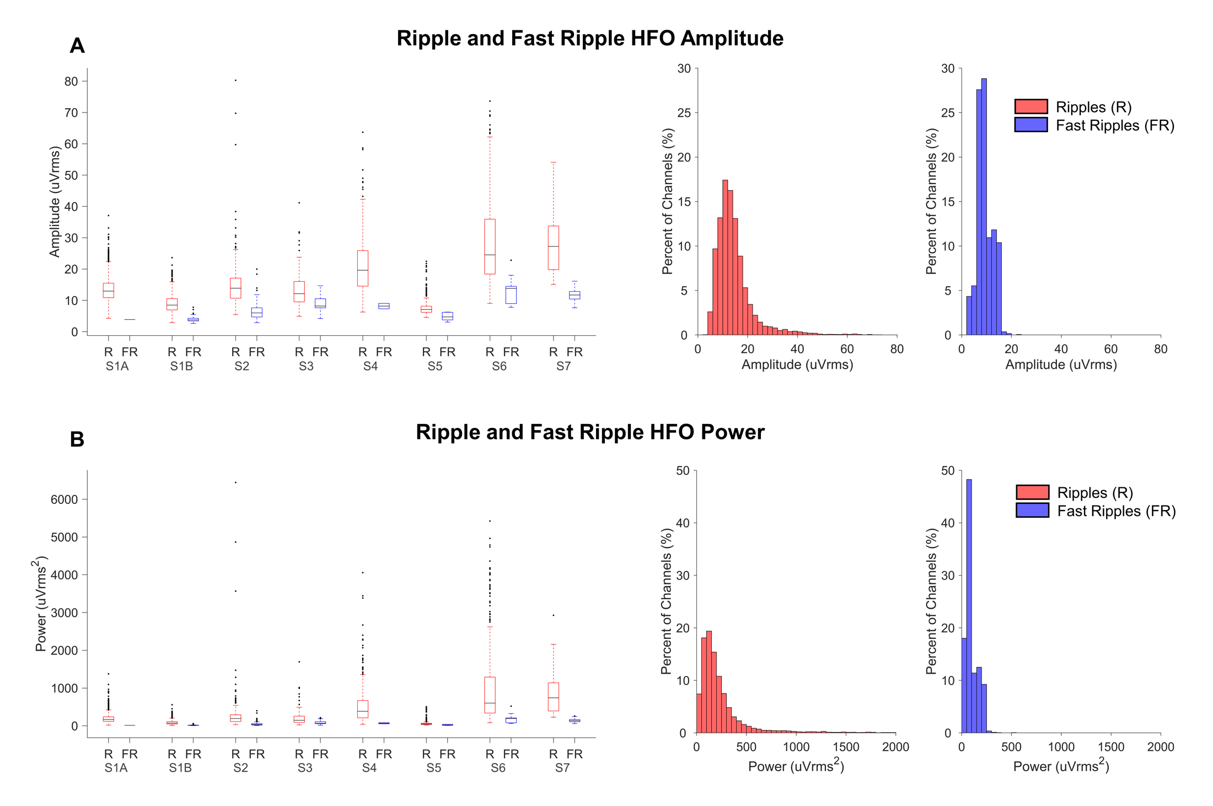
Figure S9. Amplitude and power of ripples and fast ripples. A) Amplitude (µVrms) of ripple (R) and fast ripple (FR) HFOs in the respective filter bands (80 – 250 Hz or 250 – 600 Hz), shown by subject (left) and across all subjects (right). B) Power (uVrms²) of ripple and fast ripple HFOs in the respective filter bands (80 – 250 Hz or 250 – 600 Hz), shown by subject (left) and across all subjects (right).
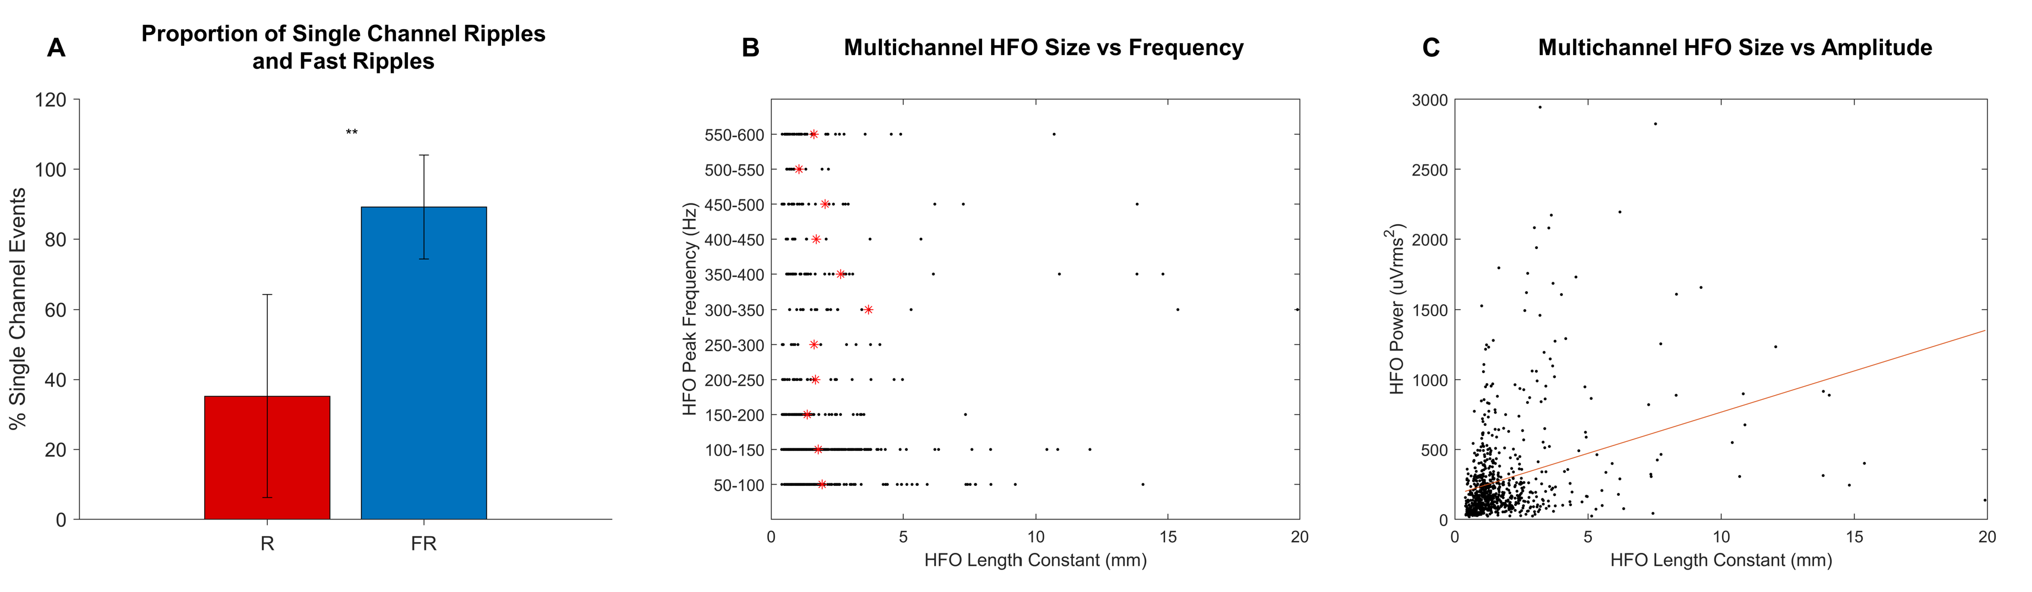
Figure S10. HFO size compared with peak frequency and amplitude. A) Proportion of ripples (R) and fast ripples (FR) which occurred on single channels, averaged across subjects. A significantly greater proportion of fast ripples occurred on single channels than ripples (p = 0.0011 by Wilcoxon rank sum test). Error bars show standard deviation. B) Peak frequency of each multichannel HFO event (ripples and fast ripples) compared with the event size (length constant). The red asterisks indicate the mean HFO length constant of events of each frequency range. C) Power (µV rms²) of each multichannel HFO event (ripples and fast ripples) compared with the event size. The R² of a linear fit to this data was 0.103, indicating a poor relationship between HFO power and event size.

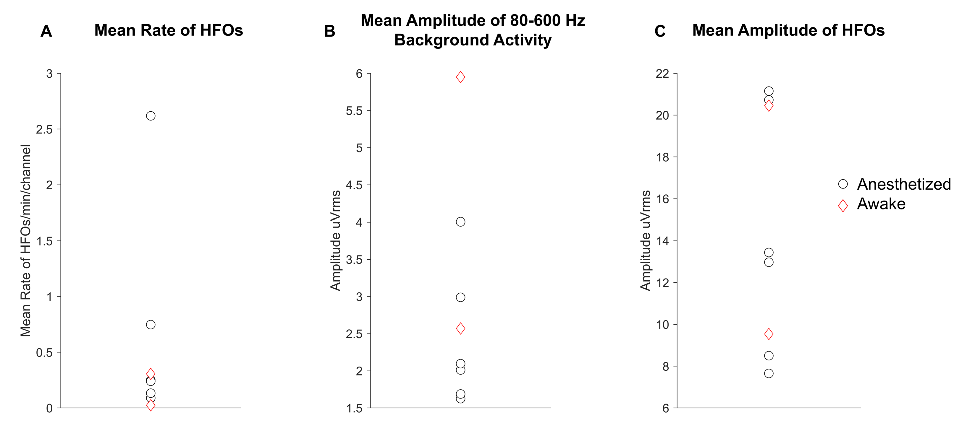
Figure S11. Comparison between anesthetized and awake subjects. A) Mean rate of HFOs (ripples and fast ripples) per channel per minute for each subject, differentiated by awake and anesthetized. B) Mean amplitude (µV rms) of background activity in the 80-600 Hz band for each subject, differentiated by awake and anesthetized cases. C) Mean amplitude (µV rms) of HFOs in the respective ripple (80-250 Hz) or fast ripple (250-600 Hz) bands for each subject, differentiated by awake and anesthetized cases.

Figure S12. Time lag at which neighboring HFOs most strongly covaried with the central HFO. Histogram of the time lags at which HFOs surrounding a central HFO event had the greatest magnitude of cross covariance. The time lags represent a phase shift in the HFOs between neighboring channels.

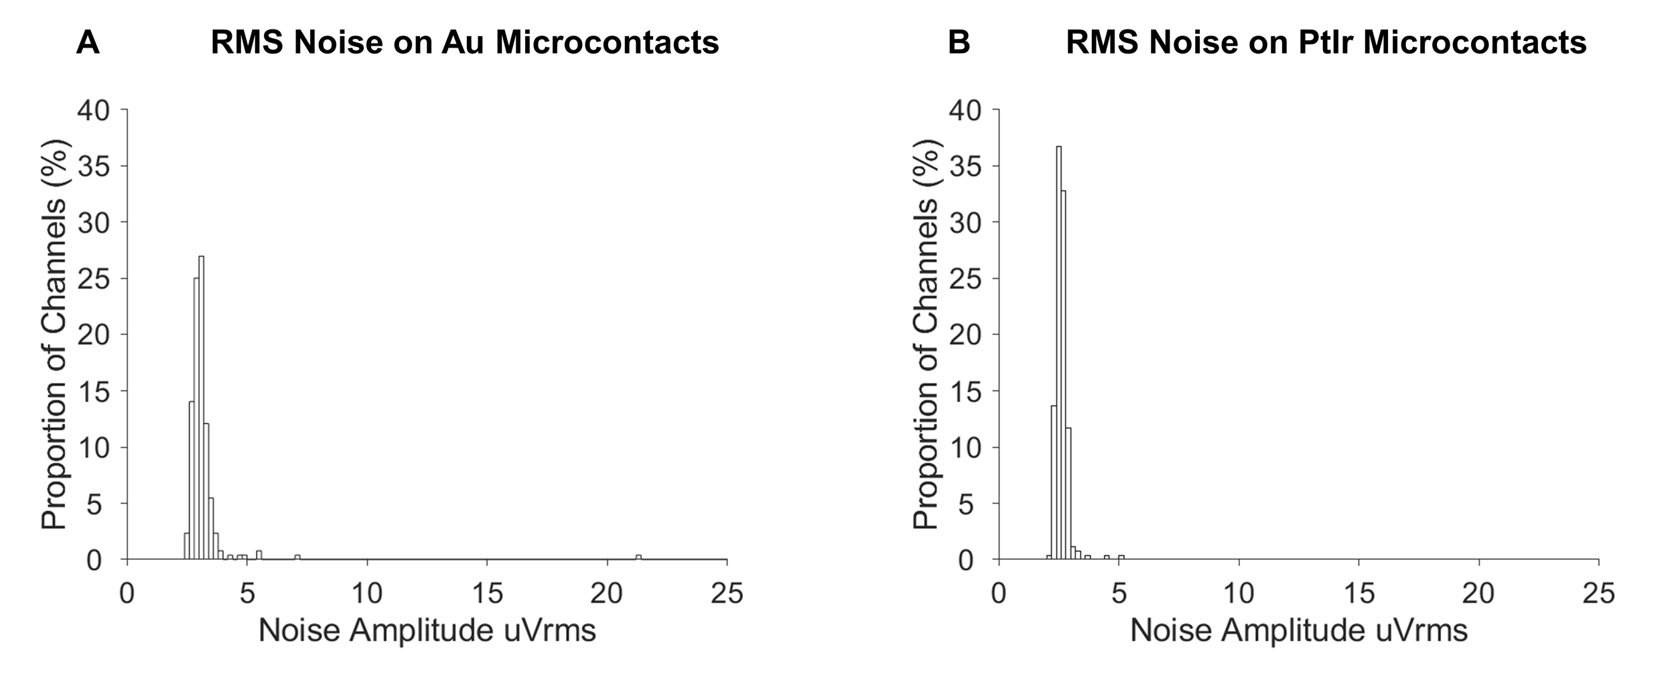
Figure S13. RMS amplitude of noise recorded in-vitro on LCP-TF arrays with Au and PtIr microcontacts in grounded saline. A) Distribution of RMS amplitude of the broadband (decimated to 2 kHz) noise (mean = 3.18 µV rms; standard deviation = 1.28 µV rms) recorded from the LCP-TF array used to record from S4. This array had 200 um diameter microcontacts platted only with Au. Subjects S1-S6 were recorded using arrays with equivalent Au microcontacts. B) Distribution of RMS amplitude of the broadband (decimated to 2kHz) noise (mean = 2.62 µV rms; standard deviation = 0.28 µV rms) recorded from the LCP-TF array used to record from S7. This array had 200 um diameter microcontacts platted with Au and then with PtIr. Subjects S7&S8 were recorded using arrays with Au microcontacts. In both cases, channels with high impedance (>500 kOhm) were excluded. The Au microcontact array additionally had 6 outlier channels with noise levels of 91 – 110 µV rms.

