Supplemental Figures 1-8
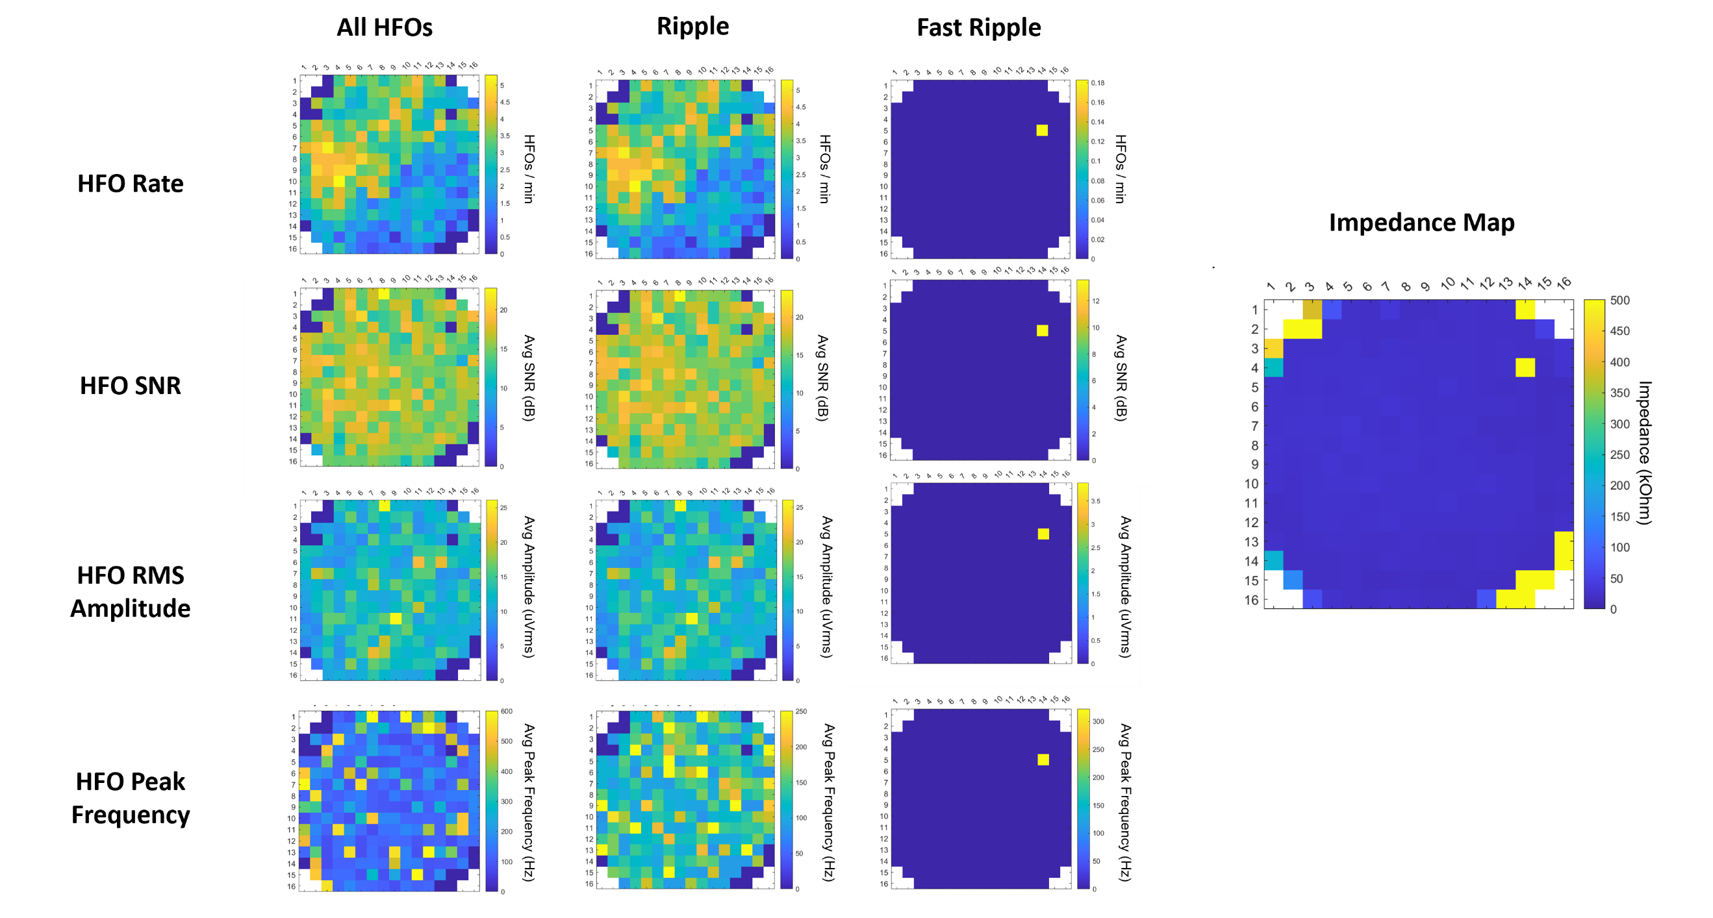
Figure S1. Maps of electrode impedance and ripple and fast ripple HFO activity across the µECoG array for S1A. Impedance for S1A was measured before the intraoperative recording in saline.

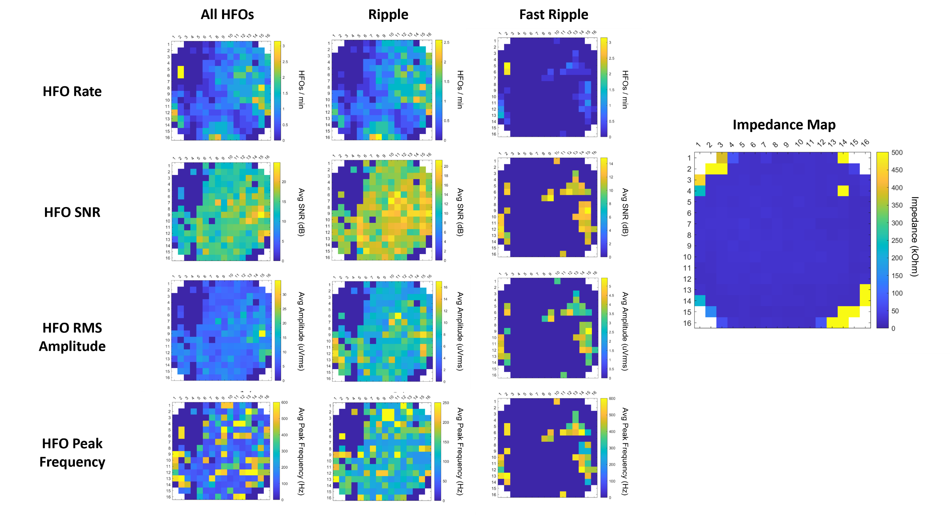
Figure S2. Maps of electrode impedance and ripple and fast ripple HFO activity across the µECoG array for S1B. Impedance for S1B was measured before the intraoperative recording in saline.

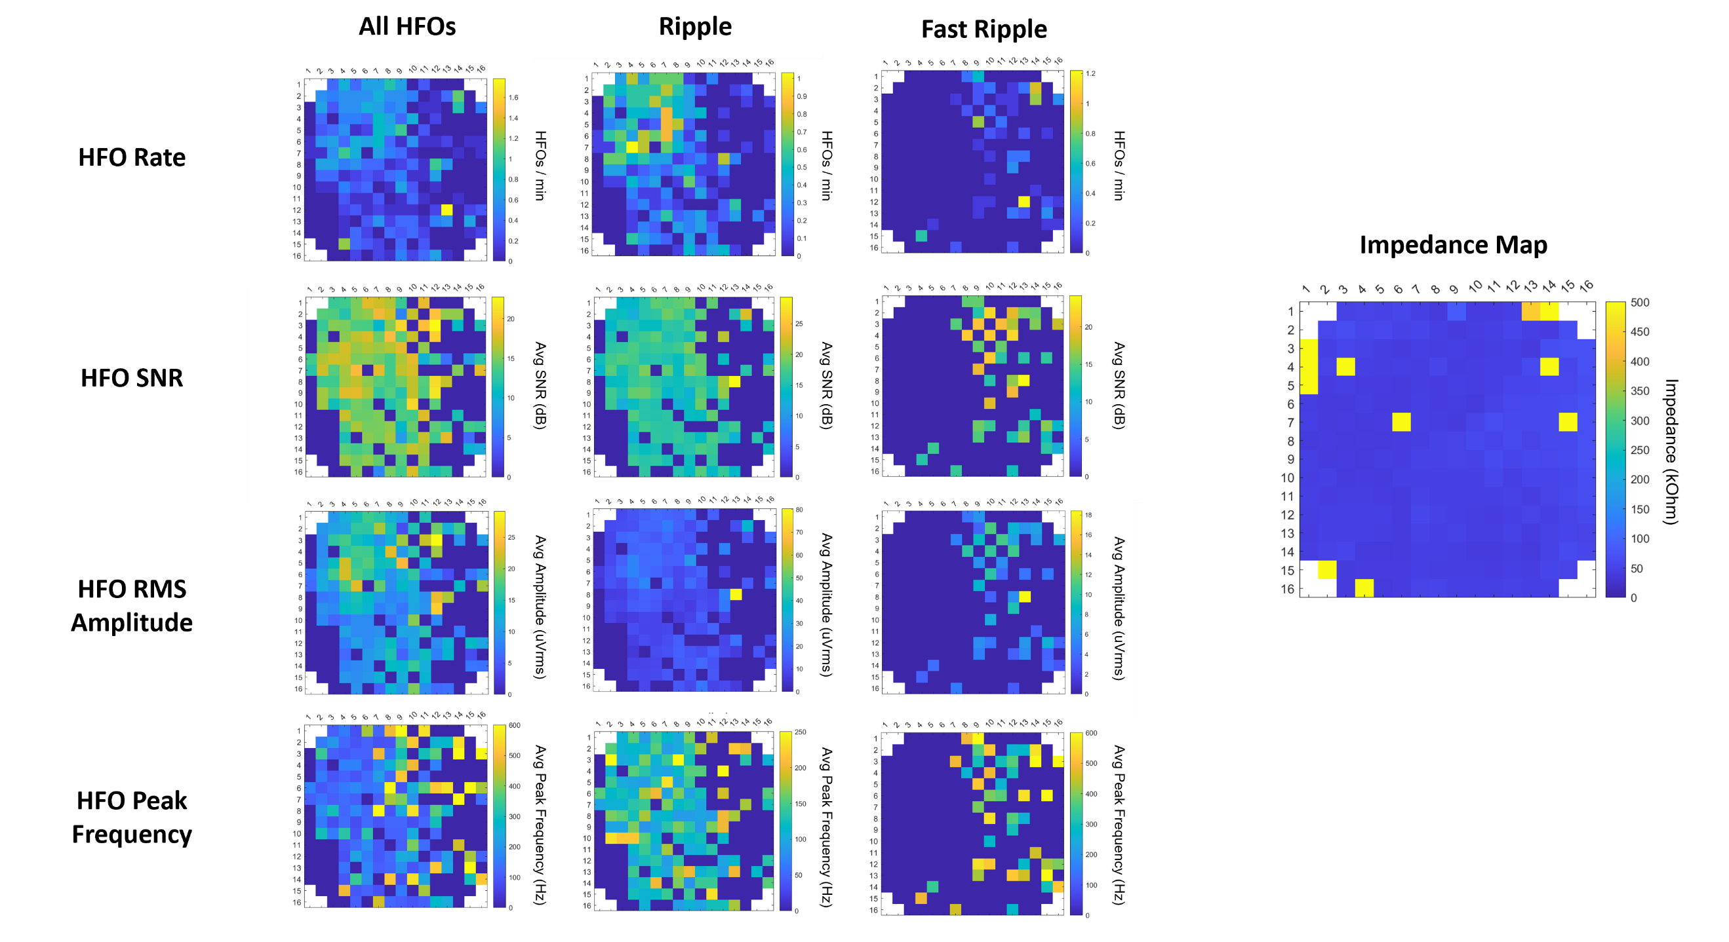
Figure S3. Maps of electrode impedance and ripple and fast ripple HFO activity across the µECoG array for S2. Impedance for S2 was measured before the intraoperative recording in saline.

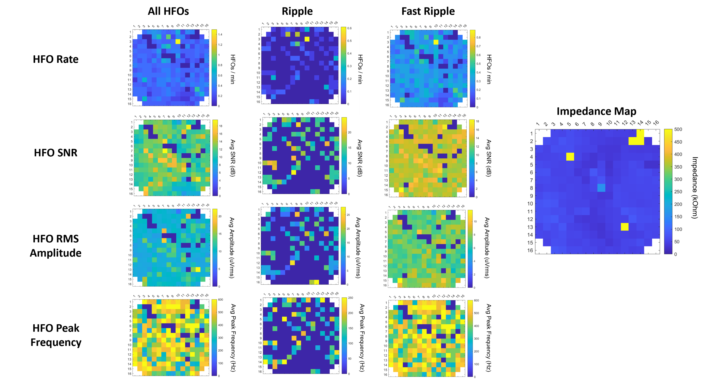
Figure S4. Maps of electrode impedance and ripple and fast ripple HFO activity across the µECoG array for S3. Impedance for S3 was measured during the intraoperative recording while placed on the cortex.

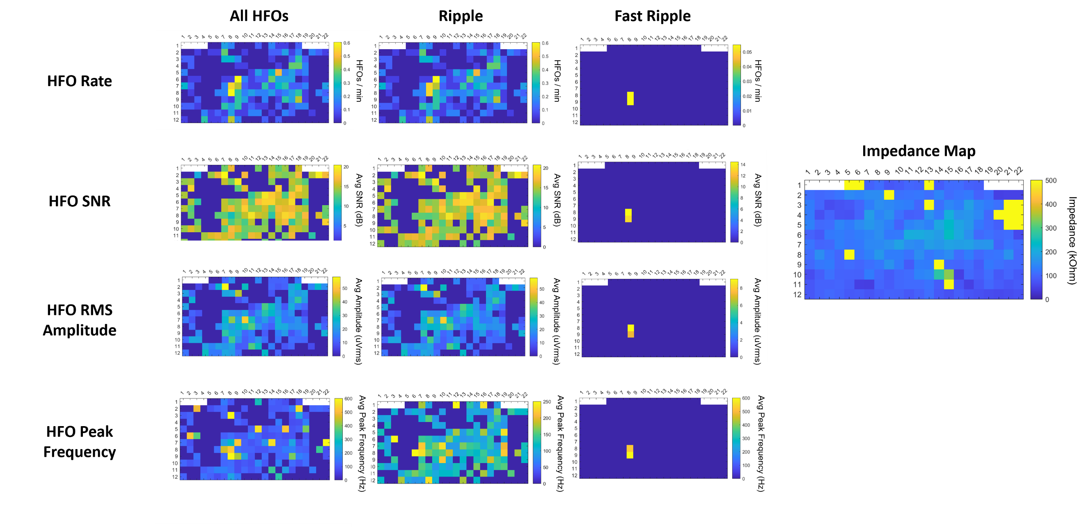
Figure S5. Maps of electrode impedance and ripple and fast ripple HFO activity across the µECoG array for S4. Impedance for S4 was measured during the intraoperative recording while placed on the cortex.

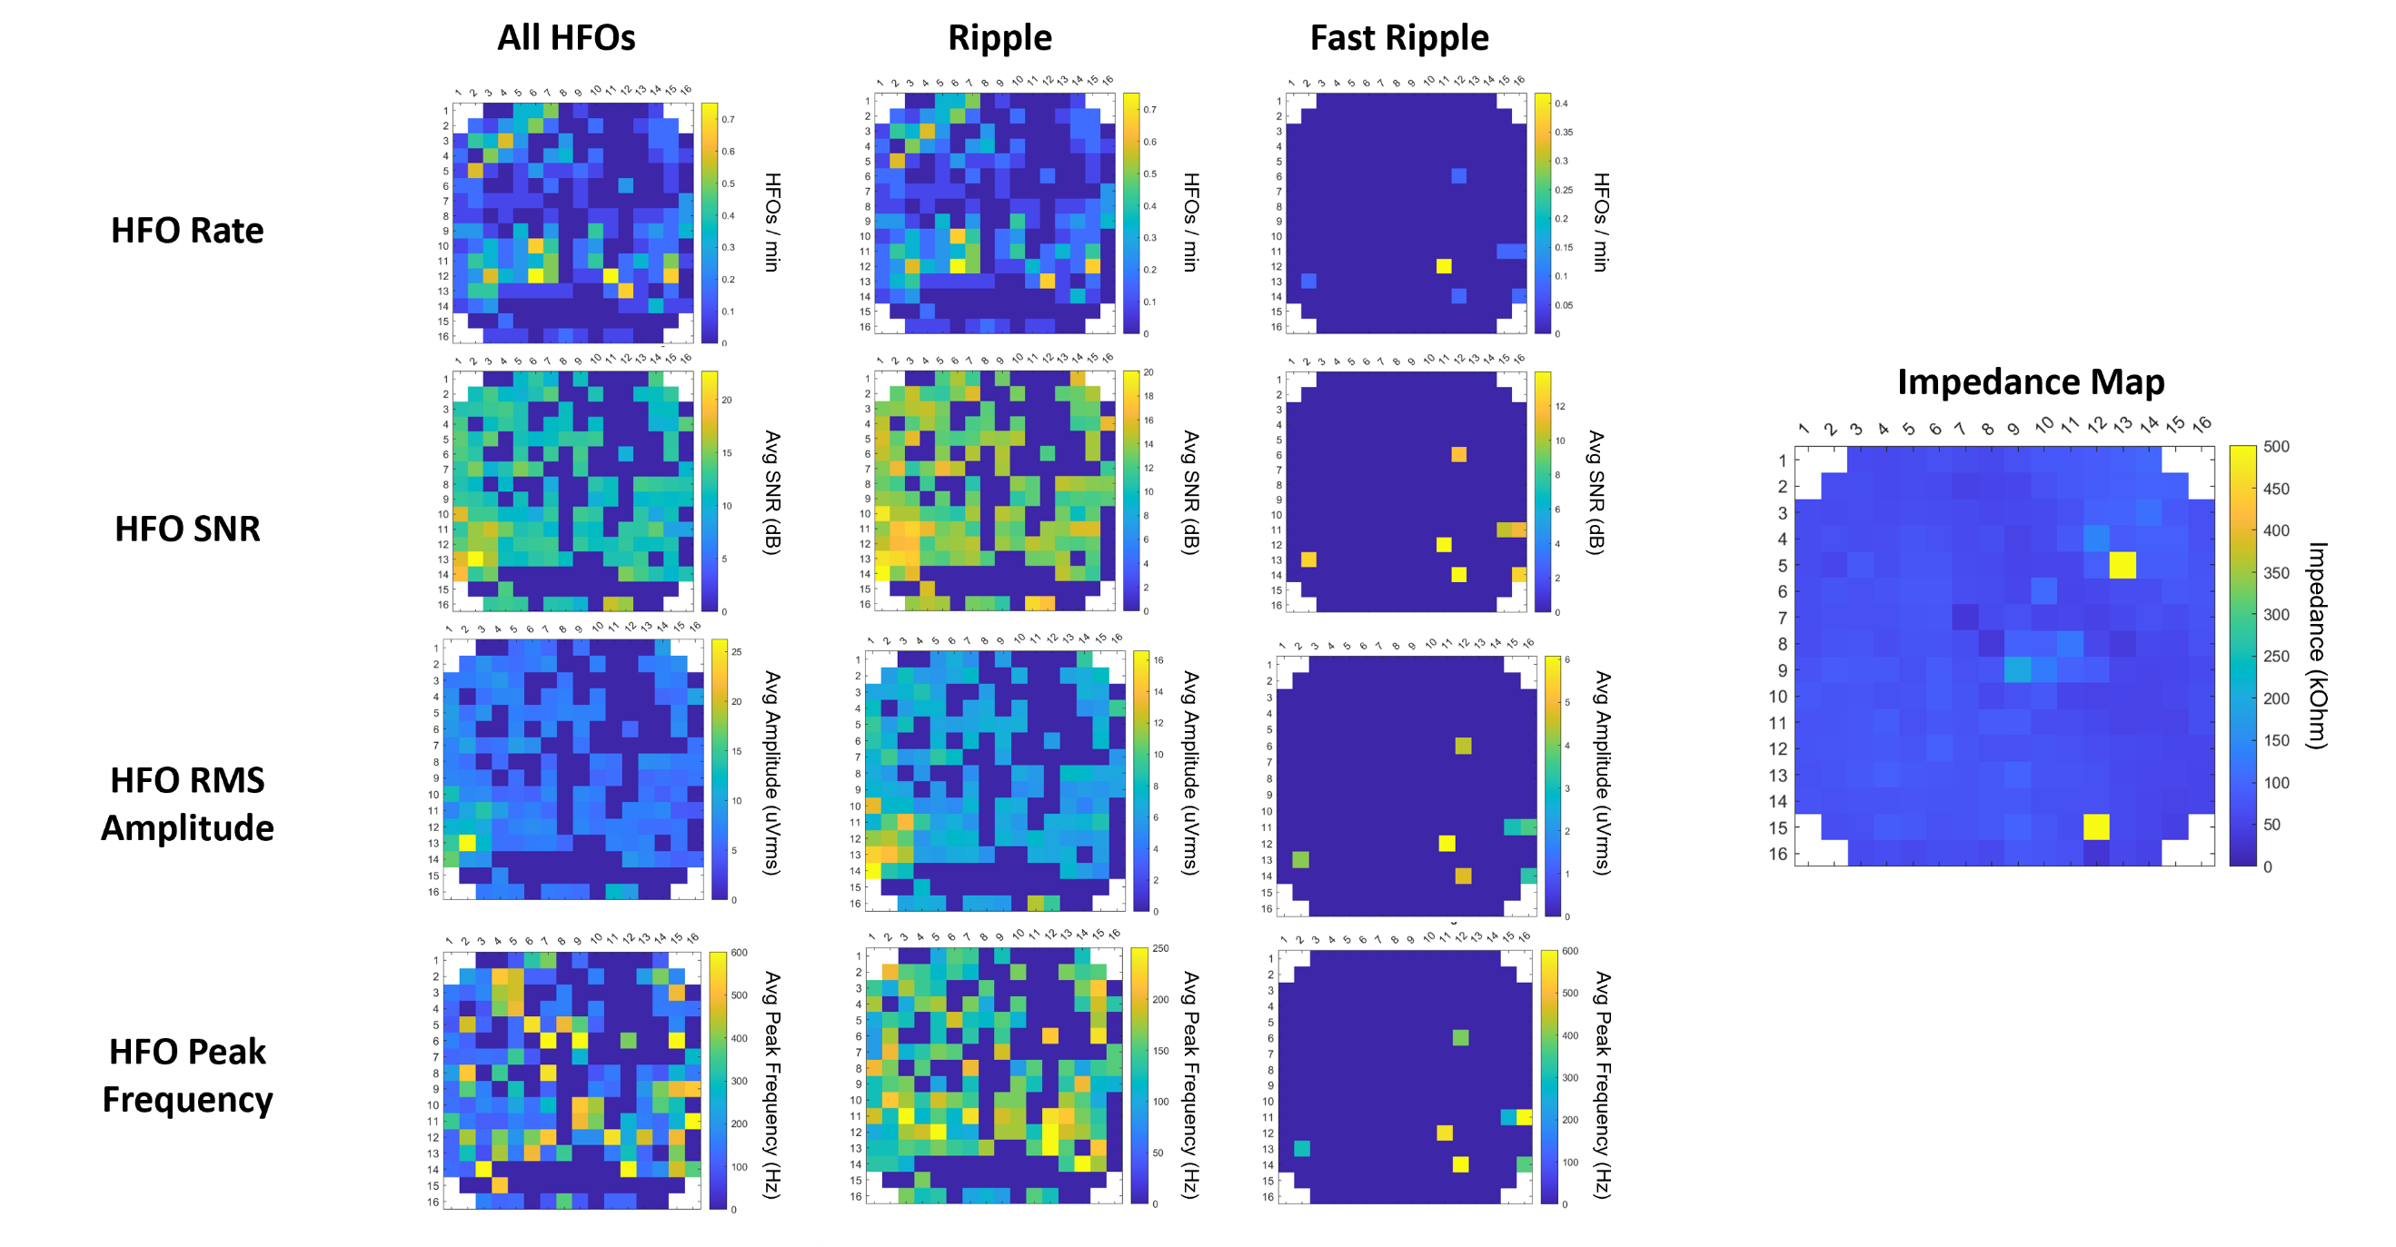
Figure S6. Maps of electrode impedance and ripple and fast ripple HFO activity across the µECoG array for S5. Impedance for S5 was measured during the intraoperative recording while placed on the cortex.

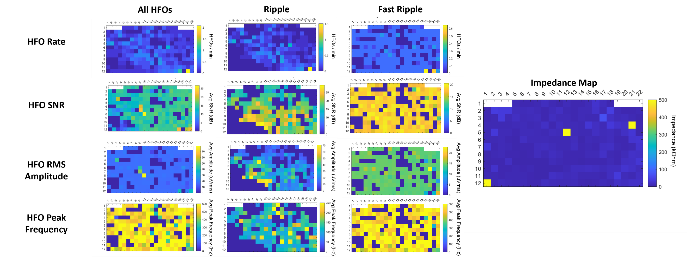
Figure S7. Maps of electrode impedance and ripple and fast ripple HFO activity across the µECoG array for S6. Impedance for S6 was measured during the intraoperative recording while placed on the cortex.

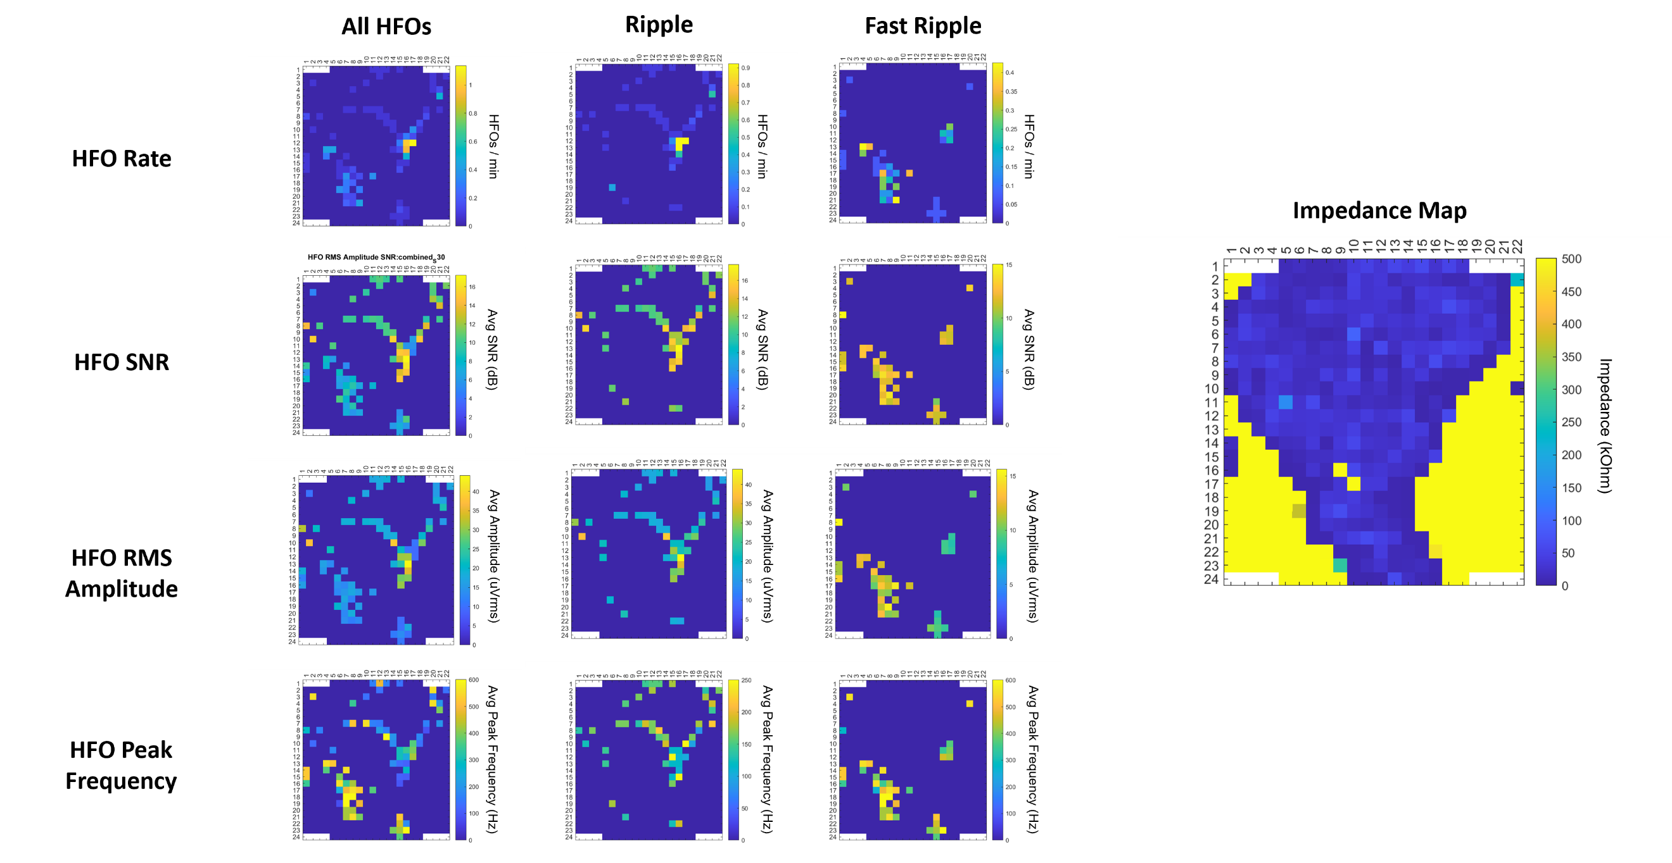
Figure S8. Maps of electrode impedance and ripple and fast ripple HFO activity across the µECoG array for S7. Impedance for S7 was measured during the intraoperative recording while placed on the cortex.

