eAppendices for “Differential employment quality and educational inequities in mental health: A causal mediation analysis”
eAppendix 1: Exposure-Induced Mediator-Outcome Confounding Exemplar.
Consider the Directed Acyclic Graph (DAG) in eFigure 1 with baseline covariate Z, exposure A, post-exposure covariate L, mediator M, and outcome Y. In this example, adjusting for L to unbiasedly estimate the Natural Indirect Effect (NIE) would bias the estimated Natural Direct Effect (NDE), given the effect of A on Y acts through L. Simultaneously, conditioning on M would result in collider stratification bias of the A-Y effect via L, biasing the estimated NDE. For this reason, Natural Effects in the presence of exposure-induced mediator-outcome confounding are unidentifiable.
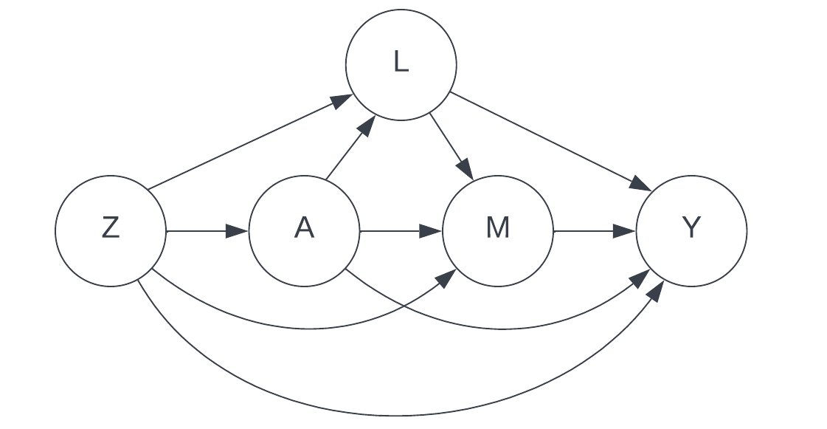
eAppendix 1 eFigure 1. Directed Acyclic Graph exemplar of exposure-induced mediator-outcome confounding. Z: Baseline Confounder. A: Exposure. L: Post-Exposure Covariate. M: Mediator. Y: Outcome.
eAppendix 2: Study Eligibility and Analysis Flow Diagram.
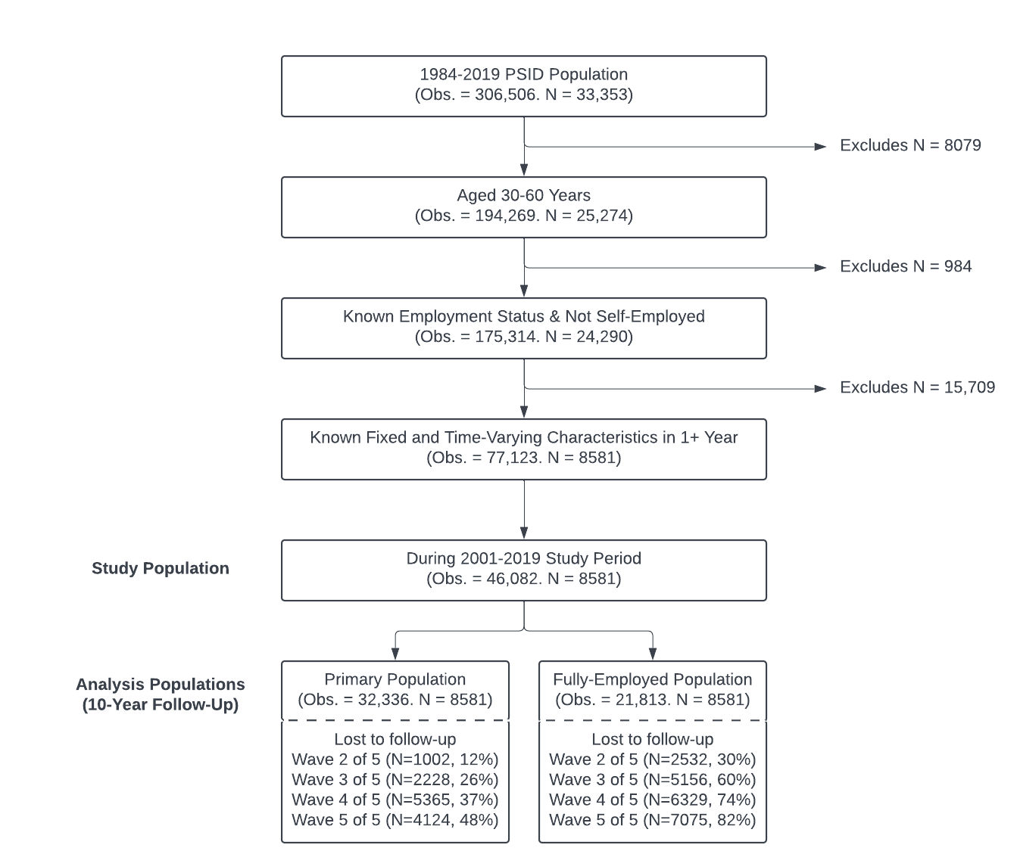
eAppendix 2 eFigure 1. Study eligibility and analysis flow diagram describing serial restrictions to the eligible population resulting in the final study population used in mediational g-formula primary and fully-employed subset analyses, as well as longitudinal loss to follow-up within assessed populations.

eAppendix 3: Conceptual Employment Quality Dimensions, Proxy Indicators, and Operationalizations.
eAppendix 3 eTable 1. Conceptual Employment Quality Dimensions, Proxy Indicators, and Operationalizations, PSID 2001-2019.
EQ Dimension |  | Proxy Indicator |  | Operationalization
 |  |  |  | PCA-Derived EQ Score | Linear EQ Score [0-5 points]
[1] | Employment Stability | [1a] | Employment tenure ª | Continuous: Age-standardized z-score | Categorical: Employed for ≥ 12 months - No, Yes [1pt]
[1] | Employment Stability | [1b] | Duration of prior year unemployment | Continuous: Linear | -
[2] | Material Rewards | [2a] | Total annual labor income ^{b} | Continuous: Age-standardized z-score | Categorical: ≥ Median age-standardized z-score – No, Yes [1/3 pts]
[2] | Material Rewards | [2b] | Employer-provided health insurance | Categorical: No, Yes | Categorical: No, Yes [1/3 pts]
[2] | Material Rewards | [2c] | Employer-provided pension contributions ª | Categorical: No, Yes | Categorical: No, Yes [1/3 pts]
[3] | Workers’ rights & Social Protections | [3a] | Salaried employment ª | Categorical: No, Yes | Categorical: No, Yes [1/2 pts]
[3] | Workers’ rights & Social Protections | [3b] | Employer paid extra for overtime ª | Categorical: No, Yes | Categorical: No, Yes [1/2 pts]
[4] | Working Time Arrangements | [4a] | Number of hours worked annually | Continuous: Linear | Categorical: ≥ 32 hrs per week on average – No, Yes [1pt]
[5] | Collective Organization | [5a] | Employee union membership ª | Categorical: No, Yes | Categorical: No, Yes [1pt]
[6] | Employability Opportunities | [6a] | - | - | -
[7] | Interpersonal Power Relations | [7a] | - | - | -
EQ: Employment Quality. ª Each assumed to be ‘No’ or ‘zero employment tenure’ for those currently unemployed/NILF prior to multiple imputation of PCA-based and Linear EQ scores. ^{b} Labor income adjusted to reflect 2017-dollar value prior to standardization using the Federal Reserve Consumer Price Index

eAppendix 4: Participant Characteristics by Employment Quality Quartile.
eAppendix 4 Table 1. Participant Characteristics by PCA Employment Quality Score Quartile, Panel Study of Income Dynamics 2001-2019.
Measure |  | Employment Quality
 |  | Q1  (Lowest) | Q2 | Q3 | Q4  (Highest)
N (Observations) |  | 2077.2 (8083.7) | 2284.1 (8084.3) | 2135.1 (8084.0) | 2084.6 (8084.0)
Baseline year
 | Mean (SD) | 2005.8 (5.2) | 2005.8 (5.6) | 2005.2 (5.4) | 2005 (5.3)
 | Median [IQR] | 2005  [2001, 2011] | 2003  [2001, 2011] | 2001  [2001, 2009] | 2001  [2001, 2009]
Baseline age (years)
 | Mean (SD) | 37.6 (7.5) | 37.8 (7.7) | 38.1 (7.8) | 38.2 (8.1)
 | Median [IQR] | 35 [31, 43] | 36 [31, 44] | 36 [31, 44] | 36 [31, 45]
Gender, N (%)
 | Men | 2337.3 (29) | 2982.8 (37) | 3232.8 (40) | 4365.0 (54)
 | Women | 5746.4 (71) | 5101.4 (63) | 4851.2 (60) | 3718.9 (46)
Race & Ethnicity, N (%)
 | Non-Hispanic white | 3444.2 (43) | 3918.0 (49) | 4548.8 (56) | 5425.1 (67)
 | Racially or Ethnically Minoritized | 4639.6 (57) | 4166.2 (52) | 3535.2 (44) | 2658.9 (33)
Grew up in US, N (%)
 | No | 727.5 (9.0) | 642.5 (7.9) | 482.9 (6.0) | 343.1 (4.2)
 | Yes | 7356.2 (91) | 7441.8 (92) | 7601.1 (94) | 7740.9 (96)
Childhood SES (Poor), N (%)
 | No | 5697.2 (71) | 5936.0 (73) | 6281.9 (78) | 6561.0 (81)
 | Yes | 2386.5 (30) | 2148.3 (27) | 1802.2 (22) | 1523.0 (19)
Baseline Education, N (%)
 | ≤High School | 4498.7 (56) | 3995.2 (49) | 3099.9 (38) | 1754.2 (22)
 | >High School | 3585.1 (44) | 4089.1 (51) | 4984.1 (62) | 6329.8 (78)
Baseline Disability Limits Work, N (%)
 | No | 6993.4 (87) | 7478.4 (93) | 7531.4 (93) | 7639.8 (95)
 | Yes | 1090.3 (14) | 605.8 (7.5) | 552.6 (6.8) | 444.2 (5.5)
Baseline Region, N (%)
 | Midwest | 1864.0 (23) | 2056.3 (25) | 2085.5 (26) | 1887.2 (23)
 | Northeast | 893.5 (11) | 985.5 (12) | 1014.4 (13) | 1542.6 (19)
 | South | 3866.7 (48) | 3593.6 (45) | 3569.7 (44) | 3100.9 (38)
 | West | 1459.5 (18) | 1448.8 (18) | 1414.4 (18) | 1553.3 (19)
Baseline Occupation, N (%)
 | Technical sales, admin support | 1533.8 (19) | 2208.1 (27) | 2673.9 (33) | 1832.4 (23)
 | Professional specialty | 605.7 (7.5) | 1013.2 (13) | 1551.1 (19) | 2932.8 (36)
 | Services | 1569.6 (19) | 1510.3 (19) | 889.8 (11) | 577.9 (7.1)
 | Operators, fabricators, laborers | 940.0 (12) | 1235.6 (15) | 1068.8 (13) | 445.5 (5.5)
 | Managerial | 308.7 (3.8) | 474.0 (5.9) | 756.3 (9.4) | 1427.1 (18)
 | Precision production, craft and repair | 409.0 (5.1) | 713.0 (8.8) | 705.8 (8.7) | 632.0 (7.8)
 | Farming, forestry, fishing | 98.8 (1.2) | 68.7 (0.8) | 31.5 (0.4) | 14.1 (0.2)
 | Military | 16.6 (0.2) | 29.0 (0.4) | 46.5 (0.6) | 93.8 (1.2)
 | Unemployed or NILF | 2601.7 (32) | 832.4 (10) | 360.4 (4.5) | 129.3 (1.6)
Unemployed or NILF, N (%) ª
 | No | 4208.8 (52) | 7845.2 (97) | 8082.1 (100) | 8084.0 (100)
 | Yes | 3875.0 (48) | 239.1 (3) | 1.9 (<0.1) | 0 (0)
Self-Rated Health, N (%) ª
 | Poor/Fair/Good | 4559.2 (56) | 3777.3 (47) | 3346.8 (41) | 2615.9 (32)
 | Very Good/Excellent | 3524.5 (44) | 4307.0 (53) | 4737.2 (59) | 5468.1 (68)
Married or Cohabitating, N (%) ª
 | No | 3907.7 (48) | 3234.1 (40) | 2773.5 (34) | 2318.8 (29)
 | Yes | 4176.0 (52) | 4850.2 (60) | 5310.5 (66) | 5765.2 (71)
Kessler-6 Score
 | Mean (SD) | 4.1 (4.5) | 3.2 (3.7) | 2.7 (3.2) | 2.6 (2.9)
 | Median [IQR] | 3 [0, 6] | 2 [0, 5] | 2 [0, 4] | 2 [0, 4]
 | <5, N (%) ª | 5268.3 (65) | 5936.5 (73) | 6394.1 (79) | 6587.8 (82)
 | ≥5, N (%) ª | 2815.4 (35) | 2147.8 (27) | 1689.9 (21) | 1496.2 (19)
ª Numbers and percentages refer to the number of observations, rather than participants. EQ: Employment Quality. SD: Standard Deviation. IQR: Inter-Quartile Range. NILF: Not in Labor Force. SES: Socioeconomic Status. Note: Data presented represent the average summary across multiply imputed datasets. Q1-4 represent summaries within employment quality quartiles. Data on ‘Unemployment or NILF’ status, ‘Self-Rated Health’, ‘Married or Cohabiting’, and ‘Kessler-6 Score’ rows represent average survey assessment summaries across analysis years, as well as respondent characteristics presented within EQ quartile columns.

eAppendix 4 Table 2 . Employment Quality Indicators by Employment Status and PCA Employment Quality Score Quartile, Panel Study of Income Dynamics 2001-2019.
Measure |  | Employment Status |  |  |  |  | Employment Quality
 |  | Unemployed/NILF |  | Employed |  | Q1 (Lowest) |  |  | Q2 |  | Q3 | Q4 (Highest)
N Observations (%) |  | 4116 (13) | 28220 (87) |  | 8084 (25) |  |  | 8084 (25) |  | 8084 (25) |  | 8084 (25)
PCA Employment Quality Score
PCA Employment Quality Score | Mean (SD) | -1.0 (0.3) | -0.1 (0.5) |  | -1.0 (0.3) |  |  | -0.3 (0.1) |  | 0.1 (0.1) |  | 0.4 (0.2)
PCA Employment Quality Score | Median [IQR] | -1.0 [-1.3, -0.9] | 0 [-0.3, 0.3] |  | -0.9 [-1.2, -0.7] |  |  | -0.3 [-0.4, -0.2] |  | 0.1 [0.0, 0.2] |  | 0.4 [0.3, 0.5]
Linear Employment Quality Score
Linear Employment Quality Score | Mean (SD) | 0.2 (0.2) | 3.2 (1.0) |  | 1.0 (0.9) |  |  | 2.7 (0.7) |  | 3.5 (0.5) |  | 4.1 (0.5)
Linear Employment Quality Score | Median [IQR] | 0 [0, 0.3] | 3.3 [2.7, 4.0] |  | 0.7 [0, 1.5] |  |  | 2.8 [2.3, 3.2] |  | 3.5 [3.2, 3.7] |  | 4.0 [4.0, 4.0]
Union Membership, N (%)
Union Membership, N (%) | No | 4116 (100) | 24107.3 (85) |  | 7958.9 (99) |  |  | 7448.1 (92) |  | 6863.1 (85) |  | 5953.2 (74)
Union Membership, N (%) | Yes | 0 (0) | 4112.7 (15) |  | 124.9 (1.5) |  |  | 636.1 (7.9) |  | 1220.9 (15) |  | 2130.8 (26)
Employer-provided HI, N (%)
Employer-provided HI, N (%) | No | 2281.4 (55) | 6100.0 (22) |  | 5540.8 (69) |  |  | 2370.0 (29) |  | 364.7 (4.5) |  | 105.9 (1.3)
Employer-provided HI, N (%) | Yes | 1834.6 (45) | 22120.0 (78) |  | 2542.9 (32) |  |  | 5714.3 (71) |  | 7719.3 (96) |  | 7978.1 (99)
Salaried Employment, N (%)
Salaried Employment, N (%) | No | 4116 (100) | 17175.3 (61) |  | 7920.9 (98) |  |  | 6809.5 (84) |  | 5037.9 (62) |  | 1523.0 (19)
Salaried Employment, N (%) | Yes | 0 (0) | 11044.7 (39) |  | 162.8 (2.0) |  |  | 1274.8 (16) |  | 3046.1 (38) |  | 6561.0 (81)
Extra Overtime Pay, N (%)
Extra Overtime Pay, N (%) | No | 4116 (100) | 2726.9 (9.7) |  | 5246.4 (65) |  |  | 1313.0 (16) |  | 232.5 (2.9) |  | 51.0 (0.6)
Extra Overtime Pay, N (%) | Yes | 0 (0) | 25493.1 (90) |  | 2837.4 (35) |  |  | 6771.3 (84) |  | 7851.5 (97) |  | 8033.0 (99)
Pension Contributions, N (%)
Pension Contributions, N (%) | No | 4116 (100) | 12328.4 (44) |  | 7884.4 (98) |  |  | 6224.2 (77) |  | 1973.3 (24) |  | 362.4 (4.5)
Pension Contributions, N (%) | Yes | 0 (0) | 15891.6 (56) |  | 199.3 (2.5) |  |  | 1860.0 (23) |  | 6110.7 (76) |  | 7721.6 (96)
Annual Work Hours (1000s)
Annual Work Hours (1000s) | Mean (SD) | 0.8 (0.9) | 2.0 (0.7) |  | 1.0 (0.8) |  |  | 2.0 (0.6) |  | 2.1 (0.5) |  | 2.4 (0.6)
Annual Work Hours (1000s) | Median [IQR] | 0.3 [0, 1.6] | 2.0 [1.8, 2.3] |  | 1.0 [0.0, 1.7] |  |  | 2.0 [1.7, 2.2] |  | 2.0 [1.9, 2.3] |  | 2.2 [2.0, 2.6]
Past Year Unemp. (months)
Past Year Unemp. (months) | Mean (SD) | 0.4 (1.4) | 0.3 (1.4) |  | 1.1 (2.5) |  |  | 0.2 (0.7) |  | 0.0 (0.3) |  | 0.0 (0.1)
Past Year Unemp. (months) | Median [IQR] | 0.0 [0.0, 0.1] | 0.0 [0.0, 0.0] |  | 0.0 [0.0, 0.4] |  |  | 0.0 [0.0, 0.0] |  | 0.0 [0.0, 0.0] |  | 0.0 [0.0, 0.0]
Employment Tenure Z-Score
Employment Tenure Z-Score | Mean (SD) | -1.4 (0) | -0.1 (1.0) |  | -1.1 (0.5) |  |  | -0.5 (0.8) |  | -0.1 (0.9) |  | 0.5 (1.0)
Employment Tenure Z-Score | Median [IQR] | -1.4 [-1.4, -1.4] | -0.4 [-0.9, 0.6] |  | -1.2 [-1.4, -1.0] |  |  | -0.7 [-1.0, -0.1] |  | -0.3 [-0.8, 0.5] |  | 0.5 [-0.3, 1.3]
Total Labor Income Z-Score
Total Labor Income Z-Score | Mean (SD) | -0.5 (0.6) | 0.3 (1.1) |  | -0.6 (0.4) |  |  | -0.1 (0.5) |  | 0.2 (0.6) |  | 1.1 (1.6)
Total Labor Income Z-Score | Median [IQR] | -0.7 [-0.9, -0.4] | 0.0 [-0.3, 0.5] |  | -0.6 [-0.9, -0.4] |  |  | -0.2 [-0.4, 0.1] |  | 0.1 [-0.1, 0.4] |  | 0.7 [0.3, 1.3]
PCA: Principal Component Analysis. SD: Standard Deviation. IQR: Inter-Quartile Range. NILF: Not in Labor Force. HI: Health Insurance. Note: Data presented represent the average summary across multiply imputed datasets. Q1-4 represent summaries within PCA employment quality score quartiles.

eAppendix 5: Parametric Mediational G-Formula Approach.
- Fit parametric linear or logistic regression models as appropriate to the observed data for all N ordered time-varying post-exposure covariates C ordered from first occurring (N=0) to last occurring (N=N) for times T=0 to T=T, adjusting in each case for baseline covariates Z, observed baseline exposure A, and causally antecedent time-varying covariates based on the causal order assumed in Figure 1. In each model we made a Markov-1 assumption to determine the antecedent covariates C to adjust for, assuming that the value of C at T=t will be independent of all C at T≤t-2, conditional on all C at T=t-1 and causally antecedent C at T=t.
- Create an expanded Monte-Carlo (MC) sample of 50,000 observations based on resampling the original data, for use in Steps 3) through 5), such that simulation error is reduced in each step through each individual being assigned multiple possible values for each time-varying covariate C.
- Use the models developed in Step 1) and MC sample created in Step 2) to simulate forward in time each time-varying covariate C following the assumed causal order from T=0 to T=T under each counterfactual exposure scenario a, allowing the mediator to be as it naturally would under a without modification. Separating out this simulation step:
  - Simulate the first time-varying covariate for each individual i at T=0, C₁(0), based on their observed Z and assigned counterfactual exposure a.
  - Simulating the second time-varying covariate for each i at T=0, C₂(0), based on Z, a, and the simulated value of C₁(0).
  - Repeating Step 3b) for each subsequent covariate C_{N}(t) and time t for each i from T=0 to T=T based on Z, a, and the set of prior simulated covariates to adjust for based on the C_{N}(t) model in Step 1), until the final mediator value is simulated at T=T for each i.
- Save the simulated mediator values from Step 3) for each i under each exposure a for each time t, M_{i}(t), and randomly permuting the order of these values across i for each t.
- Use the models developed in Step 1) and permuted mediator values from Step 4) to simulate forward in time each time-varying covariate C from T=0 to T=T as in Step 3), this time under the joint counterfactual exposure-mediator scenarios (a,M_{a}), such that for each time t, the value of C for individual i is simulated based on their observed Z, assigned exposure a, and assigned random mediator value M(t). Repeat this process until the final value of outcome Y is simulated at T=T under each exposure-mediator scenario (a,M_{a}) for each i.
- Calculate point-estimate expected end of follow-up moderate mental distress prevalences under each (A,M_{a}) scenario based on the simulated final outcomes Y(T) in Step 5), and point-estimate causal effects of interest (rTE, rPNDE, rTNIE) based on these (A,M_{a}) scenario prevalences.
- Repeat Steps 1) through 6) a number of times in separate bootstrap resamples of the original data (N=200 resamples in this analysis), creating point-estimate standard errors based on the standard deviation of bootstrap distributions for each Step 6) point-estimate outcome.
- Specific to our analysis where multiple imputation was required, we repeated Steps 1) through 7) for each of 40 multiply imputed datasets, pooling point-estimates from Step 6) and standard errors from Step 7) for each outcome across multiply imputed dataset analyses via Rubin’s Rules (Barnard & Rubin, 1999) and following the advice of Schomaker & Heumann (2018) in combining multiple imputation, bootstrapping, and analyses involving g-computation.

eAppendix 6: Covariate Model Specifications and Additional Robustness Checks.
eAppendix 6 eTable 1. Covariate model specifications used in whole-sample mediational g-formula analyses modelling the effect of low education on poor mental health mediated through employment quality.
Model | Type | Specification
A | Logistic | ∑C1-9 + C3*C4
M₀ | Linear | A + ∑C1-9 + C3*C4 + A*C3 + A*C4
TV1₀ | Logistic | M₀ + M₀² + A + ∑C1-9 + C3*C4 + A*C3 + A*C4 + A*M₀ + C3*M₀ + C4*M₀
TV2₀ | Logistic | TV1₀ + M₀ + A + ∑C1-9 + C3*C4 + A*C3 + A*C4 + A*M₀ + C3*M₀ + C4*M₀
TV3₀ | Logistic | TV2₀ + TV1₀ + M₀ + A + ∑C1-9 + C3*C4 + A*C3 + A*C4 + A*M₀ + C3*M₀ + C4*M₀
Y₀ | Logistic | TV3₀ + TV2₀ + TV1₀ + M₀ + A + ∑C1-9 + C3*C4 + A*C3 + A*C4 + A*M₀ + C3*M₀ + C4*M₀
M₁ | Linear | Y₀ + TV3₀ + TV2₀ + TV1₀ + M₀ + M₀² + A + ∑C1-9 + C3*C4 + A*C3 + A*C4 + A*M₀ + C3*M₀ + C4*M₀
TV1₁ | Logistic | M₁ + Y₀ + TV3₀ + TV2₀ + TV1₀ + M₀ + A + ∑C1-9 + C3*C4 + A*C3 + A*C4 + A*M₀ + C3*M₀ + C4*M₀ + A*M₁ + C3*M₁ + C4*M₁
TV2₁ | Logistic | TV1₁ + M₁ + Y₀ + TV3₀ + TV2₀ + TV1₀ + M₀ + A + ∑C1-9 + C3*C4 + A*C3 + A*C4 + A*M₀ + C3*M₀ + C4*M₀ + A*M₁ + C3*M₁ + C4*M₁
TV3₁ | Logistic | TV2₁ + TV1₁ + M₁ + Y₀ + TV3₀ + TV2₀ + TV1₀ + M₀ + A + ∑C1-9 + C3*C4 + A*C3 + A*C4 + A*M₀ + C3*M₀ + C4*M₀ + A*M₁ + C3*M₁ + C4*M₁
Y₁ | Logistic | TV3₁ + TV2₁ + TV1₁ + M₁ + Y₀ + TV3₀ + TV2₀ + TV1₀ + M₀ + A + ∑C1-9 + C3*C4 + A*C3 + A*C4 + A*M₀ + C3*M₀ + C4*M₀ + A*M₁ + C3*M₁ + C4*M₁
M₂ | Linear | Y₁ + TV3₁ + TV2₁ + TV1₁ + M₁ + M₁² + A + ∑C1-9 + C3*C4 + A*C3 + A*C4 + A*M₁ + C3*M₁ + C4*M₁
TV1₂ | Logistic | M₂ + Y₁ + TV3₁ + TV2₁ + TV1₁ + M₁ + A + ∑C1-9 + C3*C4 + A*C3 + A*C4 + A*M₁ + C3*M₁ + C4*M₁ + A*M₂ + C3*M₂ + C4*M₂
TV2₂ | Logistic | TV1₂ + M₂ + Y₁ + TV3₁ + TV2₁ + TV1₁ + M₁ + A + ∑C1-9 + C3*C4 + A*C3 + A*C4 + A*M₁ + C3*M₁ + C4*M₁ + A*M₂ + C3*M₂ + C4*M₂
TV3₂ | Logistic | TV2₂ + TV1₂ + M₂ + Y₁ + TV3₁ + TV2₁ + TV1₁ + M₁ + A + ∑C1-9 + C3*C4 + A*C3 + A*C4 + A*M₁ + C3*M₁ + C4*M₁ + A*M₂ + C3*M₂ + C4*M₂
Y₂ | Logistic | TV3₂ + TV2₂ + TV1₂ + M₂ + Y₁ + TV3₁ + TV2₁ + TV1₁ + M₁ + A + ∑C1-9 + C3*C4 + A*C3 + A*C4 + A*M₁ + C3*M₁ + C4*M₁ + A*M₂ + C3*M₂ + C4*M₂
M₃ | Linear | Y₂ + TV3₂ + TV2₂ + TV1₂ + M₂ + M₂² + A + ∑C1-9 + C3*C4 + A*C3 + A*C4 + A*M₂ + C3*M₂ + C4*M₂
TV1₃ | Logistic | M₃ + Y₂ + TV3₂ + TV2₂ + TV1₂ + M₂ + A + ∑C1-9 + C3*C4 + A*C3 + A*C4 + A*M₂ + C3*M₂ + C4*M₂ + A*M₃ + C3*M₃ + C4*M₃
TV2₃ | Logistic | TV1₃ + M₃ + Y₂ + TV3₂ + TV2₂ + TV1₂ + M₂ + A + ∑C1-9 + C3*C4 + A*C3 + A*C4 + A*M₂ + C3*M₂ + C4*M₂ + A*M₃ + C3*M₃ + C4*M₃
TV3₃ | Logistic | TV2₃ + TV1₃ + M₃ + Y₂ + TV3₂ + TV2₂ + TV1₂ + M₂ + A + ∑C1-9 + C3*C4 + A*C3 + A*C4 + A*M₂ + C3*M₂ + C4*M₂ + A*M₃ + C3*M₃ + C4*M₃
Y₃ | Logistic | TV3₃ + TV2₃ + TV1₃ + M₃ + Y₂ + TV3₂ + TV2₂ + TV1₂ + M₂ + A + ∑C1-9 + C3*C4 + A*C3 + A*C4 + A*M₂ + C3*M₂ + C4*M₂ + A*M₃ + C3*M₃ + C4*M₃
M₄ | Linear | Y₃ + TV3₃ + TV2₃ + TV1₃ + M₃ + M₃² + A + ∑C1-9 + C3*C4 + A*C3 + A*C4 + A*M₃ + C3*M₃ + C4*M₃
TV1₄ | Logistic | M₄ + Y₃ + TV3₃ + TV2₃ + TV1₃ + M₃ + A + ∑C1-9 + C3*C4 + A*C3 + A*C4 + A*M₃ + C3*M₃ + C4*M₃ + A*M₄ + C3*M₄ + C4*M₄
TV2₄ | Logistic | TV1₄ + M₄ + Y₃ + TV3₃ + TV2₃ + TV1₃ + M₃ + A + ∑C1-9 + C3*C4 + A*C3 + A*C4 + A*M₃ + C3*M₃ + C4*M₃ + A*M₄ + C3*M₄ + C4*M₄
TV3₄ | Logistic | TV2₄ + TV1₄ + M₄ + Y₃ + TV3₃ + TV2₃ + TV1₃ + M₃ + A + ∑C1-9 + C3*C4 + A*C3 + A*C4 + A*M₃ + C3*M₃ + C4*M₃ + A*M₄ + C3*M₄ + C4*M₄
Y₄ | Logistic | TV3₄ + TV2₄ + TV1₄ + M₄ + Y₃ + TV3₃ + TV2₃ + TV1₃ + M₃ + A + ∑C1-9 + C3*C4 + A*C3 + A*C4 + A*M₃ + C3*M₃ + C4*M₃ + A*M₄ + C3*M₄ + C4*M₄
Note: Specifications provided are for models used in whole-sample mediational g-formula analyses including those at any point unemployed or NILF. Gender (C3) or race and ethnicity (C4) strata analyses exclude as-implied model parameters and interactions terms not necessary (e.g. C3, A*C3, and C3*M_{t} terms for gender-specific analyses). Fully employed sample analyses likewise exclude models and model parameters not necessary (e.g. no TV1 models or TV1 terms). C1-9: 1. Year, 2. Age in years, 3. Gender (Male = 0, Female = 1), 4. Race and Ethnicity (Non-Hispanic White = 0, Racially and/or Ethnically Minoritized= 1), 5. Grew up in US (No = 0, Yes = 1), 6. Childhood SES (Grew up ‘poor’ = 0, ‘Average or well-off’ = 1), 7. Region (Northeast, Midwest, West, South), 8. Occupation (‘Professional or Specialty’, ‘Operators, fabricators, and laborers’, ‘Military’, ‘Farming, forestry and fishing’, ‘Technical, sales, and administrative support’, ‘Services’, ‘Managerial’, ‘Precision production, craft and repair’, ‘Unemployed or NILF’), 9. Disability status limiting ability to work (No = 0, Yes = 1). A: Highest educational attainment at baseline (>High School = 0, ≤High School or GED = 1). M_{t}: Current Employment Quality (EQ) at time t (continuous).TV1_{t}: Current unemployment or NILF status at time t (Employed = 0, Unemployed or NILF = 1). TV2_{t}: Current self-reported health at time t (‘Good, fair, or poor’ = 0, ‘Very good or excellent’ = 1). TV3_{t}: Current marital status at time t (No = 0, Yes = 1). Y_{t}: Current moderate mental distress (Kessler-6 ≥ 5) status (No = 0, Yes = 1).

Additional Robustness Checks.
In addition to analyses described under Sensitivity Analyses, additional analyses evaluated the adequacy of the Monte-Carlo sample size, sensitivity of findings to the Markov-1 assumption, robustness of findings to changes in the assumed causal order of time-varying covariates C, comparability of randomized and traditional ‘total effect’ estimates, impact of selecting the earliest set of eligible records per participant versus latest, and comparability of findings assessing moderate mental distress (Kessler-6 scores ≥5) versus severe mental distress (Kessler-6 scores ≥13).
Monte-Carlo Sample Size Adequacy.
To evaluate which Monte-Carlo sample size would be adequate to account for simulation error, the parametric mediational g-formula was repeated using the primary analysis sample (N=8581) several times. In each repetition, the Monte Carlo sample size was increased by 100 from 5000 to 100,000. The ‘Randomized Total Effect’ (TE) estimate from each analysis as well as Standard Error bounds for these estimate are presented in eAppendix 6 Figure 1 below. Based on this analysis, a Monte-Carlo sample size of 50,000 was used for all analyses.
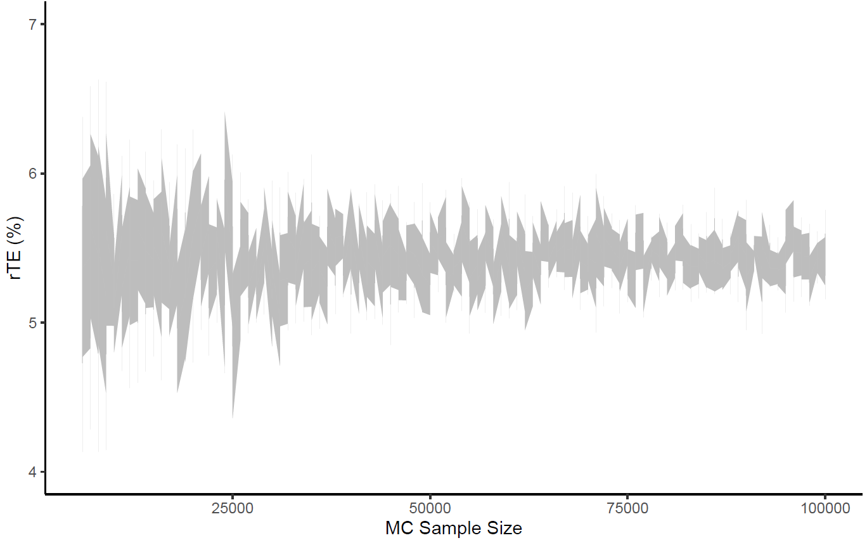

eAppendix 6 eFigure 1. Mediational g-formula primary analysis randomized total effect uncertainty under increasing Monte-Carlo sample sizes. rTE: Randomized Total Effect. N: Monte-Carlo Sample Size. Grey bars: Randomized Total Effect Standard Error Bounds. Grey Points: Individual Point Estimates.
Causal Markov-1 Assumption Sensitivity.
To evaluate the sensitivity of findings to the Markov-1 assumption, the primary sample analysis including those temporarily unemployed or NILF (N=8581) was repeated making a Markov-2 assumption: i.e. assuming that each covariate C at time T=t is independent of all covariates at times T=t-3 conditional on all C at T=t-2 and T=t-1, as well as all causally antecedent C at T=t. The summary findings from this analysis are presented in Appendix 6 Table 3 alongside findings when making a Markov-1 assumption (as in the manuscript). From this, we conclude our primary results were not sensitive to the Markov-1 assumption made, as summary findings are similar in each case.
eAppendix 6 eTable 3. Prevalence ratios and differences (95% confidence intervals) from mediational g-formula of the effect of low education on poor mental health mediated through employment quality under causal Markov-1 and Markov-2 assumptions, PSID 2001-2019.
Markov Assumption | Causal Effect Estimates (95% CI)
Markov Assumption | Prevalence Ratio |  |  | Prevalence Difference
Markov Assumption | rTE | rPNDE | rTNIE | rTE | rPNDE | rTNIE
Markov-1 | 1.24  (1.09, 1.40) | 1.16  (1.01, 1.32) | 1.07  (1.04, 1.10) | 5.3  (2.2, 8.4) | 3.5  (0.4, 6.7) | 1.7  (1.0, 2.5)
Markov-2 | 1.24  (1.08, 1.40) | 1.16  (1.01, 1.32) | 1.06  (1.03, 1.10) | 5.3  (2.0, 8.5) | 3.6  (0.3, 6.9) | 1.7  (0.8, 2.5)
CI: Confidence Interval. rTE: Randomized Total Effect. rPNDE: Randomized Pure Natural Direct Effect. rTNIE: Randomized Total Natural Indirect Effect.
Assumed Covariate Causal Order Robustness.
As all time-varying covariates – Employment Quality (M), Unemployment or NILF Status (TV1), Self-Reported Health (TV2), and Marital Status (TV3) – for each timepoint T=t were assessed in the same survey, we evaluated whether our findings were robust to changes in the assumed causal order of covariates. To do so, we repeated our primary sample analysis (N=8581) under each possible covariate order of TV1, TV2, and TV3, presuming that M cannot temporally occur after ‘Unemployment or NILF Status’ (TV1). The findings from these additional analyses as well as our primary analysis are presented in Appendix 6 Table 4. From this table, we conclude our primary results were not sensitive to the assumed causal order of time-varying covariates.
eAppendix 6 eTable 4. Prevalence ratios and differences (95% confidence intervals) from mediational g-formula of the effect of low education on poor mental health mediated through employment quality under different covariate orders, PSID 2001-2019
Causal Order | Causal Effect Estimates (95% CI)
Causal Order | Prevalence Ratio |  |  | Prevalence Difference
Causal Order | rTE | rPNDE | rTNIE |  | rTE | rPNDE | rTNIE
M > TV1 > TV2 > TV3 | 1.24  (1.09, 1.40) | 1.16  (1.01, 1.32) | 1.07  (1.04, 1.10) |  | 5.3  (2.2, 8.4) | 3.5  (0.4, 6.7) | 1.7  (1.0, 2.5)
M > TV1 > TV3 > TV2 | 1.24  (1.09, 1.40) | 1.16  (1.01, 1.32) | 1.07  (1.04, 1.10) |  | 5.3  (2.2, 8.4) | 3.5  (0.4, 6.7) | 1.7  (1.0, 2.5)
M > TV2 > TV1 > TV3 | 1.24  (1.09, 1.40) | 1.16  (1.01, 1.31) | 1.07  (1.04, 1.10) |  | 5.2  (2.2, 8.3) | 3.4  (0.3, 6.6) | 1.8  (1.0, 2.5)
M > TV2 > TV3 > TV1 | 1.24  (1.09, 1.40) | 1.16  (1.01, 1.32) | 1.07  (1.04, 1.10) |  | 5.2  (2.1, 8.4) | 3.5  (0.3, 6.7) | 1.8  (1.0, 2.5)
M > TV3 > TV1 > TV2 | 1.24  (1.09, 1.40) | 1.16  (1.01, 1.32) | 1.07  (1.04, 1.10) |  | 5.3  (2.1, 8.4) | 3.5  (0.3, 6.7) | 1.7  (1.0, 2.5)
M > TV3 > TV2 > TV1 | 1.24  (1.09, 1.40) | 1.16  (1.01, 1.31) | 1.07  (1.04, 1.10) |  | 5.3  (2.2, 8.3) | 3.5  (0.4, 6.6) | 1.8  (1.0, 2.5)
TV2 > M > TV1 > TV3 | 1.24  (1.09, 1.40) | 1.17  (1.01, 1.32) | 1.07  (1.03, 1.10) |  | 5.2  (2.1, 8.4) | 3.6  (0.4, 6.8) | 1.6  (0.9, 2.4)
TV2 > M > TV3 > TV1 | 1.24  (1.09, 1.40) | 1.17  (1.01, 1.32) | 1.07  (1.03, 1.10) |  | 5.3  (2.1, 8.4) | 3.6  (0.5, 6.8) | 1.6  (0.9, 2.4)
TV3 > M > TV2 > TV1 | 1.24  (1.09, 1.40) | 1.17  (1.01, 1.32) | 1.07  (1.03, 1.10) |  | 5.3  (2.2, 8.4) | 3.6  (0.4, 6.7) | 1.7  (0.9, 2.4)
TV3 > M > TV1 > TV2 | 1.24  (1.09, 1.40) | 1.17  (1.01, 1.32) | 1.07  (1.03, 1.10) |  | 5.3  (2.2, 8.4) | 3.6  (0.5, 6.7) | 1.7  (0.9, 2.4)
TV2 > TV3 > M > TV1 | 1.24  (1.09, 1.40) | 1.17  (1.02, 1.32) | 1.06  (1.03, 1.09) |  | 5.2  (2.1, 8.3) | 3.7  (0.5, 6.8) | 1.6  (0.8, 2.3)
TV3 > TV2 > M > TV1 | 1.24  (1.09, 1.40) | 1.17  (1.02, 1.32) | 1.06  (1.03, 1.09) |  | 5.2  (2.1, 8.3) | 3.7  (0.5, 6.8) | 1.6  (0.8, 2.3)
CI: Confidence Interval. rTE: Randomized Total Effect. rPNDE: Randomized Pure Natural Direct Effect. rTNIE: Randomized Total Natural Indirect Effect. M: Employment Quality. TV1: Unemployment or NILF Status. TV2: Self-Reported Health. TV3: Marital Status.

While we assume that M cannot temporally occur after ‘Unemployment or NILF Status’ (TV1) in our primary analyses, we further assessed whether it would materially affect our findings if it did based on the competing idea that employment quality is instantaneously influenced by current unemployment or NILF status, such that TV1 at T=t occurs before M. These sensitivity analyses are presented in Appendix 6 Table 5 below. Based on this table, we conclude that our primary findings were robust against our assumption that employment quality precedes ‘Unemployment or NILF status.’
eAppendix 6 eTable 5. Prevalence ratios and differences (95% confidence intervals) from mediational g-formula of the effect of low education on poor mental health mediated through employment quality under different covariate orders, PSID 2001-2019
Causal Order | Causal Effect Estimates (95% CI)
Causal Order | Prevalence Ratio |  |  | Prevalence Difference
Causal Order | rTE | rPNDE | rTNIE |  | rTE | rPNDE | rTNIE
TV1 > TV2 > TV3 > M | 1.25  (1.09, 1.40) | 1.18  (1.03, 1.34) | 1.05  (1.02, 1.09) |  | 5.3  (2.2, 8.3) | 3.9  (0.7, 7.0) | 1.4  (0.6, 2.2)
TV1 > TV3 > TV2 > M | 1.25  (1.09, 1.41) | 1.18  (1.03, 1.34) | 1.05  (1.02, 1.09) |  | 5.3  (2.1, 8.4) | 3.9  (0.7, 7.1) | 1.4  (0.6, 2.2)
TV2 > TV1 > TV3 > M | 1.25  (1.09, 1.40) | 1.18  (1.03, 1.34) | 1.05  (1.02, 1.09) |  | 5.3  (2.2, 8.3) | 3.9  (0.7, 7.1) | 1.4  (0.6, 2.2)
TV2 > TV3 > TV1 > M | 1.25  (1.09, 1.40) | 1.18  (1.03, 1.34) | 1.05  (1.02, 1.09) |  | 5.3  (2.2, 8.3) | 3.9  (0.7, 7.1) | 1.4  (0.6, 2.2)
TV3 > TV1 > TV2 > M | 1.25  (1.09, 1.41) | 1.18  (1.03, 1.34) | 1.05  (1.02, 1.09) |  | 5.3  (2.2, 8.4) | 3.9  (0.7, 7.1) | 1.3  (0.6, 2.2)
TV3 > TV2 > TV1 > M | 1.25  (1.09, 1.41) | 1.18  (1.03, 1.34) | 1.05  (1.02, 1.09) |  | 5.3  (2.2, 8.4) | 3.9  (0.7, 7.1) | 1.4  (0.6, 2.2)
CI: Confidence Interval. rTE: Randomized Total Effect. rPNDE: Randomized Pure Natural Direct Effect. rTNIE: Randomized Total Natural Indirect Effect. M: Employment Quality. TV1: Unemployment or NILF Status. TV2: Self-Reported Health. TV3: Marital Status.

Comparability of rTE and TE Total Effect Estimates.
Mediational g-formula analyses estimate a randomized interventional analogue of the total effect (rTE), with rTE = E[Y_{aGa} – Y_{a*Ga*}]. Though this is often comparable to the total effect (TE) estimated under the parametric g-formula, TE = E[Y_{aMa} – Y_{a*Ma*}], this is not always the case. To ensure estimates for these estimands did not meaningfully diverge in our study, we repeated our primary and fully-employed subset analyses using the parametric g-formula, assuming the same causal model as in Figure 1 with each covariate model specified as in our mediational g-formula analyses, described in Appendix 6 Table 1. The rTE and TE estimates provided using the mediational g-formula and parametric g-formula are presented in Appendix 6 Table 6 for each analysis. From this table, we conclude that differences in rTE and TE estimates would not meaningfully affect the inferences made in our study.
eAppendix 6 eTable 6. Prevalence ratios and differences (95% confidence intervals) from mediational g-formula and parametric g-formula analyses of the total effect of low education on poor mental health, PSID 2001-2019.
Analysis | Causal Effect Estimates (95% CI)
Analysis | Prevalence Ratio |  |  |  | Prevalence Difference
Analysis | rTE | TE |  | rTE |  | TE
Primary | 1.24 (1.09, 1.40) |  | 1.25 (1.10, 1.40) |  | 5.3 (2.2, 8.4) |  | 5.3 (2.3, 8.3)
Fully Employed | 1.16 (0.92, 1.42) |  | 1.16 (0.88, 1.44) |  | 3.1 (-1.3, 7.6) |  | 2.9 (-2.1, 7.8)
CI: Confidence Interval. rTE: Randomized Total Effect. TE: Total Effect.

Impact of selecting the earliest versus latest set of eligible records
In our analyses we evaluate the cumulative effect of low educational attainment on moderate mental distress over a 10-year period, selecting the earliest eligible set of records per participant where available. To assess whether our findings are robust to this decision, we repeated our whole sample primary analyses selecting the latest eligible set of records per participant. The total, direct, and mediated effect estimates under each choice are presented in Appendix 6 Table 7. Based on this table, our results did not appear sensitive to the participant records used.
eAppendix 6 eTable 7. Prevalence ratios and differences (95% confidence intervals) from mediational g-formula of the effect of low education on poor mental health mediated through employment quality in samples based on the earliest versus latest set of eligible records, PSID 2001-2019.
Records Per Participant | Causal Effect Estimates (95% CI)
Records Per Participant | Prevalence Ratio |  |  | Prevalence Difference
Records Per Participant | rTE | rPNDE | rTNIE | rTE | rPNDE | rTNIE
Earliest Set | 1.24  (1.09, 1.40) | 1.16  (1.01, 1.32) | 1.07  (1.04, 1.10) | 5.3  (2.2, 8.4) | 3.5  (0.4, 6.7) | 1.7  (1.0, 2.5)
Latest Set | 1.30  (1.10, 1.49) | 1.18  (0.99,1.37) | 1.10  (1.06, 1.14) | 6.1  (2.4, 9.7) | 3.7  (0.0, 7.4) | 2.4  (1.5, 3.3)
CI: Confidence Interval. rTE: Randomized Total Effect. rPNDE: Randomized Pure Natural Direct Effect. rTNIE: Randomized Total Natural Indirect Effect.

Comparing effects of low educational attainment on moderate and severe mental distress
In our analyses we assessed the cumulative effect of low educational attainment on moderate mental distress (defined as Kessler-6 scores ≥5) 10-years post-baseline (i.e. at end of follow-up). Assuming the same causal model, we assess the cumulative effect of low educational attainment on severe mental distress (defined as Kessler-6 scores ≥13) at end of follow-up in Appendix 6 Table 8. From this table, the randomized total effect (rTE) of low educational attainment over a 10-year period (versus high) is a point-estimated 68% greater relative prevalence of severe mental distress at end of follow-up (PR: 1.68), with this finding consistent with no effect (PR 95% CI: 0.89, 2.48). The employment quality-mediated component of this rTE (the rTNIE) would indicate a 21% greater relative prevalence of severe mental distress (PR rTNIE: 1.21, 95% CI: 1.07, 1.34) comparing two less educated populations where one, counterfactually, had employment quality comparable to that expected under more education throughout follow-up. If selecting on consistent employment and in our model inducing collider stratification bias, the estimated rTNIE would suggest better employment quality increases the prevalence of severe mental distress at end of follow-up (PR rTNIE: 0.86, 95% CI: 0.67, 1.06).
eAppendix 6 eTable 8. Prevalence ratios and differences (95% confidence intervals) from mediational g-formula of the effect of low education on moderate and severe mental distress mediated through employment quality, PSID 2001-2019.
Mental Distress | Sample | Causal Effect Estimates (95% CI)
Mental Distress | Sample | Prevalence Ratio |  |  | Prevalence Difference
Mental Distress | Sample | rTE | rPNDE | rTNIE | rTE | rPNDE | rTNIE
Moderate | Whole | 1.24  (1.09, 1.40) | 1.16  (1.01, 1.32) | 1.07  (1.04, 1.10) | 5.3  (2.2, 8.4) | 3.5  (0.4, 6.7) | 1.7  (1.0, 2.5)
Moderate | Fully Employed | 1.25  (1.09, 1.41) | 1.19  (1.03, 1.34) | 1.05  (1.02, 1.08) | 5.3  (2.2, 8.4) | 4.0  (0.9, 7.1) | 1.2  (0.6, 1.9)
Severe | Whole | 1.68  (0.89, 2.48) | 1.40  (0.71, 2.10) | 1.21  (1.07, 1.34) | 1.5  (0.0, 2.9) | 0.8  (-0.5, 2.2) | 0.6  (0.3, 1.0)
Severe | Fully Employed | 1.56  (0.48, 2.65) | 1.82  (0.60, 3.04) | 0.86  (0.67, 1.06) | 2.2  (-1.9, 6.2) | 3.3  (-1.5, 8.1) | -1.2  (-3.0, 0.7)
CI: Confidence Interval. rTE: Randomized Total Effect. rPNDE: Randomized Pure Natural Direct Effect. rTNIE: Randomized Total Natural Indirect Effect.

eAppendix 7: Natural Course, Mediational G-Formula Counterfactual Scenarios, and Primary and Secondary Analyses Findings.
eAppendix 7 eTable 1. Natural Course and counterfactual scenario prevalences (95% confidence intervals) from mediational g-formula of the effect of low education on poor mental health mediated through employment quality overall, by gender, race, and ethnicity, under different sample restrictions, employment quality operationalizations, and follow-up lengths, PSID 2001-2019
Analysis Characteristics |  |  |  |  | Percentage Prevalence of Moderate Mental Distress (Kessler-6 ≥5) at End of Follow-Up (95% CI)
EQ Measure | Follow-Up (years) | Sample | Strata | N | Observed (Unknown) | Simulated Scenarios
 |  |  |  |  |  | NC  (Actual Ed. & EQ) | a = 0, m = 0  (High Ed.,  High EQ) | a = 0, m = 1  (High Ed.,  Low EQ) | a = 1, m = 0  (Low Ed.,  High EQ) | a = 1, m = 1  (Low Ed.,  Low EQ)
PCA | 10 | P | Whole | 8581 | 23.7 (4124) | 23.6 (21.9, 25.4) | 21.8 (19.7, 23.9) | 23.4 (21.1, 25.6) | 25.3 (22.4, 28.1) | 27.0 (24.3, 29.8)
PCA | 10 | P | Female | 4991 | 25.6 (2238) | 26.5 (24.3, 28.8) | 24.2 (21.6, 26.8) | 26.7 (23.9, 29.5) | 27.5 (23.9, 31.1) | 30.7 (27.3, 34.1)
PCA | 10 | P | Male | 3590 | 20.6 (1886) | 19.3 (16.7, 22.0) | 17.8 (14.6, 21.1) | 19.7 (16.1, 23.4) | 21.8 (17.5, 26.1) | 23.5 (19.2, 27.9)
PCA | 10 | P | Non-Hispanic White | 4562 | 22.2 (2173) | 23.2 (20.9, 25.5) | 21.6 (18.9, 24.4) | 23.5 (20.6, 26.5) | 24.1 (20.1, 28.1) | 27.6 (23.8, 31.4)
PCA | 10 | P | Racially and/or Ethnically Minoritized | 4019 | 25.4 (1951) | 24.4 (21.7, 27.0) | 21.4 (18.3, 24.5) | 24.7 (21.1, 28.3) | 25.9 (21.9, 29.9) | 28.0 (24.4, 31.7)
PCA | 10 | FE | Whole | 8581 | 15.1 (7075) | 19.5 (15.4, 23.6) | 19.0 (14.7, 23.4) | 20.3 (15.9, 24.7) | 21.4 (16.0, 26.8) | 22.2 (17.0, 27.3)
PCA | 10 | FE | Female | 4991 | 16.0 (4112) | 23.6 (18.2, 29.0) | 23.2 (17.7, 28.6) | 24.6 (18.7, 30.5) | 24.6 (17.1, 32.1) | 25.9 (18.8, 33.0)
PCA | 10 | FE | Male | 3590 | 13.9 (2963) | 16.6 (11.9, 21.2) | 15.1 (10.0, 20.3) | 16.8 (11.3, 22.3) | 19.7 (12.8, 26.5) | 20.9 (14.4, 27.4)
PCA | 10 | FE | Non-Hispanic White | 4562 | 14.4 (3638) | 18.1 (13.9, 22.3) | 18.2 (13.9, 22.5) | 19.1 (14.5, 23.7) | 18.3 (12.2, 24.4) | 19.5 (13.6, 25.4)
PCA | 10 | FE | Racially and/or Ethnically Minoritized | 4019 | 16.3 (3437) | 22.0 (14.7, 29.3) | 20.3 (13.2, 27.5) | 23.2 (14.9, 31.4) | 26.6 (17.8, 35.4) | 26.9 (18.4, 35.4)
PCA | 8 | P | Whole | 8581 | 23.2 (3215) | 23.1 (21.7, 24.4) | 20.1 (18.4, 21.7) | 21.8 (20.0, 23.6) | 25.7 (23.3, 28.2) | 27.4 (25.0, 29.7)
PCA | 8 | FE | Whole | 8581 | 18.5 (6329) | 20.5 (18.6, 22.3) | 19.7 (17.3, 22.2) | 20.5 (17.8, 23.2) | 22.1 (18.5, 25.6) | 22.3 (19.0, 25.6)
PCA | 12 | P | Whole | 8581 | 23.1 (5004) | 24.7 (22.0, 27.3) | 22.1 (19.1, 25.1) | 23.8 (20.8, 26.9) | 26.9 (23.1, 30.7) | 28.6 (24.9, 32.3)
PCA | 12 | FE | Whole | 8581 | 15.8 (7613) | 17.0 (12.2, 21.8) | 15.5 (10.3, 20.7) | 15.8 (10.3, 21.4) | 22.7 (15.8, 29.6) | 22.6 (16.0, 29.1)
Linear | 10 | P | Whole | 8581 | 23.7 (4124) | 23.6 (21.7, 25.5) | 21.4 (19.3, 23.6) | 22.6 (20.4, 24.8) | 25.5 (22.6, 28.3) | 26.7 (23.9, 29.5)
Linear | 10 | FE | Whole | 8581 | 15.1 (7075) | 20.2 (15.6, 13.8) | 19.2 (14.6, 23.7) | 20.3 (15.6, 25.0) | 22.1 (16.4, 27.7) | 22.5 (17.0, 28.0)
CI: Confidence Interval. EQ: Employment Quality. NC: Natural Course. a: Exposure History. m: Mediator History. PCA: Principal Component Analysis. P: Primary. FE: Fully Employed.

eAppendix 7 eTable 2. Prevalence ratios and differences (95% confidence intervals) from mediational g-formula analyses of the effect of low education on poor mental health mediated through employment quality, overall and by gender, race and ethnicity, PSID 2001-2019.
Population | N | Causal Effect Estimate (95% CI)
Population | N | Prevalence Ratio |  |  | Prevalence Difference
Population | N | rTE | rPNDE | rTNIE | rTE | rPNDE | rTNIE
Whole | 8581 | 1.24  (1.09, 1.40) | 1.16  (1.01, 1.32) | 1.07  (1.04, 1.10) | 5.3  (2.2, 8.4) | 3.5  (0.4, 6.7) | 1.7  (1.0, 2.5)
Female | 4991 | 1.27  (1.10, 1.44) | 1.14  (0.97, 1.31) | 1.11  (1.06, 1.17) | 6.5  (2.8, 10.2) | 3.3  (-0.5, 7.2) | 3.1  (1.7, 4.5)
Male | 3590 | 1.33  (1.02, 1.63) | 1.23  (0.94, 1.52) | 1.08  (1.02, 1.15) | 5.7  (0.9, 10.5) | 3.9  (-0.8, 8.6) | 1.8  (0.5, 3.1)
Non-Hispanic White | 4562 | 1.28  (1.07, 1.49) | 1.12  (0.92, 1.33) | 1.15  (1.07, 1.22) | 6.0  (1.9, 10.1) | 2.5  (-1.7, 6.8) | 3.5  (1.9, 5.1)
Racially or Ethnically Minoritized | 4019 | 1.31  (1.10, 1.53) | 1.21  (1.00, 1.43) | 1.08  (1.01, 1.15) | 6.6  (2.6, 10.6) | 4.5  (0.2, 8.8) | 2.1  (0.5, 3.8)
CI: Confidence Interval. rTE: Randomized Total Effect. rPNDE: Randomized Pure Natural Direct Effect. rTNIE: Randomized Total Natural Indirect Effect.

eAppendix 7 eTable3. Prevalence ratios and differences (95% confidence intervals) from mediational g-formula analyses of the effect of low education on poor mental health mediated through employment quality under different mediator operationalizations, sample restrictions, and follow-up lengths, PSID 2001-2019.
Analysis | N | Causal Effect Estimate (95% CI)
Analysis | N | Prevalence Ratio |  |  | Prevalence Difference
Analysis | N | rTE | rPNDE | rTNIE | rTE | rPNDE | rTNIE
Linear EQ Score | 8581 | 1.25  (1.09, 1.41) | 1.19  (1.03, 1.34) | 1.05  (1.02, 1.08) | 5.3  (2.2, 8.4) | 4.0  (0.9, 7.1) | 1.2  (0.6, 1.9)
Fully Employed | 8581 | 1.16  (0.92, 1.42) | 1.13  (0.87, 1.39) | 1.03  (0.95, 1.13) | 3.1  (-1.3, 7.6) | 2.4  (-2.3, 7.0) | 0.6  (-1.0, 2.6)
8-Year Follow-Up | 8581 | 1.36  (1.21, 1.52) | 1.28  (1.13, 1.44) | 1.06  (1.03, 1.09) | 7.3  (4.5, 10.0) | 5.6  (2.8, 8.5) | 1.6  (0.9, 2.4)
12-Year Follow-Up | 8581 | 1.30  (1.11, 1.48) | 1.22  (1.04, 1.40) | 1.06  (1.03, 1.10) | 6.5  (2.9, 10.1) | 4.8  (1.2, 8.5) | 1.7  (0.8, 2.5)
CI: Confidence Interval. EQ: Employment Quality. rTE: Randomized Total Effect. rPNDE: Randomized Pure Natural Direct Effect. rTNIE: Randomized Total Natural Indirect Effect. Note: Each sensitivity analysis reported above differs from the Whole Population Primary Analysis along one dimension only: 1) EQ measure used (PCA-based vs. Linear), 2) eligible population (including/excluding records when unemployed/NILF), or 3) length of follow-up period (8 or 12-years vs. 10-years).

