Supplemental Information

for

Evaluation of a Portable Aerosol Collector and Spectrometer to Measure Particle Concentration by Composition and Size

Changjie Cai¹, Larissa V. Stebounova², David W. Peate³, and Thomas M. Peters^{2*}

¹Department of Occupational and Environmental Health, University of Oklahoma Health Sciences Center, University of Oklahoma, Oklahoma, USA
²Department of Occupational and Environmental Health, The University of Iowa, Iowa, USA
³Department of Earth and Environmental Sciences, The University of Iowa, Iowa, USA

*Corresponding author
Thomas M. Peters, PhD
145 N Riverside Dr, S325 CPHB
The University of Iowa, Iowa City, Iowa 52242
e-mail: Thomas-m-peters@uiowa.edu

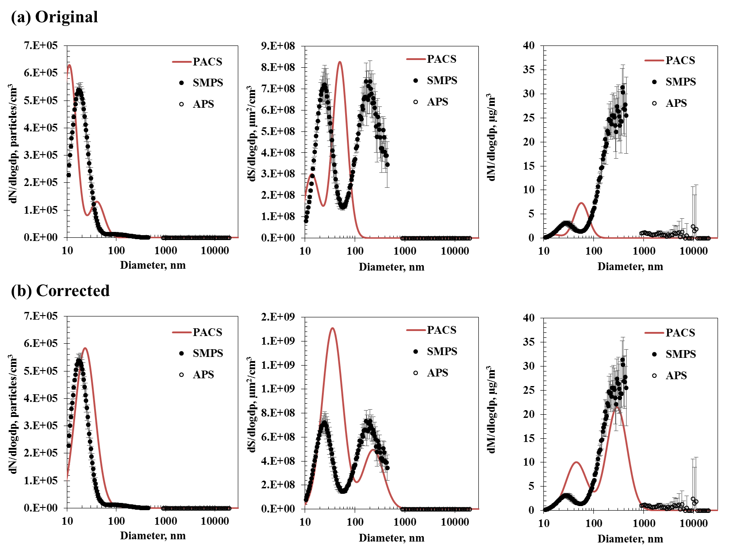
Figure S1. Near-real-time number, surface area, and mass concentration by size measured with the PACS compared to the SMPS/APS for the two-mode aerosol: (a) original output size distributions from the algorithm. Error bars represent the standard deviation of three measurements during the 1st hour experiment.

