Online Resource 1. UV Photograph Risk Feedback (example included below is not a real participant)

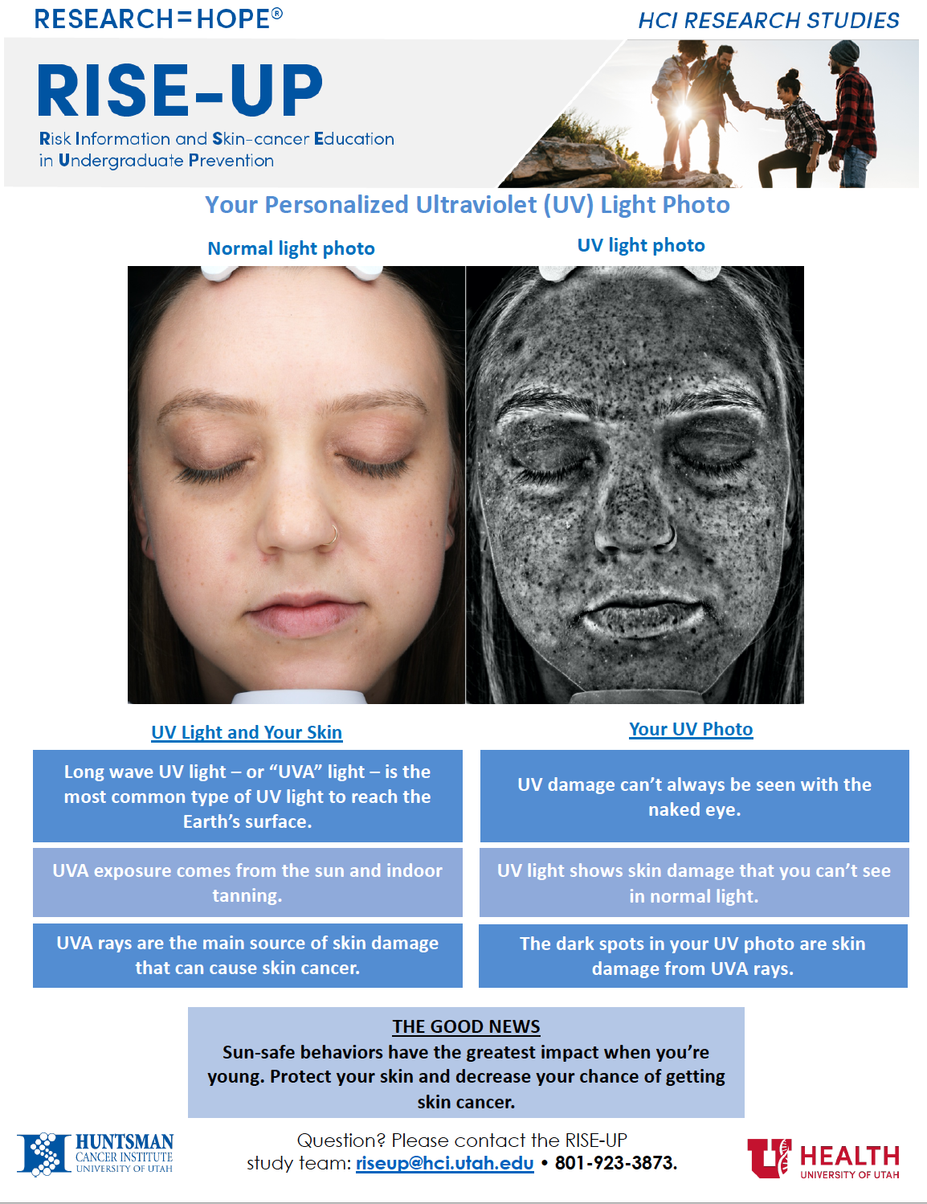

Online Resource 2. *MC1R* Increased Risk Feedback (example included below is not a real participant)

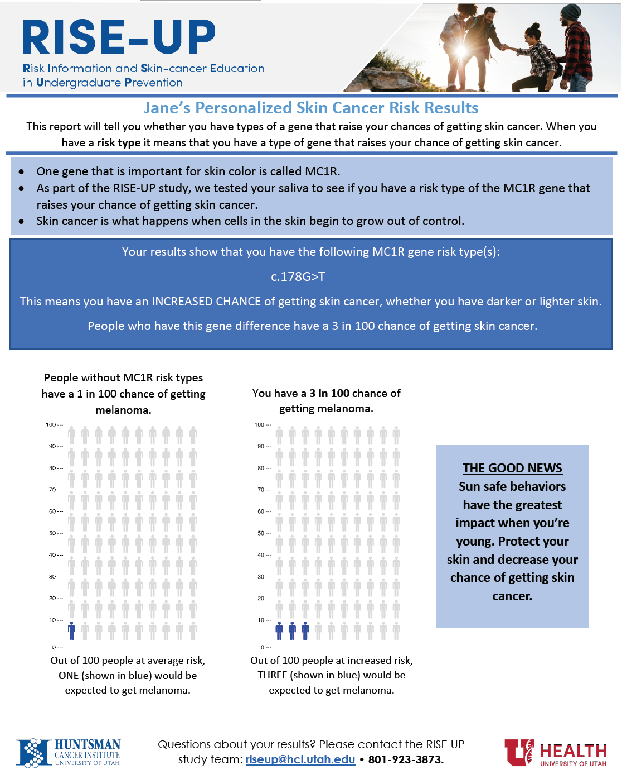

Online Resource 3. *MC1R* Average Risk Feedback (example included below is not a real participant)