Supplemental File:
Supplemental Figure 1:
Boxplots showing raw metabolite concentrations (µM) at all 4 sampling time points for the top 5 metabolite differences using repeated measures ANOVA; p-value is from repeated measures ANOVA, FDR (false discovery rate) is Benjamini Hochberg correction to the p-value.
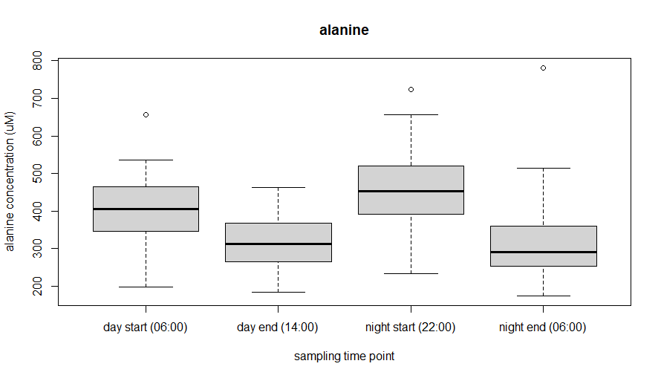
p < 0.001
FDR < 0.001

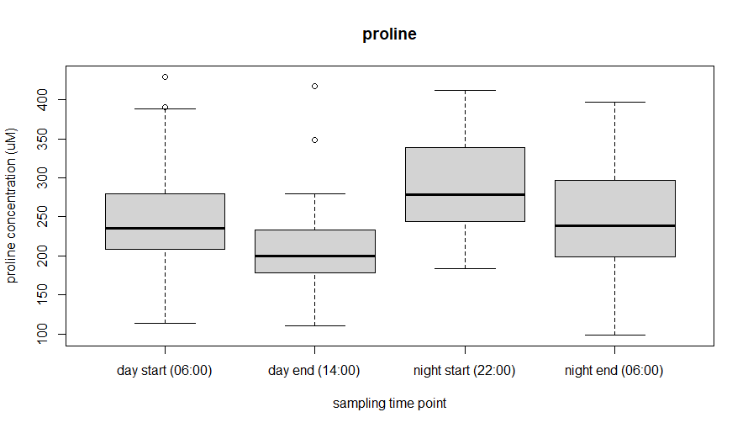
p < 0.001; FDR < 0.001

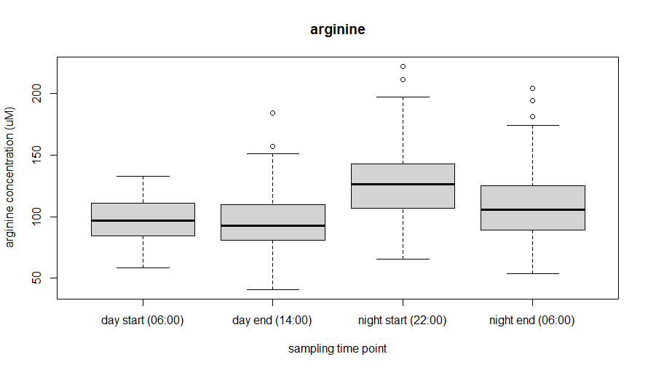
p < 0.001
FDR < 0.001

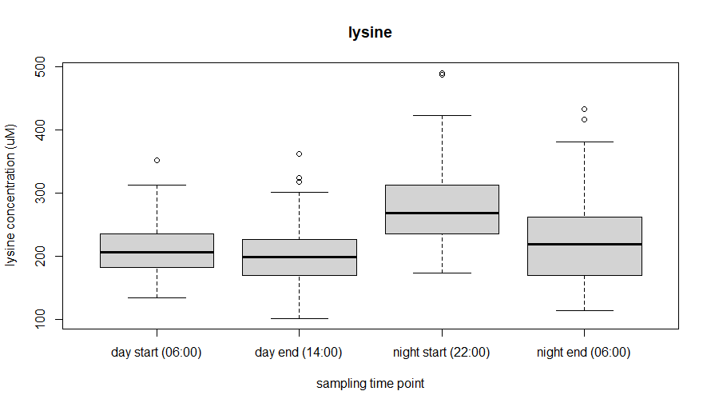
p < 0.001
FDR < 0.001

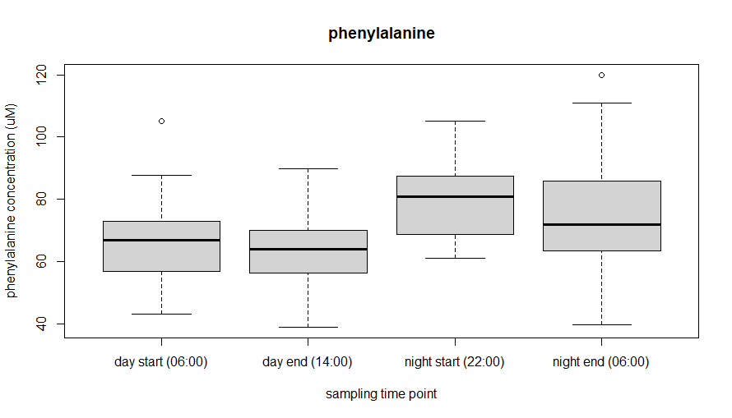
p < 0.001
FDR < 0.001

