Rapid LC-MS/MS quantification of Organophosphate non-specific Metabolites in Hair Using Alkaline Extraction Approach
Khue N. Nguyen ª, Roheeni Saxena ^{bc}, Diane B. Re ^{bc}, Beizhan Yan ^{ac*}

ª Lamont Doherty Earth Observatory, Columbia University, Palisades, New York, USA
^{b} Department of Environmental Health Sciences, Mailman School of Public Health, Columbia University, New York, NY, USA
^{c} NIEHS Center for Environmental Health and Justice in Northern Manhattan, Columbia
* Corresponding author: yanbz@ldeo.columbia.edu 845-3658448
Keywords: Organophosphate pesticides, dialkyl phosphates, Hair matrix, Solvent pH, ElectroSpray Ionization, LC/MS/MS.

Table of contents
List of tables and figures
Table S1 | Different simplified procedures to determine DAPs in human hair
Table S2 | Comparing limit of detection LOD (pg/mg) of different hair analysis methods. Our current method provides satisfactory sensitivity.
Figure S1 | Extracted ion chromatogram MRM of DAPs their corresponding labeled internal standards

Table S1: Different simplified procedures to determine DAPs in human hair
Compound(s) | External decontamination | Extraction procedure | Purification | Derivatization | Instrument analysis | References
DMP, DMTP, DEP | Wash with water and then methanol | 5mL of water, sonicate for 1 hour, shake for 12 hour. Get supernatant, add 5g NaCl, 1ml of HCl (6mol/L), 50mg of Na2S2O5 and 5mL of diethyl:acetonitrile (1:1 v/v) (two times). The concentrated extract was subjected to derivatization. | Pass extracts through solid phase of 3g florisil, 1g of bondesil-PSA and 0.5 g of anhydrous sodium sulfate. Wash with 5mL of acetone:n-hexane (2:98, v/v). Elute with 5mL of acetone: n-hexane (15:85, v/v). | PFBBr | GC/MS | Margariti et al  [15]
DMP, DEP, DETP, DEDTP | Wash twice with water and then methanol | 2mL of methanol for 50mg hair; incubate in an ultrasonic bath for 4hrs, centrifuge. The supernatant was filtered before derivatization step. Derivatized extracts were concentrated and reconstituted in toluene. | No | PFBBr | GC/MS | Tsatsakis et al  [18]
DMP, DMTP, DMDTP, DEP, DETP, DEDTP, and others | Wash with water and then acetonitrile | 1mL of acetonitrile/water (80:20) and shake overnight at 40C. The mixture was centrifuged. 300µL of supernatant was evaporated, then derivatized. The derivatized solution was concentrated and reconstituted in ethyl acetate. | The solution was centrifuged to remove particles. Transferred this solution to a vial, repeat concentration step to dryness and reconstitute the solution into 20µL of ethyl acetate. | PFBBr | GC/MS | Hardy et al [16]
DMP, DMTP, DMDTP, DEP, DETP, DEDTP | Wash twice with water and then methanol | 1mL of 2% NH4OH in methanol ,; shake overnight at room temperature; sonicate in a water bath at 40°C for 1 hour. Take out 0.6mL of extract. Concentrate the extract to dryness. Reconstitute in 150µL of methanol. | Centrifuge the solution to remove the solid and particles. Transferred the extract to filter vials. | no | LC-MS/MS  ESI(-) | This study

Table S2: Comparing limit of detection LOD (pg/mg) of different hair analysis methods. Our current method provides satisfactory sensitivity.
 | This study | [18] | [16] | [15]
DMP | 0.82 | 6 | 0.5 | 100
DMTP | 0.41 | 5 | 0.5 | 100
DMDTP | 0.3 | 5 | 1.3 | -
DEP | 0.24 | 3 | 5.5 | 20
DETP | 0.24 | - | 1.5 | -
DEDTP | 0.23 | - | - | -

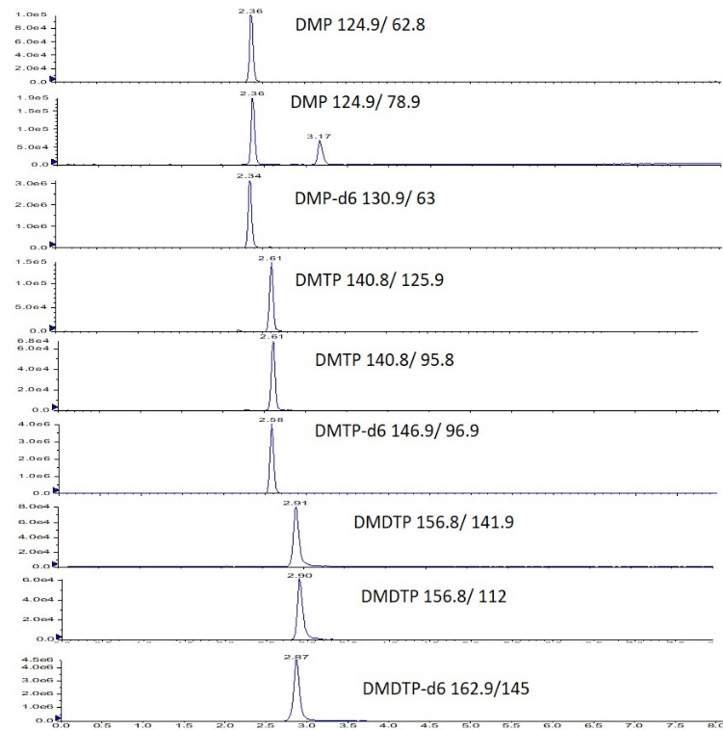 | 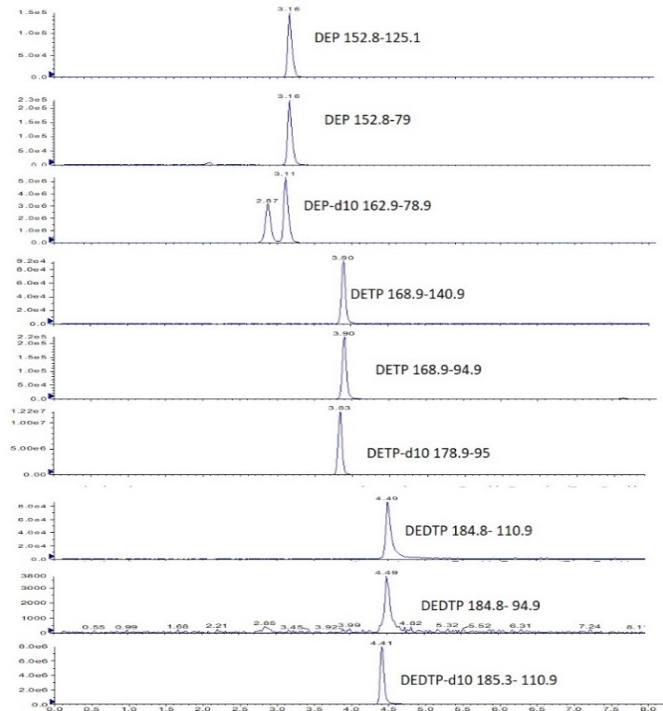
Figure S1: Extracted ion chromatogram MRM of DAPs their corresponding labeled internal standards

Table 2: Method validation data for DAPs
Analytes | R2 of calibration curve | LOD (pg/mg)  (S/N= 3) | LOQ (pg/mg)  (S/N= 10) | Extraction efficiency | Intra-day precision  (n=2) | Inter-day precision  (n=4) | Accuracy
 |  |  |  |  |  |  | 0.1 ng/mg | 0.2 ng/mg
DMP | 0.998 | 0.82 | 2.46 | 113 | 5 | 24 | 108 | 111
DMTP | 0.994 | 0.41 | 1.23 | 89 | 7 | 13 | 106 | 111
DMDTP | 0.997 | 0.30 | 0.9 | 152 | 9 | 10 | 111 | 109
DEP | 0.999 | 0.24 | 0.72 | 86 | 6 | 12 | 111 | 115
DETP | 0.999 | 0.24 | 0.72 | 92 | 5 | 11 | 111 | 106
DEDTP | 0.999 | 0.23 | 0.69 | 72 | 0 | 19 | 101 | 108

