Supplemental Figures
This document includes forest plots showing the main features of meta-analysis results of the median nerve cross-sectional area among the upper extremity regions not shown in the manuscript. These plots comprehensively visualize the direction and magnitude of the overall effects and potential heterogeneity across the individual studies.

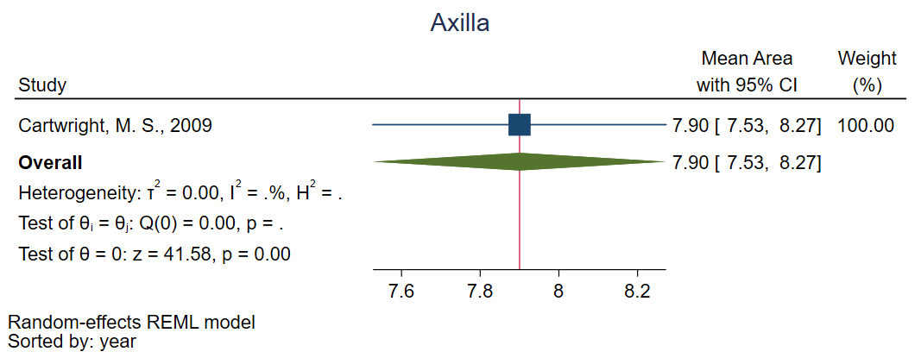

Supplemental Figure 1. Weighted averages of median nerve cross-sectional area (CSA) in the axillary region.

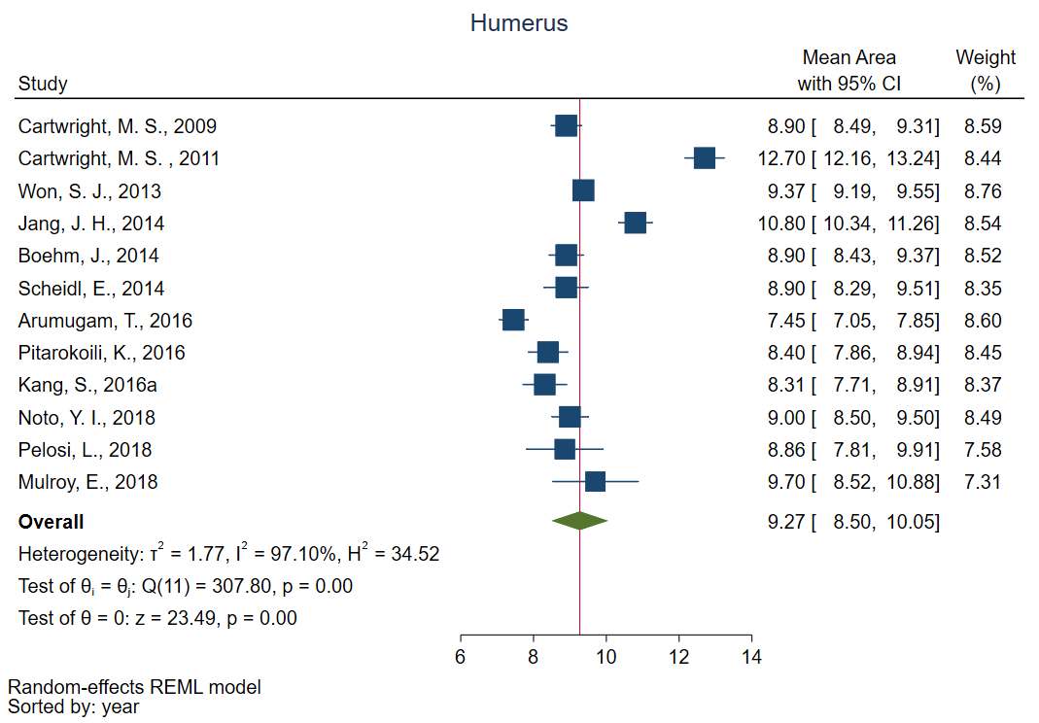

Supplemental Figure 2. Weighted averages of median nerve cross-sectional area (CSA) in upper arm across any anatomical locations between the axilla and elbow.

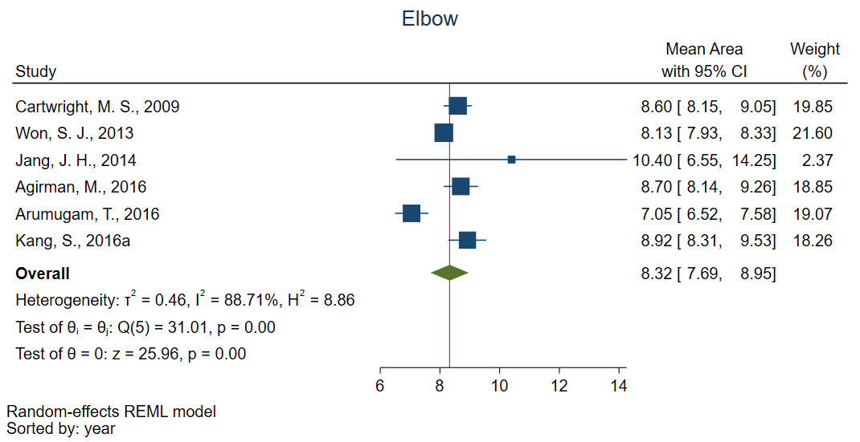

Supplemental Figure 3. Weighted averages of median nerve cross-sectional area (CSA) in the elbow region primarily between the antecubital fossa and pronator teres muscle.

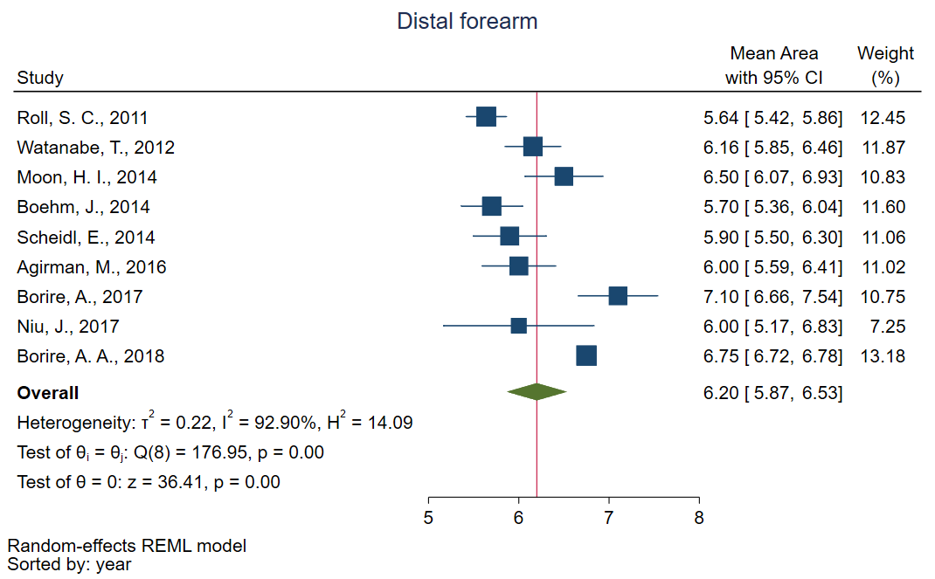

Supplemental Figure 4. Weighted averages of median nerve cross-sectional area (CSA) in the distal forearm anywhere between 4cm and 10cm proximal to the distal wrist crease.

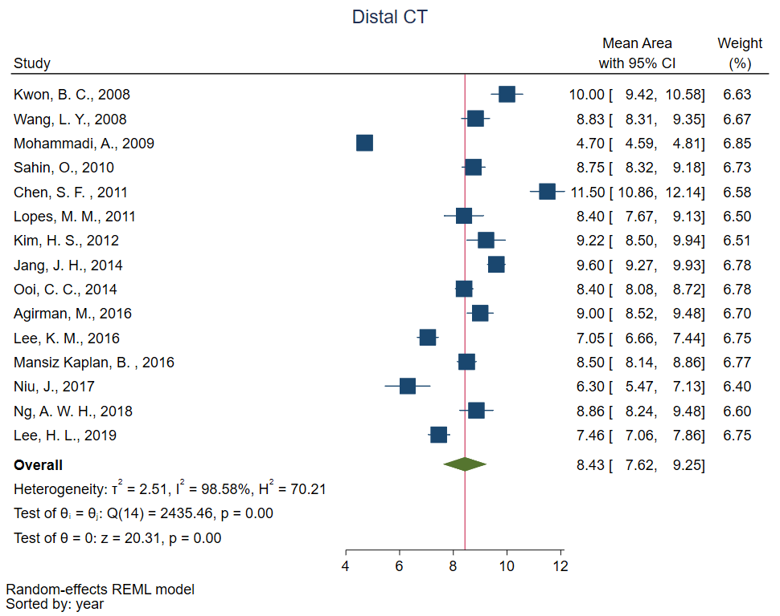

Supplemental Figure 5. Weighted averages of median nerve cross-sectional area (CSA) in the distal carpal tunnel (CT) at the level of the hamate or trapezium carpal bones.

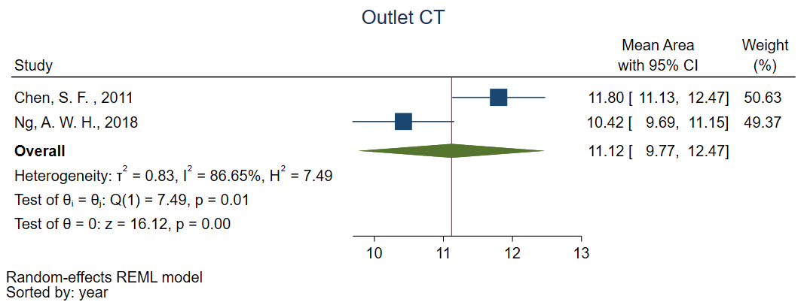

Supplemental Figure 6. Weighted averages of median nerve cross-sectional area (CSA) at the outlet of the carpal tunnel (CT) into the proximal palm.

