SUPPLEMENTARY MATERIALS

METHODS

Executing the Huff model at the census tract level
Census tracts are the smallest administrative unit in terms of area, so results were spatially precise. Census tracts could also be aggregated to corresponding counties. A spatial dataset of all (~74,000) census tracts within the United States was obtained from the United States Census Bureau (2016).

Airport locations and representation of attractiveness

We used outbound travel volume rather than inbound or total volume to represent airport attractiveness because this is the most direct measure of the tendency of an individual living at a particular geography to be attracted to an airport and use that airport to fly to a destination. This approach assumes that an individual will use the same airport they used to fly outbound to fly inbound when they return home.

While IATA provides airport codes to uniquely identify each airport, they do not provide accurate geographic locations for all airports. A dataset from Geonames (2018) was used to associate each airport identified in the IATA dataset with more accurate latitude and longitude coordinates.

Miami International Airport (MIA)

Miami International Airport (MIA) is located in Miami-Dade County, where 13% of the population of Florida resides. It is the main airport in South Florida for international flights and is one of the largest airline hubs in the United States. In 2016, 46% of passengers traveling internationally from Florida departed from MIA (IATA, 2019).

Executing the Huff model at ZIP code level for MDT test case
Five-digit ZIP code boundaries were obtained from the United States Census Bureau (2015). Although we retrieved boundaries for the year 2000 to be consistent with the comparison study, there appeared to be some inconsistencies between our dataset and that used by Fuellhart (2007). However, they were deemed similar enough to still provide a meaningful comparison. Total population by five-digit ZIP code was obtained through the 2000 census (United States Census Bureau, 2000), to be comparable with the MDT sample that was taken in 2001.

Raw Huff model results would represent probability to use MDT by ZIP code area, but the sample provided by Fuellhart represented proportion of total MDT users by ZIP code area. The following equation was applied to raw Huff model results to calculate the estimated proportion of MDT users per ZIP code area:

$$K_{ij}={P_{ij}*Q_{i}}/{\sum_{i=1}^{n}{P_{ij}*Q_{i}}}$$
Where K_{ij} is the proportion of airport j users located at i, P_{ij} the probability of an individual located at ZIP code i choosing airport j, and Q is the total population of ZIP code i.

DISCUSSION
Expected differences between the MDT observed data and modelled results
Comparison with observational data on MDT travellers provided validation for our model. We expected differences between our modelled results and the observational data for two reasons. First, Fuellhart’s sample likely underestimated the proportion of airport users from ZIP code areas close to the airport. These users would have access to other means of transportation to the airport such as taxi or public transportation, and therefore would be less likely to park at the airport. Second, the Huff model assumes that the entire population has an equal opportunity to travel. This is not representative of the reality in which populations of high socio-economic status likely have more opportunity to travel, compared to those of lower socio-economic status. While not reflected in our model, this difference in opportunity to travel is likely reflected in the observational data.

Primary Statistical Areas (PSAs) as a proxy for airport catchment areas
Wittman (2014) proposed using a simplistic method to define airport catchment areas – using Primary Statistical Areas (PSAs) from the United States Census Bureau as a proxy. He argues that defining catchment areas “requires some degree of local knowledge of the cultural and geographic boundaries of each metropolitan region”. Applying local knowledge within an entire region or country would not be feasible in most cases. Using PSAs to define catchment areas bypasses this intensive work, since the Census Bureau already divides the country into PSAs that are associated with a variety of census data tailored to each region (Wittman, 2014). Wittman indicated that using PSAs as a proxy for airport catchment areas has many advantages, including: 1) districts are defined consistently by a central authority, removing arbitrary judgement, 2) local knowledge is used to define districts, 3) PSAs can cross political boundaries, and 4) using a pre-defined land cover helps avoid the Modifiable Areal Unit Problem (MAUP) – a result of analytical bias when choosing an arbitrary geographic unit for analysis (Wittman, 2014). PSA boundaries are generic and were not created specifically to represent airport catchment areas.
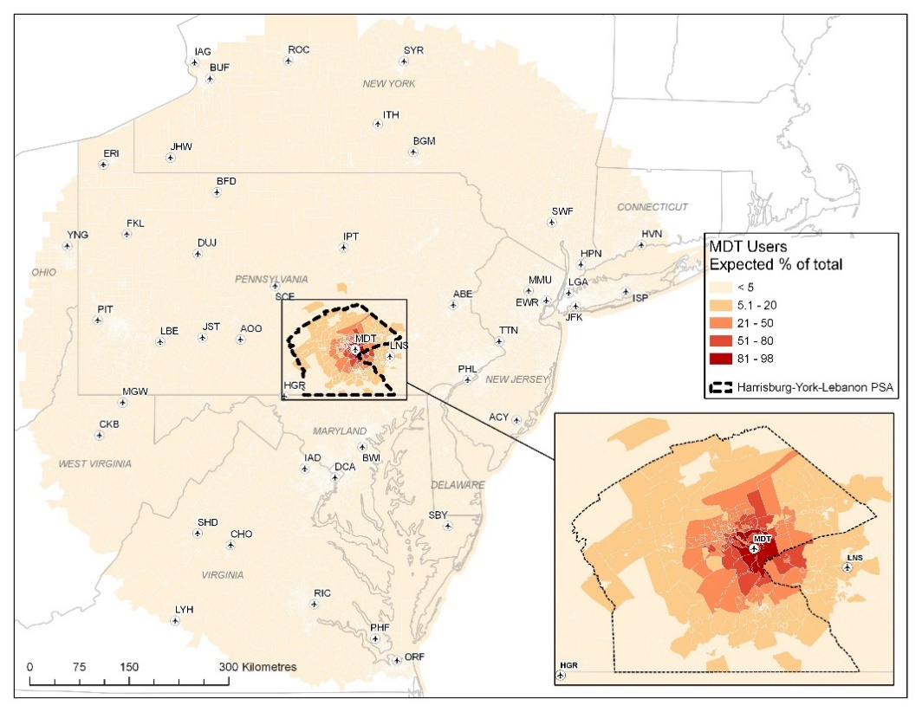
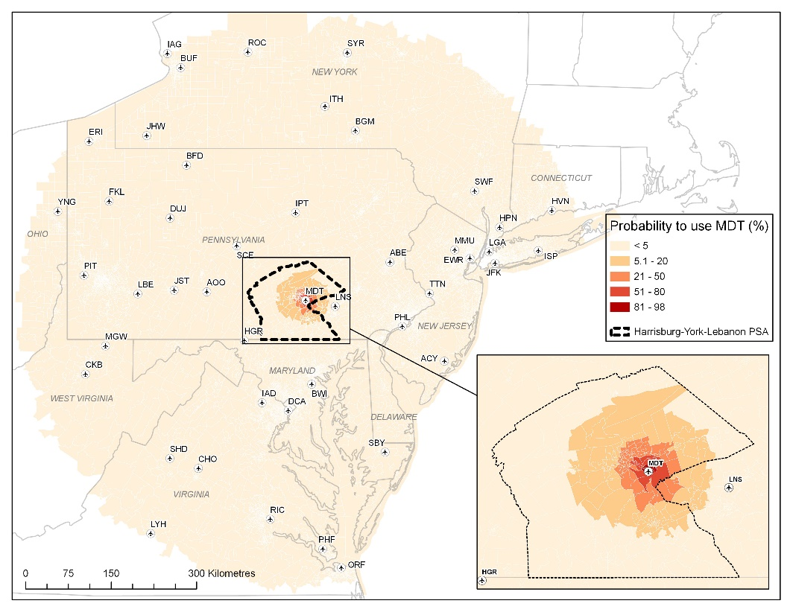
Supplementary Figure 1: Huff model results for MDT with ‘Harrisburg-York-Lebanon’ PSA boundary overlaid. (A) Huff model results represent probability to use MDT by census tract. (B) Huff model results transformed to represent proportion of total MDT users by census tract.

A
B

REFERENCES
Arino, J., & Khan, K. (2015). Using mathematical modeling to integrate disease surveillance and global air transportation data. In D. Chen, B. Moulin, & J. Wu (Eds.), Analyzing and Modeling Spatial and Temporal Dynamics of Infectious Diseases (First Edit, pp. 97–107). John Wiley & Sons, Inc. https://doi.org/10.1002/9781118630013.ch5
Barbosa-filho, H., Barthelemy, M., Ghoshal, G., James, C. R., Simini, F., & Tomasini, M. (2018). Human mobility: Models and applications. Physics Reports, 734, 1–74. https://doi.org/10.1016/j.physrep.2018.01.001
Başar, G., & Bhat, C. (2004). A parameterized consideration set model for airport choice: An application to the San Francisco Bay Area. Transportation Research Part B: Methodological, 38(10), 889–904. https://doi.org/10.1016/j.trb.2004.01.001
Bilotkach, V., Clougherty, J. A., Mueller, J., & Zhang, A. (2012). Regulation, privatization, and airport charges: Panel data evidence from European airports. Journal of Regulatory Economics, 42(1), 73–94. https://doi.org/10.1007/s11149-011-9172-1
Bland, J., & Altman, D. (1986). Statistical methods for assessing agreement between two methods of clinical measurement. Lancet, 1(8476), 307–310.
Bogoch, I. I., Brady, O. J., Kraemer, M. U. G., German, M., Creatore, M. I., Brent, S., Watts, A. G., Hay, S. I., Kulkarni, M. A., Brownstein, J. S., & Khan, K. (2016). Potential for Zika virus introduction and transmission in resource-limited countries in Africa and the Asia-Pacific region: a modelling study. The Lancet Infectious Diseases, 16(11), 1237–1245. https://doi.org/10.1016/S1473-3099(16)30270-5
Bogoch, I. I., Brady, O. J., Kraemer, M. U. G., German, M., Creatore, M. I., Kulkarni, M. A., Brownstein, J. S., Mekaru, S. R., Hay, S. I., Groot, E., Watts, A., & Khan, K. (2016). Anticipating the international spread of Zika virus from Brazil. The Lancet, 387(10016), 335–336. https://doi.org/10.1016/S0140-6736(16)00080-5
Bogoch, I. I., Creatore, M. I., Cetron, M. S., Brownstein, J. S., Pesik, N., Miniota, J., Tam, T., Hu, W., Nicolucci, A., Ahmed, S., Yoon, J. W., Berry, I., Hay, S. I., Anema, A., Tatem, A. J., MacFadden, D., German, M., & Khan, K. (2015). Assessment of the potential for international dissemination of Ebola virus via commercial air travel during the 2014 west African outbreak. The Lancet, 385(9962), 29–35. https://doi.org/10.1016/S0140-6736(14)61828-6
Bogoch, I. I., Watts, A., Thomas-Bachli, A., Huber, C., Kraemer, M. U. G., & Khan, K. (2020). Potential for global spread of a novel coronavirus from China. Journal of Travel Medicine, 27(2), 1–3. https://doi.org/10.1093/jtm/taaa011
Boots, B. (1980). Weighting Thiessen polygons. Economic Geography, 56(3), 248–259. https://doi.org/10.2307/142716
Brent, S. E., Watts, A., Cetron, M., German, M., Kraemer, U. G., Bogoch, I. I., Brady, O. J., Hay, S. I., Creatore, I., & Khan, K. (2018). International travel between global urban centres vulnerable to yellow fever transmission. Bulletin of the World Health Organization, 95(5), 343–354. https://doi.org/10.2471/BLT.17.205658
Centers for Disease Control and Prevention. (2017). South Florida Maps. https://www.cdc.gov/zika/intheus/florida-maps.html
Cliff, A., & Haggett, P. (2004). Time, travel and infection. British Medical Bulletin, 69(1), 87–99. https://doi.org/10.1093/bmb/ldh011
Esri. (2016). How original Huff model works. http://desktop.arcgis.com/en/arcmap/10.3/tools/business-analyst-toolbox/how-original-huff-model-works.htm
European Centre for Disease Prevention and Control. (2018). Yellow fever risk assessment: High number of infected travellers highlights the needs of vaccination before travelling to Brazil. European Centre for Disease Prevention and Control
Florida Health. (2017). Zika Incident Response Playbook. http://www.floridahealth.gov/diseases-and-conditions/mosquito-borne-diseases/_documents/zika-playbook.pdf
Fuellhart, K. (2007). Airport catchment and leakage in a multi-airport region: The case of Harrisburg International. Journal of Transport Geography, 15(4), 231–244. https://doi.org/10.1016/j.jtrangeo.2006.08.001
GeoNames. (2018). GeoNames geographical database.
Golnar, A. J., Kading, R. C., & Hamer, G. L. (2016). Quantifying the potential pathways and locations of Rift Valley fever virus entry into the United States. Transboundary and Emerging Diseases, 65(1), 85–95. https://doi.org/10.1111/tbed.12608
Hatcher, M. J., Dick, J. T. A., & Dunn, A. M. (2012). Disease emergence and invasions. Functional Ecology, 26(6), 1275–1287. https://doi.org/10.1111/j.1365-2435.2012.02031.x
Hernandez, T., Lea, T., & Bermingham, P. (2004). What’s in a trade area?
Hess, S., & Polak, J. W. (2005). Mixed logit modelling of airport choice in multi-airport regions. Journal of Air Transport Management, 11(2), 59–68. https://doi.org/10.1016/j.jairtraman.2004.09.001
Huff, D. L. (1963). A probabilistic analysis of shopping center trade areas. Land Economics, 39(1), 81. https://doi.org/10.2307/3144521
Huff, D. L. (2003). Parameter estimation in the Huff model. ArcUser, 34–36. www.esri.com
Huff, D. L., & Black, W. C. (1997). The Huff model in retrospect. Applied Geographic Studies, 1(2), 83–93.
IATA. (2017a). About Us. http://www.iata.org/about/pages/index.aspx
IATA. (2017b). Passenger Intelligence Services (PaxIS). http://www.iata.org/services/statistics/intelligence/paxis/Pages/index.aspx
IATA. (2019). Air Transport Statistics. http://www.iata.org/services/statistics/air-transport-stats/Pages/index.aspx
Ishii, J., Jun, S., & Van Dender, K. (2009). Air travel choices in multi-airport markets. Journal of Urban Economics, 65(2), 216–227. https://doi.org/10.1016/j.jue.2008.12.001
Kilpatrick, A. M., Daszak, P., Goodman, S. J., Rogg, H., Kramer, L. D., Cedeño, V., & Cunningham, A. A. (2006). Predicting pathogen introduction: West Nile virus spread to Galápagos. Conservation Biology, 20(4), 1224–1231. https://doi.org/10.1111/j.1523-1739.2006.00423.x
Kim, A. M., & Ryerson, M. S. (2018). A long drive: interregional airport passenger “leakage” in the U.S. Tourism Management, 65, 237–244. https://doi.org/10.1016/j.tourman.2017.10.012
Kraemer, M. U. G., Sinka, M. E., Duda, K. A., Mylne, A. Q. N., Shearer, F. M., Barker, C. M., Moore, C. G., Carvalho, R. G., Coelho, G. E., Van Bortel, W., Hendrickx, G., Schaffner, F., Elyazar, I. R., Teng, H. J., Brady, O. J., Messina, J. P., Pigott, D. M., Scott, T. W., Smith, D. L., … Hay, S. I. (2015). The global distribution of the arbovirus vectors Aedes aegypti and Ae. albopictus. ELife, 4, 1–18. https://doi.org/10.7554/eLife.08347
Krieger, N. (2006). A century of census tracts: Health & the body politic (1906-2006). Journal of Urban Health: Bulletin of the New York Academy of Medicine, 83(3), 355–361. https://doi.org/10.1007/s11524-006-9040-y
Leon, S. (2011). Airport choice modeling: Empirical evidence from a non-hub airport. Journal of the Transportation Research Forum, 50(2), 5–16. https://doi.org/10.5399/osu/jtrf.50.2.2711
Lieshout, R. (2012). Measuring the size of an airport’s catchment area. Journal of Transport Geography, 25, 27–34. https://doi.org/10.1016/j.jtrangeo.2012.07.004
Lin, T., Xia, J., Robinson, T. P., Olaru, D., Smith, B., Taplin, J., & Cao, B. (2016). Enhanced Huff model for estimating Park and Ride (PnR) catchment areas in Perth, WA. Jounral of Transport Geography, 54, 336–348. https://doi.org/10.1016/j.jtrangeo.2016.06.011
McLay, P., & Reynolds-Feighan, A. (2006). Competition between airport terminals: The issues facing Dublin Airport. Transportation Research Part A: Policy and Practice, 40(2), 181–203. https://doi.org/10.1016/j.tra.2005.06.002
Paliska, D., Drobne, S., Borruso, G., Gardina, M., & Fabjan, D. (2016). Passengers’ airport choice and airports’ catchment area analysis in cross-border Upper Adriatic multi-airport region. Journal of Air Transport Management, 57, 143–154. https://doi.org/10.1016/j.jairtraman.2016.07.011
Pels, E., Nijkamp, P., & Rietveld, P. (2003). Access to and competition between airports: a case study for the San Francisco Bay Area. Transportation Research Part A, 37(1), 71–83.
Powers, A. M. (2015). Risks to the Americas associated with the continued expansion of chikungunya virus. Journal of General Virology, 96(1), 1–5. https://doi.org/10.1099/vir.0.070136-0
Semenza, J. C., Sudre, B., Miniota, J., Rossi, M., Hu, W., Kossowsky, D., Suk, J. E., Van Bortel, W., & Khan, K. (2014). International dispersal of dengue through air travel: importation risk for Europe. PLoS Neglected Tropical Diseases, 8(12). https://doi.org/10.1371/journal.pntd.0003278
Suzuki, Y. (2007). Modeling and testing the “two-step” decision process of travelers in airport and airline choices. Transportation Research Part E: Logistics and Transportation Review, 43(1), 1–20. https://doi.org/10.1016/j.tre.2005.05.005
Tatem, A. J., Huang, Z., Das, A., Qi, Q., Roth, J., & Qiu, Y. (2012). Air travel and vector-borne disease movement. Parasitology, 139(14), 1816–1830. https://doi.org/10.1017/S0031182012000352
Tuite, A. R., Watts, A. G., Khan, K., & I.I., B. (2019). Countries at risk of importation of chikungunya virus cases from Southern Thailand: A modeling study. Infectious Disease Modelling, 4, 251–256. https://doi.org/10.1016/j.idm.2019.09.001
United States Census Bureau. (2000). Total population. https://factfinder.census.gov/faces/tableservices/jsf/pages/productview.xhtml?pid=DEC_00_SF1_P001&prodType=table
United States Census Bureau. (2015). ZIP Code Tabulation Areas (ZCTAsTM). https://www.census.gov/geo/reference/zctas.html
United States Census Bureau. (2016). Cartographic Boundary Shapefiles - Census Tracts. https://www.census.gov/geo/maps-data/data/cbf/cbf_tracts.html
Wang, F. (2000). Modeling commuting patterns in Chicago in a GIS environment: A job accessibility perspective. Professional Geographer, 52(1), 120–133. https://doi.org/10.1111/0033-0124.00210
WHO. (2020). Coronavirus disease 2019 (COVID-19), Situation Report 35. https://www.who.int/docs/default-source/coronaviruse/situation-reports/20200224-sitrep-35-covid-19.pdf
Wittman, M. D. (2014). An assessment of air service accessibility in U.S. metropolitan regions, 2007-2012 (Issue 5).

