SUPPORTING INFORMATION
Prevalence and Descriptive Epidemiology of Turner Syndrome in the United States, 2000-2017: A Report from the National Birth Defects Prevention Network
Bailey A. Martin-Giacalone^{1,2}, Angela E. Lin³, Sonja A. Rasmussen⁴⁻⁶, Russell S. Kirby⁷, Eirini Nestoridi⁸, Rebecca F. Liberman⁸, A.J. Agopian⁹, John C. Carey¹⁰, Janet D. Cragan¹¹, Nina Forestieri¹², Vinita Leedom⁶, Aubree Boyce¹³, Wendy N. Nembhard¹⁴, Monika Piccardi¹⁵, Theresa Sandidge¹⁶, Xiaoyi Shan¹⁷, Charles J. Shumate¹⁸, Erin B. Stallings¹¹, Roger Stevenson¹⁹, Philip J. Lupo²

¹ Washington University in St. Louis School of Medicine, St. Louis, Missouri, USA
² Baylor College of Medicine, Houston, Texas, USA
³ Mass General for Children, Boston, Massachusetts, USA
⁴ The Johns Hopkins University School of Medicine, Baltimore, MD, USA
⁵ University of Florida College of Medicine, Gainesville, Florida, USA
⁶ South Carolina Department of Health and Environmental Control, Columbia, South Carolina, USA
⁷ University of South Florida, Tampa, Florida, USA
⁸ Massachusetts Department of Public Health, Boston, Massachusetts, USA
⁹ UTHealth School of Public Health, Houston, Texas, USA
¹⁰ University of Utah Health, Salt Lake City, Utah, USA
¹¹ Centers for Disease Control and Prevention, Atlanta, Georgia, USA
¹² North Carolina Department of Health and Human Services, Raleigh, North Carolina, USA
¹³ Utah Department of Health and Human Services, Salt Lake City, Utah, USA
¹⁴ University of Arkansas for Medical Sciences, Little Rock, Arkansas, USA
¹⁵ Maryland Department of Health, Baltimore, Maryland, USA
¹⁶ Illinois Department of Public Health, Springfield, Illinois, USA
¹⁷ Arkansas Children’s Research Institute, Little Rock, Arkansas, USA
¹⁸ Texas Department of State Health Services, Austin, Texas, USA
¹⁹ Greenwood Genetic Center, Greenwood, South Carolina, USA

Supplementary Table 1. Birth defect coding system by birth defect surveillance program
Program | Codes
Arkansas Reproductive Health Monitoring System | BPA‡ codes modified by CDC†
California Birth Defects Monitoring Program | BPA codes modified by the California Birth Defects Monitoring Program
Massachusetts Birth Defects Monitoring Program | BPA codes modified by CDC
Metropolitan Atlanta Congenital Defects Program | BPA codes modified by CDC
South Carolina Birth Defects Program/Greenwood Genetic Center | ICD-9§, ICD-10
Texas Birth Defects Epidemiology and Surveillance Branch | BPA codes modified by the Texas Birth Defects Epidemiology and Surveillance Branch
Utah Birth Defect Network | BPA codes modified by the Utah Birth Defect Network

† British Pediatric Association (BPA) classification of diseases
‡ Center for Disease Control and Prevention (CDC)
§ International Classification of Diseases (ICD)

Program | All cases,  >20 weeks gestation | Female live births,  >20 weeks gestation | Prevalence per  10,000 live births
Utah† | 78 | 228,635 | 3.4 (2.7-4.3)
Massachusetts | 41 | 245,321 | 1.7 (1.2-2.3)
California | 55 | 399,301 | 1.4 (1.1-1.8)
MACDP‡ | 89 | 328,865 | 2.7 (2.2-3.3)
Arkansas | 52 | 320,599 | 1.6 (1.2-2.1)
Texas | 704 | 3,461,429 | 2.0 (1.9-2.2)
South Carolina | 15 | 474,771 | 0.3 (0.2-0.5)
Total | 1,129 | 5,458,939 | 2.1 (2.0-2.2)
Supplementary Table 2. Prevalence of Turner syndrome cases >20 weeks gestational age

† Gestational age data was not available in Utah for years prior to 2009. Thus, for this analysis, the data for this program represents years 2009 to 2017.
‡ Metropolitan Atlanta Congenital Defects Program

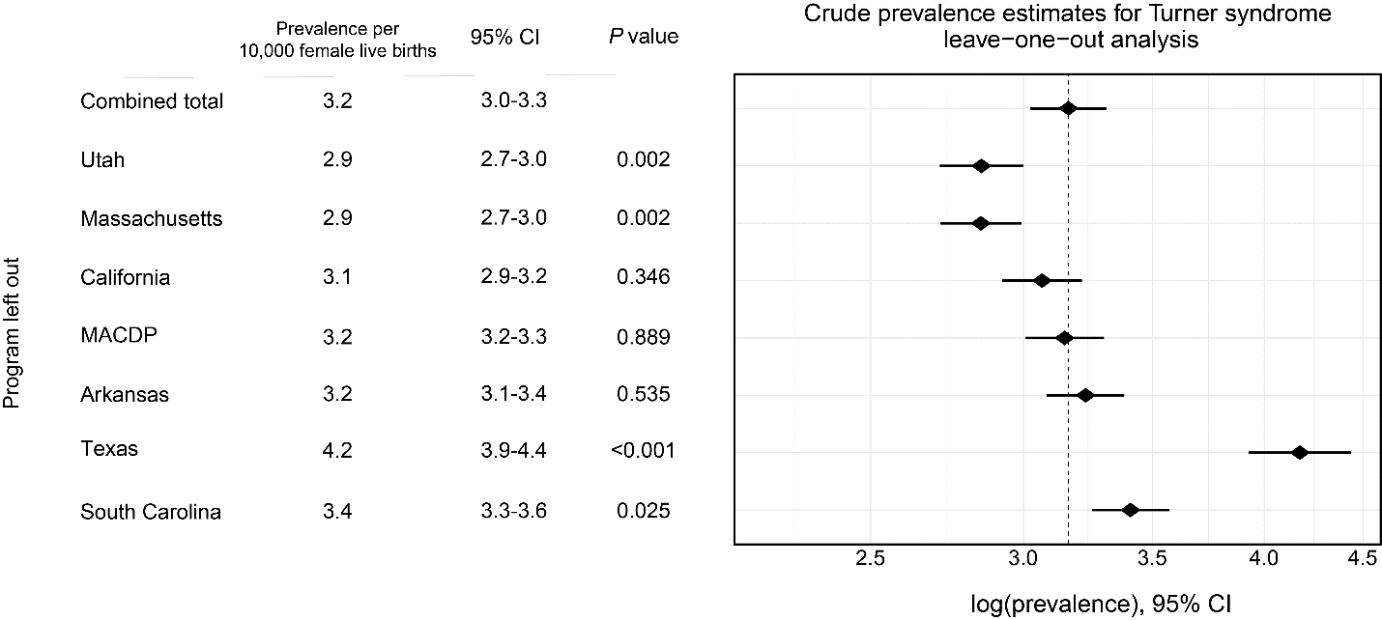

Supplementary Figure 1. Leave-one-out sensitivity analysis of the crude prevalence of Turner syndrome. The x-axis represents the log of the prevalence estimate, while the estimates in the left-hand table are the raw values. Each row indicates the prevalence estimate resulting from removal of data from that respective program. MACDP = Metropolitan Atlanta Congenital Defects Program.

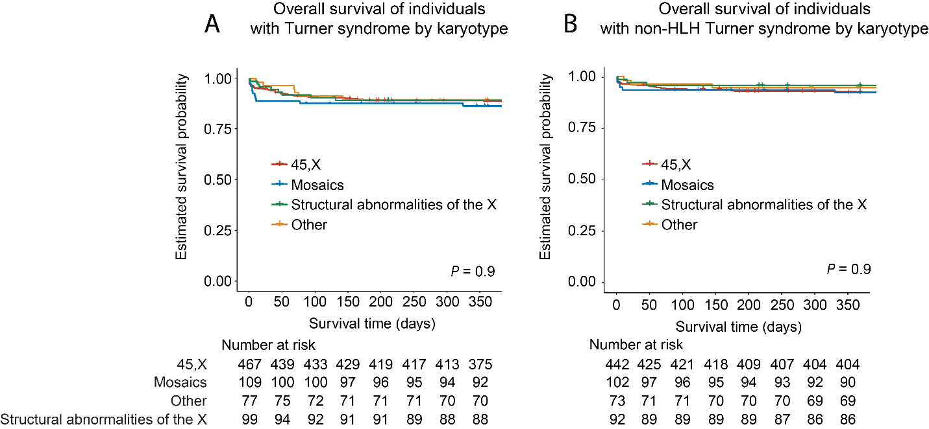

Supplementary Figure 2. One-year survival by karyotype of individuals with (A) Turner syndrome and (B) Turner syndrome without hypoplastic left-heart (non-HLH). “Other” includes Turner syndrome cases with rare karyotypes and cases not otherwise specified. “Structural abnormalities” include 46,XX,del(Xp22.3), 46,X,r(X)/46,XX, 46,X, i(Xq), and 46,X, idic(Xp). “Mosaics” include 45,X/46,XX; 45,X/47,XXX; 45,X/46,XX/47,XXX; and 45,X/46,XY.

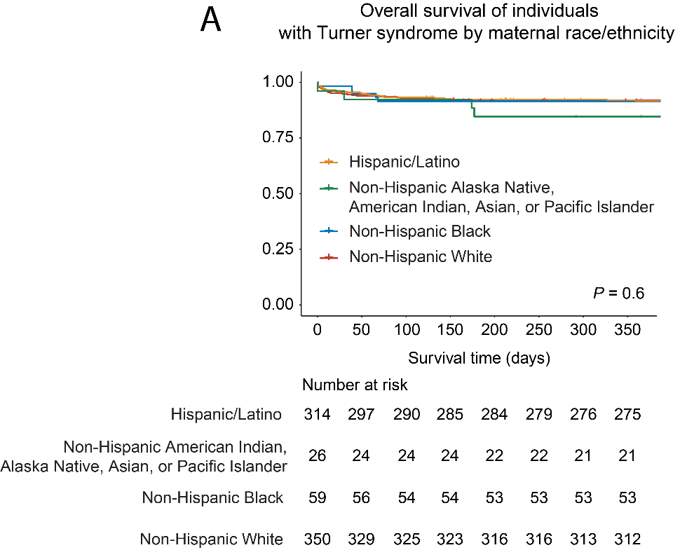

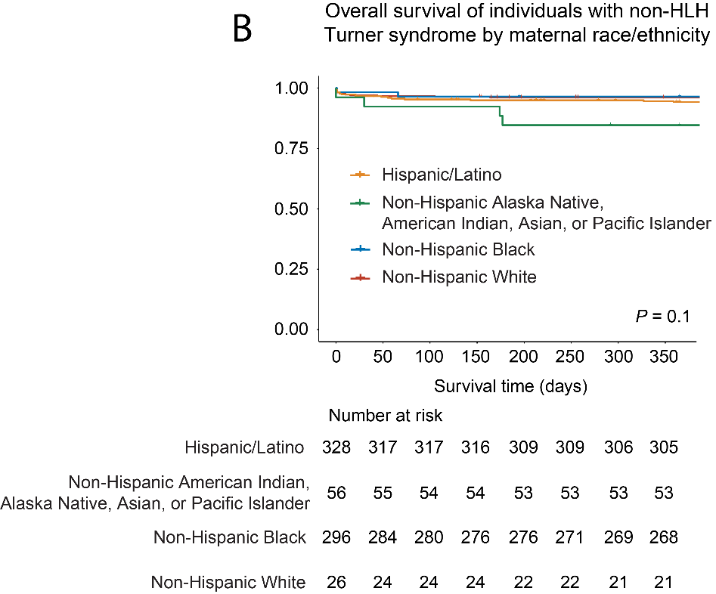

Supplementary Figure 3. One-year survival by maternal race and ethnicity of individuals with (A) Turner syndrome and (B) Turner syndrome without hypoplastic left-heart (non-HLH).

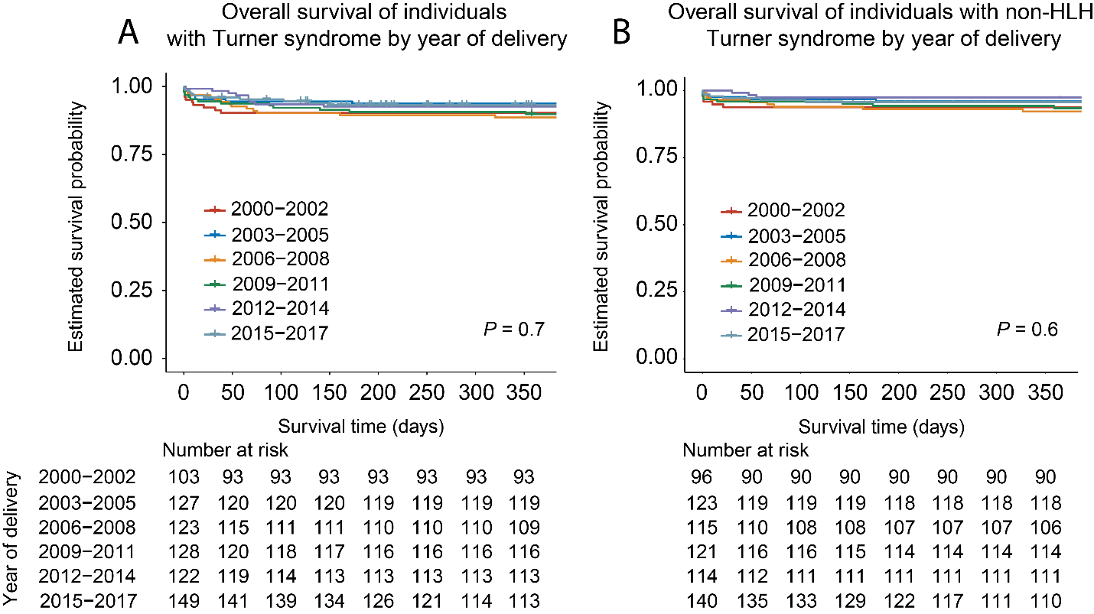
Supplementary Figure 4. One-year survival by year of delivery category of individuals with (A) Turner syndrome and (B) Turner syndrome without hypoplastic left-heart (non-HLH).

