**SUPPLEMENARY INFORMATION**

**Supplementary Methods**

The heat-related illness (HRI) claim setting was determined through manual review of Washington (WA) workers’ compensation HRI claims. For each claim, a researcher manually reviewed the following claim fields: injury event description (worker & employer), injury/accident site (e.g., job site, employer premises, other), and ‘job title / duty description’ from the initial claim form, and Standard Occupational Classification (SOC) description, North American Industrial Classification System (NAICS) description, and risk class description. Outdoor setting was then categorized, using the scheme in **Supplementary Table I**, based on the definition of outdoor work in the current WA heat rule:11,12“An environment where work activities are conducted outside. Work environments such as inside vehicle cabs, sheds, and tents or other structures may be considered an outdoor environment if the environmental factors affecting temperature are not managed by engineering controls. Construction activity is considered to be work in an indoor environment when performed inside a structure after the outside walls and roof are erected.”

**Supplementary Table I.** Outdoor/indoor categorization scheme

|  |  |
| --- | --- |
| **Category** | **Description** |
| Definitely outdoor | Enough information to meet outdoor definition |
| Probably outdoor | Can reasonably infer outdoor definition is likely from information available |
| Unlikely outdoor | Information available suggests does not meet outdoor definition |
| Uncertain | Not enough information to determine |

**Supplementary Table II.** Characteristics of excluded claims compared to included HRI claims, 2006-2021

|  |  |  |  |  |
| --- | --- | --- | --- | --- |
|  | **Excluded claims (n=89)** | | **Included claims (N=1,241)** | |
|  | **# claims** | **% claims** | **# claims** | **% claims** |
| **Claim status** |  |  |  |  |
| Accepted | 46 | 51.7 | 811 | 65.4 |
| Rejected | 43 | 48.3 | 430 | 34.6 |
|  |  |  |  |  |
| **Quarter** |  |  |  |  |
| 1 (Jan-Mar) | 0 | 0 | 13 | 1.0 |
| 2 (Apr-Jun) | 25 | 28.1 | 357 | 28.8 |
| 3 (Jul-Sept) | 62 | 69.7 | 857 | 69.1 |
| 4 (Oct-Dec) | 2 | 2.2 | 14 | 1.1 |
|  |  |  |  |  |
| **Work setting** |  |  | 1 |  |
| Definitely Outdoor | 49 | 55.1 | 651 | 52.5 |
| Probably Outdoor | 9 | 10.1 | 85 | 6.9 |
| Unlikely Outdoor | 6 | 6.7 | 212 | 17.1 |
| Uncertain | 25 | 28.1 | 291 | 23.5 |
|  |  |  |  |  |
| **Top Five Industries** | 2 |  | 3 |  |
| Construction | 24 | 27.9 | 294 | 23.9 |
| Agriculture, Forestry, Fishing, and Hunting | 15 | 17.4 | 209 | 17.0 |
| Administrative Support and Waste Management and Remediation Services | 10 | 11.6 | 106 | 8.6 |
| Public Administration | 6 | 7.0 | 167 | 13.6 |
| Manufacturing | 5 | 5.8 | 105 | 8.5 |

1Two missing; 2three missing; 3nine missing

HRI = heat-related illness

**Supplementary Table III.** Number and percent of ‘sudden increase’ HRI claims by industry for industries with more than one HRI claim, 2006-2021

|  |  |  |  |
| --- | --- | --- | --- |
| **Industry1** | **Total number of HRI claims** | **Number of HRI claims occurring on 'sudden increase' days** | **Percent of HRI claims occurring on 'sudden increase' days** |
| Construction | 294 | 92 | 31.3% |
| Agriculture, Forestry, Fishing and Hunting | 209 | 58 | 27.8% |
| Manufacturing | 105 | 34 | 32.4% |
| Administrative and Support and Waste Management and Remediation Services | 106 | 27 | 25.5% |
| Public Administration | 167 | 26 | 15.6% |
| Wholesale Trade | 59 | 21 | 35.6% |
| Accommodation and Food Services | 58 | 20 | 34.5% |
| Retail Trade | 54 | 16 | 29.6% |
| Transportation and Warehousing | 45 | 15 | 33.3% |
| Real Estate and Rental and Leasing | 25 | 12 | 48.0% |
| Other Services (except Public Administration) | 26 | 9 | 34.6% |
| Arts, Entertainment, and Recreation | 15 | 5 | 33.3% |
| Health Care and Social Assistance | 22 | 5 | 22.7% |
| Educational Services | 11 | 4 | 36.4% |
| Professional, Scientific, and Technical Services | 21 | 4 | 19.0% |
| Mining, Quarrying, and Oil and Gas Extraction | 5 | 2 | 40.0% |
| Utilities | 8 | 2 | 25.0% |
| All industries | 1,232 | 352 | 28.6% |

1Nine observations missing

HRI = heat-related illness

**Supplementary Table IV.** Characteristics of days with a cluster of ten or more HRI claims among 2006-2021 HRI claims that were ‘definitely’ or ‘probably’ outdoor (n=736)

|  |  |  |  |  |  |  |  |
| --- | --- | --- | --- | --- | --- | --- | --- |
| **Dates** | **# HRI claims** | **# 'sudden increase' claims** | **% HRI claims that were 'sudden increase' claims** | **Mean DOI Tmax,PRISM (°F)** | **Mean DOI – 1 Tmax,PRISM (°F)** | **Mean DOI – 2 Tmax,PRISM (°F)** | **Mean cumulative three day average (DOI, DOI -1, DOI -2) Tmax,PRISM (°F)** |
| 7/11/2007 | 6 | 4 | 66.7% | 93.3 | 84.4 | 80.5 | 86.1 |
| 7/28/2009 | 10 | 7 | 70.0% | 95.1 | 89.4 | 87.6 | 90.7 |
| 7/29/2009 | 8 | 8 | 100.0% | 95.2 | 91.8 | 85.2 | 90.8 |
| 6/27/2021 | 7 | 4 | 57.1% | 100.3 | 91.2 | 86.2 | 92.6 |
| 6/28/2021 | 20 | 17 | 85.0% | 104.9 | 101.2 | 91.3 | 99.1 |
| 6/29/2021 | 7 | 3 | 42.9% | 108.8 | 106.7 | 102.4 | 106 |
| All cluster dates | 58 | 43 | 74.1% | 100.6 | 95.6 | 89.4 | 95.2 |
| All other dates | 678 | 176 | 26.0% | 86.8 | 84.5 | 82.5 | 84.6 |

DOI = day of illness; HRI = heat-related illness; Tmax,PRISM = daily maximum temperature

**Supplementary Table V.** Characteristics of days with seven, three, and two or more claims (days with a frequency of claims at or above the 95th, 70th, and 45th percentiles, among days with more than one HRI claim), among all 2006-2021 HRI claims

|  |  |  |  |  |  |
| --- | --- | --- | --- | --- | --- |
| **Cluster type** | **# HRI cluster/non-cluster claims** | **% HRI cluster/non-cluster claims that were 'sudden increase' claims, χ(df), *p*** | **Mean DOI cluster/non-cluster Tmax,PRISM (°F), t(df), *p*** | **Mean DOI – 1 cluster/non-cluster Tmax,PRISM (°F), t(df), *p*** | **Mean DOI – 2 cluster/non-cluster Tmax,PRISM (°F), t(df), *p*** |
| 95th percentile (≥7 claims/day) | 171/1070 | 70.2%/22.0%  χ2(1)=165.5, *p*<0.001 | 96.8/85.3  t(269)=-15.4, *p*<0.001 | 91.8/83.2  t(238)=-9.6, *p*<0.001 | 86.7/81.4  t(244)=-6.1, *p*<0.001 |
| 70th percentile (≥3 claims/day) | 578/663 | 43.4%/15.7%  χ2(1)=115.0, *p*<0.001 | 91.7/82.7  t(1189)=-15.2, *p*<0.001 | 88.2/81.1  t(1229)=-11.3, *p*<0.001 | 84.8/79.8  t(1235)=-7.8, *p*<0.001 |
| 45th percentile (≥2 claims/day) | 814/427 | 36.2%/14.1%  χ2(1)=66.4, *p*<0.001 | 90.4/80.0  t(649)=-14.9, *p*<0.001 | 87.4/78.6  t(685)=-12.3, *p*<0.001 | 84.5/77.6  t(687)=-9.5, *p*<0.001 |

DOI = day of illness; HRI = heat-related illness; Tmax,PRISM = daily maximum temperature

t(df) = Student’s t test statistic (degrees of freedom) comparing DOI and prior day mean Tmax,PRISM of cluster versus non-cluster claims

χ2(df) = Chi-squared test statistic (degrees of freedom) comparing proportions of sudden increase ‘cluster’ versus ‘non-cluster’ claims

**Supplementary Figure 1.** Difference between Hesketh et al 20203 maximum temperature and PRISM maximum temperature (Tmax,PRISM) on HRI claim DOIs by WA county

DOI = day of illness; HRI = heat-related illness; PRISM = **parameter-elevation regressions on independent slopes model; WA = Washington State**

**Supplementary Figure 2.** Mean (+/- standard error) Tmax,PRISM and proportion of ‘sudden increase’ claims by ‘cluster’ size (number of HRI claims per day)

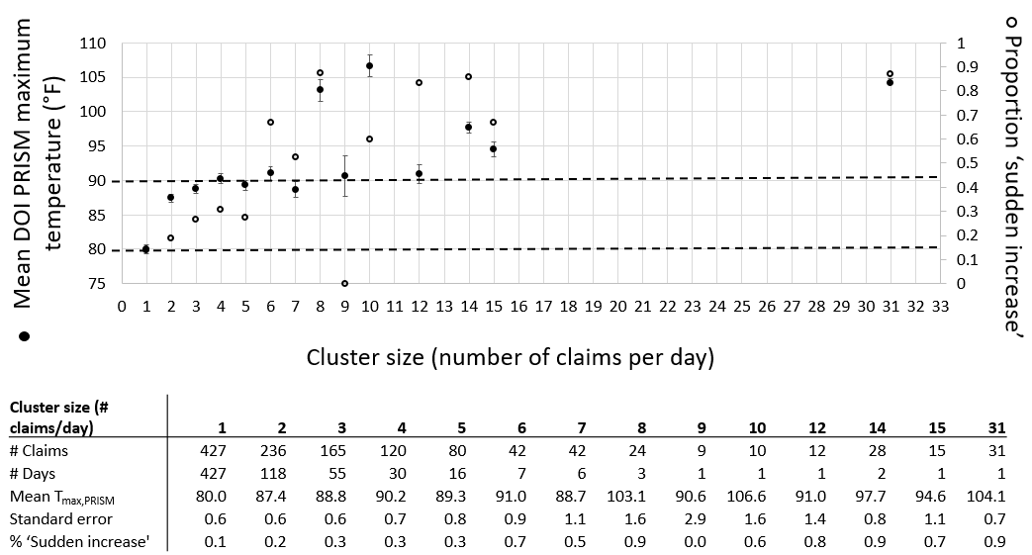

DOI= day of illness; PRISM = **parameter-elevation regressions on independent slopes model;** Tmax,PRISM = daily maximum temperature;

**Closed circles are mean** Tmax,PRISM (left axis), **and open circles are the proportion of ‘sudden increase’ heat-related illness claims (right axis). Dotted lines indicate** Tmax,PRISM of 80 and 90ºF (27 and 32°C)

**Error bars are +/- standard error**

**Supplementary Figure 3.** The number of all HRI claims, accepted HRI claims, and claims ‘definitely’ or ‘probably’ outdoors occurring on ‘sudden increase’ days by year, 2006-2021

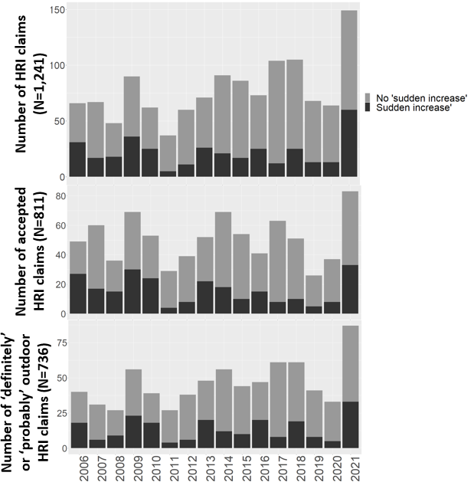

**Supplementary Figure 4.** Mean (+/- standard error) maximum daily PRISM temperatures on 2006-2021 HRI claims DOI and five days prior, for sensitivity analyses that considered cluster claims as those occurring on days with: a) seven or more claims (frequency of claims at or above the 95th percentile, among days with more than one HRI claim); b) three or more claims (frequency of claims at or above the 70th percentile, among days with more than one HRI claim); and c) two or more claims (frequency of claims at or above the 45th percentile, among days with more than one HRI claim)

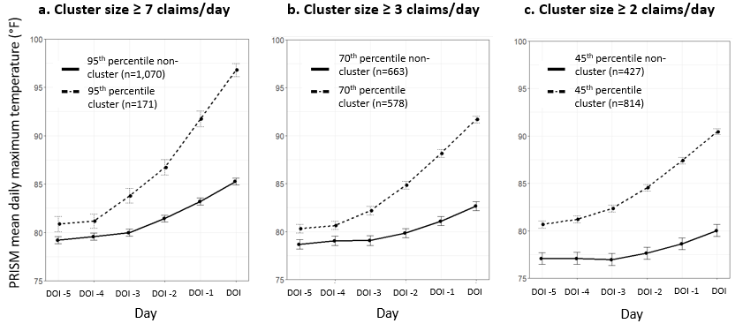

**Supplementary Figure 5.** 2006-2021 HRI claims in Washington State: a) proportion of claims occurring on ‘sudden increase’ days; b) number of HRI claims occurring on ‘cluster’ days

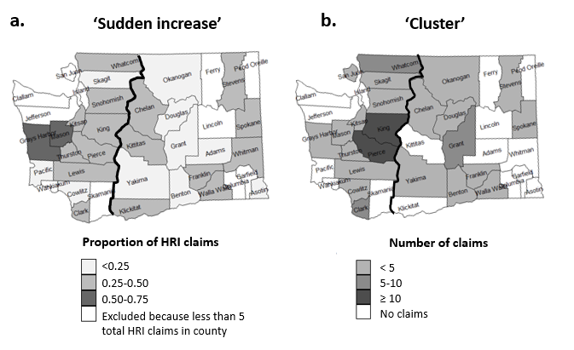

Black line = Central/Eastern Washington and Western Washington regions are defined using county borders nearest the Cascade Ridge line 32

**Supplementary Figure 6.** Number of HRI claims by county for all industries and for construction and agricultural industries in Washington State, 2006-2021

HRI = heat-related illness

Grey designates no values