Supplemental Figure 1. Directed Acyclic Graph (DAG) for Confounders and Mediators between PA Profile and HRV
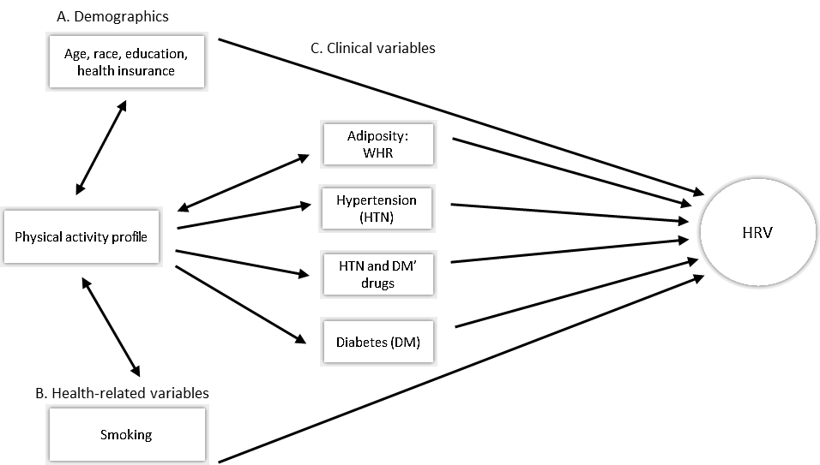
Supplemental Table 1. Characteristics of Included vs. Excluded Women from the Analyses.
Total N = 678 | Included Participants (N = 286)  Mean (SD), Median (25th– 75th), or N (%) | Excluded Participants (N = 392)  Mean (SD), Median (25th– 75th), or N (%) | p-value
Age (years) | 38.61 (5.7) | 37.03 (5.7) | <0.001
Race  White  African American  Others | 194 (67.8)  77 (26.9)  15 (5.2) | 196 (50.0)  173 (44.1)  23 (5.9) | <0.001
Education  High School or Less  Some College  College Degree | 53 (18.5)  132 (46.2)  101 (35.3) | 126 (32.1)  176 (44.9)  90 (23.0) | <0.001
Insurance  Private  Medicaid  None | 171 (59.8)  87 (30.4)  28 (9.8) | 200 (51.0)  166 (42.4)  26 (6.6) | 0.005
Current Smoking  No  Yes | 227 (79.4)  59 (20.6) | 261 (66.6)  131 (33.4) | <0.001
Waist-to-Hip Ratio | 0.80 (0.1) | 0.81 (0.1) | 0.2730
Systolic Blood Pressure (mmHg) | 112.71 (12.9) | 116.65 (14.7) | <0.001
Diastolic Blood Pressure (mmHg) | 74.51 (10.8) | 77.16 (11.1) | 0.002
Hypertension  No  Yes  Using Medication  Not Using Medication | 242 (84.6)  44 (15.4)  24 (54.5)  20 (45.5) | 297 (75.8)  95 (24.2)  65 (68.4)  30 (31.6) | 0.005  0.005
Diabetes  No  Yes  Using Medication  Not Using Medication | 274 (95.8)  12 (4.2)  5 (41.7)  7 (58.3) | 366 (93.4)  26 (6.6)  19 (73.1)  7 (26.9) | 0.173  0.062
Bold indicates significant difference (p≤0.05). mm/Hg: millimeters of mercury.

Supplemental Table 2. Isotemporal Associations of Replacing 30 Minutes/Day of ST, LPA, and MVPA with Heart Rate and HRV in Women without Chronic Conditions and who Met the Respiration Rate Criteria (n=264)
Outcomes | Heart Rate  (beat/min) | SDNN  ln(ms) | RMSSD  ln(ms)
Outcomes | B±SE  (p-value) | B±SE  (p-value) | B±SE  (p-value)
Replacing ST with  LPA | -0.140±0.231  (0.545) | 0.013±0.009  (0.146) | 0.006±0.012  (0.643)
Replacing ST with  MVPA | -0.271±0.368  (0.462) | -0.001±0.018  (0.942) | 0.009±0.022  (0.675)
Replacing LPA with  MVPA | -0.13±0.425  (0.758) | 0.001±0.021  (0.972) | 0.004±0.026  (0.889)
Bold indicates significant difference (p≤0.05). B: beta coefficient; LPA: light physical activity; MVPA: moderate-to-vigorous physical activity; RMSSD: root mean square of successive differences; SDNN: standard deviation of normal R-R intervals; SE: standard error; ST: sedentary time.
All models adjusted for age, race, education, insurance, smoking, hypertension, diabetes, antihypertensive medication, glucose-lowering medications, and waist-to-hip ratio. Participants with conditions that could impact HRV (e.g., cardiac disease; n = 12) and whose estimated respiration rate were outside of the normal range (i.e., 9-20 breaths/minute; n = 10) were excluded from these analyses.

Supplemental Table 3. Isotemporal Associations of Replacing 30 Minutes/Day of ST, LPA, MPA, and VPA with Heart Rate and HRV in Women without Chronic Conditions and who Met the Respiration Rate Criteria (n=264)
Outcomes | Heart Rate  (beat/min) | SDNN  ln(ms) | RMSSD  ln(ms)
Outcomes | B±SE  (p-value) | B±SE  (p-value) | B±SE  (p-value)
Replacing ST with  LPA | -0.167±0.237  (0.483) | 0.018±0.010  (0.080) | 0.009±0.013  (0.496)
Replacing ST with  MPA | -0.041±0.810  (0.959) | -0.043±0.046  (0.346) | -0.019±0.057  (0.738)
Replacing ST with  VPA | -0.789±1.418  (0.579) | 0.093±0.066  (0.161) | 0.074±0.090  (0.413)
Replacing LPA with  MPA | 0.125±0.888  (0.888) | -0.061±0.051  (0.233) | -0.028±0.064  (0.657)
Replacing LPA with  VPA | -0.622±1.385  (0.654) | 0.074±0.062  (0.231) | 0.065±0.086  (0.455)
Replacing MPA with  VPA | -0.748±2.089  (0.721) | 0.135±0.107  (0.208) | 0.093±0.141  (0.511)
Bold indicates significant difference (p≤0.05). B: beta coefficient; LPA: light physical activity; MPA: moderate physical activity; RMSSD: root mean square of successive differences; SDNN: standard deviation of normal R-R intervals; SE: standard error; ST: sedentary time; VPA: vigorous physical activity.
All models adjusted for age, race, education, insurance, smoking, hypertension, diabetes, antihypertensive medication, glucose-lowering medications, and waist-to-hip ratio. Participants with conditions that could impact HRV (e.g., cardiac disease; n = 12) and whose estimated respiration rate were outside of the normal range (i.e., 9-20 breaths/minute; n = 10) were excluded from these analyses.

