Supplementary Methods 3: Bland-Altman Plots

Figure S1. Counts of Walking to Work, 1-Year (2019) and 5-Year (2015–2019) Estimates,
American Community Survey
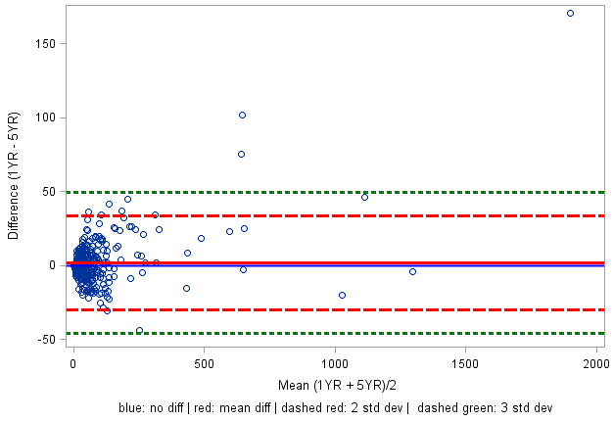
Figure S2. Counts of Bicycling to Work, 1-Year (2019) and 5-Year (2015–2019) Estimates,
American Community Survey
