Supporting Information for manuscript

NanoSpotTM Collector for Aerosol Sample Collection for Direct Microscopy and Spectroscopy Analysis

Orthodoxia Zervaki ^{a,b}, Braden Stump ^{c}, Patricia Keady ^{c}, Dionysios D. Dionysiou^{b}, Pramod Kulkarni ^{a*a}

ª Centers for Disease Control and Prevention, National Institute for Occupational Safety and Health, Cincinnati, OH, USA
^{b} Environmental Engineering and Science Program, Department of Chemical and Environmental Engineering (ChEE), University of Cincinnati, Cincinnati, Ohio 45221, United States
^{c} Aerosol Devices Inc, Fort Collins, CO 80524, USA

Disclaimer – The findings and conclusions in this report are those of the author(s) and do not necessarily represent the official position of the National Institute for Occupational Safety and Health, Centers for Disease Control and Prevention.

*Corresponding author: Email: PSKulkarni@cdc.gov; Phone: (513) 841-4300; Fax: (513) 841-4545;

S1 Numerical simulations: Saturation ratio and Kelvin diameter

Table S-1. Values and expressions of the parameters used for the saturation ratio and droplet growth rate simulations
Parameters | Values and expressions
Equilibrium vapor pressure of water, $P_{0}$¹ | $P_{0}={10}^{\left(10.23-\left({1750}/{\left(-38+T\right)}\right)\right)}$, Pa
Molecular weight of water, ${MW}_{w}$ | 18.02 g mol⁻¹
Molecular weight of air,${ MW}_{air}$ | 28.97 g mol⁻¹
Surface tension of water, σ^{2,3} | $σ=0.0761-1.55×{10}^{-4}\left(T-273\right)$, J m⁻²
Diffusivity of water vapor in air, $D_{v}$² | $D_{v}={0.211}/{P_{i}}{\left(T/{273}\right)}^{1.94}$, cm² s⁻¹
Density of water, ρ | 1.0 g cm⁻³
Thermal conductivity of air, $k_{a}$² | $k_{a}=\left(4.39+0.071 T\right){×10}^{-3}$, J m⁻¹ s⁻¹ K⁻¹
Heat capacity of air, $c_{p}$ | 1.005 J g⁻¹ K⁻¹
Mass and thermal accommodation coefficients, $a_{c}$ and $a_{T}$^{2,4} | 1.0
Latent heat of water, ${ΔH}_{v}$² | ${ΔH}_{v}=2.5{ \left({273.15}/T\right)}^{0.167+3.67×{10}^{-4} T}$, kJ g⁻¹
Universal gas constant, R | 8.31 J mol⁻¹ K⁻¹
¹Obtained by Kulkarni, Baron, and Willeke (2011)
²Obtained by Seinfeld and Pandis (2012)
³Obtained by Pruppacher and Klett (1997)
⁴Obtained by Laaksonen et al. (2005)

S2 Numerical simulations: Losses due to inertial deposition
Numerical simulations were also conducted for the generation of the transmission efficiency curve of particles undergoing inertial deposition as a function of the particle size diameter (Figure S-1; COMSOL Multiphysics® (v 5.6)). A 3D component was selected to solve momentum transfer Equations (2), (3) and the time-dependent particle’s position and velocity through Equations (10)-(13). A total number of approximately 26 ×10⁶ mesh elements were used. An atmospheric pressure boundary condition was assigned at the inlet, while an average air flow velocity of 25.5 m s⁻¹ was selected as an outlet boundary condition for the laminar flow module, solved at steady state. A time-dependent study was selected for the particle tracing module and a time step of 10⁻⁴ s was used to obtain adequately space- and time-resolved particle trajectories. A total of 100 particles were released at the inlet of the NSC and the transmission efficiency was measured at the outlet of the converging nozzle, for different particle diameters.
Figure S-1. Calculated transport efficiency and losses of particles undergoing inertial deposition across the NSC.

S3 Diffusive deposition

Figure S-2. Calculated transmission efficiency of particles undergoing diffusive deposition inside the growth tubes of the NSC (Gormley and Kennedy 1949; Brockmann 2011).

S4 Spot sample characteristics: Deposit diameter
Figure S-3. (a-d) SEM images and (e-h) axial distribution of the deposition spot formed by Polystyrene Latex (PSL) particles of 20 nm, 100 nm, 700 nm, and 1,900 nm size, when T_{conditioner}= 5 °C, T_{initiator}= 45 °C, and T_{moderator}= 12 °C.

S5 Spot sample characteristics: Deposit Uniformity

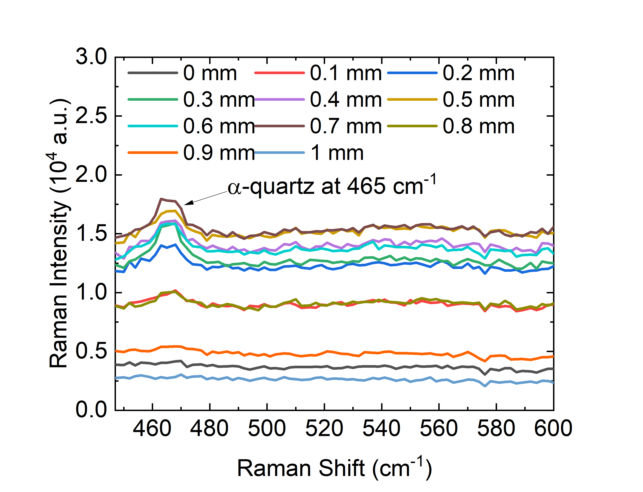
Figure S-4. Raman spectra obtained during deposition uniformity evaluation across the 2nd diagonal sampling path.
S6 Raman Intensity-Particulate Mass
Figure S-5. Raman spectra acquired during the calibration curves extracted of Raman Intensity per unit time as a function of particulate mass per unit area, for an initiator temperature of (a) 40 °C and (b) 45 °C.
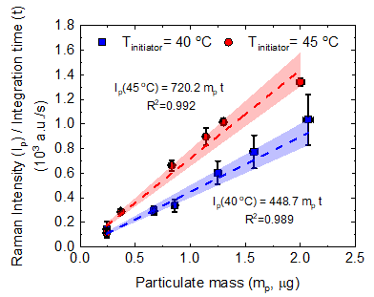
Figure S-6. Calibration curves extracted for Raman Intensity per unit time as a function of the particulate mass. Crystalline silica particles were collected. The y-error bars represent the standard deviation of the three Raman intensity replicates obtained. The x-error bars represent the uncertainty of the particulate mass of the spot sample. The dashed lines represent the linear fit of the experimental data. The shaded area represents the 95% confidence limits of the fitted curves.
Figure S-7. Size distribution of Min-U-Sil@5 particles generated from the Fluidized Bed, during the sample collection for the Raman Intensity calibration curve extraction.
S7 Mass uncertainty calculation
The measured particulate mass uncertainty was also calculated and included in the plots as x-error bars, and it was dependent on the standard uncertainties provided by each input variable. The variables (quantities) used for calculating the particulate mass were the collection efficiency ($η_{c})$, the sample flowrate ($Q)$, the aerosol concentration ($C_{in})$, and the collection time ($t_{c})$:
$$m_{p}=η_{c} Q C_{in} t_{c}$$ | (S-1)
The quantities are independent; thus, no covariance needs to be included. The “propagation of uncertainty” method, as proposed by Taylor and Kuyatt (1994), becomes as presented here:
$$u_{c}\left(m_{p}\right)={\left[{\left(\frac{∂m_{p}}{∂η_{c}}\right)}^{2}u^{2}\left(η_{c}\right)+{\left(\frac{∂m_{p}}{∂Q}\right)}^{2}u^{2}\left(Q\right)+{\left(\frac{∂m_{p}}{∂\left(C_{in} t_{c}\right)}\right)}^{2}u^{2}\left(C_{in} t_{c}\right)\right]}^{1/2}$$ | (S-2)

Where $u_{c}\left(m_{p}\right)$ is the calculated measurement uncertainty of the particulate mass, and u$\left(x_{i}\right)$ is the standard deviation provided for each variable $x_{i}$.

References

Allen, M. D., and O. G. Raabe. 1982. “Re-Evaluation of Millikan’s Oil Drop Data for the Motion of Small Particles in Air.” Journal of Aerosol Science 13 (6): 537–47. https://doi.org/10.1016/0021-8502(82)90019-2.
Bird, R. Byron, Warren E. Stewart, and Edwin N. Lightfoot. 2007. Transport Phenomena. Edited by John Wiley & Sons. 2nd ed.
Brockmann, John E. 2011. “Aerosol Transport in Sampling Lines and Inlets.” In Aerosol Measurement: Principles, Techniques, and Applications, Third, 69–105. New Jersey: John Wiley & Sons, Inc. https://doi.org/10.9783/9780812207347.23.
C N Davies. 1945. “Definitive Equations for the Fluid Resistance of Spheres.” Proceedings of the Physical Society 57 (4): 259–70. https://doi.org/10.1088/0959-5309/57/4/301.
Clift, Roland, John R. Grace, and Martin E. Weber. 1978. Bubbles, Drops and Particles. 3rd ed. Academic Press.
Gormley, P. G., and M. Kennedy. 1949. “Diffusion from a Stream Flowing through a Cylindrical Tube.” Proceedings of the Royal Irish Academy. Section A: Mathematical and Physical Sciences 52.
Hinds, W. C. 1999. Aerosol Technology: Properties, Behavior, and Measurement of Airborne Particles. 2nd ed. New York: Wiley.
Kim, Myung Man, and Andrew L. Zydney. 2004. “Effect of Electrostatic, Hydrodynamic, and Brownian Forces on Particle Trajectories and Sieving in Normal Flow Filtration.” Journal of Colloid and Interface Science 269 (2): 425–31. https://doi.org/10.1016/j.jcis.2003.08.004.
Kulkarni, Pramod, Paul A. Baron, and Klaus Willeke. 2011. Aerosol Measurement : Principles , Techniques , and Applications. Third. New Jersey: John Wiley & Sons, Inc.
Laaksonen, A., T. Vesala, M. Kulmala, P.M. Winkler, and P.E. Wagner. 2005. “Commentary on Cloud Modelling and the Mass Accommodation Coefficient of Water.” Atmospheric Chemistry and Physics 5 (2): 461–64.
Li, Amy, and Goodarz Ahmadi. 1992. “Dispersion and Deposition of Spherical Particles from Point Sources in a Turbulent Channel Flow.” Aerosol Science and Technology 16 (4): 209–26. https://doi.org/10.1080/02786829208959550.
Pruppacher, H.R., and J.D. Klett. 1997. Microphysics of Clouds and Precipitation. Kluwer, Dordrecht, The Netherlands.
Seinfeld, J. H., & Pandis, S. N. 2012. “Cloud Physics.” In Atmospheric Chemistry and Physics : From Air Pollution to Climate Change.
Taylor, Barry N., and Chris E. Kuyatt. 1994. “Guidelines for Evaluating and Expressing the Uncertainty of NIST Measurement Results. NIST Technical Note 1927.” U.S. Government Printing Office. Washington, DC. http://physics.nist.gov/TN1297.

