Supplementary file

Characterization of aerosolized particles from nanoclay-enabled composites during manipulation processes

Eun Gyung Lee, Lorenzo Cena, Jiwoon Kwon, Ali Afshari, HaeDong Park, Gary Casuccio, Kristin Bunker, Traci Lersch, Ashley Gall, Huy Pham, Alixandra Wagner, Sushant Agarwal, Cerasela Zoica Dinu, Rakesh Gupta, Sherri Friend, Todd A. Stueckle

Supplemental Method

During the CCSEM/EDS analysis, the energy and abundance of X-rays emitted by a particle were displayed as spectrum of X-ray counts verses energy, and the X-ray counts for each element were determined by the processing of the spectrum. The individual particles of the CCSEM data were classified into particle types according to their elemental composition. This was accomplished using a set of rules developed through examination of the EDS results obtained from the composite and sandpaper samples. For a particle to be classified to a specific particle type, it must conform to the elemental criteria listed in Table S1. In this table, elemental criteria are defined for thirteen particle types. Each individual particle was tested against these rules in succession beginning with the first type until the conditions of a class were satisfied. If a particle did not fall into one of the predefined particle types, it was classified in the miscellaneous category. The classification of composite particles is described in the electron microscopy analysis section.

Supplemental Tables

Table S1. Criteria applied to establish CCSEM particle classification rules
Particle Class | Elemental Criteria
Composite | C+O>80% - Plus manual evaluation of trace elements and morphology
Na-F-Al | Na>=10% and F>=10% and Al>3%
Si-Ca | Si>20% and Ca>10% and Si+Ca+O+C>50%
Si-Al | Si>20% and Al>5% and Si+Al+O+C>50%
Si-rich | Si>30% and C+Si+O>70%
Ca-rich | Ca>20% and C+Ca+O>70%
Al-Zr | Al>10% and Zr>10%
Zr-rich | Zr>30%
Al-rich | Al>20% and Al+O+C>50% and Si<10%
Fe-rich | Fe>=15% and Fe+C+O>50%
C(NaF) | C+O>60% and Na>1% and F>1%
C-rich | C+O>80%
Misc. | All remaining particles

Table S2. Summary of particle number concentrations using silicon carbide sandpaper.
Material ID | Composites | Sandpaper grit | Average number concentration  (particles cm⁻³)
PP | Polypropylene (PP) (virgin) | P120 | 31213
PP | Polypropylene (PP) (virgin) | P320 | 6549
1%25A-PP | Cloisite 25A-PP (1% w/w) | P120 | 48809
1%25A-PP | Cloisite 25A-PP (1% w/w) | P320 | NC
4%25A-PP | Cloisite 25A-PP (4% w/w) | P120 | 27038
4%25A-PP | Cloisite 25A-PP (4% w/w) | P320 | NC
1%93A-PP | Cloisite 93A-PP (1% w/w) | P120 | 29712
1%93A-PP | Cloisite 93A-PP (1% w/w) | P320 | NC
4%93A-PP | Cloisite 93A-PP (4% w/w) | P120 | 35870
4%93A-PP | Cloisite 93A-PP (4% w/w) | P320 | NC
NC: Test not conducted

Table S3. Temperatures measured at the surface where a composite block contacted the sandpaper
Material ID | Sand paper grit | Before sanding  (°C) | 1-min sanding (°C) | 14-min sanding (°C) | Δ (14-min – before) (°C)
PP | P100 | 23.0 | 28.1 | 28.2 | 5.2
PP | P180 | 24.8 | 28.1 | 28.7 | 3.9
1%25A-PP | P100 | 25.7 | 30.2 | 31.1 | 5.4
1%25A-PP | P180 | 24.1 | 28.2 | 29.7 | 5.5
4%25A-PP | P100 | 24.9 | 29.9 | 30.9 | 6.0
4%25A-PP | P180 | 23.7 | 28.4 | 29.6 | 5.9
1%93A-PP | P100 | 24.0 | 29.6 | 30.6 | 6.7
1%93A-PP | P180 | 24.5 | 28.6 | 29.8 | 5.2
4%93A-PP | P100 | 25.0 | 30.5 | 31.7 | 6.8
4%93A-PP | P180 | 24.9 | 30.4 | 31.7 | 6.7

Table S4. Average elemental compositions for each composite dust sample based on relative X-ray counts for each particle class. Each column in the table pertains to the relative percentage of X-ray counts of each element averaged for each particle assigned to the class. The last line provides the overall average X-ray counts attributed to all particle classes considered together normalized to 100 percent.

- Average composition for particle classes on sample 1%25A-PP (P100, IOM filter)
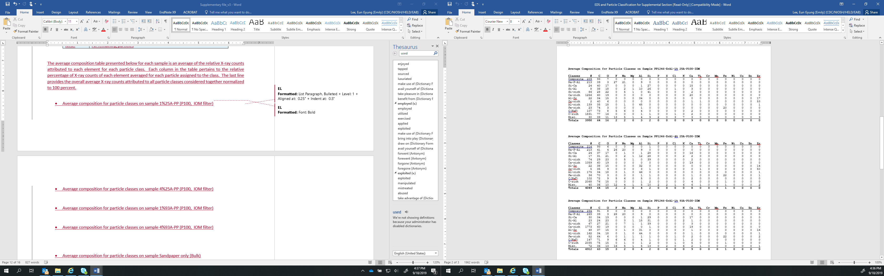
- Average composition for particle classes on sample 4%25A-PP (P100, IOM filter)

- Average composition for particle classes on sample 1%93A-PP (P100, IOM filter)
- Average composition for particle classes on sample 4%93A-PP (P100, IOM filter)
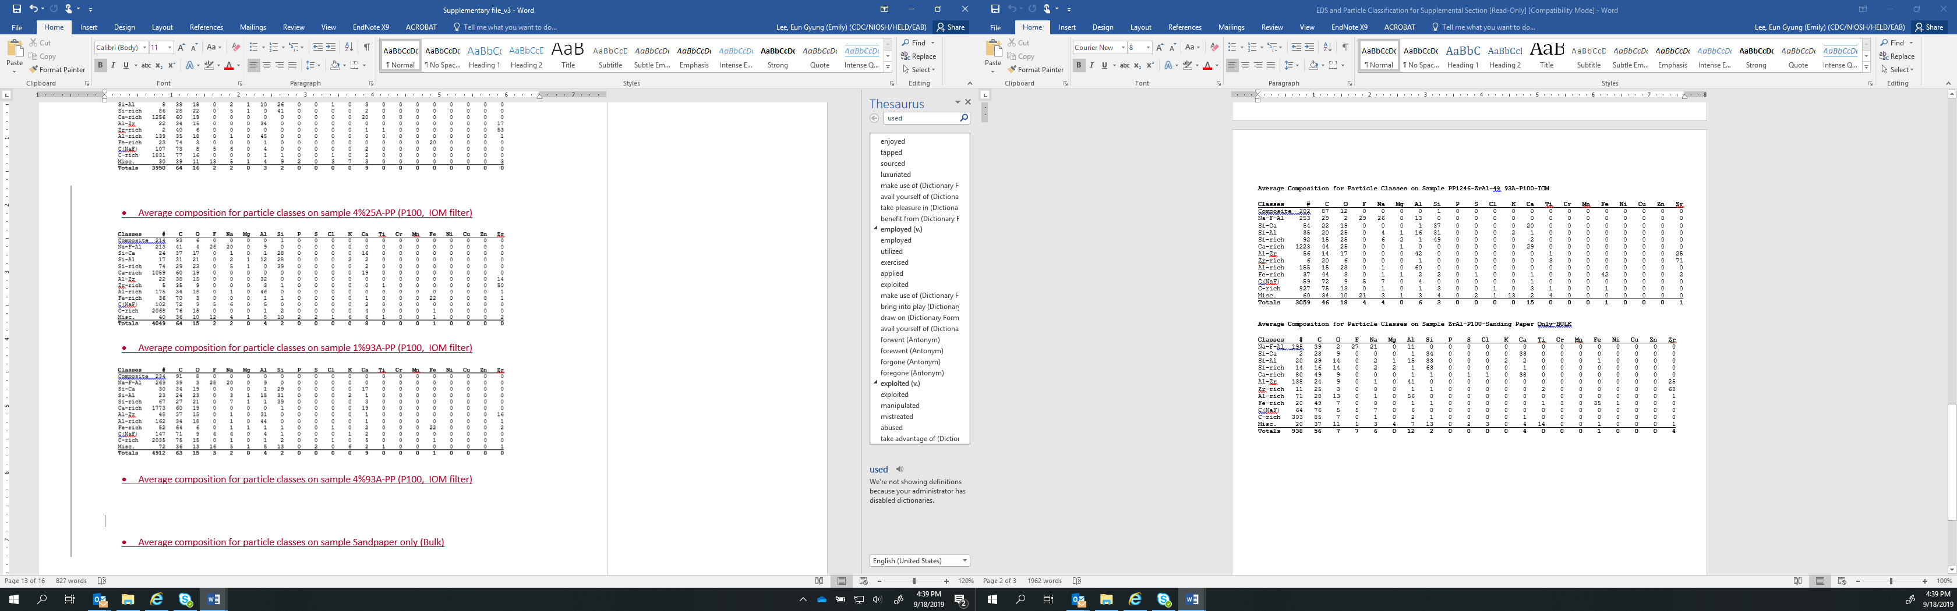
- Average composition for particle classes on sample Sandpaper only (Bulk)

Supplemental Figures

Cloisite 25A
N⁺
CH₂CH(CH₂)₃CH₃
HT
CH₃
CH₃
C₂H₅
N⁺
H
HT
HT
CH₃
Cloisite 93A

Fig. S1. Chemical structures of Cloisite 25A® and Cloisite 93A®. HT indicates dehydrogenated tallow.

A

B

Fig. S2. Summary of mechanical properties of nanoclay-enabled polypropylene composites. A) Pearson correlation coefficient (r_{p}) indicates the relationship between the released particle number concentrations and individual mechanical properties. B) For each composite material, one out of 10 stress-strain curves were presented.

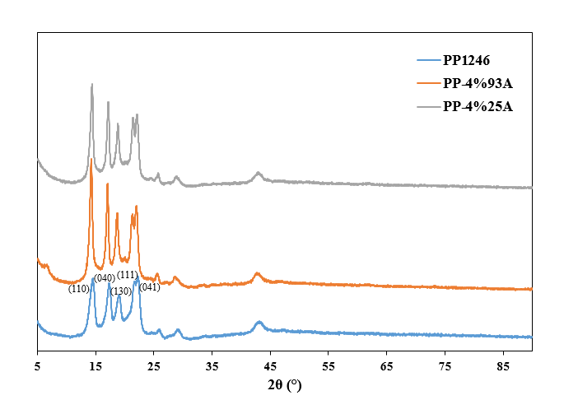
Fig. S3. Characteristic of crystallinity of nanoclay-enabled polypropylene composite compared to the virgin polypropylene (PP) determined by XRD.

Cloisite 93A
Cloisite 93A

Fig. S4. Representative diversity of particulate collected on TEM grids during machining of 4% 93A PP nanocomposite via TEM analysis. As-prepared Cloisite 93A was imaged to assist in identifying free release of nanoclay. Scale bars represent 300 nm.

Sandpaper debris

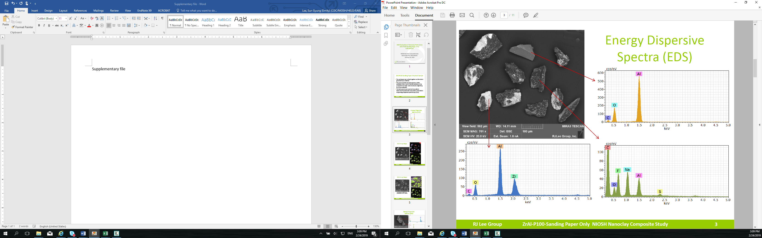
100 µm

4%93A-PP
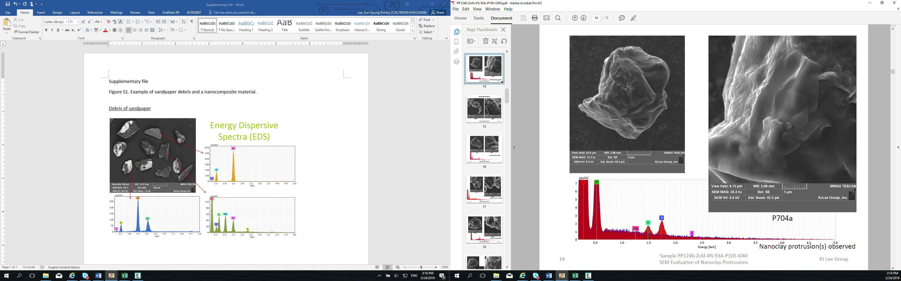

EDS overlay in blue was acquired from the particle; and the EDS in red was collected from the protrusion

4%25A-PP
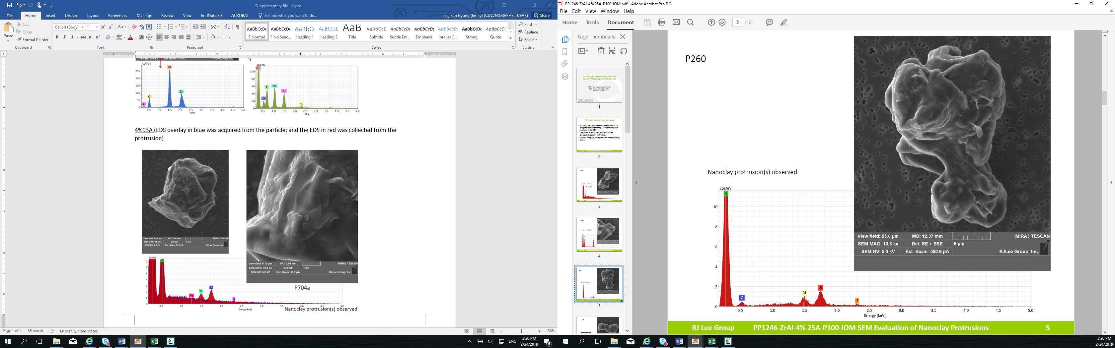

Fig. S5. Morphology of sandpaper debris and composite particles

Fig. S6. Size distribution frequency by number (%) of nanoclay-enabled polypropylene composites.

Fig. S7. Size distribution frequency by weight (%) of nanoclay-enabled polypropylene composites.

No protrusions
Nanoclay protrusions

Fig. S8. Representative diversity of 1% 93A PP nanocomposite particulate with (white arrows) and without nanoclay protrusions. Nanoclay protrusions were positively identified using manual FESEM/EDX spectra for both silica and aluminum presence. Scale bars represent 2 µm.

