Figure, Supplemental Digital Content 5
Publication Bias for Retention in HIV Care Studies
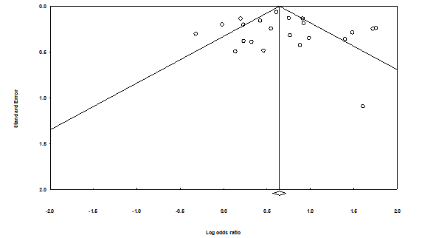
Egger’s Regression Intercept = 0.54; p = 0.54
Duval’s Trim and Fill: 0 studies trimmed; observed values = 2.01; adjusted values = 2.01

