**Appendix**

**Trends in Incidence of Type 1 and Type 2 Diabetes in Youth, 2002-2018:**

**SEARCH for Diabetes in Youth Study**

Table of Contents:

Appendix Methods: Models used to estimate adjusted trends by diabetes type

Populations Under Surveillance and Number of Cases Identified over the Period 2002 – 2018: SEARCH for Diabetes in Youth

Appendix Figure 1: Incidence of type 1 and type 2 diabetes in Hispanic, Non-Hispanic Black, and Non-Hispanic White youth by single year of age of diagnosis. (Figures for Asian/Pacific Islander and American Indian youth are not presented due to small sample sizes).

Appendix Figure 2: Distribution of Month of Diagnosis by Site for Type 1 Diabetes (top) and Type 2 Diabetes (bottom)

Appendix Table 1. Type 1 Diabetes Cases (Numerator)

Appendix Table 2. Type 1 Diabetes Number at Risk (Denominator)

Appendix Table 3. Unadjusted Incidence of Type 1 Diabetes and 95% Confidence Intervals

Appendix Table 4. Type 2 Diabetes Cases (Numerator)

Appendix Table 5. Type 1 Diabetes Number at Risk (Denominator)

Appendix Table 6. Unadjusted Incidence of Type 2 Diabetes and 95% Confidence Intervals

Appendix Table 7. Self-reported case presentation of diabetes diagnosis (percent) by incident year and diabetes type among youth 20 years of age and younger, SEARCH for Diabetes in Youth Study 2002–2018

Appendix Table 8. Self-reported case presentation of diabetes diagnosis (percent) by month and diabetes type among youth 20 years of age and younger, SEARCH for Diabetes in Youth Study 2002–2018

Methods: Models used to estimate adjusted trends by diabetes type.

Note: The correlation coefficient between two consecutive incidence estimates is calculated as θ / (1 + θ2). θ is the final parameter in the models below.

|  |  |
| --- | --- |
| Type 1: | |
| All | $$\log\left(μ_{t}\right)=3.966+0.020*t+0.119*I\left(Male\right)+\left\{\begin{aligned}0.678*I\left(5-9\right) \\ 0.841*I\left(10-14\right) \\ -0.020* I\left(15-19\right)\end{aligned}\right.+\left\{\begin{aligned}-1.711*I\left(NHB\right) \\ -1.484*I\left(Hisp\right) \\ -3.388*I\left(API\right) \\ -4.682*I\left(AI\right)\end{aligned}\right.+0.125*log\left(\frac{N_{t-1}}{μ_{t-1}}\right)$$ |
| Age | $$\log\left(μ_{t}\right)=4.001+0.006*t+0.118*I\left(Male\right)+\left\{\begin{aligned}0.645*I\left(5-9\right) \\ 0.798*I\left(10-14\right) \\ -0.071* I\left(15-19\right)\end{aligned}\right.+\left\{\begin{aligned}-1.713*I\left(NHB\right) \\ -1.486*I\left(Hisp\right) \\ -3.392*I\left(API\right) \\ -4.689*I\left(AI\right)\end{aligned}\right.+\left\{\begin{aligned} 0.014*I\left(5-9\right)*t \\ 0.019*I\left(10-14\right)*t \\ 0.022*I\left(15-19\right)*t\end{aligned}\right.+0.111*log\left(\frac{N_{t-1}}{μ_{t-1}}\right)$$ |
| Sex | $$\log\left(μ_{t}\right)=3.973+0.017*t+0.106*I\left(Male\right)+\left\{\begin{aligned}0.678*I\left(5-9\right) \\ 0.841*I\left(10-14\right) \\ -0.021* I\left(15-19\right)\end{aligned}\right.+\left\{\begin{aligned}-1.712*I\left(NHB\right) \\ -1.484*I\left(Hisp\right) \\ -3.389*I\left(API\right) \\ -4.683*I\left(AI\right)\end{aligned}\right.+0.006*I\left(Males\right)*t+0.122*log\left(\frac{N_{t-1}}{μ_{t-1}}\right)$$ |
| Race | $$\log\left(μ_{t}\right)=3.998+0.006*t+0.123*I\left(Male\right)+\left\{\begin{aligned}0.673*I\left(5-9\right) \\ 0.836*I\left(10-14\right) \\ -0.027* I\left(15-19\right)\end{aligned}\right.+\left\{\begin{aligned}-1.765*I\left(NHB\right) \\ -1.568*I\left(Hisp\right) \\ -3.499*I\left(API\right) \\ -4.715*I\left(AI\right)\end{aligned}\right.+\left\{\begin{aligned}0.023*I\left(NHB\right)*t \\ 0.035*I\left(Hisp\right)*t \\ 0.041*I\left(API\right)*t \\ 0.012*I\left(AI\right)*t\end{aligned}\right.+0.103*log\left(\frac{N_{t-1}}{μ_{t-1}}\right)$$ |
| Site | $$\log\left(μ_{t}\right)=2.804+0.016*t+0.139*I\left(Male\right)+\left\{\begin{aligned}0.653*I\left(5-9\right) \\ 0.820*I\left(10-14\right) \\ -0.048* I\left(15-19\right)\end{aligned}\right.+\left\{\begin{aligned}-0.461*I\left(OH\right) \\ 0.391*I\left(CO\right) \\ -0.481*I\left(CA\right) \\ 0.030*I\left(WA\right)\end{aligned}\right.+\left\{\begin{aligned}-0.015*I\left(OH\right)*t \\ 0.005*I\left(CO\right)*t \\ 0.003*I\left(CA\right)*t \\ -0.008*I\left(WA\right)*t\end{aligned}\right.+0.158*log\left(\frac{N_{t-1}}{μ_{t-1}}\right)$$ |
| Type 2: | |
| All | $$\log\left(μ_{t}\right)=2.705+0.052*t-0.387*I\left(Male\right)+0.195*I(15-19)+\left\{\begin{aligned}0.580*I\left(NHB\right) \\ 0.410*I\left(Hisp\right) \\ -1.278*I\left(API\right) \\ -1.155*I\left(AI\right)\end{aligned}\right.+0.209*log\left(\frac{N_{t-1}}{μ_{t-1}}\right)$$ |
| Age | $$\log\left(μ_{t}\right)=2.721+0.046*t-0.387*I\left(Male\right)+0.165*I\left(15-19\right)+\left\{\begin{aligned}0.580*I\left(NHB\right) \\ 0.409*I\left(Hisp\right) \\ -1.279*I\left(API\right) \\ -1.155*I\left(AI\right)\end{aligned}\right.+0.010*I\left(15-19\right)*t+0.206*log\left(\frac{N_{t-1}}{μ_{t-1}}\right)$$ |
| Sex | $$\log\left(μ_{t}\right)=2.704+0.052*t-0.384*I\left(Male\right)+0.195*I\left(15-19\right)+\left\{\begin{aligned}0.580*I\left(NHB\right) \\ 0.410*I\left(Hisp\right) \\ -1.278*I\left(API\right) \\ -1.155*I\left(AI\right)\end{aligned}\right.-0.001*I\left(Males\right)*t+0.209*log\left(\frac{N_{t-1}}{μ_{t-1}}\right)$$ |
| Race | $$\log\left(μ_{t}\right)=2.800+0.018*t-0.392*I\left(Male\right)+0.189*I(15-19)+\left\{\begin{aligned}0.471*I\left(NHB\right) \\ 0.266*I\left(Hisp\right) \\ -1.495*I\left(API\right) \\ -1.197*I\left(AI\right)\end{aligned}\right.+\left\{\begin{aligned}0.040*I\left(NHB\right)*t \\ 0.051*I\left(Hisp\right)*t \\ 0.067*I\left(API\right)*t \\ 0.016*I\left(AI\right)*t\end{aligned}\right.+0.155*log\left(\frac{N_{t-1}}{μ_{t-1}}\right)$$ |
| Site |  |

|  |  |  |  |  |  |
| --- | --- | --- | --- | --- | --- |
| Populations Under Surveillance and Number of Cases Identified over the Period 2002 – 2018: SEARCH for Diabetes in Youth | | | | | |
|  | Colorado | Ohio | South Carolina | Washington | California |
| Population | All 64 counties plus selected American Indian reservations in Arizona and New Mexico. For American Indians, eligibility required participation in Indian Health Services. | 8 counties | All 46 counties | 5 counties | Enrollees in 7 counties in the Kaiser Permanente Southern California health plan |
| Type 1 Diabetes, Ages 0-19:  Cases and Number at Risk (N) | 5735  24,390,582 | 2334  9,345,664 | 3859  20,355,813 | 3861  16,947,282 | 2380  14,044,394 |
| Type 2 Diabetes,  Ages 10-19: Cases and Number at Risk (N) | 915  12,274,034 | 512  4,762,948 | 1711  10,453,131 | 662  8,480,422 | 1493  7,794,406 |

Appendix Figure 1: Incidence of type 1 and type 2 diabetes in Hispanic, Non-Hispanic Black, and Non-Hispanic White youth by single year of age of diagnosis. (Figures for Asian/Pacific Islander and American Indian youth are not presented due to small sample sizes).

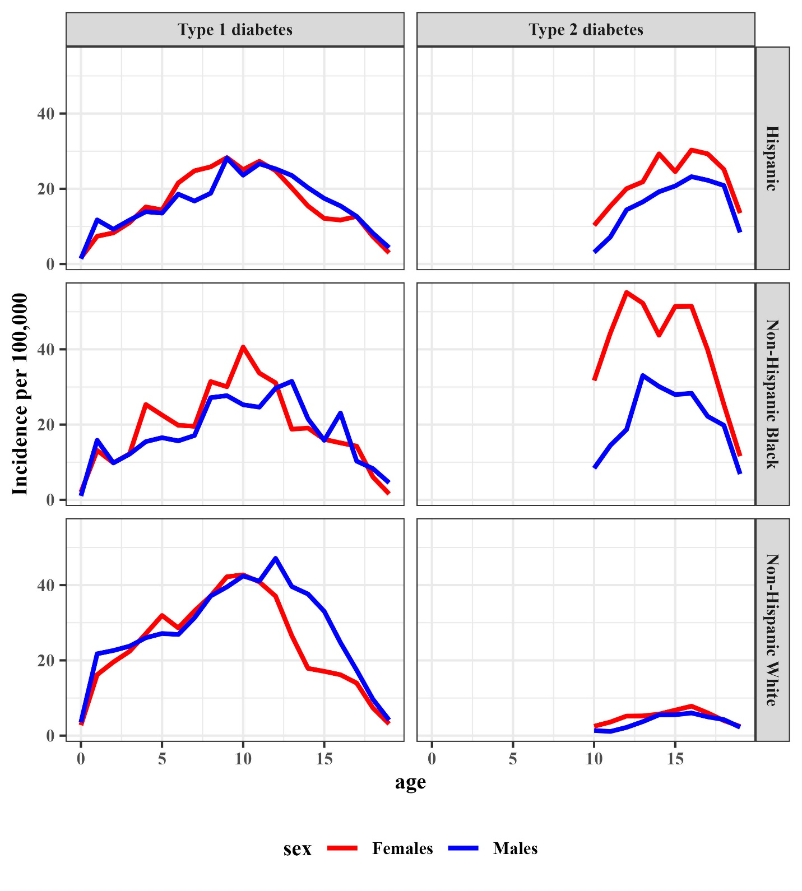

Appendix Figure 2: Distribution of Month of Diagnosis by Site for Type 1 Diabetes (left) and Type 2 Diabetes (right)

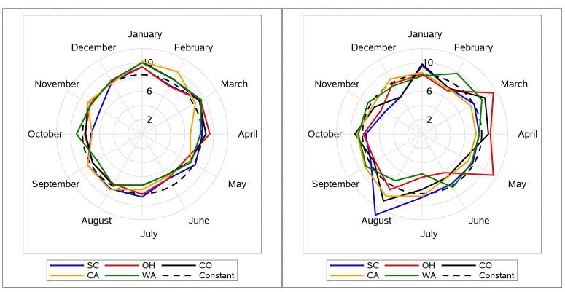

Footnote: SC=South Carolina; OH=Ohio; CO=Colorado; CA=California; WA=Washington. Numbers represent the percentage of cases diagnosed in that month. The values 2%, 6% and 10% are shown as the axis labels. The constant line is drawn with a dashed line at 8.3% (or 1/12th of annual cases).













|  |  |  |  |  |  |  |  |  |  |  |
| --- | --- | --- | --- | --- | --- | --- | --- | --- | --- | --- |
| Appendix Table 7. Self-reported case presentation of diabetes diagnosis (percent) by incident year and diabetes type among youth 20 years of age and younger, SEARCH for Diabetes in Youth Study 2002–2018 | | | | | | | | | | |
|  | Type 1 Diabetes (n=15,666) | | | | | Type 2 Diabetes (n=3,812) | | | | |
|  | Symptoms | Checkup | Community Screening | Other | p-value | Symptoms | Checkup | Community Screening | Other | p-value |
| Incident Years |  |  |  |  |  |  |  |  |  |  |
| 2002-2004 | 95.4 | 3.7 | 0.2 | 0.8 | 0.0323 | 71.7 | 23.7 | 2.8 | 1.8 | <0.0001 |
| 2005-2007 | 94.7 | 3.5 | 0.4 | 1.4 | 65.7 | 29 | 2.4 | 2.9 |
| 2008-2010 | 94 | 4 | 0.3 | 1.7 | 59.4 | 36.5 | 3.2 | 0.9 |
| 2011-2013 | 94.3 | 4.1 | 0.3 | 1.4 | 57.9 | 39.2 | 0.9 | 2.1 |
| 2014-2016 | 93.9 | 4.1 | 0.3 | 1.7 | 58 | 38.2 | 1.3 | 2.5 |
| 2017-2018 | 93.4 | 5 | 0.3 | 1.3 | 51.2 | 45.9 | 1.2 | 1.7 |
| Adjusted Estimatesa |  |  |  |  |  |  |  |  |  |  |
| 2002-2004 | 95.5 | 3.2 | 0.3 | 1 | 0.0609 | 68.9 | 26.4 | 3 | 1.7 | <0.0001 |
| 2005-2007 | 95.3 | 3.3 | 0.3 | 1.1 | 66 | 29.8 | 2.4 | 1.8 |
| 2008-2010 | 95 | 3.5 | 0.3 | 1.2 | 62.8 | 33.4 | 2 | 1.8 |
| 2011-2013 | 94.8 | 3.6 | 0.3 | 1.3 | 59.3 | 37.2 | 1.6 | 1.9 |
| 2014-2016 | 94.5 | 3.8 | 0.3 | 1.5 | 55.6 | 41.2 | 1.3 | 1.9 |
| 2017-2018 | 94.2 | 3.9 | 0.3 | 1.6 | 51.8 | 45.2 | 1 | 1.9 |
| aAdjusted for age at diagnosis (0-4, 5-9, 10-14, 15-19), sex (male/female), and white/non-white. | | | | | | | | | | |

Appendix Table 8. Self-reported case presentation of diabetes diagnosis (percent) by month and diabetes type among youth 20 years of age and younger, SEARCH for Diabetes in Youth Study 2002–2018

|  |  |  |  |  |  |  |  |  |
| --- | --- | --- | --- | --- | --- | --- | --- | --- |
|  | Type 1 | | | | Type 2 | | | |
|  | Symptoms | Checkup  (Routine Health Visit) | Community Screening | Other | Symptoms | Checkup  (Routine Health Visit) | Community Screening | Other |
| **Jan** | 95.59 | 2.92 | 0.32 | 1.17 | 58.97 | 34.76 | 2.56 | 3.7 |
| **Feb** | 95.63 | 2.67 | 0.44 | 1.26 | 61.25 | 35.64 | 1.73 | 1.38 |
| **Mar** | 94.87 | 3.71 | 0.2 | 1.21 | 61.34 | 36.92 | 0.87 | 0.87 |
| **Apr** | 94.23 | 4.33 | 0.38 | 1.06 | 59.49 | 37.66 | 1.58 | 1.27 |
| **May** | 94.79 | 3.45 | 0.16 | 1.6 | 60.82 | 35.42 | 2.82 | 0.94 |
| **June** | 92.81 | 4.55 | 0.36 | 2.28 | 58.54 | 35.54 | 1.05 | 4.88 |
| **July** | 93.3 | 5.05 | 0.25 | 1.41 | 60.81 | 36.82 | 1.35 | 1.01 |
| **Aug** | 91.44 | 6.74 | 0.38 | 1.44 | 57.82 | 40.05 | 0.95 | 1.18 |
| **Sept** | 93.96 | 4.55 | 0.24 | 1.25 | 60.75 | 34.58 | 1.87 | 2.8 |
| **Oct** | 94.23 | 4.07 | 0.41 | 1.3 | 58.82 | 38.08 | 1.24 | 1.86 |
| **Nov** | 94.41 | 3.94 | 0.08 | 1.57 | 60.44 | 34.43 | 3.3 | 1.83 |
| **Dec** | 95.55 | 3.24 | 0.15 | 1.06 | 55.35 | 39.11 | 3.32 | 2.21 |