**Supplemental Figure 1**: Trends in Positive Tests, new initiation on antiretroviral therapy ART), and proxy linkage* to ART among Adolescents in PEPFAR-supported programs, October 2017-September 2020, by A) Younger (10-14) vs. Older (15-19) and Female vs. Male B) Region. Year 1=October 2017-September 2018, Year 2=October 2018-September 2019, Year 3=October 2019-September 2020

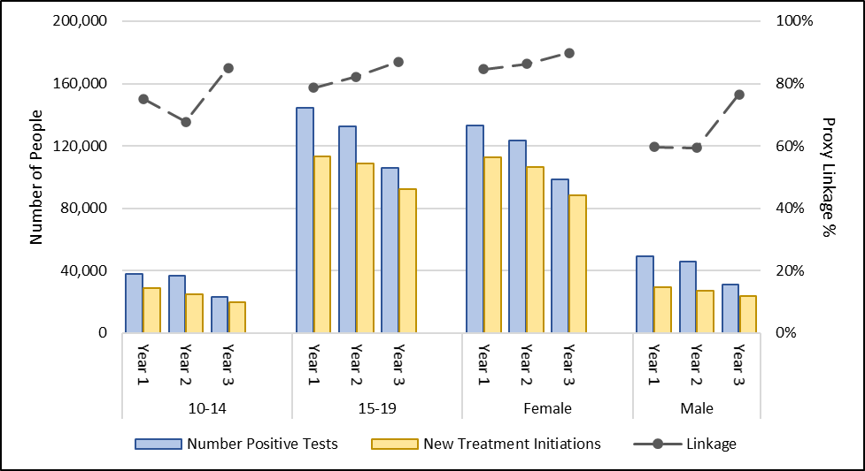

A

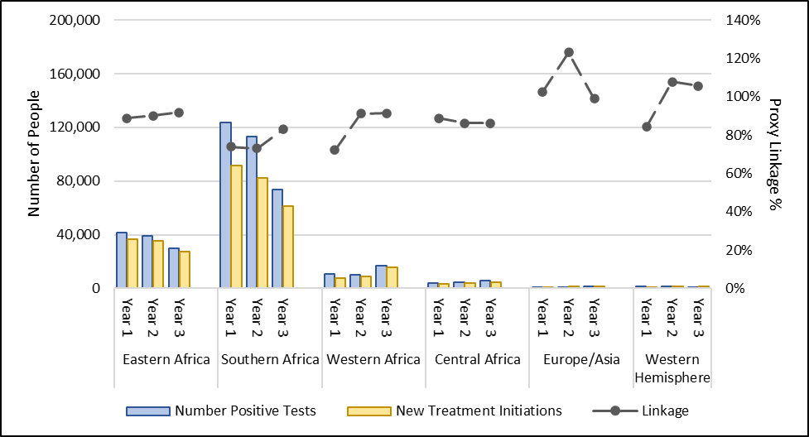

B

* Proxy calculations use aggregate numbers across different indicators and may result in results >100%.

**Supplemental Figure 2**: Trends in Viral Load Testing, Coverage, and Suppression among Adolescents in PEPFAR-supported programs, October 2017-September 2020, by A) Younger (10-14) vs. Older (15-19) and Female vs. Male B) Region. Year 1=October 2017-September 2018, Year 2=October 2018-September 2019, Year 1=October 2019-September 2020. VLC = viral load coverage, VLS = viral load suppression.

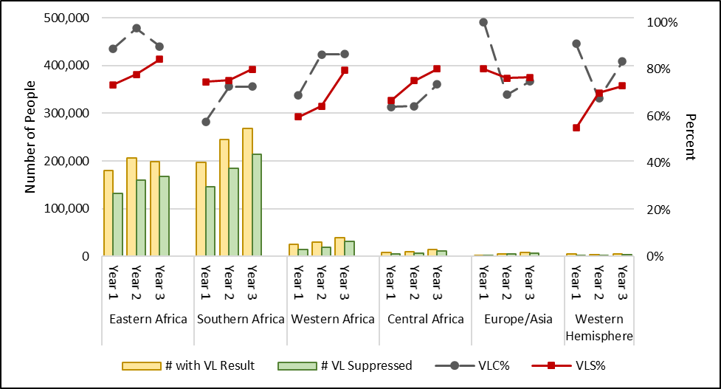

B

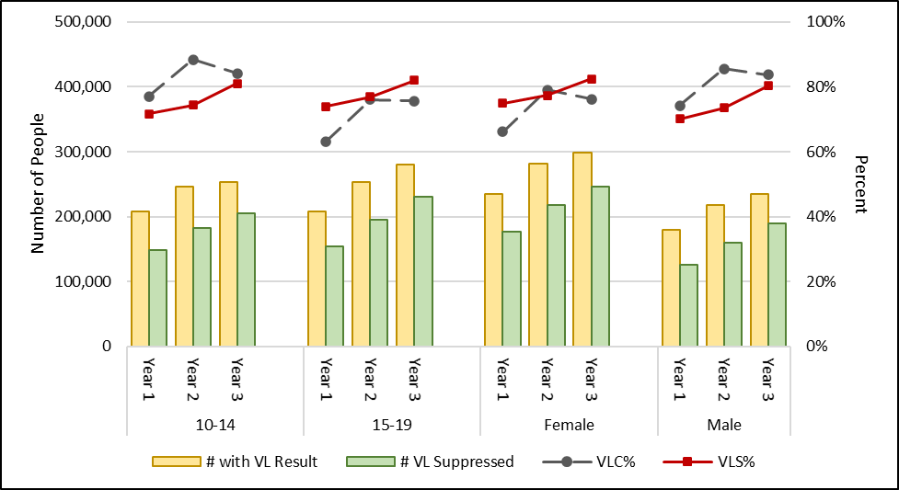

A