Title
On-column Trypsin Digestion Coupled with LC-MS/MS for Quantification of Apolipoproteins

Christopher A Toth, Zsuzsanna Kuklenyik*, Jeffrey I Jones, Brian A Parks, Michael S Gardner, David Schieltz, Jon C Rees, Michael L Andrews, Lisa G McWilliams, James L Pirkle and John R Barr
Centers for Disease Control and Prevention, Division of Laboratory Sciences, Atlanta, GA
*Corresponding author, ZKuklenyik@cdc.gov

Supporting Information

Figure S1. Valve diagram

Table S1. MRM precursor and fragment ion masses, and fragment ion ratio %CVs were calculated from the 4 highest calibrator data in a typical run.
Protein | Peptide sequence | Precursor ion m/z | Fragment ion |  |  | Native C/Q Ion ratio %CV | IS C/Q Ion ratio %CV
Protein | Peptide sequence | Precursor ion m/z | m/z | Type | Quantitation (Q) Confirmation (C) | Native C/Q Ion ratio %CV | IS C/Q Ion ratio %CV
apoA-I | ATEHLSTLSEK | 608.3 | 664.4 | y6 | Q | 3.2 | 3.4
apoA-I | ATEHLSTLSEK | 608.3 | 777.4 | y7 | C | 3.2 | 3.4
apoA-I | THLAPYSDELR | 651.3 | 950.5 | y8 | Q | 2.4 | 1.3
apoA-I | THLAPYSDELR | 651.3 | 1063.5 | y9 | C | 2.4 | 1.3
apoA-I | AKPALEDLR | 506.8 | 716.4 | y6 | C | 9.2 | 4.6
apoA-I | AKPALEDLR | 506.8 | 813.4 | y7 | Q | 9.2 | 4.6
apoA-II | EQLTPLIK | 471.3 | 470.3 | y4 | C | 1.3 | 5.0
apoA-II | EQLTPLIK | 471.3 | 571.4 | y5 | Q | 1.3 | 5.0
apoA-IV | LEPYADQLR | 552.8 | 765.4 | y6 | Q | 2.1 | 4.8
apoA-IV | LEPYADQLR | 552.8 | 862.4 | y7 | C | 2.1 | 4.8
apoA-IV | LTPYADEFK | 542.3 | 772.4 | y6 | Q | 0.6 | 3.4
apoA-IV | LTPYADEFK | 542.3 | 869.4 | y7 | C | 0.6 | 3.4
apoB | ATGVLYDYVNK | 621.8 | 801.4 | y6 | Q | 3.5 | 4.2
apoB | ATGVLYDYVNK | 621.8 | 914.5 | y7 | C | 3.5 | 4.2
apoB | TGISPLALIK | 506.8 | 654.5 | y6 | Q | 3.8 | 6.4
apoB | TGISPLALIK | 506.8 | 741.5 | y7 | C | 3.8 | 6.4
apoB | AAIQALR | 371.7 | 487.3 | y4 | C | 1.3 | 3.4
apoB | AAIQALR | 371.7 | 600.4 | y5 | Q | 1.3 | 3.4
apoC-I | EWFSETFQK | 601.3 | 739.4 | y6 | Q | 1.9 | 3.1
apoC-I | EWFSETFQK | 601.3 | 886.4 | y7 | C | 1.9 | 3.1
apoC-I | TPDVSSALDK | 516.8 | 620.3 | y6 | C | 8.0 | 7.5
apoC-I | TPDVSSALDK | 516.8 | 834.4 | y8 | Q | 8.0 | 7.5
apoC-II | TYLPAVDEK | 518.3 | 658.3 | y6 | C | 2.4 | 2.0
apoC-II | TYLPAVDEK | 518.3 | 771.4 | y7 | Q | 2.4 | 2.0
apoC-II | ESLSSYWESAK | 643.8 | 870.4 | y7 | Q | 4.5 | 6.4
apoC-II | ESLSSYWESAK | 643.8 | 957.4 | y8 | C | 4.5 | 6.4
apoC-III | GWVTDGFSSLK | 598.8 | 753.4 | y7 | Q | 6.6 | 1.9
apoC-III | GWVTDGFSSLK | 598.8 | 854.4 | y8 | C | 6.6 | 1.9
apoC-III | DALSSVQESQVAQQAR | 858.9 | 887.5 | y8 | Q | 4.2 | 0.7
apoC-III | DALSSVQESQVAQQAR | 858.9 | 1016.5 | y9 | C | 4.2 | 0.7
apoE | SELEEQLTPVAEETR | 865.9 | 801.4 | y7 | Q | 3.2 | 1.9
apoE | SELEEQLTPVAEETR | 865.9 | 902.5 | y8 | C | 3.2 | 1.9
apoE | LQAEAFQAR | 517.3 | 721.4 | y6 | C | 11.5 | 4.9
apoE | LQAEAFQAR | 517.3 | 792.4 | y7 | Q | 11.5 | 4.9

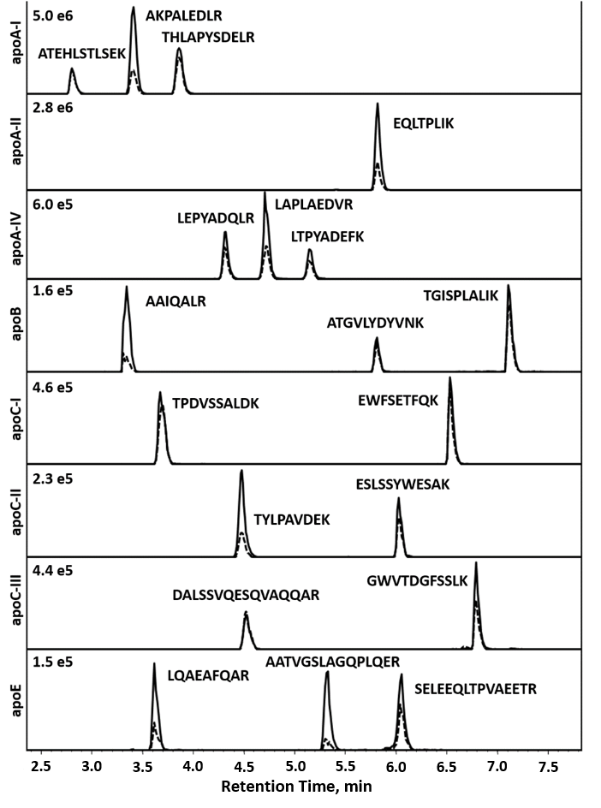
Figure S2. Representative MRM chromatograms of native quantification (solid) and confirmation (dashed) ions for native peptides in 1:100 diluted serum calibrator. Ordinate has been grouped by protein, and signal intensity shown represents peak maxima per grouping.
Figure S3. Peptide separation gradient (Acetonitrile w/ 0.1% formic acid)

LC-MS/MS data processing workflow. Although in this paper we report the analysis of only 8 apolipoproteins (34 native and labeled peptides, each with two MS/MS transitions total of 68), we actually acquired ~100 MRM transitions to monitor numerous other apolipoproteins for exploratory purposes. When the number of MRM transitions gets this high, entering the actual concentrations for all ~100 transitions into the Analyst batch file for each calibrator becomes very tedious. It is more simple to enter only the dilution factor for each calibrator level into the acquisition batch table (the dilution factor is a generic sample parameter and has to be entered only once for each injection). Furthermore, the integration of the ~100 LC-MS/MS peaks is not possible by the Analyst software, that is why we have to process the data file with Multiquant. At this point, it is easier to create calibration curves and calculate unknown concentration with all expected calibrator concentration set to 1 but different dilution factors at each calibrator level, in other words, work with “peptide response ratio vs. concentration ratio calibration curves”. This way the output for each LC-MS/MS peak is calculated concentration ratio (unitless). After peak integration, the Multiquant concentration ratios are exported into JMP, where we use a JMP script to convert each concentration ratio into the final reported concentration in nmol/L units. The actual calibrator pool concentrations for each protein is imbedded into the JMP script which multiply each calculated concentration ratio with the concentration of the calibrator serum pool (nmol/L in serum without dilution). The script also selects the quantitation ions and calculates the average of the peptide concentrations. This unconventional workflow becomes the only practical way to process >200 MRM/injection data sets for ~100-sample batches daily.
Off-line digestion IDMS method. This off-line digestion IDMS method was used for the apoA-I and apoB-100 measurements of individual and pooled serum samples. The method was validated in our laboratory [Parks et al., manuscript in preparation]. To 30 µL 100x diluted serum aliquots 5 µL of 0.6% RapiGest SF detergent was added, followed by addition of 5 µL of 1 µg/µL trypsin. Isotopically labeled peptide internal standards were added before the digestion. After a three hour incubation at 37 °C, 3 µL of 0.5M HCl was added followed by incubation for 1 hour to degrade the RapiGest detergent. Then, 10 μL of the samples were analyzed by UPLC-MS/MS, using an Aquity UPLC system (Waters Corporation, Milford, MA), a similar LC gradient and the same MS/MS instrument as used for the IMER-IDMS method. The apoA-I and apoB-100 concentration of the samples were calculated with native/IS peak area ratios vs. native/IS peptide concentration ratio calibration curves (linear regression with 1/x weighting). The apoA-I concentration in the serum pool was calculated (with the assumption of complete trypsin cleavage) based on AELQEGAR/AEL[Q-U7]EGAR and AHVDALR/AHVDA[L-U7]R ratio data. ApoB-100 concentration was measured using ATGVLYDYVNK/ATGVLYDY[V-U6]NK and LATALSLSNK/ LATALS[L-U6]NK ratio data.
The concentration of the native and labeled peptide standard materials were determined in-house by a validated method which incorporated isobaric-tagging (iTRAQ, AB Sciex) and isotope dilution mass spectrometry, using 15 NIST (U.S. National Institute of Standards and Technology) certified native amino acid calibrators and their isotope labeled analogs.²¹
ELISA assay. The calibration series was prepared from the lyophilized purified human Apo B standard provided by the vendor (Abcam, Cambridge, MA). All samples including the calibration curve was analyzed in duplicates. After allowing the capture and detector antibodies to bind the ApoB-100 in the samples, the antibody-ApoB-100 complex was immobilized on the anti-tag antibody coated wells. The wells were washed to be remove any unbound ApoB-100. 3,3',5,5'-tetramethylbenzidine (TMB) substrate is used to stain the antibody complex. The reaction was completed by adding Stop Solution. The reaction color changed from blue to yellow. The intensity was measured using a spectrophotometer at 450 nm. The concentration of Apo B is proportional to the color produced after the reaction is completed.
Figure S4: Examination of method bias in quality control materials and ApoB-100 harmonization standard (SP3-08). On-line and off-line measurements were performed in five analytical replicates on 3 days (N=15). ELISA assay was performed in triplicate on a single day.

Standard addition measurements. Commercially available protein solutions were purchased from Academy Biomedical and Novoprotein Scientific. The protein concentrations in the individual protein stock solutions were measured by amino acid analysis by Midwest Bio-Tech. (Fishers, IN, U.S.A.). The protein stock solutions were prepared in sodium bicarbonate buffered saline to final concentrations of 593 nmol/L apoA-II, 55 nmol/L apoA-IV, 150 nmol/L apoC-I, 80 nmol/L apoC-II, 450 nmol/L apoC-III and 90 nmol/L apoE3. A 7-point dilution series was prepared in triplicate from the stock solution mix with 1, 1.25, 1.67, 2.5, 5, 10 and 20 fold dilutions, including a solvent blank. To a protein low bind 96-well plate, 50 μL of each target protein spiked dilution was added, followed by a 50 μL aliquot of 1:100 diluted serum pool and 50 uL of 0.45% Zwittergent 3-12. The spiked sample series was analyzed by the same IMER-IDMS method described in the manuscript. Light/heavy area ratio vs. protein dilution ratio linear regression curves were calculated for each peptide transition, of which one peptide transition for each protein are shown (Figure S2). The concentration of the diluted serum pool was calculated by dividing the area ratio y-intercept with the regression slope, multiplied by the protein stock concentration and dilution factor (Table S2). For comparison, this standard addition experiment was also performed using an EDTA plasma pool and blank buffer solution (Figure S2).
Figure S5. Standard addition of purified protein materials to in-house serum pool (), in-house plasma pool () and digest buffer blank ().x-axes is 1/[dilution factor] of the pure recombinant protein standard.

Table S2. Apolipoprotein concentrations measured in the calibrator serum pool. ApoA-I and apoB-100 concentrations were measured by off-line batch digestion using peptide calibrators. All other proteins were measured by standard addition procedure using purified proteins. Means and %CVs were calculated from triplicate standard addition experiments (analytical replicates).

Protein  (MW) | Peptide 1 |  | Peptide 2 |  | Protein Avg.
Protein  (MW) | Mean Conc.  µM  (µg/mL) | CV | Mean Conc.  µM  (µg/mL) | CV | Mean Conc.  µM  (µg/mL) | CV
apoA-I  (28000) | 50ª  (1400.0) | 4.3 | 44.6 ^{b}  (1250) | 9.0 | 47.3  (1325.0) | 8.0
apoA-II  (9304) | 40.8  (379.4) | 7.0 | - | - | 40.8  (379.4) | 7.0
apoA-IV  (44440) | 0.9  (39.6) | 7.2 | 0.9  (41.5) | 5.9 | 0.9  (40.6) | 3.3
apoB  (515000) | 1.8 ^{c}  (913.1) | 5.0 | 1.5 ^{d}  (786.4) | 7.3 | 1.7  (849.8) | 10.5
apoC-I  (6631) | 8.9  (59.1) | 16.0 | 7.6  (50.4) | 8.5 | 8.3  (54.8) | 11.2
apoC-II  (8915) | 4.6  (40.8) | 4.3 | 4.4  (39.1) | 4.7 | 4.5  (40.0) | 3.0
apoC-III  (8765) | 4.9  (43.2) | 5.1 | 5.5  (48.5) | 6.5 | 5.2  (45.9) | 8.1
apoE  (35274) | 0.9  (30.8) | 13.0 | 1.2  (41.0) | 9.3 | 1.0  (35.8) | 20.1

Peptides used for the off-line batch digestion based analysis of the calibrator serum pool:
ª apoA-I Peptide 1 AELQEGAR; ^{b} apoA-I Peptide 2 AHVDALR; ^{c} apoB-100 Peptide 1 ATGVLYDYVNK;
^{d} apoB-100 Peptide 2 LATALSLSNK.

Cholesterol and triglyceride analysis. A direct LC-MS/MS method was developed for analysis of cholesterol and triglyceride in diluted human serum [Gardner et. al., in preparation]. The calibration standard mix was prepared in isopropanol. Total cholesterol was quantified as the sum of free cholesterol and cholesteryl esters, using free cholesterol and cholesteryl palmitate as calibrator, respectively. Total triglycerides was measured using triolein, tripalmitin, and trilinolein in a ratio of 3.0:1.8:1 by weight. Internal standard (IS) mix was prepared in ethanol, containing 0.033 mg/dL d7-cholesterol (for FC quantitation), 0.098 mg/dL cholesteryl-d7-palmitate (for CE quantitation), and 0.125 mg/dL d98-tripalmitin (for TG quantitation). 50µL aliquots were transferred from serum samples diluted 1:100 with phosphate buffered saline (PBS) into a 96-well plate. The protein-precipitation/extraction, by the addition of 0.2 mL IS/ethanol mix, was followed by evaporation and reconstitution in 100 µL nonane. The plate was covered with a heat-sealing foil mat for analysis by UHPLC-MS/MS. The analysis method used normal phase liquid chromatography separation and in-source collision-induced dissociation (CID), coupled with tandem mass spectrometry detection. The UHPLC system was a UHPLC-SA (Spark-Holland, Emmen, Netherlands). The mass spectrometer was a Sciex 4000 QTrap (AB Sciex, Framingham, MA). From each sample, 2µL was injected (full loop). The column was a Luna HILIC 3µm, 2x50mm (Phenomenex, Torrance, CA). Mobile phase A was hexanes with 0.1% isopropanol. Mobile phase B was 50:45:5 hexanes:ethanol:methanol. The mobile phase flow rate was 600 µL / min with gradient elution. The gradient started at 0% B, holding for 0.5 minute, then to 15% B over 0.5 minute, holding for 0.5 minute, returning to 0% B over 0.1 minute, holding 0% B for 1.9 minutes. The Heated Nebulizer (APCI) source is installed. The source conditions for all time periods in the method are: Curtain Gas = 10 psi, Nebulizer Current = 4µA, Temperature = 325°C, Gas 1 = 70 psi, CAD = “Medium”. MRM conditions are given in Table S3. The free cholesterol and cholesteryl esters eluted in two separate chromatographic peaks but in the same m/z MRM trace, while all the triglycerides eluted in one single peak in the same m/z MRM trace. The total cholesterol concentrations in mg/dL were calculated as a sum of the measured free cholesterol and the free-cholesterol-equivalent of all cholesteryl esters. Triglyceride concentrations were calculated in mg/dL triolein-equivalent concentration.

Table S3. MRM monitored analytes, precursor and fragment ion mass, and fragment ion ratios. Ion ratio %CVs were calculated from 4 highest standards in a typical run.
Compound | Precursor ion m/z | Fragment ion |  |  |  |  |  | C/Q  Ion ratio  %CV
Compound | Precursor ion m/z | m/z | Dwell Time (ms) | DP | CE | CXP | Quantitation (Q)  Confirmation (C) | C/Q  Ion ratio  %CV
Cholesteryl Ester and Free Cholesterol | 369 | 161 | 25 | 54 | 35 | 5.0 | Q | 2.12  2.04
Cholesteryl Ester and Free Cholesterol | 369 | 81 | 25 | 54 | 35 | 5.0 | C | 2.12  2.04
Cholesteryl-d7-palmitate and  d7-Free Cholesterol | 376 | 161 | 25 | 54 | 35 | 5.0 | Q | 1.57  1.51
Cholesteryl-d7-palmitate and  d7-Free Cholesterol | 376 | 81 | 25 | 54 | 35 | 5.0 | C | 1.57  1.51
[dummy transition]* | 94 | 66 | 5 | 262 | 20 | 10.7 | N/A | N/A
Triglycerides | 95 | 67 | 50 | 262 | 20 | 10.7 | Q | 0.49
Triglycerides | 95 | 55 | 50 | 262 | 26 | 8.8 | C | 0.49
D98-Tripalmitin | 98 | 50 | 50 | 262 | 25 | 15 | Q | 2.59
D98-Tripalmitin | 106 | 74 | 50 | 262 | 25 | 15 | C | 2.59
[dummy transition]* | 368 | 160 | 5 | 54 | 35 | 5 | N/A | N/A
*Dummy transitions were employed to reduce noise in the MRM signal. During method development, we found that combining the cholesteryl ester / free cholesterol MRM signal in the same method with the triglyceride MRM greatly increased the background noise in both transitions, when compared with quantifying these analytes in separate methods. Placing the additional transitions as indicated in the table (5ms dwell) prior to the quantititation transitions when switching from low to high DP, reduced the noise to normal levels. This is not normally necessary on a Sciex 4000, and we speculate that switching between a normal and unusually high DP value in an MRM table contributes to this problem. We have also observed that the problem can be alleviated by placing the low and high DP transitions in separate time periods, which also requires chromatographic separation of the analytes

Figure S6. Example of carryover contribution from duplicate injections of the highest calibration standard (50 µL of 1:15 diluted human sera) to two subsequent blank injections (50 µL of digest buffer). The intensities are plotted for two peptides, THLAPYSDELR (apoA-I; left axis) and TGISPLALIK (apoB; right axis). Over the range of the calibration series, protein amount in the injection solution varies between these two analytes from 150 fmol down to 5 fmol on column respectively. Total protein injected ranged from 2.5-250 µg on column (assuming 80 g/L total protein).

Figure S7. Demonstration of calibration curve linearity for each quantification peptide transition, 1/X weighting applied.
Figure S8. Bland Altman analysis of peptide comparison data.

