Supplemental Figures

Figure S1: Test results for participants in analysis who were enrolled as a close contact to a person with pulmonary TB and had a follow-up test result.
Each row represents a participant, and each circle represents a test, colored by result. Only participants who were enrolled as close contacts with a follow-up test are shown. Repeat means the test was performed twice on two different blood samples taken 2–3 days apart. Split means the test was performed twice on the same sample taken at the same time. QFT, QuantiFERON Gold In-Tube; TSPOT, T-SPOT.TB

Figure S2. Comparison of the QuantiFERON Gold In-Tube (QFT) repeat quantitative test results for discordant participants.
QFT was performed twice on two different blood samples taken 2–3 days apart. Each line connecting the first and second test represents a single participant. The left plot shows the results for participants who converted (first test negative, second test positive) while the right plot shows the participants who reverted (first test positive, second test negative). The gray box represents the negative test result region (<0.35 IU/mL).

Figure S3. Comparison of the T-SPOT.TB (TSPOT) repeat quantitative test results for discordant participants.
TSPOT was performed twice on two different blood samples taken 2–3 days apart. Each line connecting the first and second test represents a single participant. The left plot shows the results for participants with quantitative results who converted (first test negative, second test positive) while the right plot shows the participants with quantitative results who reverted (first test positive, second test negative) when treating the U.S. borderline results as negative. Light gray indicates the borderline region, while dark gray indicates negative test result region.

Figure S4. Comparison of the first T-SPOT.TB (TSPOT) split quantitative test results for discordant participants.
TSPOT was performed twice on the same sample taken at the same time. Each line connecting the first and second test represents a single participant. The left plot shows the results for participants who converted (first test negative, second test positive) while the right plot shows the participants who reverted (first test positive, second test negative) when treating the U.S. borderline results as negative. Light gray indicates the borderline region, while dark gray indicates negative test result region.

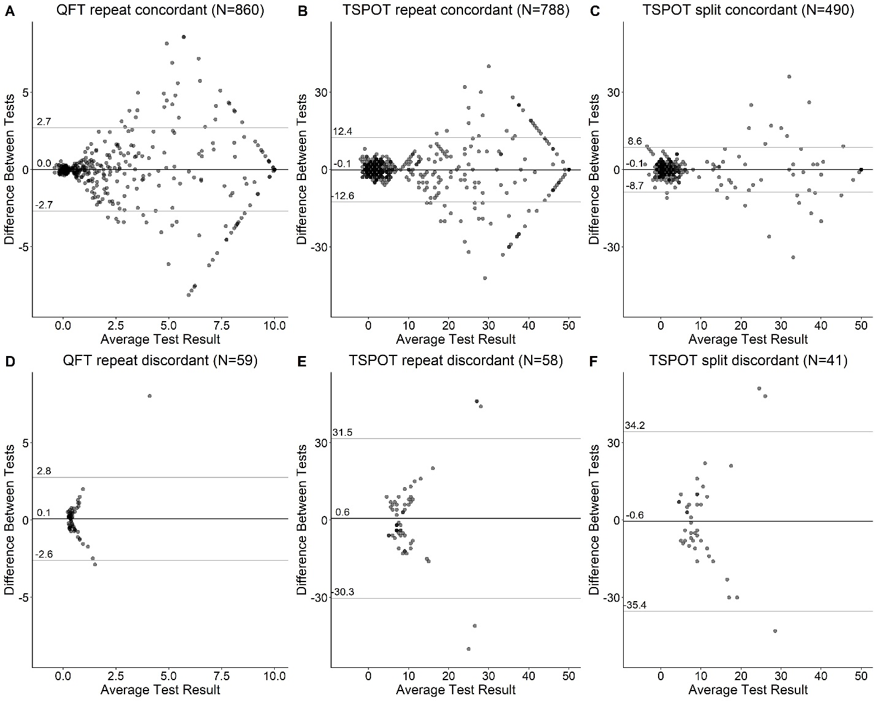

Figure S5. Bland-Altman plots for quantitative test results.
Bland-Altman analysis for the two tests from (A,D) QuantiFERON Gold In-Tube (QFT) repeat, (B,E) T-SPOT.TB (TSPOT) repeat, and (C,F) TSPOT split. Repeat means the test was performed twice on two different blood samples taken 2–3 days apart. Split means the test was performed twice on the same sample taken at the same time. (A-C) Contain all patients with a quantitative result where the dichotomous result was concordant (both tests positive or both tests negative). (D-F) Contain all patients with a quantitative result where the dichotomous result was discordant (one test positive and one test negative). The horizontal axis is the average of the two test results while the vertical axis is the first test minus the second test. The horizontal black line indicates the mean difference while the horizontal gray lines represent the lower and upper limits of agreement, calculated as the mean difference ± 1.96 × standard deviation. The numbers above each of these three lines indicates their values. For QFT, all TB antigen minus nil values >10 IU/mL were set to 10 IU/mL. For TSPOT, all spot counts with a value >50 were set to 50.

Figure S6. Percentage of participants with discordant results as the cutoff is varied.
Tests with a value greater than the cutoff (horizontal axis) are considered positive. Repeat means the test was performed twice on two different blood samples taken 2–3 days apart. Split means the test was performed twice on the same sample taken at the same time. (A) Percentage of discordant results (one test is negative and the other positive) in QuantiFERON Gold In-Tube (QFT) repeat study when the TB antigen minus nil cutoff between positive and negative is varied. Current test cutoff is 0.35 IU/mL (vertical gray line). Note that the horizontal axis is on the log scale to better see the region around the cutoff (as opposed to the other panels, which are on a linear scale). (B-C) Percentage of discordant results in T-SPOT.TB (TSPOT) repeat study (B) or TSPOT split study (C) when the maximum number of spots for the cutoff between positive and negative is varied. Using the U.S. Food and Drug Administration (FDA)-approved cutoff for positive(1), tests with 4 or fewer spots are interpreted as negative, 5–7 spots as borderline, and 8 or more spots as positive. The vertical gray line indicates 8 spots.

Figure S7. Distribution of the differences between T-SPOT.TB (TSPOT) panel results.
Boxplot of the second test result minus the first test result for (A) TSPOT repeat and (B) TSPOT split. Repeat means the test was performed twice on two different blood samples taken 2–3 days apart. Split means the test was performed twice on the same sample taken at the same time. Maximum indicates maximum value of panel A minus nil and panel B minus nil, which is used clinically to determine whether the test was positive or negative. Panel A indicates the test panel A minus nil value. Panel B indicates the panel B minus nil value.

Supplemental Tables
 |  | TSPOT repeat |  |  |  | TSPOT split
 |  | second test result |  |  |  | second test result
 |  | − | B | + |  | − | B | +
first test result | − | 519 | 25 | 10 |  | 366 | 17 | 11
 | B | 20 | 14 | 21 |  | 10 | 6 | 11
 | + | 14 | 15 | 247 |  | 12 | 7 | 91

Table S1. Comparison of interpreted TSPOT.TB (TSPOT) repeat and split results with borderline (B; 5–7 spots) separated.
Repeat means the test was performed twice on two different blood samples taken 2–3 days apart. Split means the test was performed twice on the same sample taken at the same time.
 |  | TSPOT repeat |  |  | TSPOT split
 |  | second test result |  |  | second test result
 |  | − | + |  | − | +
first test result | − | 542 | 36 |  | 379 | 25
 | + | 26 | 281 |  | 21 | 106

Table S2. Comparison of interpreted TSPOT.TB (TSPOT) repeat and split results using the international cutoff (six or more spots is positive).
Repeat means the test was performed twice on two different blood samples taken 2–3 days apart. Split means the test was performed twice on the same sample taken at the same time.

References
1. Oxford Immunotec. T-SPOT.TB Package Insert US version 8 [cited 2020 Nov 16]. Available from: https://www.tspot.com/wp-content/uploads/2020/09/TB-PI-US-0001-V8.pdf.

