Supplementary Material
High Resolution Mass Spectrometry Newborn Screening Applications for Quantitative Analysis of Amino Acids and Acylcarnitines from Dried Blood Spots
C. Austin Pickens, Konstantinos Petritis
Biochemical Mass Spectrometry Laboratory, Newborn Screening and Molecular Biology Branch, Centers for Disease Control and Prevention, MS F19, Atlanta, GA 30341, USA.

Corresponding Author: Konstantinos Petritis. 4470 Buford Highway, Atlanta, GA, 30341. Phone: (404)498-5248. Email: kpetritis@cdc.gov

Chemicals, internal standards, and consumables
Optima® LC/MS Acetonitrile (Fisher Scientific, Pittsburgh, PA, USA), Optima® LC/MS Water (Fisher Chemical), Optima® LC/MS Methanol (Fisher Chemical) solvents were used for the extraction and resuspension of all samples analyzed in the study. LC/MS grade formic acid [Lot# SF2369172] (Thermo Scientific GmbH, Bremen, Germany) was used in extraction and resuspension solutions. The working IS solution was prepared using the NSK-A [Lot# PR-28967], NSK B-1 [Lot# PR-30305], and NSK-B-G1-1 [Lot# 28413] (Cambridge Isotope Laboratories Inc., Andover, MA, USA), and methyl d-3 creatine, [Product# DLM-1302, Lot# PR-25929A] (Cambridge Isotope Laboratories Inc.). All samples were extracted, processed, and resuspended in Corning 3365 96 well round bottom polypropylene plates (VMR International Corp, Suwanee, GA, USA). The TriVersa NanoMate n-ESI spray chips used in this study were HD_A_384 and chip IDs were AHM521CN, AIE133CF, and AIH030DF (Advion, Ithaca, NY, USA).
Glutarylcarnitine-d3 (C5DC-d3) internal standard interference at low mass resolving power
It was observed during preliminary analyses (data not shown), in only SIM acquired data, that analytes utilizing glutarylcarnitine-²H₃ (C5DC-d3, theoretical m/z 279.1636) had an inverse relationship between concentration and mass resolving power. Upon further investigation, it was determined these quantitative differences across resolving powers were due to varying C5DC-d3 peak area. In fact, the mass error of C5DC-d3 m/z at lower mass resolving powers exceeded 10 ppm mass error.
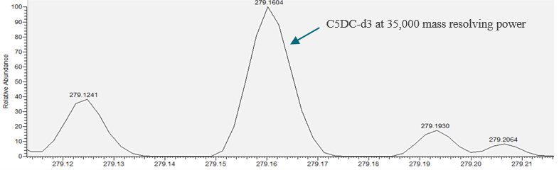
Fig. A.1 SIM MS acquisition of C5DC-d3 at 35,000 mass resolving power. The spectrum was acquired from an extracted QC sample with internal standards. C5DC-d3 mass error >10 ppm.
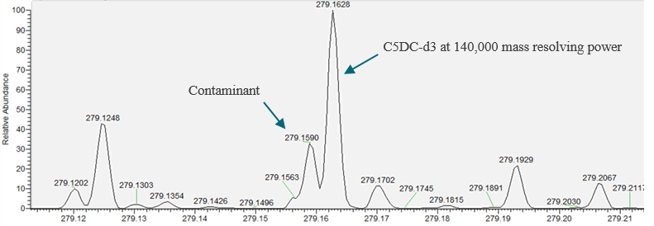
Fig. A.2 Observed m/z of C5DC-d3 at 140,000 mass resolving power. The spectrum was acquired from an extracted QC sample with internal standards, C5DC-d3 mass error < 3 ppm.

It was determined that a contaminant leaching from plastic components, most notably from plastics in the LC system, was an isobaric m/z at mass resolving powers < 70,000. The contaminant was extracted from plastic-based LC tubing by pumping a mixture of organic solvents through the system, collecting, and evaporating to obtain a concentrated crude mixture. The crude mixture was then resuspended in mobile phase and infused into the QE+ using the HESI-II source. Overall the contaminant had an observed accurate m/z ranging from 279.1590 to 279.1599 across biological samples and the crude mixture.
Fig. A.3 SIM mass spectra acquired from contaminants in crude mixture of LC component extracts. The spectrum was acquired through infusion in SIM mode using 140,000 mass resolving power at m/z 279.1 with a 0.4 m/z window

The crude mixture of contaminants from LC tubing was selected for HCD fragmentation at 279.1 with a 0.4 m/z window. The product ion pattern of these contaminants did not have the characteristic m/z 85.03 of acylcarnitines, which accounts for normal quantitation of analytes using C5DC-d3 IS acquired by PRM and on triple quadrupole MS/MS platforms.
Fig. A.4 PRM mass spectra acquired from contaminants in crude mixture of LC component extracts. PRM spectrum acquired at 15 CE of crude mixture. The m/z 149.02 is characteristic fragment of alkyl phthalate esters.

After the PRM spectra of crude extracts was obtained, we examined data acquired from DBS samples in preliminary analyses and confirmed fragments from the crude extract were present under normal analysis conditions. The fragmentation pattern of the crude extract was clearly visible in the PRM spectra of a DBS extracted with IS.
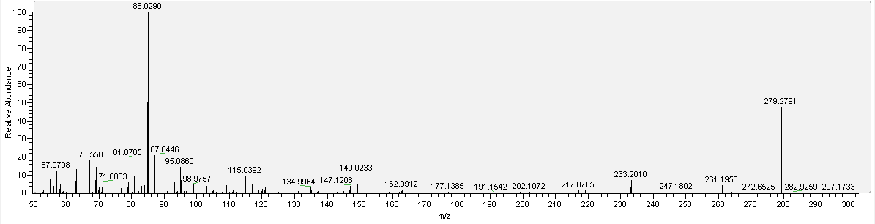
Fig A.5 PRM mass spectra from DBS extracts containing C5DC-d3.The PRM of m/z 279.1 with a 0.4 m/z window was acquired at 25 CE. The m/z 85.029 is the indicative fragment of an acylcarnitine, in this instance corresponding to C5DC-d3. The fragments m/z 81.071, 95.086, and 149.023 corresponded with the PRM spectra of crude LC components extract mixtures of contaminants isolated from LC plastic-based tubing observed in Fig. A.4.

The m/z 149.02 is characteristic of ≥ 2 carbon alkyl phthalate esters and after searching our observed accurate m/z of the contaminant 279.1590 in the Mass Spectrometry Contaminants Database (MaConDa, maconda.bham.ac.uk) the only candidate ID was dibutyl phthalate (theoretical m/z 279.1591). Furthermore, quantitation of analytes using C5DC-d3 in SIM mode improved after switching to a direct infusion nanospray system which eliminates LC system components from sample delivery. However, while greatly reduced, there was still a small varying portion of the m/z 279.1590 in samples. This was likely leaching from plastic pipette tips, plates, and other components in the sample prep or analysis workflow. We notified the IS manufacturer of this issue, and a permanent solution would be synthesis of an isotopologue with a different amount of ²H, ¹³C, or ¹⁵N. Since the contaminant does not have an m/z 85.03 product ion, it does not impact data acquired by fragmentation. The Association of Public Health Laboratories has compiled a comprehensive list of known analyte interferences in newborn screening and we expect to nominate this interference. The list can be found at: https://www.aphl.org/programs/newborn_screening/Pages/NBS%20Interference%20List.aspx

Metabolite (Analyte Short Name) | Enrichment | Mean Value | 95% LCL | 95% HCL
Arginine (ARG) | 200.0 | 173.4 | 143.1 | 203.6
Citrulline (CIT) | 100.0 | 102.0 | 82.0 | 122.0
Leucine (LEU) | 300.0 | 360.3 | 323.2 | 397.4
Methionine (MET) | 150.0 | 125.9 | 110.9 | 140.9
Ornithine (ORN) | 200.0 | 257.2 | 206.1 | 308.3
Phenylalanine (PHE) | 300.0 | 305.9 | 273.1 | 338.7
Creatine (CRE) | 300.0 | 421.4 | 358.7 | 484.2
Succinylacetone (SUAC) | 10.0 | 4.0 | 3.1 | 4.9
Tyrosine (TYR) | 600.0 | 525.3 | 465.7 | 584.8
Valine (VAL) | 300.0 | 329.9 | 298.7 | 361.1
Free Carnitine (C0) | 20.0 | 41.0 | 36.6 | 45.4
Acetylcarnitine (C2) | 20.0 | 36.1 | 32.7 | 39.4
Propionylcarnitine (C3) | 8.0 | 9.8 | 8.8 | 10.8
Malonylcarnitine (C3DC) † | 1.5 | 1.2 | 1.0 | 1.4
Hydroxybutyrylcarnitine (C4OH) † | 1.0 | 0.8 | 0.7 | 0.9
C3DC+C4OH | 2.5 | 0.7 | 0.6 | 0.7
Butyrylcarnitine (C4) | 3.0 | 2.7 | 2.4 | 3.0
Isovalerylcarnitine (C5) | 1.5 | 1.5 | 1.4 | 1.7
Tiglylcarnitine (C5:1) | 1.5 | 1.1 | 0.9 | 1.2
Glutarylcarnitine (C5DC) | 1.0 | 1.1 | 0.9 | 1.3
Hydroxyisovalerylcarnitine (C5OH) | 2.0 | 2.1 | 1.9 | 2.3
Hexanoylcarnitine (C6) | 1.0 | 0.8 | 0.8 | 0.9
Octanoylcarnitine (C8) | 1.0 | 1.1 | 0.9 | 1.2
Decanoylcarnitine (C10) | 1.0 | 1.3 | 1.1 | 1.5
Dodecanoylcarnitine (C12) | 2.0 | 1.8 | 1.6 | 2.0
Myristoylcarnitine (C14) | 1.5 | 1.6 | 1.4 | 1.8
Tetradecenoylcarnitine (C14:1) | 1.5 | 1.4 | 1.2 | 1.5
Palmitoylcarnitine (C16) | 8.0 | 7.2 | 6.2 | 8.3
Hydroxypalmitoylcarnitine (C16OH) | 1.0 | 1.0 | 0.9 | 1.2
Stearoylcarnitine (C18) | 3.0 | 3.0 | 2.6 | 3.5
Hydroxystearoylcarnitine (C18OH) | 1.0 | 0.6 | 0.5 | 0.6

Table A.1 QC pool C1815 data presented were disseminated from 2019 Set 2 MSMS1 Non-derivatized and Derivatized NSQAP Quality Control Specimen Certification Data reports. All data presented are non-derivatized, except those denoted with † to indicate derivatized data is presented for the analytes C3DC and C4OH. Units are presented as µmol/L blood.

Metabolite (Analyte Short Name) | Parent > Product ion (m/z) | Internal Standard | HCD CE
Valine (VAL) | 118.0868 > 72.08 | VAL-d8 | 10
Valine-²H₈ (VAL-d8) | 126.1370 > 80.13 |  | 10
4-Hydroxyproline (4HPRO) | 132.0661 > 86.06 |  | 10
Creatine (CRE) | 132.0773 > 90.06 | CRE-d3 | 10
Leucine (LEU) | 132.1025 > 86.10 | LEU-d3 | 10
Ornithine (ORN) | 133.0977 > 70.07 | ORN-d2 | 10
Creatine-²H₃ (CRE-d3) | 135.0961 > 93.07 |  | 10
Ornithine-²H₂ (ORN-d2) | 135.1103 > 72.08 |  | 10
Leucine-²H₃ (LEU-d3) | 135.1213 > 89.12 |  | 10
Methionine (MET) | 150.0589 > 104.05 | MET-d3 | 14
Methionine-²H₃ (MET-d3) | 153.0777 > 107.07 |  | 14
Succinylacetone-hydrazone (SUAC) | 155.0821 > 137.07 | SUAC-13C5 | 12
SUAC-¹³C₅-hydrazone (SUAC-13C5) | 160.0988 > 142.08 |  | 12
Free Carnitine (C0) | 162.1130 > 85.03 | C0-d9 | 25
Free Carnitine-²H₃ (C0-d3) | 165.1319 > 85.03 | C0-d9 | 25
Phenylalanine (PHE) | 166.0868 > 120.08 | PHE-13C6 | 11
Free Carnitine-²H₉ (C0-d9) | 171.1695 > 85.03 |  | 25
Phenylalanine-¹³C₆ (PHE-13C6) | 172.1069 > 126.10 |  | 11
Arginine (ARG) | 175.1195 > 70.07 | ARG-13C-d4 | 18
Citrulline (CIT) | 176.1035 > 113.07 | CIT-d2 | 10
Citrulline-²H₂ (CIT-d2) | 178.1161 > 115.08 |  | 10
Arginine-¹³C₁²H₄ (ARG-13C-d4) | 180.1480 > 75.09 |  | 18
Tyrosine (TYR) | 182.0817 > 136.08 | TYR-13C6 | 12
Tyrosine-¹³C₆ (TYR-13C6) | 188.1019 > 142.10 |  | 12
Acetylcarnitine (C2) | 204.1236 > 85.03 | C2-d3 | 17
Acetylcarnitine-²H₃ (C2-d3) | 207.1424 > 85.03 |  | 17
Propionylcarnitine (C3) | 218.1392 > 85.03 | C3-d3 | 25
Propionylcarnitine-²H₃ (C3-d3) | 221.1581 > 85.03 |  | 25
Butyrylcarnitine (C4) | 232.1549 > 85.03 | C4-d3 | 23
Butyrylcarnitine-²H₃ (C4-d3) | 235.1737 > 85.03 |  | 23
Tiglylcarnitine (C5:1) | 244.1549 > 85.03 | C5-d9 | 20
Isovalerylcarnitine (C5:0) | 246.1705 > 85.03 | C5-d9 | 20
Malonylcarnitine (C3DC) | 248.1134 | C5DC-d3
Hydroxybutyrylcarnitine (C4OH) | 248.1498 | C5OH-d3
C3DC+C4OH | 248.1 > 85.03 | C4-d3 | 23
Isovalerylcarnitine-²H₉ (C5-d9) | 255.2270 > 85.03 |  | 20
Hexanoylcarnitine (C6) | 260.1862 > 85.03 | C5-d9 | 20
Succinylcarnitine (C4DC) | 262.1291 | C5DC-d3
Hydroxyisovalerylcarnitine (C5OH) | 262.1655 | C5OH-d3
C4DC+C5OH | 262.1 > 85.03 | C5OH-d3 | 23
Hydroxyisovalerylcarnitine-²H₃ (C5OH-d3) | 265.1843 > 85.03 |  | 23
Glutarylcarnitine (C5DC) | 276.1447 | C5DC-d3
Hydroxyhexanoylcarnitine (C6OH) | 276.1811 | C5OH-d3
C5DC+C6OH | 276.1 > 85.03 | C5DC-d3 | 22
Glutarylcarnitine-²H₃ (C5DC-d3) | 279.1636 > 85.03 |  | 22
Octanoylcarnitine (C8) | 288.2175 > 85.03 | C8-d3 | 21
Methylglutarylcarnitine (C6DC) | 290.1604 > 85.03 | C5DC-d3
Octanoylcarnitine-²H₃ (C8-d3) | 291.2363 > 85.03 |  | 21
Hydroxyoctanoylcarnitine (C8OH) | 304.2124 > 85.03 | C5OH-d3 | 23
Decadienoylcarnitine (C10:2) | 312.2175 > 85.03 | C8-d3 | 21
Decenoylcarnitine (C10:1) | 314.2331 > 85.03 | C8-d3 | 21
Decanoylcarnitine (C10:0) | 316.2488 > 85.03 | C8-d3 | 21
Dodecenoylcarnitine (C12:1) | 342.2644 > 85.03 | C12-d9 | 25
Dodecanoylcarnitine (C12:0) | 344.2801 > 85.03 | C12-d9 | 25
Dodecanoylcarnitine-²H₉ (C12-d9) | 353.3366 > 85.03 |  | 25
Tetradecenoylcarnitine (C14:1) | 370.2957 > 85.03 | C14:0-d9 | 27
Tetradecanoylcarnitine (C14:0) | 372.3114 > 85.03 | C14:0-d9 | 27
Tetradecanoylcarnitine-²H₉ (C14:0-d9) | 381.3679 > 85.03 |  | 27
Palmitoylcarnitine (C16) | 400.3427 > 85.03 | C16-d3 | 28
Palmitoylcarnitine-²H₃ (C16-d3) | 403.3615 > 85.03 |  | 28
Hydroxyhexadecanoylcarnitine (C16OH) | 416.3376 > 85.03 | C16OH-d3 | 30
Hydroxyhexadecanoylcarnitine-²H₃ (C16OH-d3) | 419.3564 > 85.03 |  | 30
Oleoylcarnitine (C18:1) | 426.3583 > 85.03 | C18:0-d3 | 30
Stearoylcarnitine (C18:0) | 428.3740 > 85.03 | C18:0-d3 | 30
Stearoylcarnitine-²H₃ (C18:0-d3) | 431.3928 > 85.03 |  | 30
Hydroxystearoylcarnitine (C18OH) | 444.3689 > 85.03 | C18:0-d3 | 30

Table A.2 Complete list of amino acid and acylcarnitines name, analyte short names, accurate parent m/z and product ion m/z, internal standard used for quantitation, and corresponding high collision dissociation (HCD) collision energies (CE) employed. These metabolites were multiplexed into the SIM/parallel reaction monitoring (PRM) hybrid method analyzed on the Q-Exactive Plus (QE+) for quantitation or as proof-of-concept for analytes not enriched in our quality control samples. All nominal isobars with identical fragmentation patterns (i.e., C3DC and C4OH, C4DC and C5OH, and C5DC and C6OH) were analyzed by SIM, and combined (i.e., C3DC+C4OH, C4DC+C5OH, and C5DC+C6OH) with transition, internal standard, and CE specified. Since the quality control samples are not enriched for C6OH and C4DC, the results presented for C5DC and C5OH analyzed by PRM represent only their enriched concentrations, respectively. 4HPRO also is not enriched in our QC materials and was added to the hybrid method as proof-of-concept to distinguish from LEU in a single transition at CE 10.

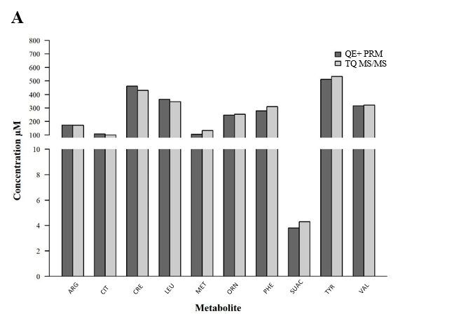
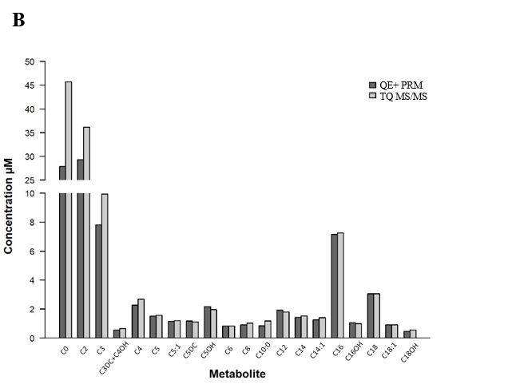
Fig A.6 Comparison of non-derivatized amino acids (A) and acylcarnitines (B) from DBS extracts analyzed by QE+ in PRM to triple quadrupole platform (TQ-MS/MS). Metabolite full names, IS, and CE used in PRM correspond with data presented in Supplementary Table A.1.
Correction factor for C3DC comparing derivatized to non-derivatized data
C3DC can only be distinguished from C4OH under FIA condition on TQ-MS/MS by derivatization. Upon analysis of C3DC by HRMS SIM acquisition, it was observed the quantified concentration of non-derivatized C3DC was roughly 70% the concentration of derivatized C3DC quantified by TQ MS/MS. After investigation, it was determined that this was related to ionization differences between non-derivatized and derivatized C3DC and the IS, since C3DC utilizes C5DC-d3 as a surrogate IS. The correction factor was created by analyzing 5 replicates of 5 DBS pools linearly enriched with C3DC by non-derivatized and derivatized sample analysis. This data was used to construct a linear regression to generate an equation to adjust non-derivatized C3DC quantitation to derivatized C3DC quantitation on the QE+, for comparison of derivatized C3DC data acquired on TQ-MS/MS. Since ionization of compounds and CE can vary between sources, the correction factors will likely differ between instrument vendor and source.

Differences in C0 quantitation comparing SIM and PRM acquired data
C0 quantitation was observed to differ when comparing data acquired by SIM and PRM. To investigate this discrepancy, equimolar C0, C0-d3, and C0-d9 were mixed and analyzed on the QE+ in both full scan and PRM. While C0-d9 is used for C0 quantification, C0-d3 is used to monitor hydrolysis of acylcarnitines, since most acylcarnitine internal standards contain C0-d3. The area of C0/C0-d9 parent m/z and product m/z were compared between the two modes. On average, comparing the area ratio of product m/z for C0/C0-d9 was 24% ± 6% (n=6, acquired by PRM) lower compared to the area ratio of parent m/z for C0/C0-d9 (n=6, acquired by full scan). Next, both C0, C0-d3, and C0-d9 optimal CE were assessed by infusion into a Sciex 4500 using the collision ramping feature.
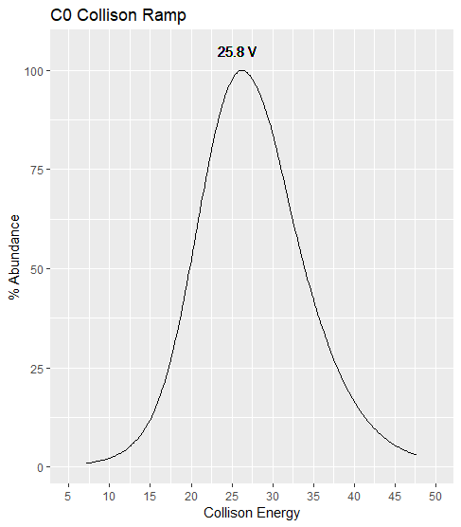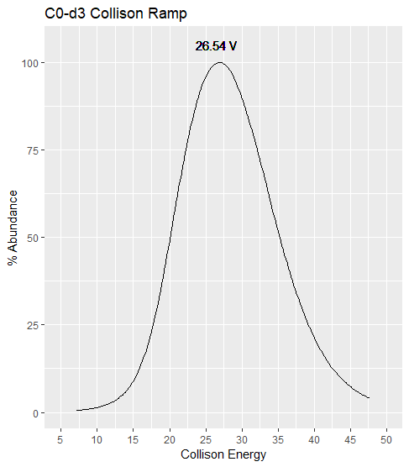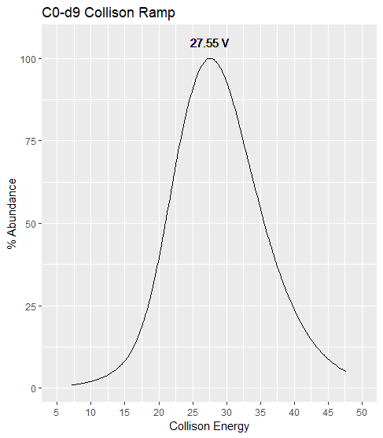
Fig A.7 Comparison of CE ramping of C0, C0-d3, and C0-d9 on Sciex 4500.

As mentioned in Section 2.3 CE were optimized on the QE+ based on the IS used in the study (i.e., C0-d9). The differences in CE between C0 and C0-d9 account for the lower concentrations produced in PRM, since the optimal CE for C0-d9 reduces the intensity of the C0 product ion, which may be related to fragmentation kinetic differences related to the kinetic isotope effect.
Differences in TYR quantitation comparing SIM and PRM acquired data
TYR quantitation was observed to differ when comparing data acquired by SIM and PRM. To investigate this discrepancy, equimolar TYR and TYR-13C6 were mixed and analyzed on the QE+ in both full scan and PRM. The area of TYR/TYR-13C6 parent m/z and product m/z were compared between the two modes. On average, comparing the area ratio of product m/z for TYR/TYR-13C6 was 26% ± 3% (n=6, acquired by PRM) lower compared to the area ratio of parent m/z for TYR / TYR-13C6 (n=6, acquired by full scan). Next, both TYR and TYR-13C6 optimal CE were assessed by infusion into a Sciex 4500 using the collision ramping feature.
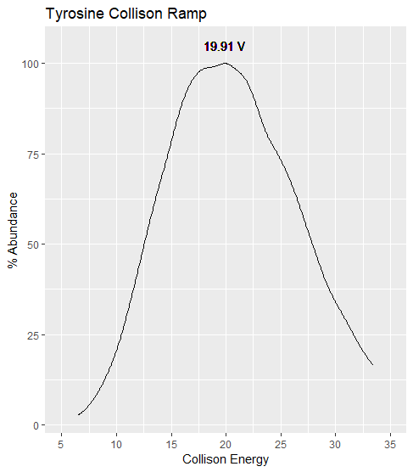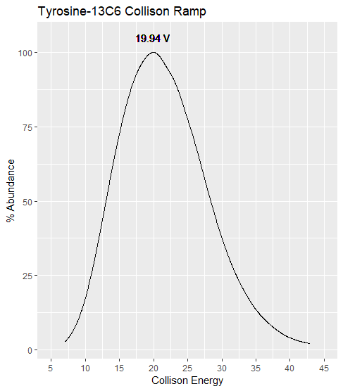
Fig A.8 Comparison of CE ramping of TYR and TYR-13C6 on Sciex 4500.

Although the optimal CE appear similar on a Sciex 4500, a lower quantitative value of TYR is produced on the QE+. This could be related to the higher collision dissociation used by the QE+, slight differences in CE between TYR and TYR-13C6, or fragmentation kinetic differences related to the kinetic isotope effect.
Differences in VAL quantitation comparing SIM and PRM acquired data
VAL quantitation was observed to differ when comparing data acquired by SIM and PRM. It was suspected that since VAL utilizes VAL-d8 IS for quantitation, the 8 deuterium atoms on the IS yielded a slightly higher CE compared to unlabeled VAL. To investigate this discrepancy, equimolar VAL and VAL-d8 were mixed and analyzed on the QE+ in both full scan and PRM. The area of VAL/VAL-d8 parent m/z and product m/z were compared between the two modes. On average, comparing the area ratio of product m/z for VAL/VAL-d8 was 16% ± 3% (n=6, acquired by PRM) higher compared to the area ratio of parent m/z for VAL/VAL-d8 (n=6, acquired by full scan). This indicated that unlabeled VAL likely had a lower CE compared to VAL-d8. Next, both VAL and VAL-d8 optimal CE were assessed by infusion into a Sciex 4500 using the collision ramping feature.
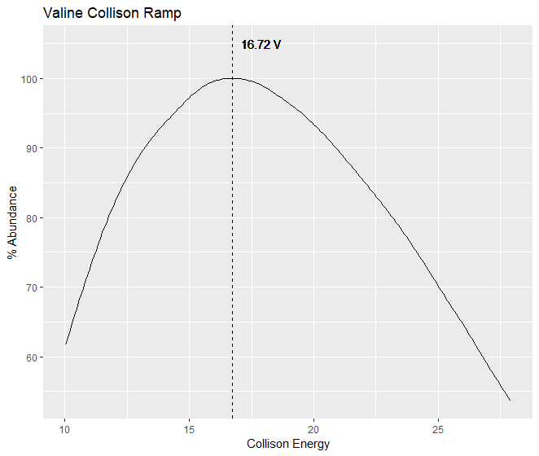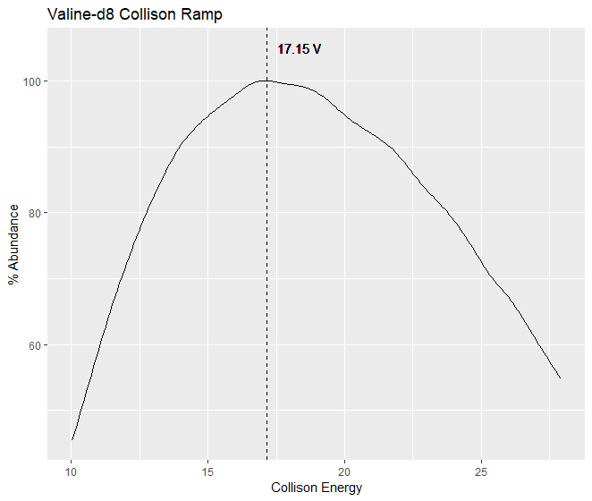
Fig. A.9 Comparison of CE ramping of VAL and VAL-d8 on Sciex 4500.

As mentioned in Section 2.3 CE were optimized on the QE+ based on the IS used in the study. It is likely that the differences in CE between VAL and VAL-d8 account for the higher concentrations produced in PRM, especially since the PRM data was similar to data acquired on the TQ MS/MS platform.
Quantitative issues associated with leucine and creatine acquired by SIM
Leucine (m/z 132.1025) and creatine (m/z 132.0773) data were highly variable in SIM acquired data. Upon further examination it was determined that the issue was localized to the 132.1 ion trace, and the corresponding d3 labeled internal standards at the 135.1 ion trace were unaffected. Investigation of the raw ion traces indicated that in a majority of samples, the signal intermittently dropped throughout the 8 minute analysis across all mass resolving powers in SIM. Samples that experienced these signal drops had less peak area, thus, appeared to have lower concentrations of leucine and creatine in the sample, since the issue did not impact the internal standards.
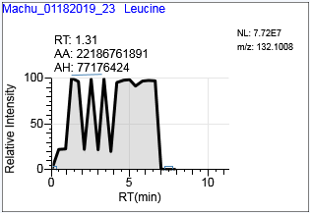
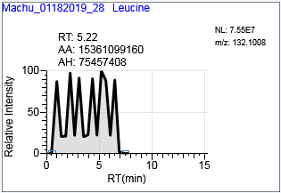
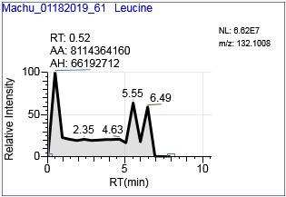
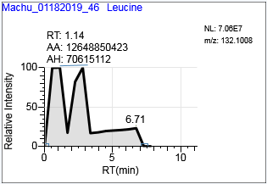

Fig. A.10 Leucine ion trace at mass resolving powers of 17000, 35000, 70000, and 140000

Interestingly, when signal drops occurred the m/z of leucine would shift while creatine m/z would stay relatively consistent. Also when the signal drops occurred the Ion Injection Time would increase from roughly 30-50ms to the Maximum IT of 500ms.
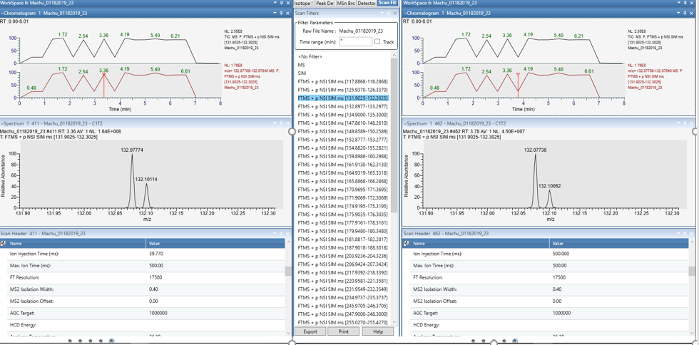
Fig. A.11 Comparison of mass spectra and ion injection times during normal signal (left) and a signal drop (right) in the same sample acquired by SIM.

After verifying that the issue was not related to spray instability associated with the Triversa Nanomate source (data not shown), samples were butyl ester derivatized to rule any contaminants that could be suppressing ionization at the 132.1 ion trace. The ion trace m/z 188.1 for leucine and creatine derivatized data experienced the same issue with signal drops, and similar to the non-derivatized method the derivatized d3 internal standards (m/z 191.1 trace) were unaffected (data not shown).
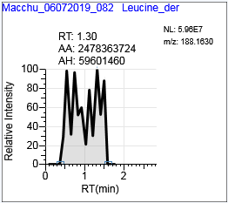
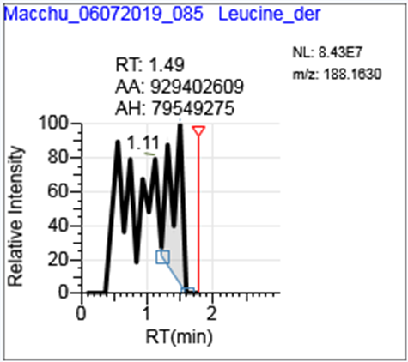
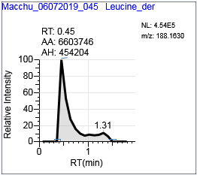
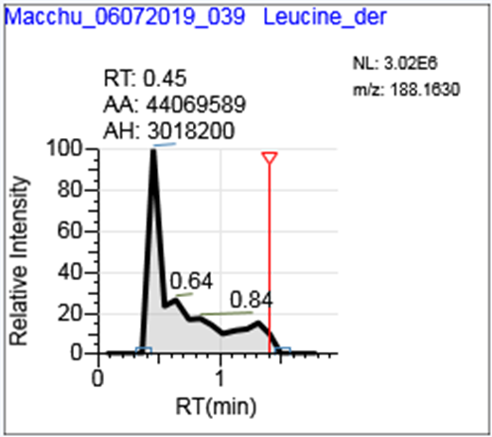

Fig. A.12 Chromatograms of several samples containing butyl ester derivatized leucine (m/z 188.1) acquired at mass resolving power 140,000

Furthermore, to rule out any matrix effects associated with our issue we confirmed it occurs in solutions containing only unlabeled leucine and creatine standards (data not shown). The next logical step was to investigate if this issue was due to creatine and leucine presence in the C-Trap together or some electronics issue associated with 132.1 m/z window. This was possible in non-derivatized samples, since the inclusion list m/z of leucine and creatine could be altered (e.g., mass offset) so they would not enter the C-trap at the same time. The results of the offset mass analysis were normal, indicating that indeed the issue associated with signal drops observed at the 132.1 ion trace were related to leucine and creatine presence in the C-trap together as parent m/z. As mentioned, we experienced no issues in PRM.
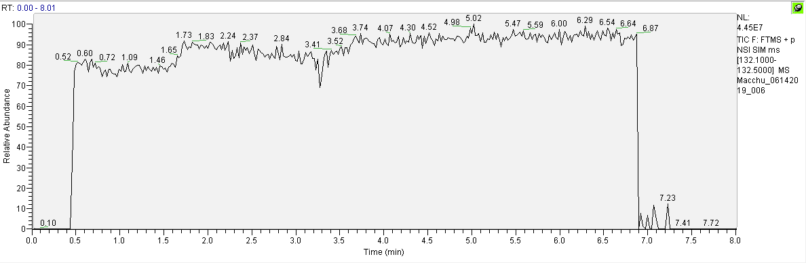
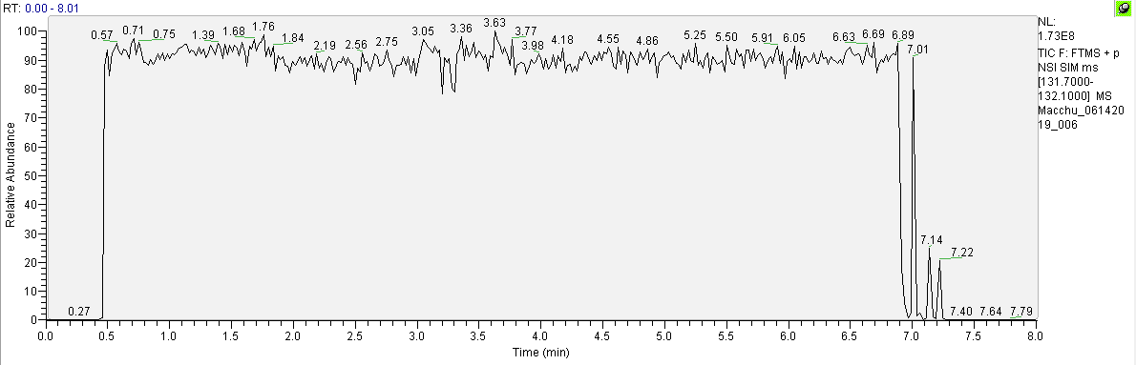
Fig A.13 Results from analyzing leucine (top) and creatine (bottom) in separate ion traces, which was achieved by altering the inclusion list m/z for each metabolite to offset each into individual ion traces. Samples were DBS extracts and analysis was conducted at 140,000 mass resolving power.

After the instrument received a preventative maintenance, where normal function was verified, and the problem continued to persist, we contacted Thermo Exactive Support for assistance resolving this issue. In brief, the issue appears related several factors including the high concentration of leucine and creatine in the samples, these two metabolites similarity in m/z, combined with our high AGC setting of 1e6 and Maximum IT of 500 ms which were optimized for low abundance poor-ionizing acylcarnitines. The high sample concentrations, metabolite m/z similarity, and MS settings may have impacted online correction of the eFT, possibly overfilling of the C-Trap and saturation leading to loss of ions. This would also explain our observation that this issue only occurs in SIM and not PRM, since in PRM the product ions for leucine (m/z 86.10) and creatine (m/z 90.06) differ by several Da, and the Maximum IT are set to 20ms to account for the higher-throughput required in the 1.5 minute method. To confirm lowering the AGC would resolve our issue, we created variant MS method with a 5e5 AGC for the 140K 8 min SIM analysis, and observed normal quantitation for both leucine and creatine in SIM mode.

