Supplementary Materials
Supplementary Material 1:
We modeled the forces in the ladder system and applied statics equations to demonstrate that our center of pressure (COP) calculation equations were appropriate. Below we model all the expected forces acting on the ladder in our experimental setup, calculate the COP while considering these forces (COP Full model), and compare the COP full model with the simplified COP model (i.e. COP Bottom model) that only considers forces acting at the bottom rail. The ladder in our experiment was constrained to a sliding rail system at the top and bottom ends of the ladder on the left and right ladder siderails. The sliding rail system allowed the ladder to translate in the medial-lateral direction and the bottom ladder-rail connection was further constrained with brakes. These top and bottom connections simulated roller and pin joint connections, respectively.
The following assumptions were made for our COP calculations:
- The ratio of the vertical forces at the top and bottom rails were equal between the left and right sides (i.e. $\frac{R_{ZLB}}{R_{ZLT}}=\frac{R_{ZRB}}{R_{ZRT}}$).
- 36% of the participant weight was applied in the anterior-posterior (AP) direction at the bottom rails (based on observed forces of previous ladder climbing literature [23].
- The horizontal forces in the AP direction on each side of the ladder are force couples (i.e. $R_{YLB}={-R}_{YLT}$ and $R_{YRB}={-R}_{YRT}$).
- There are no moments about the y-axis (i.e. in the frontal plane) and no medial-lateral force at the top ladder rails due to the support constraints of the pins and rollers.

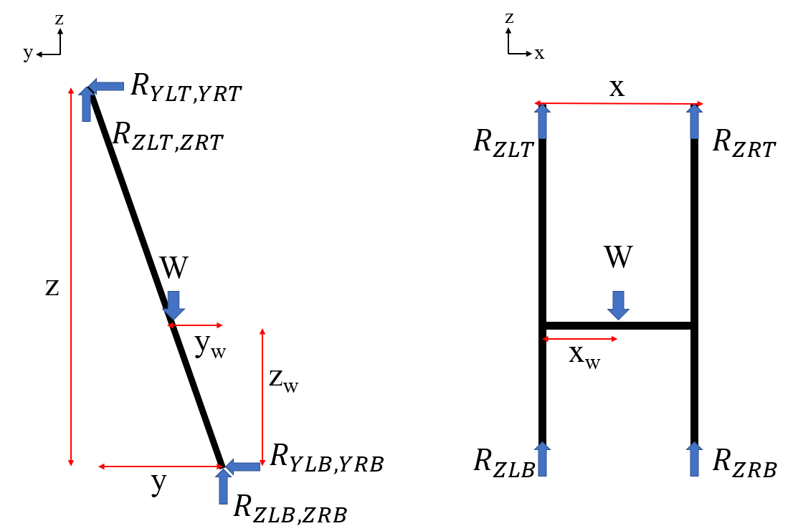
(a)
(b)
Supplementary Material Figure 1.1: Free body diagram of forces acting on the ladder in the sagittal (a) and frontal (b) planes.
COP Equation Assumptions:
$$\frac{R_{ZLB}}{R_{ZLT}}=\frac{R_{ZRB}}{R_{ZRT}}$$
$$R_{YLB}={-R}_{YLT}$$
$$R_{YRB}={-R}_{YRT}$$
$$R_{YLB}+R_{YRB}=0.36W$$
COP Full Model Equations:
$$\sum{F_{z}=0=R_{ZLB}+R_{ZLT}+R_{ZRT}+R_{ZRB}-W}$$
$$\sum{F_{y}=0=R_{YLB}+R_{YLT}+R_{YRT}+R_{YRB}}$$
$$\sum{M_{y}=0=R_{ZRT}x+R_{ZRB}x-Wx_{W}}$$
$$\sum{M_{x}=0=Wy_{W}-R_{ZLT}y-R_{ZRT}y}+R_{YLT}z+R_{YRT}z$$
$$COP= x_{w}-\frac{x}{2}$$
$$COP= \frac{R_{ZRT}x+R_{ZRB}x}{W}- \frac{x}{2}$$

Note: moments were calculated around the $R_{ZLB}$, therefore, the medial-lateral forces at the base of the ladder are negligible due to no moment arm.

COP Bottom Model Equations:
$$\sum{F_{z}=0=R_{ZLB}+R_{ZLT}-W}$$
$${W=R}_{ZLB}+R_{ZRB}$$
$$\sum{M_{y}=0=R_{ZRB}x-Wx_{W}}$$
$$COP= x_{w}-\frac{x}{2}$$
$$COP= \frac{R_{ZRB}x}{R_{ZLB}+R_{ZRB}}- \frac{x}{2}$$
We conducted a sensitivity analysis with the COP full and bottom model with variations in the bottom AP forces (R_{YLB} & R_{YRB}) and the top left vertical force (R_{ZLT}). R_{YLB} ranged from 0% to 36% bodyweight, with the sum of R_{YLB} & R_{YRB} always totaling 36% bodyweight. R_{ZLT} ranged from -60% to 60% bodyweight based upon our data for a maximum reach trial (i.e. our assumptions and the known bottom vertical forces of the trial were used to calculate this expected R_{ZLT} force range). Bodyweight was set to 700 N. This sensitivity analysis showed that the COP full and bottom models matched across all the force conditions with the AP forces having no effect on either COP.

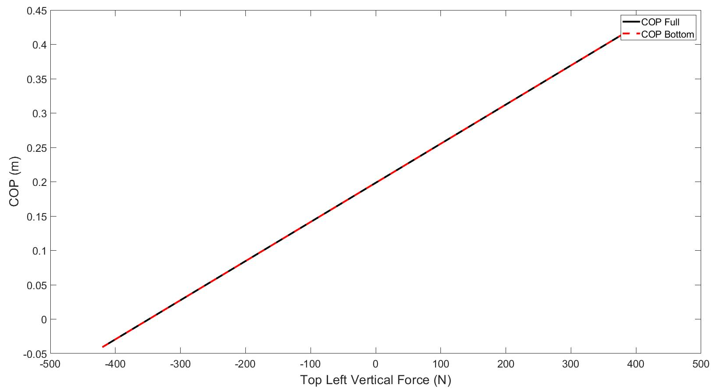
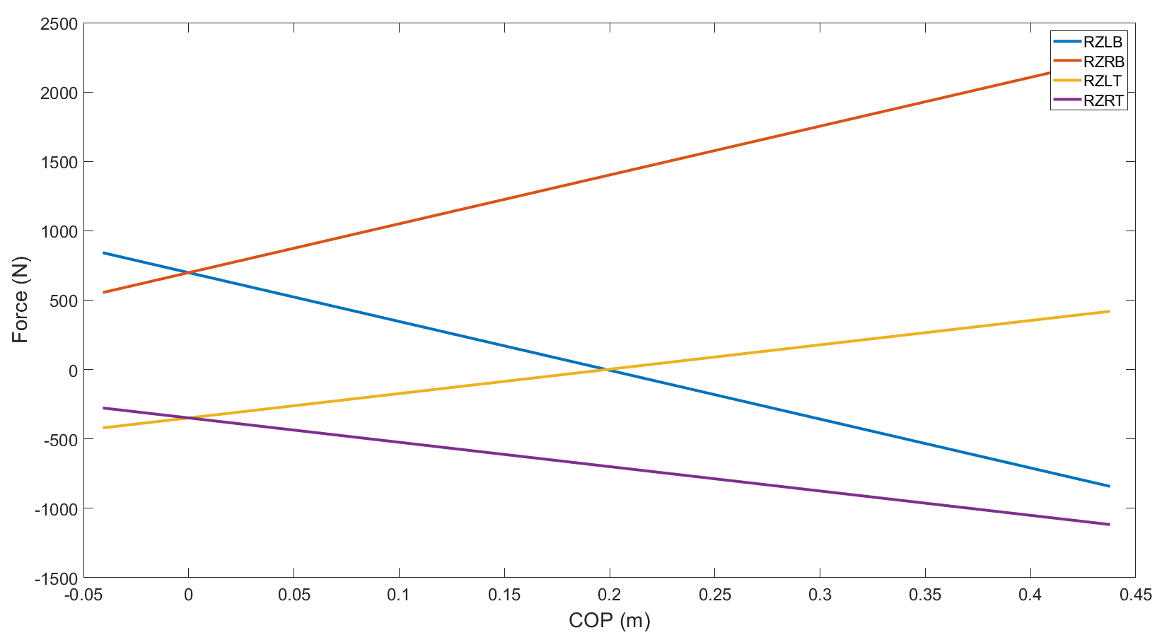
Supplementary Material Figure 1.2: Vertical reaction forces at the top and bottom of the ladder over a range of COP values. Negative COP values are reaches to the left while negative force values are forces in the negative z-direction.
Supplementary Material Figure 1.3: COP Full Model and COP Bottom Model over a range of vertical forces at the top left ladder support. Negative COP values are reaches to the left while negative force values are forces in the negative z-direction.
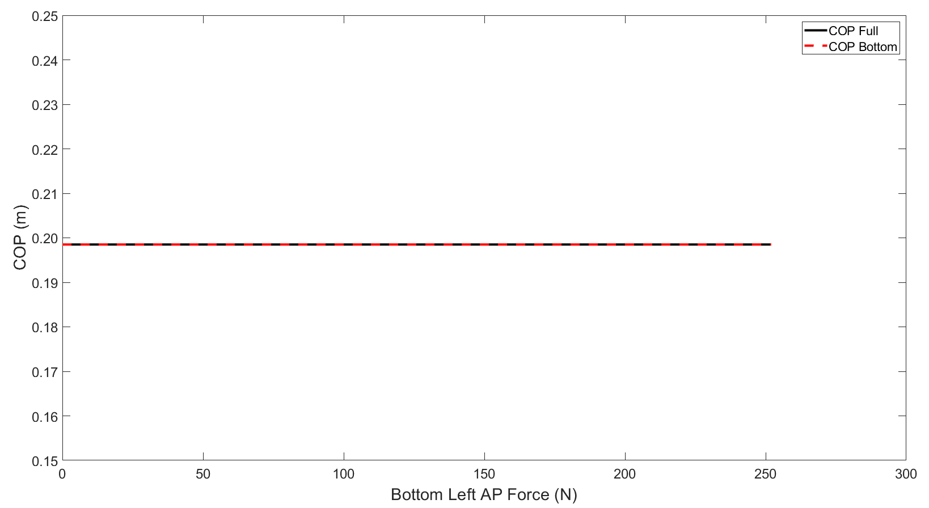
Supplementary Material Figure 1.4: COP Full Model and COP Bottom Model over a range of AP forces at the bottom left ladder support with a top left vertical force of 0 N. A constant COP across bottom left AP force values was maintained for any top left vertical force value.
Supplementary Material 2:
COP correlations with gender, height, and weight (Supplementary Figure 2).
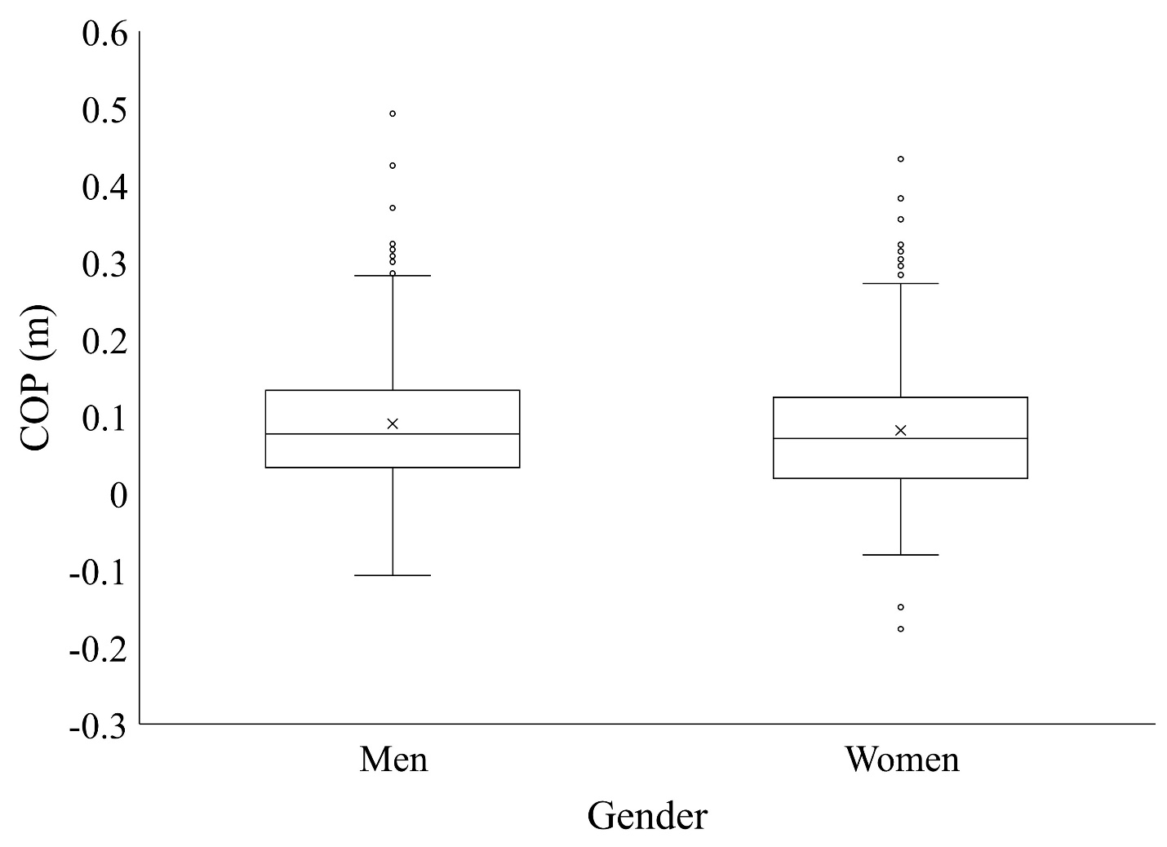
F_{1,826}=2.22; p=0.14

Supplementary Material Figure 2.1: Distribution of COP for the different gender groupings.
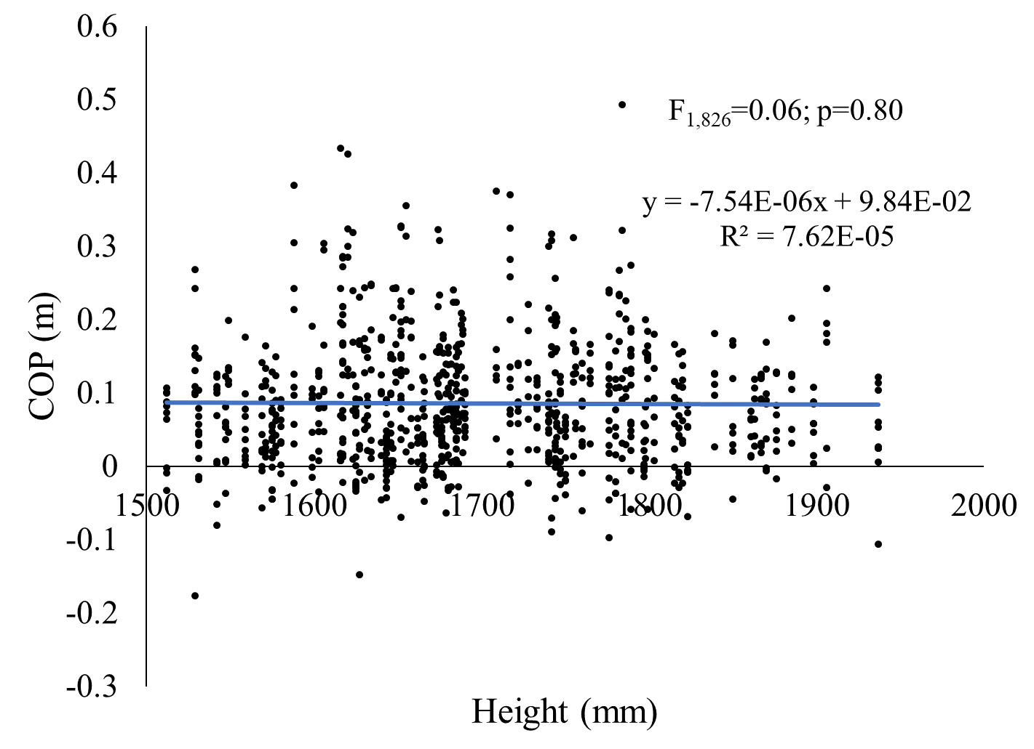
Supplementary Material Figure 2.2: Individual regression of COP against participant height.

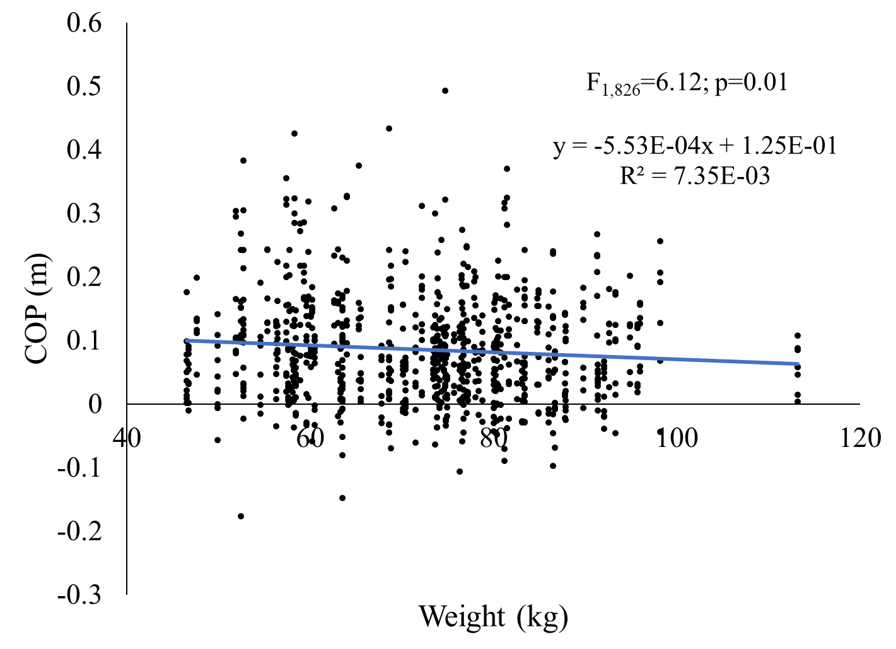
Supplementary Material Figure 2.3: Individual regression of COP against participant weight.

