Estimated Incidence and Prevalence of Gonorrhea in the
United States, 2006-2019
Modeling and Data Supplement
Pollock, Emily D; Clay, Patrick A; Kreisel, Kristen M; Spicknall, Ian H

Contents
Supplementary Tables 3
Table S1: Number of Incident Gonococcal Infections, Among 15-39-Year-Olds, United States, 2006-2019 3
Table S2: Number of Prevalent Gonococcal Infections, Among 15-39-Year-Olds, United States, 2006-2019 4
Sensitivity Analyses 5
Figure S1: Varying vs. Static Screening Rate (σ) 5
Figure S2: Varying vs. Static Case Reporting Rate (ρ) 6
Modeling Framework 7
Overview 7
GC Natural history 7
Infection 7
Recovery as a result of natural clearance 7
Recovery as a result of symptomatic treatment seeking 7
Recovery due to background screening 8
GC natural history equations 8
Point prevalence equation 8
Population size equation 9
Case reporting equation 9
Description of state space and parameters 9
GC equation solving 10
Data Inputs 13
Table S3: Input Parameters Overview 13
Population Size (N) 14
Table S4 : Population Sizes from ACS, 2006-2019 14
Number of Case Reports (κ) 15
Table S5: Case Reports, 2006-2019 15
Case Reporting Fraction (ρ) 16
Table S6: Case Reporting Rate to CDC 16
Proportion of Cases that are Asymptomatic (β) 17
Annual Background Screening Rate (σ) 17
Table S7 : Proportion who Screened for STIs 18
Rate of Natural Clearance (ψ) 18
Table S8. Rate of and days to natural clearance of untreated Neisseria gonorrhoeae, by sex. 19
Rate of Symptomatic Treatment Seeking (τ) 19
Table S9. Rate of and days to symptomatic treatment seeking for infections due to Neisseria gonorrhoeae, 20
References 21

Supplementary Tables

Table S1: Number of Incident Gonococcal Infections, Among 15-39-Year-Olds, United States, 2006-2019
Age | 2006 | 2007 | 2008 | 2009 | 2010 | 2011 | 2012 | 2013 | 2014 | 2015 | 2016 | 2017 | 2018 | 2019
Men
15-24 | 200399 (171909-238947) | 198549 (170658-238048) | 186647 (160675-223775) | 169927 (145491-203867) | 175512 (151173-209860) | 180985 (155375-216284) | 182623 (156730-218932) | 176197 (151715-212032) | 184767 (158796-222106) | 206975 (176907-248135) | 235559 (200988-283032) | 266352 (229404-319271) | 269203 (230998-324382) | 273551 (234524-330037)
25-39 | 167478 (144376-201371) | 157244 (134884-188958) | 137174 (117481-163808) | 119549 (102515-143396) | 121024 (103763-145056) | 125402 (108084-150012) | 142187 (122275-170951) | 155261 (133577-186113) | 181427 (156380-217745) | 224551 (193428-268820) | 284898 (244408-341991) | 350605 (302167-423334) | 384419 (330358-459601) | 412157 (355720-495638)
All | 379162 (337138-431662) | 366144 (326177-420544) | 332754 (296140-381178) | 298040 (263975-340724) | 305114 (271100-348051) | 314807 (280365-360775) | 334252 (297388-382577) | 341493 (303617-390552) | 377804 (335571-432547) | 444619 (396035-507755) | 536377 (475917-616099) | 634760 (565892-727714) | 672572 (597620-771384) | 706652 (627855-811891)
Women
15-24 | 516547 (439521-616384) | 515813 (437840-612335) | 491005 (417669-581033) | 431912 (368005-514354) | 436115 (372608-517976) | 457917 (388649-545774) | 436977 (372714-520223) | 388758 (332639-463240) | 374365 (320238-444484) | 387058 (331382-459782) | 422263 (359278-500074) | 489967 (414501-581774) | 489306 (415983-584479) | 509092 (433531-608408)
25-39 | 216851 (184612-260321) | 209764 (176978-252329) | 190537 (160955-228724) | 160352 (136230-192806) | 160742 (135739-191816) | 161679 (137431-191901) | 175692 (149737-209130) | 178764 (152405-212175) | 189888 (161662-224923) | 213126 (182848-252653) | 255695 (219386-302809) | 318114 (272011-377520) | 349766 (297367-414884) | 346859 (294160-414094)
All | 746428 (659953-857749) | 737506 (649972-844973) | 693113 (611384-789562) | 602373 (530490-691031) | 606304 (535942-692308) | 628159 (553858-717431) | 622714 (551574-713063) | 576504 (511822-659058) | 574029 (509640-654303) | 611534 (542989-694887) | 690895 (613177-783098) | 823019 (729698-938362) | 859005 (762047-975504) | 873256 (775665-993515)
Both
15-24 | 733443 (644894-840348) | 729658 (642144-835540) | 691017 (609131-791015) | 613660 (542149-702269) | 624244 (552081-713307) | 652113 (573251-748852) | 631468 (557943-724099) | 577300 (511719-662880) | 574755 (506611-654194) | 608110 (539464-692957) | 673728 (595099-768226) | 773663 (682431-884591) | 777662 (688384-890382) | 802318 (709381-918263)
25-39 | 395416 (349755-451870) | 376346 (333335-432382) | 336324 (296888-384224) | 287894 (255211-329511) | 288946 (255235-330085) | 294395 (261403-334828) | 326535 (290009-372722) | 342301 (304132-390094) | 380502 (339173-432812) | 448631 (401411-510829) | 553596 (493371-631541) | 688304 (611306-783232) | 753381 (671765-854333) | 778441 (693441-885715)
All | 1142744 (1040250-1266805) | 1118338 (1017486-1242299) | 1038347 (948097-1150322) | 915699 (829872-1011126) | 922351 (841370-1023181) | 957600 (871084-1059891) | 970421 (883723-1074002) | 931707 (849692-1028613) | 966482 (883253-1063831) | 1071506 (983071-1174360) | 1245735 (1139369-1367156) | 1481086 (1355537-1629883) | 1555643 (1424639-1709931) | 1603473 (1467801-1767779)
Note: Incident infections are the number of new infections in each calendar year. Results shown are the median and 25th-75th percentiles of the simulated distributions.

Table S2: Number of Prevalent Gonococcal Infections, Among 15-39-Year-Olds, United States, 2006-2019
Age | 2006 | 2007 | 2008 | 2009 | 2010 | 2011 | 2012 | 2013 | 2014 | 2015 | 2016 | 2017 | 2018 | 2019
Men
15-24 | 13633 (10060-18818) | 13471 (9947-18759) | 12570 (9303-17596) | 11352 (8459-16033) | 11727 (8704-16252) | 12106 (9010-16794) | 12221 (9077-17138) | 11796 (8667-16414) | 12494 (9240-17302) | 13900 (10378-19349) | 16096 (11708-22284) | 18210 (13404-25039) | 18266 (13491-25567) | 18542 (13616-25653)
25-39 | 11334 (8419-15709) | 10595 (7824-14803) | 9291 (6866-12842) | 8100 (5949-11121) | 8160 (5988-11335) | 8474 (6228-11728) | 9576 (7118-13334) | 10417 (7668-14506) | 12134 (8966-16990) | 15101 (11108-20932) | 19330 (14127-26576) | 23806 (17482-33244) | 26027 (19196-36024) | 28006 (20719-38647)
All | 26366 (21057-33603) | 25702 (20405-32367) | 23108 (18543-29611) | 20672 (16429-26510) | 21104 (16728-26713) | 21832 (17369-27899) | 23162 (18436-29500) | 23737 (18864-30250) | 26141 (20944-33488) | 30687 (24675-39236) | 37496 (29935-47666) | 44393 (35452-56621) | 46968 (37539-59964) | 49074 (39152-62845)
Women
15-24 | 93139 (73602-119262) | 92706 (73328-118716) | 87543 (69337-112008) | 77100 (60462-98064) | 77986 (61642-98974) | 82347 (64816-105440) | 79065 (62189-100657) | 70354 (55323-89114) | 67159 (52847-85301) | 69797 (54978-88289) | 75322 (59679-95921) | 88304 (69268-112772) | 88728 (69851-112646) | 91885 (72566-117271)
25-39 | 39542 (31124-50984) | 38169 (29982-49281) | 34712 (27206-44437) | 29406 (22872-37956) | 29233 (22724-37648) | 29079 (22735-37060) | 31476 (24780-40201) | 32009 (25214-40841) | 33815 (26680-42908) | 37902 (29804-48171) | 45544 (36139-57291) | 56586 (44613-72157) | 62142 (49039-79153) | 61985 (48671-78799)
All | 136550 (113993-164373) | 134564 (112501-162956) | 125449 (104948-151465) | 108881 (90713-131841) | 109515 (91369-131887) | 113753 (94305-137825) | 113199 (93947-136643) | 104531 (87617-126083) | 103404 (86832-124058) | 110479 (93004-131682) | 124027 (104774-148102) | 149492 (125515-178227) | 155568 (130300-184973) | 158967 (133803-189152)
Both
15-24 | 109061 (88382-135106) | 108424 (88365-134978) | 102151 (83365-127081) | 90437 (73241-111679) | 91415 (74452-112637) | 96319 (77987-119827) | 93178 (75819-114810) | 84146 (68266-103595) | 81633 (66510-100756) | 85937 (70050-105370) | 93878 (77164-115802) | 109333 (88871-134759) | 110151 (89788-135018) | 113514 (92628-140258)
25-39 | 52661 (43052-65215) | 50510 (41130-62288) | 45425 (37063-56054) | 38849 (31458-47976) | 38573 (31516-47732) | 38828 (31700-47591) | 42468 (34974-52005) | 44054 (36204-53735) | 47832 (39247-58486) | 54925 (45318-67404) | 66988 (55480-81641) | 83963 (68520-102407) | 92012 (75922-111791) | 93438 (77134-114129)
All | 165216 (141728-194249) | 162415 (139116-191652) | 150589 (129419-177013) | 131660 (112453-154996) | 132275 (113607-155712) | 137987 (117195-162304) | 138590 (118177-162411) | 130162 (112310-152536) | 131802 (113861-153885) | 144112 (124794-166502) | 164497 (142573-190331) | 197072 (170597-229300) | 206366 (178834-238733) | 211867 (184167-245681)
Note: Prevalent infections are the number of existing infections in each calendar year. Results shown are the median and 25th-75th percentiles of the simulated distributions.

Sensitivity Analyses

Figure S1: Varying vs. Static Screening Rate (σ)
Compares varying rate to counterfactual where rates are unchanged since 2006
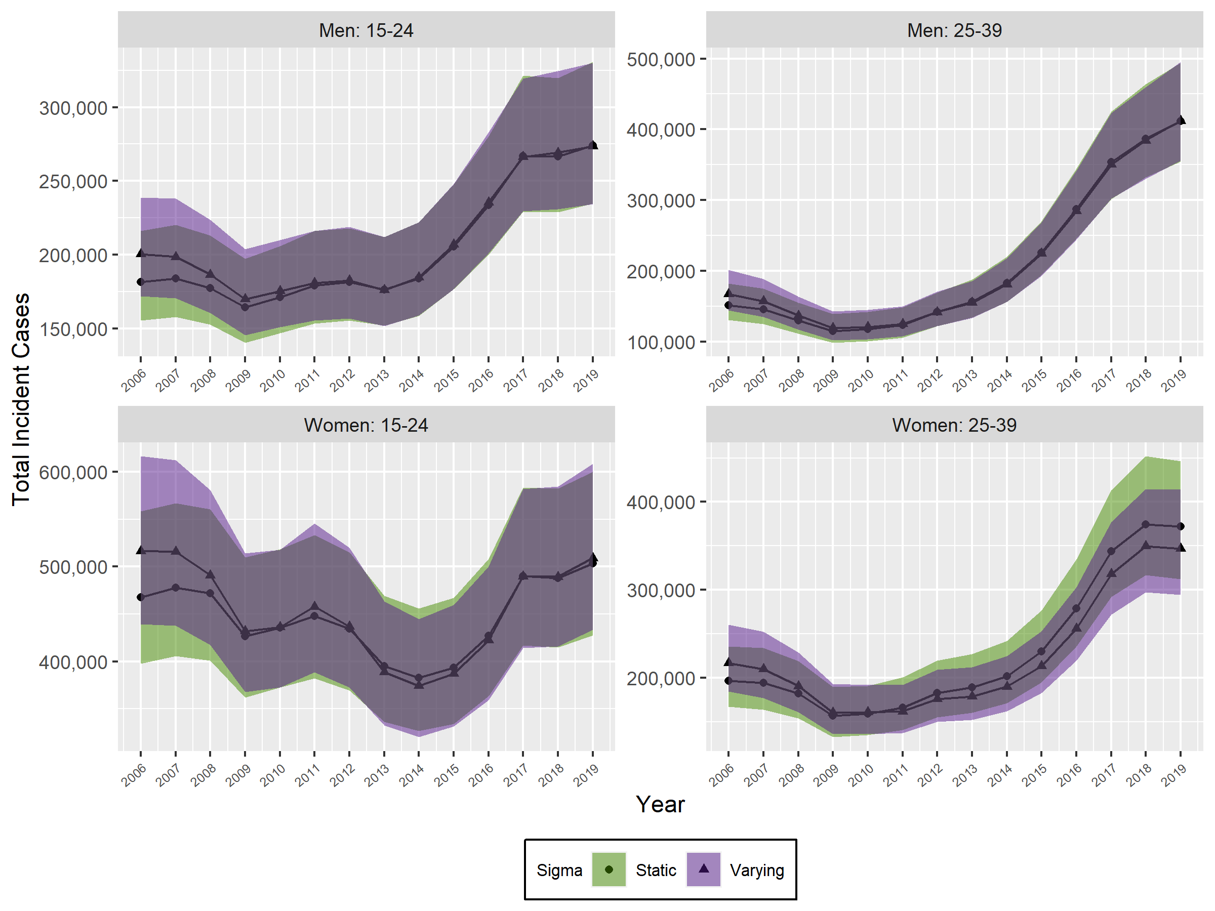

Figure S2: Varying vs. Static Case Reporting Rate (ρ)
Compares varying rate to counterfactual of 95% case reporting rate post-ELR implementation
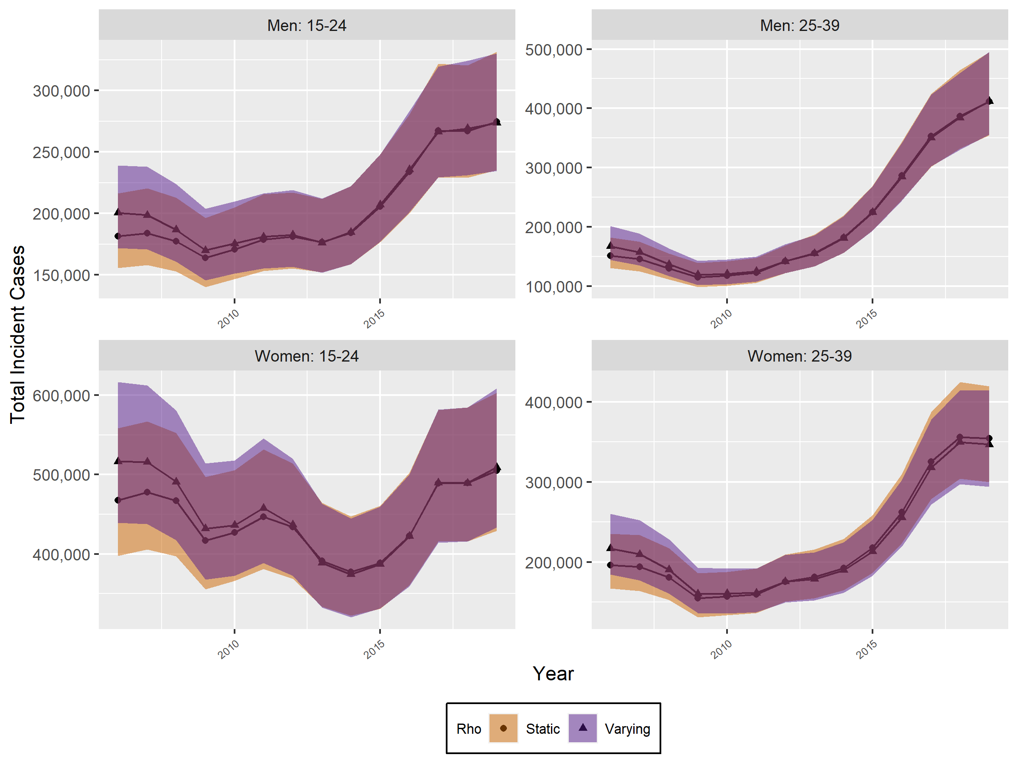

Modeling Framework

Overview
Our modeling framework accounts for how symptoms due to infection with Neisseria gonorrhea (GC) differentially affect both recovery and being reported as a diagnosed case. Those with an asymptomatic infection will be less likely to be tested for infection, and thus less likely to be a reported case. This framework mathematically describes the natural history of infection, how cases are reported, what is represented by prevalence estimates, and population sizes. These equations and descriptions follow.

GC Natural history
We elaborate upon the general SIS model. We assume three possible states of infection: uninfected (U), asymptomatically infected (A), and symptomatically infected (S). All people must be in one of these three states. We consider four mechanisms: 1) infection, 2) recovery as a result of natural clearance, 3) recovery as a result of background screening, and 4) recovery as a result of symptomatic treatment seeking. These are described in more detail below.

Infection
Uninfected people acquire infection at rate λ, also known as the force of infection. Here, we make a simplifying assumption, that the force of infection is constant, which is consistent with our assumption of steady state dynamics overall described in more detail below. A proportion of newly infected people ($β$) develop asymptomatic infection, and a complementary proportion $(1-β)$ develop symptomatic infection.

Recovery as a result of natural clearance
Infected people (regardless of symptoms) can recover from infection due to natural clearance. This occurs at rate ψ, which is the inverse duration of time to natural clearance.

Recovery as a result of symptomatic treatment seeking
Those with symptomatic infection are likely to seek medical care at a rapid rate. Assuming
perfect test characteristics (i.e., 100% sensitivity and specificity), and assuming all who test positive are treated effectively (no treatment failure) the rate of symptomatic treatment seeking (τ) is equivalent to the
rate of recovery due to this process. Highly sensitive and specific nucleic acid amplification tests (NAATs) were available for the duration of our study period, so we make this assumption because it dramatically simplifies the equation solving described below.

Recovery due to background screening
Recovery from background screening can occur in both the symptomatically and asymptomatically infected. Background screening is meant to describe screening in the absence of symptoms of all people within a given subpopulation (or representative sample). Subpopulations will have screening rates specific to them. Within a subpopulation, the screening rate is considered homogeneous, and averaged across all who comprise the subpopulation. Assuming perfect test characteristics (i.e., 100% sensitivity and specificity), and assuming all who test positive are treated effectively (no treatment failure) the rate of screening the asymptomatically infected people (σ) is the rate of recovery in this group. Those who are symptomatically infected may also experience background screening, in addition to their symptom-related treatment seeking, though it is likely that the rate of background screening is much slower than the other rate. As a result, the symptomatically infected people also recover at the rate at which they are screened (σ).

GC natural history equations
These mechanisms are described mathematically in the following differential equations. The equations for each year and each age/sex subgroup are the same, but the input data change when we solve each age/sex/year combination.

$$\frac{dU}{dt}= -λU + (ψ + σ)A + (ψ + σ + τ)S$$
$$\frac{dA}{dt}= λUβ-(ψ + σ)A$$
$$\frac{dS}{dt}= λU\left(1-β\right)- (-ψ + σ + τ)S$$

Point prevalence equation
Assuming perfect diagnostic testing and the natural history equations above, the point prevalence of infection (P) includes both the symptomatically and asymptomatically infected in the numerator:

$$P=\frac{A+S}{A + S + U}$$

Population size equation
Population size for a given subpopulation is summarized as:
$$N = A + S + U$$

Case reporting equation
Cases are supposed to be reported as they are diagnosed, either from symptomatic treatment seeking or background screening. The background screening rate is homogenous among each age/sex subgroup and specific to each year. The below equation assumes only a proportion of cases (r) are reported; it also assumes perfect testing. The number of cases reported over a year (K) may be summarized as:

$$K = ρ(σ(A + S) + τS)$$

Description of state space and parameters

Symbol | Description
λ | Force of infection (rate)
β | Proportion of new gonococcal infections that are asymptomatic
ψ | Natural gonococcal clearance rate
σ | Background screening rate
τ | Symptom related treatment seeking rate
ρ | Reporting fraction
N | Population size
U | Number of people who are uninfected and susceptible to infection
S | Number of people with symptomatic infection
A | Number of people with asymptomatic infection
K | Case report number (over a specified period)

GC equation solving
The solution utilizes the five equations below to estimate annual incidence and point prevalence. We solve for four unknowns: the three state variables plus the force of infection (λ).

$$\frac{dU}{dt}= -λU + (ψ + σ)A + (ψ + σ + τ)S$$
$$\frac{dA}{dt}= λUβ-(ψ + σ)A$$
$$\frac{dS}{dt}= λU\left(1-β\right)- (-ψ + σ + τ)S$$

$$N = A + S + U$$
$$K = ρ(σ(A + S) + τS)$$

We use symbolic algebra in Python to solve these systems of equations for their steady state values. By solving for the state variable formulations (i.e., U, A, and S) as well as force of infection formulation (λ), we are able to derive steady state solutions for the annual number of incident infections (λU) and the point prevalence of infection $\frac{A+S}{A+S+U}$.

Solving for steady state values of the natural history equations requires assuming that the change over time in each state (A, S, and U) is zero; thus, these differential equations are set to zero, implying no change, while all others remain unchanged.

Below is python code to initialize the size equations described above.

In [23]: from sympy.interactive import printing
printing.init_printing(use_latex=True)
from sympy import Eq, solve_linear_system, Matrix, Symbol
import sympy as sp
import math
############################################
eq1=sp.Function('eq1')
eq2=sp.Function('eq2')
eq3=sp.Function('eq3')
eq4=sp.Function('eq4')
eq5=sp.Function('eq5')

#DEFINE STATE VARIABLES
A,U,S,N, K=sp.symbols('A, U, S, N, K')

#DEFINE MODEL PARAMETERS
LAMBDA, BETA, SIGMA, TAU, PSI, RHO = sp.symbols('lambda, beta, sigma, tau, psi, rho')
eq1 = Eq((TAU+SIGMA+PSI)*S + (PSI+SIGMA)*A - LAMBDA*U)
eq2 = Eq(-(PSI+SIGMA)*A + LAMBDA*BETA *U )
eq3 = Eq(-(TAU+SIGMA+PSI)*S + LAMBDA*(1 - BETA)*U )
eq4= Eq(A+S+U, N)
eq5= Eq(RHO*((SIGMA+TAU)*S +SIGMA*A) , K)
display(eq1, eq2, eq3, eq4, eq5)

$$A \left(ψ + σ\right)+ S \left(ψ + σ + τ\right)-Uλ = 0$$

$$A (-ψ- σ) + Uβλ = 0$$

$$S (-ψ- σ- τ) + Uλ (-β+ 1) = 0$$

$$A + S + U = N$$

$$ρ (Aσ + S (σ +τ)) = K$$

We use the sympy function solve to find the solutions as shown below. These solutions are then used to estimate incidence and prevalence (further below). We are able to formulate prevalence from the state variables where$P = \frac{A+S}{A+S+U}$.

In [24]: #solve GC equation system (no Prev / ONLY case reports available)
sol_gc = sp.solve(( eq1, eq3, eq4, eq5), (U,A,S, LAMBDA))
display(sol_gc)
solution= sol_gc
gc_inc = sp.simplify(solution[0][0]*solution[0][3]) # annual incident infections
gc_prev = sp.factor((solution[0][1]+solution[0][2])/(solution[0][0]+solution[0][1]+solution[0][2])) display(gc_inc)
display(gc_prev)

$$[(\frac{Kβτ + Kψ + Kσ + Nβψρτ- Nψρσ- Nψρτ- Nρσ2-Nρστ}{ρ(βψτ- ψσ- ψτ- σ2- στ)},$$

$$-\frac{Kβ\left(ψ + σ + τ\right)}{ρ(βψτ- ψσ- ψτ- σ2- στ)},$$

$$\frac{K\left(β- 1\right)\left(ψ + σ\right)}{ρ(βψτ-ψσ- ψτ-σ2-στ)},$$

$$-\frac{K\left(ψ + σ\right)\left(ψ + σ + τ\right)}{Kβτ + Kψ + Kσ + Nβψρτ- Nψρσ- Nψρτ- Nρσ2- Nρστ})]$$

$$\frac{K\left(ψ + σ\right)\left(ψ + σ + τ\right)}{ρ(-βψτ+ ψs + ψτ + σ2 + στ)}$$

$$-\frac{K\left(βτ + ψ + σ\right)}{Nρ(βψτ- ψσ- ψτ- σ2- στ)}$$

Thus, the annual number of incident gonococcal infections is formulated as:
$\frac{K\left(ψ+σ\right)\left(ψ+σ+τ\right)}{ρ (-βψτ+ψσ +ψτ+σ2+στ) }$, and the point prevalence of gonococcal infection is formulated as:
$-\frac{K\left(bτ+ψ+ σ\right)}{Nρ(βψτ-ψσ-ψτ-σ2-στ)}$

Data Inputs

Table S3: Input Parameters Overview
Input Parameter |  |  | Group | Time-Varying | Source
$$N$$ | Population size |  | Sex & Age | Yes | American Community Survey [1]–[13]
$$K$$ | Case reports |  | Sex & Age | Yes | STD Surveillance Reports [14]–[16]
$$ρ$$ | Case reporting fraction |  | All | Yes | [17]
$$ψ$$ | Duration of untreated infection |  | Sex | No | Varies, see appendix
$$σ$$ | Probability of STI screening per year |  | Sex & Age | Yes | National Survey of Family Growth [18]–[22]
$$β$$ | Probability of asymptomatic infection |  | Sex | No | [23]
$$τ$$ | Time to treatment seeking (symptomatic infections) |  | Sex & Age | Yes | Composite parameter, see appendix.

Population Size (N)
For the population size estimates, we used data from the United States (US) Census Bureau’s American Community Survey (ACS) representing the full resident population of the US in each year from 2006 to 2019 [1], [2], [11]–[13], [24], [3]–[10]. We assume that these population estimates are constant and stable throughout each year.

Table S4 : Population Sizes from ACS, 2006-2019
 | Women |  | Men
Year | 15-24 | 25-39 | 15-24 | 25-39
2006 | 20,663,430 | 30,221,735 | 21,940,188 | 30,941,575
2007 | 20,690,932 | 30,259,297 | 22,080,993 | 30,975,829
2008 | 20,881,854 | 30,272,683 | 22,093,052 | 31,068,928
2009 | 20,947,774 | 30,476,694 | 22,204,375 | 31,321,010
2010 | 21,290,166 | 30,582,417 | 22,416,963 | 30,566,397
2011 | 21,373,662 | 30,563,887 | 22,528,285 | 30,685,561
2012 | 21,438,463 | 30,705,878 | 22,482,748 | 30,964,172
2013 | 21,453,673 | 31,036,621 | 22,610,585 | 31,331,576
2014 | 21,439,028 | 31,554,480 | 22,579,211 | 31,831,558
2015 | 21,400,208 | 32,054,135 | 22,505,621 | 32,329,190
2016 | 21,240,936 | 32,454,197 | 22,389,627 | 32,767,421
2017 | 21,157,069 | 32,922,210 | 22,255,024 | 33,411,414
2018 | 21,025,717 | 33,171,851 | 22,076,120 | 33,757,505
2019 | 20,858,211 | 33,363,757 | 21,912,920 | 33,993,899

Number of Case Reports (κ)
Case reports represent diagnosed gonococcal infections reported to the Centers for Disease Control and Prevention (CDC) via the Nationally Notifiable Disease Surveillance System (NNDSS) from 2006 to 2019 [14]. The counts among each age and sex subgroup used are included below.
Various factors should be considered when interpreting gonococcal case report data. These data do not include infections that remained undiagnosed, nor infections that may have been diagnosed but not reported to the CDC. Also, given the current inability of case report data to adequately capture all anatomic sites of infection of a reported case, we assumed they represented urogenital infections only, ignoring infections at extragenital sites, such as the rectum and oropharynx. As a result, the full burden of gonorrhea may be underestimated due to the possibility of gonococcal infection at additional anatomic sites. In addition, we assumed no uncertainty in the case report data.

Table S5: Case Reports, 2006-2019
 | Women |  | Men
Year | 15-24 | 25-39 | 15-24 | 25-39
2006 | 127,328 | 51,817 | 78,850 | 65,972
2007 | 129,362 | 50,863 | 79,938 | 63,596
2008 | 127,973 | 47,893 | 77,264 | 56,308
2009 | 115,789 | 41,271 | 71,430 | 49,980
2010 | 118,441 | 41,819 | 74,710 | 51,005
2011 | 121,503 | 43,669 | 77,735 | 53,910
2012 | 117,563 | 47,917 | 78,929 | 61,721
2013 | 107,509 | 49,746 | 77,267 | 68,002
2014 | 103,728 | 52,861 | 80,695 | 79,574
2015 | 106,582 | 60,324 | 89,690 | 98,481
2016 | 115,640 | 73,352 | 102,283 | 124,712
2017 | 132,151 | 90,513 | 115,954 | 153,324
2018 | 132,291 | 98,139 | 116,427 | 167,733
2019 | 136,458 | 96,919 | 118,680 | 179,822
% Change | 6.7 | 46.5 | 33.6 | 63.3

Case Reporting Fraction (ρ)
The case reporting fraction represents the proportion of all diagnosed cases that are reported to CDC. A number of changes were made to the case reporting system during the study period, namely the transition from paper/fax reporting to electronic laboratory reporting (ELR). We use rates based on previous work from Learner et al. 2020. This study focused on chlamydia, but because gonorrhea is also a reportable condition in all states and the District of Columbia (i.e., all positive laboratory results are sent to public health authorities), and the diagnostic used since the early 2000s tests for both gonorrhea and chlamydia we felt it reasonable to assume reporting rate would be the same for both. We maintain the assumption that case reporting post-ELR implementation is still less than 100% due to transmission and/or data entry errors. We also assumed that the case reporting fraction was uniformly distributed and did not vary by sex or age group.

Table S6: Case Reporting Rate to CDC
Year | Rho | Lower | Upper
2006 | 0.86 | 0.848 | 0.872
2007 | 0.88 | 0.868 | 0.892
2008 | 0.90 | 0.888 | 0.912
2009 | 0.91 | 0.898 | 0.922
2010 | 0.92 | 0.908 | 0.932
2011 | 0.93 | 0.918 | 0.942
2012 | 0.94 | 0.928 | 0.952
2013 | 0.95 | 0.938 | 0.962
2014 | 0.95 | 0.938 | 0.962
2015 | 0.95 | 0.938 | 0.962
2016 | 0.95 | 0.938 | 0.962
2017 | 0.95 | 0.938 | 0.962
2018 | 0.95 | 0.938 | 0.962
2019 | 0.95 | 0.938 | 0.962

Proportion of Cases that are Asymptomatic (β)
Though gonococcal infections can exist in one of two states, either symptomatic or asymptomatic, infections are often without symptoms and the proportion varies by sex. To quantify this for use in the models, we used data from one manuscript that estimated 41.3% (Q1=31.8%, Q3=51.1%) of men and 68.4% (Q1 = 61.8%, Q3 = 74.2%) of women infected with gonorrhea are asymptomatic. By using these data we assumed that the proportion of cases that are asymptomatic did not vary by age group and also that the subjects from the study from which these numbers were drawn, which was a convenience sample of people aged 18–29 years in New Orleans, were representative of all people with gonococcal infections [23].

Annual Background Screening Rate (σ)
We estimated the annual background screening rate for gonorrhea using data from multiple cycles of the National Survey of Family Growth (NSFG) during 2006-2019 [18]. The smallest cycle interval based on the provided nationally representative survey weights in this survey is two years, so we calculated the screening rate among these two-year intervals during 2006-2019 and used the mean estimate for years that contained multiple NSFG cycles.
The use of these data came with several assumptions. First, we assumed the data were normally distributed. Second, we assumed that background screening was constant and stable throughout the cycle. Third, we assumed that if a person was screened for chlamydia, they were also screened for gonorrhea. Lastly, these estimates are based on self-reported data, which are inherently subject to recall bias. The question asked of women was: “In the last 12 months, have you been tested for chlamydia?” This question assumed that the rate of testing (typically for diagnostic purposes among symptomatic persons) was reflective of the rate of background screening in (typically asymptomatic) women. There is an additional question that asks about testing for gonorrhea and syphilis, but to stay consistent with previous work, we use the initial screening question. The question asked of men was: “In the past 12 months, have you been tested for a sexually transmitted disease like gonorrhea, chlamydia, herpes, or syphilis?” This question assumed that the rate of background screening in men was equivalent to the rate of testing for all STIs in men.

Table S7 : Proportion who Screened for STIs
 | Women |  | Men
Year | 15-24 | 25-39 | 15-24 | 25-39
2006 | 0.256 (0.231 - 0.281) | 0.201 (0.18 - 0.221) | 0.147 (0.124 - 0.17) | 0.155 (0.134 - 0.177)
2007 | 0.256 (0.231 - 0.281) | 0.201 (0.18 - 0.221) | 0.147 (0.124 - 0.17) | 0.155 (0.134 - 0.177)
2008 | 0.275 (0.248 - 0.302) | 0.212 (0.192 - 0.233) | 0.16 (0.136 - 0.183) | 0.156 (0.135 - 0.176)
2009 | 0.294 (0.266 - 0.322) | 0.223 (0.203 - 0.244) | 0.172 (0.148 - 0.196) | 0.156 (0.136 - 0.176)
2010 | 0.294 (0.266 - 0.322) | 0.223 (0.203 - 0.244) | 0.172 (0.148 - 0.196) | 0.156 (0.136 - 0.176)
2011 | 0.26 (0.231 - 0.288) | 0.264 (0.241 - 0.288) | 0.166 (0.144 - 0.188) | 0.172 (0.15 - 0.194)
2012 | 0.26 (0.231 - 0.288) | 0.264 (0.241 - 0.288) | 0.166 (0.144 - 0.188) | 0.172 (0.15 - 0.194)
2013 | 0.271 (0.243 - 0.3) | 0.273 (0.249 - 0.296) | 0.153 (0.131 - 0.175) | 0.17 (0.149 - 0.192)
2014 | 0.283 (0.255 - 0.311) | 0.281 (0.258 - 0.304) | 0.141 (0.119 - 0.162) | 0.169 (0.147 - 0.19)
2015 | 0.278 (0.247 - 0.309) | 0.296 (0.271 - 0.322) | 0.142 (0.118 - 0.167) | 0.173 (0.149 - 0.196)
2016 | 0.273 (0.24 - 0.307) | 0.311 (0.284 - 0.339) | 0.144 (0.117 - 0.171) | 0.176 (0.151 - 0.201)
2017 | 0.261 (0.23 - 0.293) | 0.299 (0.274 - 0.325) | 0.139 (0.114 - 0.164) | 0.162 (0.14 - 0.184)
2018 | 0.249 (0.22 - 0.279) | 0.287 (0.264 - 0.311) | 0.134 (0.111 - 0.157) | 0.148 (0.13 - 0.166)

Rate of Natural Clearance (ψ)
Informed by data from the literature, we calculated the rate of natural clearance of gonorrhea among untreated infected people as: # of people who cleared their infection without treatment / total person-time contributed until clearance occurred. For gonorrhea in women, data were based on NAATs and only included a sample of 16 women with a total person-time of 1.26 person-years [26]. We found gonococcal natural clearance data for men only in studies conducted in 1974 and both were based on culture, Gram stain, or fluorescent antibody tests [27], [28]. Given the use of outdated and less sensitive diagnostic test technology in these studies, we used the more recent study based on NAAT testing done solely in women and assumed (based on expert opinion) that men naturally clear gonorrhea twice as fast as women. Because of the small sample size, rather than bootstrapping, we sampled from a gamma distribution with a resulting median similar to the study. Specifically, we sampled from a gamma distribution with shape parameter = 16 and rate = 16/4.089 to generate a distribution of natural clearance in women; for men, we assumed the rate was twice as fast, also sampling from a gamma distribution. Based on these inputs, estimates of the rate of and days to natural clearance for gonorrhea by sex are presented in Supplemental Table S6.

Table S8. Rate of and days to natural clearance of untreated Neisseria gonorrhoeae, by sex.
Sex | Median
Sex | (25th – 75th Percentile)
Sex | Rate | Days
Men | 8.02 | 45.54
 | (6.71-9.47) | (38.56-54.44)
Women | 4.00 | 91.25
 | (3.36-4.72) | (77.33-108.63)

There were a variety of assumptions that factored into these calculations. First, we assumed that the natural clearance of gonorrhea did not vary by age group. Second, we assumed a constant exponential clearance rate from available data. Lastly, we assumed that the subjects in the studies from which these numbers were drawn were representative of all people with gonococcal infection.

Rate of Symptomatic Treatment Seeking (τ)
Among symptomatically infected people, we estimated the rate of seeking treatment as a function of multiple inputs. These included the probability of a person never seeking treatment (ζ), the time from infection acquisition to symptom onset (d1), and time from symptom onset to testing due to symptoms (d2). These were combined as: τ = (1- ζ)/(d1+d2). Note that ζ does not represent the proportion of symptomatic infections that ever receive treatment, as this would be given by (σ+τ)/(σ+τ+ψ).
We used estimates from the literature for incubation period to estimate d1 [29]. For gonorrhea, this was 6.2 days (Q1 = 4.3 days, Q3 = 8.1 days) in men and 11.2 days (Q1 = 7.9 days, Q3 = 14.6days) in women. To estimate d2, we used unpublished data from the STD Surveillance Network (PS13-1306, 2016–2018) summarizing time from symptoms to testing (among those who sought treatment). In men, this was 6.5 days (Q1 = 6.4 days, Q3 = 6.6 days); in women, this was 13.9 days (Q1 = 13.7 days, Q3 = 14.1 days). We looked at the data over a longer interval for this follow-up paper but based on lack of evidence that this rate has meaningfully changed, we applied the original d2 estimate across all years. To estimate (1- ζ), we used data from Farley et al, which found that only a fraction of symptomatic people never sought treatment due to their urogenital symptoms: 20.8% (Q1 = 19.3%, Q3 = 22.3%) (4). Non-parametric bootstrapping techniques were used to resample data for d2, while uniform and beta distributions were sampled from for d1and ζ. Finally, we assume that the proportion of people with symptomatic infections who will never seek treatment (ζ) is influenced by the proportion of people who are screened for STIs (σ). We adjust ζ by changes in this proportion over time using 2007 as our screening starting point by the following equation: ζ _(2007+i) = ζ + σ_2007 – σ_(2007+i). We ran versions of this analysis with and without this correction the difference was minimal, but we still use the time-varying versions to maintain consistency with the annual screening parameter. The estimates of the rate (year-1) of and days to symptomatic treatment seeking for gonorrhea, by sex and NSFG survey year, are shown in Supplemental Table S9.

Table S9. Rate of and days to symptomatic treatment seeking for infections due to Neisseria gonorrhoeae, by sex and NSFG survey cycle.
Year | Sex | Median
 | Sex | (25th – 75th Percentile)
 | Sex | Rate | Days
 | Men | 26.5 | 13.8
2007-2008 |  | (22.6 - 32.2) | (11.3 – 16.2)
 | Women | 13.3 | 27.5
 |  | (11.5 – 15.8) | (23.1 – 31.6)
 | Men | 26.7 | 13.7
2009-2010 |  | (22.7 – 32.1) | (11.4 – 16.1)
 | Women | 13.3 | 27.4
 |  | (11.6 – 15.8) | (23.1 – 31.5)
 | Men | 26.7 | 13.7
2011-2012 |  | (22.7 – 32.2) | (11.3 – 16.1)
 | Women | 13.3 | 27.4
 |  | (11.6 – 15.9) | (23 – 31.5)
 | Men | 26.4 | 13.8
2013-2014 |  | (22.6 – 32) | (11.4 – 16.2)
 | Women | 13.4 | 27.3
 |  | (11.6 – 15.8) | (23.1 – 31.5)
 | Men | 27.9 | 13.1
2015-2016 |  | (23.7 – 33.5) | (10.9 – 15.4)
 | Women | 14 | 26.1
 |  | (12.1 – 16.6) | (22 – 30.2)
 | Men | 27.4 | 13.3
2017-2019 |  | (23.4 – 33.1) | (11 – 15.6)
 | Women | 13.8 | 26.5
 |  | (11.9 – 16.3) | (22.4 – 30.6)

References

[1] United States Census Bureau, “American Community Survey, 2019 American Community Survey 1-Year Estimates, Table B01001.” 2021, [Online]. Available: https://data.census.gov/cedsci/.
[2] United States Census Bureau, “American Community Survey, 2018 American Community Survey 1-Year Estimates, Table B01001.” 2019.
[3] United States Census Bureau, “American Community Survey, 2009 American Community Survey 1-Year Estimates, Table B01001.” 2010.
[4] United States Census Bureau, “American Community Survey, 2008 American Community Survey 1-Year Estimates, Table B01001.” 2009.
[5] United States Census Bureau, “American Community Survey, 2007 American Community Survey 1-Year Estimates, Table B01001.” 2008.
[6] United States Census Bureau, “American Community Survey, 2017 American Community Survey 1-Year Estimates, Table B01001.” 2018.
[7] United States Census Bureau, “American Community Survey, 2016 American Community Survey 1-Year Estimates, Table B01001.” 2017.
[8] United States Census Bureau, “American Community Survey, 2015 American Community Survey 1-Year Estimates, Table B01001.” 2016.
[9] United States Census Bureau, “American Community Survey, 2014 American Community Survey 1-Year Estimates, Table B01001.” 2015.
[10] United States Census Bureau, “American Community Survey, 2013 American Community Survey 1-Year Estimates, Table B01001.” 2014.
[11] United States Census Bureau, “American Community Survey, 2012 American Community Survey 1-Year Estimates, Table B01001.” 2013.
[12] United States Census Bureau, “American Community Survey, 2011 American Community Survey 1-Year Estimates, Table B01001.” 2012.
[13] United States Census Bureau, “American Community Survey, 2010 American Community Survey 1-Year Estimates, Table B01001.” 2011.
[14] Centers for Disease Control and Prevention, “Sexually Transmitted Disease Surveillance 2019: Table 21,” Atlanta, 2021.
[15] Centers for Disease Control and Prevention, “Sexually Transmitted Disease Surveillance 2014: Table 21,” Atlanta, 2015.
[16] Centers for Disease Control and Prevention, “Sexually Transmitted Disease Surveillance 2009: Table 21,” Atlanta, 2010.
[17] E. R. Learner, K. A. Powers, E. A. Torrone, B. W. Pence, J. P. Fine, and W. C. Miller, “The Influence of Screening, Misclassification, and Reporting Biases on Reported Chlamydia Case Rates Among Young Women in the United States, 2000 Through 2017,” Sex. Transm. Dis., vol. 47, no. 6, pp. 369–375, Jun. 2020, doi: 10.1097/OLQ.0000000000001157.
[18] National Center for Health Statistics, “Public Use Data, National Survey of Family Growth: 2006–2010.” U.S. Department of Health and Human Services, Centers for Disease Control and Prevention, Hyattsville, MD, 2011.
[19] National Center for Health Statistics, “Public Use Data, National Survey of Family Growth: 2011-2013.” U.S. Department of Health and Human Services, Centers for Disease Control and Prevention, Hyattsville, MD, 2014.
[20] National Center for Health Statistics, “Public Use Data, National Survey of Family Growth: 2013-2015.” U.S. Department of Health and Human Services, Centers for Disease Control and Prevention, Hyattsville, MD, 2016.
[21] National Center for Health Statistics, “Public Use Data, National Survey of Family Growth: 2015-2017.” U.S. Department of Health and Human Services, Centers for Disease Control and Prevention, Hyattsville, MD, 2018.
[22] National Center for Health Statistics, “Public Use Data, National Survey of Family Growth: 2017-2019.” U.S. Department of Health and Human Services, Centers for Disease Control and Prevention, Hyattsville, MD, 2020.
[23] T. A. Farley, D. A. Cohen, and W. Elkins, “Asymptomatic sexually transmitted diseases: The case for screening,” Prev. Med. (Baltim)., vol. 36, no. 4, pp. 502–509, Apr. 2003, doi: 10.1016/S0091-7435(02)00058-0.
[24] United States Census Bureau, “American Community Survey, 2006 American Community Survey 1-Year Estimates, Table B01001.” 2007.
[25] E. R. Learner, E. A. Torrone, J. P. Fine, B. W. Pence, K. A. Powers, and W. C. Miller, “Chlamydia Prevalence Trends among Women and Men Entering the National Job Training Program from 1990 Through 2012,” Sex. Transm. Dis., vol. 45, no. 8, pp. 554–559, Aug. 2018, doi: 10.1097/OLQ.0000000000000798.
[26] N. W. Stupiansky, B. Van Der Pol, J. A. Williams, B. Weaver, S. E. Taylor, and J. D. Fortenberry, “The natural history of incident gonococcal infection in adolescent women,” Sex. Transm. Dis., vol. 38, no. 8, pp. 750–754, Aug. 2011, doi: 10.1097/OLQ.0B013E31820FF9A4.
[27] H. H. Handsfield, T. O. Lipman, J. P. Harnisch, E. Tronca, and K. K. Holmes, “Asymptomatic Gonorrhea in Men,” http://dx.doi.org/10.1056/NEJM197401172900301, vol. 16, no. 2, pp. 103–107, Jan. 2010, doi: 10.1056/NEJM197401172900301.
[28] J. Portnoy, J. Q. Mendelson, and L. Heisler, “Asymptomatic gonorrhea in the male,” Can Med Assoc J, vol. 110, no. 2, pp. 169–171, 1974.
[29] E. L. Korenromp et al., “What proportion of episodes of gonorrhoea and chlamydia becomes symptomatic?,” Int. J. STD AIDS, vol. 13, no. 2, pp. 91–101, Jun. 2002, doi: 10.1258/0956462021924712.

