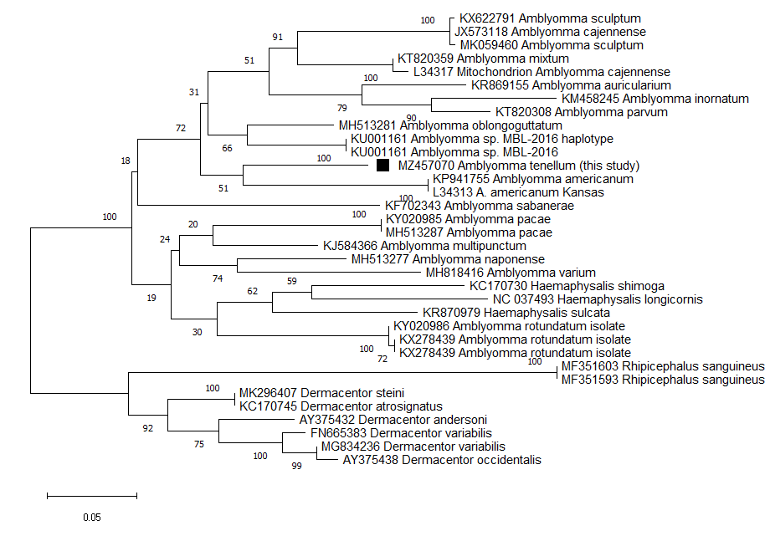
Supplement 1. Phylogenetic tree of Mitochondrial 16S ribosomal RNA gene from Amblyomma tenellum, inferred using the Maximum Likelihood method based on the General Time Reversible model with a discrete Gamma distribution (1.0). The bootstrap consensus tree inferred from 1000 replicates, a total of 376 nucleotides were analyzed. The square corresponds to the sequence obtained from A. tenellum in this study. (GenBank accession number: MZ457070).

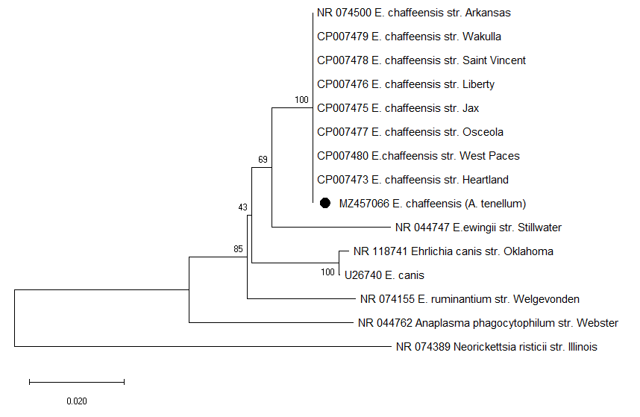

Supplement 2. Phylogenetic tree of 16srRNA gene from Ehrlichia chaffeensis, inferred using the Neighbor-Joining method. The bootstrap consensus tree inferred from 1000 replicates, a total of 418 nucleotides were analyzed. The circle ● corresponds to the sequence obtained in this study. (GenBank accession number: MZ457066).

