**Characterization of the Emissions and Crystalline Silica Content of Airborne Dust Generated from Grinding Natural and Engineered Stones**

Drew Thompson and Chaolong Qi*

Centers for Disease Control and Prevention

National Institute for Occupational Safety and Health

Division of Field Studies and Engineering

Cincinnati, OH 45226, USA

*Author to whom correspondence should be addressed: Chaolong Qi; Phone: (001) 513-841-4532; e-mail: hif1@cdc.gov

**Laboratory testing system**

The laboratory testing system used in this study, designed and operated to comply with European Standard EN 1093-3 (CEN, 2006), is given in Figure S1. The system consisted of an enclosed chamber where the airborne dust was generated, a funnel, and a duct where the airborne dust was sampled. A house ventilation system equipped with a variable-speed blower drew room air into the test system through pre- and HEPA filters. The flow rate was monitored by a micromanometer (AirflowTM MEDM 500, Airflow Developments LTD., UK) connected to a delta tube (306AM-11-AO, Midwest instruments, USA) which functioned as an averaging pitot tube. Under the operating flow rate used in this study, the average flow velocity in the chamber was 0.11 m s-1, meeting the standard’s requirement that the average flow be larger than or equal to 0.1 m s-1 for the transport of respirable dust. The Reynolds numbers for the chamber and duct were 9,100 and 46,000, respectfully, indicating that the flow was turbulent. Turbulent flow causes aerosol mixing and allows for collection of representative samples in the sampling section. After the sampling section, air was passed through the filter cartridges inside an air handling unit (PSKB-1440, ProVent LLC, USA) that was not driving airflow before discharging into the house ventilation duct.

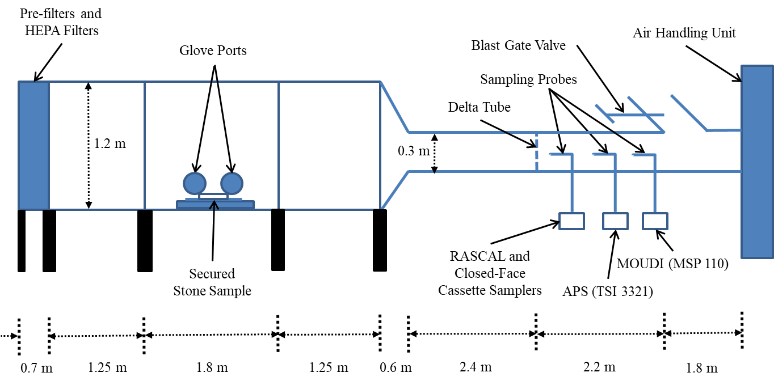

Figure S*.* Diagram of the laboratory testing system.

Three isoaxial sampling probes extracted aerosols from the duct of the testing system. Probes were connected to their respective samplers using metallic fittings and Tygon® or conductive silicone tubing to minimize particle losses caused by electrostatic effects. Figure S2 shows how the sampled aerosol flow was distributed to RASCAL and closed-face cassette samplers for each experimental run. The aerosol flow was split by first passing through a wye fitting followed by a 4-way flow splitter (Model 3708, TSI Inc., USA) on both branches. The sampling flow rates for the RASCAL and closed-face cassette samplers were provided by Leland Legacy Sample Pumps (SKC Inc., USA). Note that in Figure S2(b) for the first experimental run of Stone C, two ports of a 4-way flow splitter show flow rates of 0-9 l min-1. This is because two pumps collecting samples unrelated to this study malfunctioned and turned off mid-run.

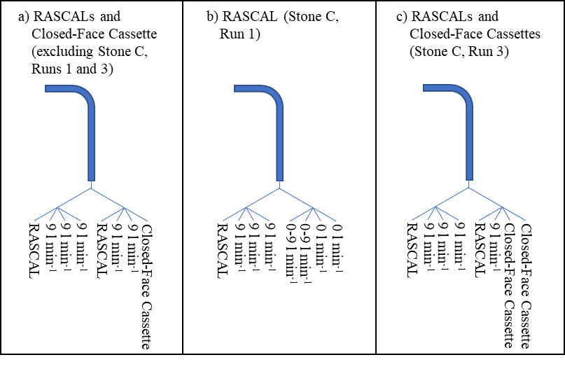

Figure S. Differing sampling train configurations for RASCAL and closed-face cassette samplers for each stone/experimental run.

**Estimation of sampling efficiency**

Aerosol sampling efficiency was estimated using the framework outlined by Brockmann (2011) and calculated as the product of the inlet efficiency and transport efficiency. Inlet efficiency was the product of the isoaxial aspiration efficiency (Liu et al., 1989) and the inertial transmission efficiency for isoaxial sub-isokinetic (Liu et al., 1989) or super-isokinetic sampling (Hangal and Willeke, 1990). The transport efficiency was the product of the following transport efficiencies for laminar flow in a tube with circular cross section: gravitational settling in a straight horizontal tube (Thomas, 1958), diffusion (Gormley and Kennedy, 1948), inertial deposition in a bend (Brockmann, 2011; Pui et al., 1987), and inertial deposition in a flow contraction (Muyshondt et al., 1996). No attempt was made to account for particle losses in the flow divisions of the wye-fitting and 4-way flow splitters in the RASCAL and closed-face cassette sampling train. Additionally, losses due to the Saffman lift force (Vincent, 2007) were excluded from the analysis. Particles were assumed to be spherical with a standard density (1000 kg m-3).

Estimated inlet, transport, and sampling efficiencies are plotting in Figure S3 for the (a) APS, (b) MOUDI, and (c, d) RASCAL/closed-face cassette samplers. Figure S3(c) and (d) also display the ACGIH criterion for the respirable fraction (Vincent, 2007) for reference. Note that Figure S3(d) shows the estimated sampling efficiency for the RASCALs for the first experimental run of Stone C. In this run two pumps collecting samples unrelated to this study that were operating at 9 l min-1 malfunctioned and turned off. Because of this, two curves are plotted for each efficiency. One represents when those pumps were on and the other when they were off. A hatched area fills the space between the two curves.

Figure S. Estimated inlet, transport, and sampling efficiencies for the (a) APS, (b) MOUDI, (c) RASCALs and closed-face cassettes (excluding Stone C, run 1), and (d) RASCAL (Stone C, run 1). The respirable fraction criterion is included for reference in (c) and (d).

**Treatment of APS data**

The particle shape and density correction for the APS outlined by Marshall et al. (1991) is identical to the density correction algorithm that is implemented into AIM (Wang and John, 1987) if the particle density, $ρ_{p}$, is replaced by the particle density divided by the dynamic shape factor, $ρ_{p}/χ$. In this study particle density and dynamic shape factor were assumed to be particle size-independent and particle density was assumed to be equal to the bulk material density of the stone samples.

Particle dynamic shape factor was unknown and found in the following manner. The mass in APS channel $i$ at time $t$, $m_{i,t}$, was found using Equation S1 where $n_{i,t}$ is the particle count in channel $i$ at time $t$ and ${d_{v}}_{i}$ is the particle volume diameter at the midpoint of channel $i$.

|  |  |  |
| --- | --- | --- |
|  | $$m_{i,t}=\frac{π}{6}ρ_{p}n_{i,t}{d_{v}}_{i}^{3}$$ | Equation S |

Particle volume diameter was related to the particle aerodynamic diameter, $d_{a}$, by Equation S2 where $ρ_{0}$ is a standard density of 1000 kg m-3 (Hinds, 1999).

|  |  |  |
| --- | --- | --- |
|  |  | Equation S |

The respirable mass sampled by the APS, $m_{APS, respir}$, was then found by Equation S3 where $R_{i}$ is the ACGIH criterion for the respirable fraction (Vincent, 2007) calculated at the midpoint of channel $i$.

|  |  |  |
| --- | --- | --- |
|  | $$m_{APS, respir}=\sum_{t}{\sum_{i}{R_{i}m_{i,t}}}$$ | Equation S |

The sum of the squared residuals, $S$, was then determined using Equation S4 where ${{\overline{m}}_{RASCAL}}_{j}$ is the average respirable mass collected by the RASCAL samplers in experiment run $j$, $Q_{RASCAL}$ is the flowrate of the RASCAL sampler (9.0 l min-1), and is the aerosol sample flowrate in the APS (1.0 l min-1).

|  |  |  |
| --- | --- | --- |
|  |  | Equation S |

The estimated dynamic shape factor was then identified by minimizing the sum of the squared residuals as demonstrated in Figure S4. The best fit dynamic shape factors are listed in Table S1 and ranged from 1.5 to 1.7. These values were comparable to those found by (Davies, 1979) for quartz (1.36) and sand (1.57).

Figure S. Sum of squared residuals from APS-derived respirable mass as a function of particle dynamic shape factor. Plotted curves are simple spline curves generated by SigmaPlot (v14.5, Inpixon, USA).

After correcting for particle shape and density, the particle number distribution measurements, ${dN}/{d\log{d_{a}}}$, were averaged over the periods of active grinding from the three experimental runs. Trimodal lognormal size distribution functions, as defined in Equation S5, were then fit to the APS-measured number-based particle size distributions using the Trust Region Reflective minimization algorithm (Branch et al., 1999) implemented in the Python package SciPy (Virtanen et al., 2020). Here, $N_{i}$ is the number concentration of mode $i$, ${μ_{g}}_{i}$ is the geometric mean aerodynamic diameter of mode $i$, and ${σ_{g}}_{i}$ is the geometric standard deviation of mode $i$.

|  |  |  |
| --- | --- | --- |
|  | $$f\left(d_{a}\right)=\sum_{i=1}^{3}{\frac{N_{i}}{\sqrt{2π}\ln{{σ_{g}}_{i}}}\exp\left[-\frac{{\left(\ln{d_{a}}-\ln{{μ_{g}}_{i}}\right)}^{2}}{2{\left(\ln{{σ_{g}}_{i}}\right)}^{2}}\right]}$$ | **Equation S5** |

Parameters for the best fit distribution are summarized in Table S1. Note that for convenience the total number concentration, $N_{T}=\sum_{i=1}^{3}{N_{i}}$, was factored out of the results to allow for easier comparisons of the weight of each mode, $f_{i}$, where $f_{i}={N_{i}}/{N_{T}}$.

Table S. Best fit dynamic shape factor and trimodal lognormal distribution parameters (and resulting coefficient of determination, $R^{2}$) for number-weighted particle size distributions as a function of aerodynamic diameter as measured by APS.

|  |  |  |  |  |  |  |  |  |  |  |  |  |
| --- | --- | --- | --- | --- | --- | --- | --- | --- | --- | --- | --- | --- |
| Stone | (-) | (cm-3) | (-) | (µm) | (-) | (-) | (µm) | (-) | (-) | (µm) | ${σ_{g}}_{3}$ (-) | $R^{2}$ (-) |
| Granite | 1.7 | 6500 | 0.0701 | 1.03 | 1.25 | 0.893 | 1.96 | 1.75 | 0.0373 | 6.88 | 1.24 | 0.999 |
| A | 1.5 | 4290 | 0.374 | 1.09 | 1.45 | 0.525 | 2.32 | 1.47 | 0.101 | 5.44 | 1.41 | 0.999 |
| B | 1.5 | 5580 | 0.328 | 1.11 | 1.43 | 0.550 | 2.34 | 1.49 | 0.122 | 5.59 | 1.41 | 0.999 |
| C | 1.6 | 6890 | 0.240 | 1.08 | 1.40 | 0.643 | 2.31 | 1.53 | 0.117 | 5.81 | 1.37 | 0.999 |

**Potential effect of particle bounce on the measurement of silica content in MOUDI samples**

Supermicrometer particles are more prone to bouncing than submicrometer particles (Marple and Olson, 2011). The hardness of particles influences particle bounce, with those made of softer materials bouncing less due to undergoing more plastic deformation upon impact (Hinds et al., 1985). If particles have a distribution of crystalline silica content due to heterogeneity in engineered stone, one might expect particles containing a higher percentage of crystalline silica will be harder and, thus, bounce more frequently. This would cause not only a negative bias on the stages where the bouncing occurs, but also a positive bias where those bounced particles are finally collected on subsequent stages. Such behavior might explain why for Stone A the first two MOUDI stages had crystalline silica content lower than the bulk dust, while the third stage had the highest crystalline silica content of all stages. For the case of the MOUDI-derived total size fraction, the crystalline silica content was estimated from the sum of the masses on each stage. Thus, particle bounce would have no effect on its arithmetic mean. For MOUDI-derived respirable fraction, the mass collected on each MOUDI stage was weighted by the respirable fraction criterion at the midpoint aerodynamic diameter of that stage. In this instance, particle bounce would affect the estimation of crystalline silica content.

Chubb and Cauda (2017) presented a sampling strategy to address the positive bias due to particle bounce in the MOUDI when using uncoated substrates for silica analysis. Two MOUDIs collected concurrent samples with substrates on each stage alternating between PVC filters and aluminum foil coated with grease. One MOUDI had PVC filters on the even number stages and the other MOUDI had them on the odd stages. This strategy, however, did not address the negative bias introduced by particle bounce. The present study did not employ this strategy because the use of a second MOUDI would have come at the expense of other concurrent samplers due to the limited number of sample ports in the testing system.

**Additional tables and figures**

Table S2. *p*-values from Welch’s ANOVA test to determine whether the crystalline silica content collected by the following samplers was equal: (1) all individual MOUDI stages and (2) all size-integrated samples (RASCAL, closed-face cassette, MOUDI-derived respirable dust, and MOUDI-derived total dust). Sample sizes for the MOUDI, RASCAL, and closed-face cassette samples were 3, 6, and 3, respectively.

|  |  |  |
| --- | --- | --- |
|  | MOUDI stages | Size-integrated samples |
| Granite | 0.051 | 0.98 |
| Stone A | 0.030 | 0.92 |
| Stone B | 0.42 | 0.14 |

Table S. *p*-values from Welch’s *t*-test of the null hypothesis that the means of crystalline silica content collected by MOUDI stages and that collected by closed-face cassettes were equal. Sample sizes of both MOUDI and closed-face cassette samples equaled 3.

|  |  |  |  |  |  |  |  |  |  |  |  |  |
| --- | --- | --- | --- | --- | --- | --- | --- | --- | --- | --- | --- | --- |
|  | < 0.056 μm | 0.056 – 0.1 μm | 0.1 – 0.18 μm | 0.18 – 0.32 μm | 0.32 – 0.56 μm | 0.56 – 1 μm | 1 – 1.8 μm | 1.8 – 3.2 μm | 3.2 – 5.6 μm | 5.6 – 10 μm | 10 – 18 μm | > 18 μm |
| Granite | 0.27 | 0.21 | 0.64 | 0.48 | 0.59 | 0.81 | 0.97 | 0.65 | 0.55 | 0.79 | 0.76 | 0.87 |
| Stone A | 0.19 | 0.075 | 0.17 | 0.20 | 0.63 | 0.82 | 0.90 | 0.92 | 0.87 | 0.25 | 0.48 | 0.20 |
| Stone B | 0.30 | 0.11 | 0.65 | 0.78 | 0.53 | 0.64 | 0.20 | 0.77 | 0.41 | 0.35 | 0.25 | 0.37 |

Table S. Arithmetic mean ± standard deviation of the mass and volume removal rate from three experimental runs of grinding of engineered and natural stone samples

|  |  |  |
| --- | --- | --- |
| Stone | Mass removal rate (g min-1) | Volume removal rate (cm3 min-1) |
| Granite | 15.7 ± 2.8 | 6.0 ± 1.1 |
| A | 11.0 ± 1.0 | 5.22 ± 0.50 |
| B | 17.1 ± 2.0 | 8.15 ± 0.96 |
| C | 26.0 ± 6.3 | 10.0 ± 2.4 |

Figure S. Average mass-weighted particle size distributions of dust generated for entire duration of the experimental run for (a) Granite, (b) Stone A, (c) Stone B, and (d) Stone C. Error bars represent the standard deviation of three replicates.

**Supplementary data**

The attached spreadsheets tabulate the experimental data plotted in Figures 1, 2, 3, 4, 5, S4, and S5.





**References**

Branch MA, Coleman TF, Li Y. (1999) A Subspace, Interior, and Conjugate Gradient Method for Large-Scale Bound-Constrained Minimization Problems. *SIAM J Sci Comput*; 21: 1-23.

Brockmann JE. (2011) Aerosol Transport in Sampling Lines and Inlets. *In:* Kulkarni P, Baron PA, Willeke K. (eds.) *Aerosol measurement : principles, techniques, and applications.* Hoboken, NJ: John Wiley & Sons, Inc. ISBN 9780470387412.

CEN. (2006). Safety of machinery - Evaluation of the emission of airborne hazardous substances - Part 3: Test bench method for the measurement of the emission rate of a given pollutant, EN 1093-3. Brussels, Belgium: CEN.

Chubb LG, Cauda EG. (2017). Characterizing Particle Size Distributions of Crystalline Silica in Gold Mine Dust. *Aerosol Air Qual Res*; 17: 24-33.

Davies CN. (1979) Particle-fluid interaction. *J Aerosol Sci*; 10: 477-513.

Gormley PG, Kennedy M. (1948) Diffusion from a Stream Flowing through a Cylindrical Tube. *Proc R Ir Acad Sect A*; 52: 163-169.

Hangal S, Willeke K. (1990). Overall efficiency of tubular inlets sampling at 0–90 degrees from horizontal aerosol flows. *Atmos Environ*; 24: 2379-2386.

Hinds WC. (1999). *Aerosol technology: properties, behavior, and measurement of airborne particles,* New York, NY, John Wiley & Sons, Inc. ISBN 0471194107.

Hinds WC, Liu W-CV, Froines JR. (1985) Particle Bounce in a Personal Cascade Impactor: A Field Evaluation. *Am Ind Hyg Assoc J*; 46: 517-523.

Liu BYH, Zhang ZQ, Kuehn TH. (1989) A numerical study of inertial errors in anisokinetic sampling. *J Aerosol Sc*; 20: 367-380.

Marple VA, Olson BA. (2011) Sampling and Measurement Using Inertial, Gravitational, Centrifugal, and Thermal Techniques. *In:* Kulkarni P, Baron PA, Willeke K. (eds.) *Aerosol measurement : principles, techniques, and applications.* Hoboken, NJ: John Wiley & Sons, Inc. ISBN 9780470387412.

Marshall IA, Mitchell JP, Griffiths WD. (1991) The behaviour of regular-shaped non-spherical particles in a TSI aerodynamic particle sizer. *J Aerosol Sci*; 22: 73-89.

Muyshondt A, Mcfarland AR, Anand NK. (1996) Deposition of Aerosol Particles in Contraction Fittings. *Aerosol Sci Technol*; 24: 205-216.

Pui DYH, Romay-Novas F, Liu BYH. (1987) Experimental Study of Particle Deposition in Bends of Circular Cross Section. *Aerosol Sci Technol*; 7: 301-315.

Thomas JW. (1958) Gravity Settling of Particles in a Horizontal Tube. *J Air Pollut Control Assoc*; 8: 32-34.

Vincent JH. (2007) *Aerosol sampling : science, standards, instrumentation and applications,* Chichester, England, John Wiley & Sons Ltd. ISBN 0470027258.

Virtanen P, Gommers R, Oliphant TE, Haberland M, Reddy T, Cournapeau D, Burovski E, Peterson P, Weckesser W, Bright J, Van Der Walt SJ, Brett M, Wilson J, Millman KJ, Mayorov N, Nelson ARJ, Jones E, Kern R, Larson E, Carey CJ, Polat İ, Feng Y, Moore EW, Vanderplas J, Laxalde D, Perktold J, Cimrman R, Henriksen I, Quintero EA, Harris CR, Archibald AM, Ribeiro AH, Pedregosa F, Van Mulbregt P, Vijaykumar A, Bardelli AP, Rothberg A, Hilboll A, Kloeckner A, Scopatz A, Lee A, Rokem A, Woods CN, Fulton C, Masson C, Häggström C, Fitzgerald C, Nicholson DA, Hagen DR, Pasechnik DV, Olivetti E, Martin E, Wieser E, Silva F, Lenders F, Wilhelm F, Young G, Price GA, Ingold G-L, Allen GE, Lee GR, Audren H, Probst I, Dietrich JP, Silterra J, Webber JT, Slavič J, Nothman J, Buchner J, Kulick J, Schönberger JL, De Miranda Cardoso JV, Reimer J, Harrington J, Rodríguez JLC, Nunez-Iglesias J, Kuczynski J, Tritz K, Thoma M, Newville M, Kümmerer M, Bolingbroke M, Tartre M, Pak M, Smith NJ, Nowaczyk N, Shebanov N, Pavlyk O, Brodtkorb PA, Lee P, Mcgibbon RT, Feldbauer R, Lewis S, Tygier S, Sievert S, Vigna S, Peterson S, More S, Pudlik T, Oshima T, et al. (2020) SciPy 1.0: fundamental algorithms for scientific computing in Python. *Nat Methods*; 17: 261-272.

Wang H-C, John W. (1987) Particle Density Correction for the Aerodynamic Particle Sizer. *Aerosol Sci Technol*; 6: 191-198.