Supplemental Materials
Characterizing exposure to benzene, toluene, and naphthalene in firefighters wearing different types of new or laundered PPE

Alexander C. Mayer, Kenneth W. Fent, Andrea Wilkinson, I-Chen Chen, Steve Kerber, Denise L. Smith, Richard M. Kesler, and Gavin P. Horn
Keywords: Personal protective equipment (PPE), firefighters, exposure assessment, volatile organic compounds (VOCs), breath, benzene

Correspondence to:
Alexander Mayer, MPH
Division of Field Studies and Engineering
National Institute for Occupational Safety and Health
1090 Tusculum Ave, MS R-14
Cincinnati, OH 45226
(work) 513.458-7180
(fax) 513.841-4486

Tables

Table S1. Summary of airborne concentrations of total PAHs for measurements taken from pumps affixed to turnout jackets in the chest region from standing mannequins and firefighters.
Analytes | Measure On | N | Mean | Median | Range
Total PAHs (µg/m³) | Standing Mannequin | 12 | 189,000 | 196,000 | 40,400 – 315,000
 | Mobile Firefighter | 48 | 45,800 | 51,000 | 6,780 – 152,000

Table S2. Change (post-pre) in toluene concentrations (ppbv) in exhaled breath samples collected from firefighters stratified by hood design and treatment.
Analytes | Hood Design | N | Mean | Median | Range | P-value  (Testing Difference of Post and Pre) | P-value  (Comparisons of Hood Designs)
Toluene | New-Knit (K) | 24 | 0.24 | 0.14 | -0.89 – 1.46 | 0.050 | Reference
 | New-Blocking (B) | 24 | 0.13 | 0.00 | -2.09 – 2.19 | 0.570 | 0.707 | Reference
 | Laundered-Blocking (L) | 24 | -0.01 | 0.00 | -3.49 – 3.34 | 0.983 | 0.413 | 0.656

Table S3. Correlation between under and outside turnout jacket air samples and the change in exhaled breath toluene concentrations stratified by treatment (excluding new knit hood grouping).
Outcome | Change in Pre- to Post-Shift Exhaled Breath Toluene Concentrations
Covariate | Estimate | SE | P-value
Outside Jacket Samples (B+L) | -0.0003 | 0.0002 | 0.260
Inside Jacket Samples (B+L) | 0.0003 | 0.0003 | 0.234
Stratify by Treatment
Outside New-Blocking (B) | -0.0001 | 0.0004 | 0.799
Under New-Blocking (B) | 0.0006 | 0.0003 | 0.047
Outside Laundered-Blocking (L) | -0.0003 | 0.0003 | 0.287
Under Laundered-Blocking (L) | -0.0001 | 0.0005 | 0.822

Figures

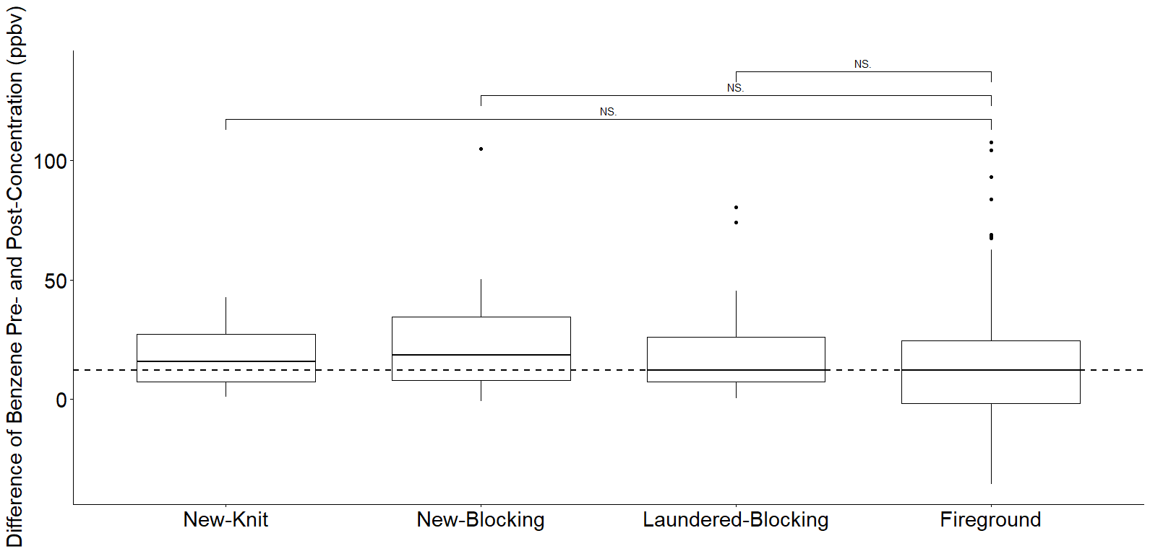
Figure S1. Box-and-whisker plots of the change (post-pre) of benzene concentrations (ppbv) in exhaled breath by PPE ensemble including hood design/treatment and sample collection time. The change in breath concentrations of benzene measured during our previous fireground study (Fent et al. 2020) is also provided for reference (used as a referent group for Student’s t tests; “NS” represents non-significant). The dashed line represents the median change in breath concentration for the fireground study. The box represents the interquartile range (IQR), the horizontal line in each box represents the median, the upper whisker represents the upper fence 1.5 IQR above the 75th percentile, the lower whisker represents the lower fence 1.5 IQR below the 25th percentile, and the dots represent potential outliers.

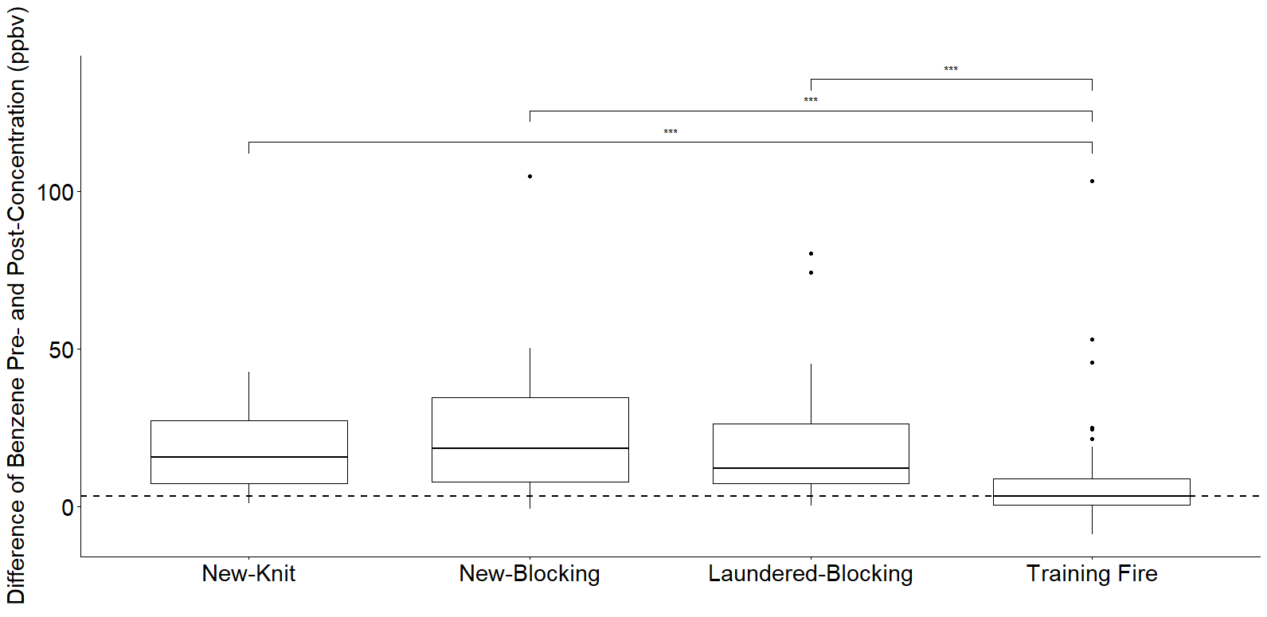
Figure S2. Box-and-whisker plots of the change (post-pre) of benzene concentrations (ppbv) in exhaled breath by PPE ensemble including hood design/treatment and sample collection time. The change in breath concentrations of benzene measured during our previous training fire study (Fent et al., 2019b) is also provided for reference (used as a referent group for Student’s t tests; “***” represents p-value < 0.001). The dashed line represents the median change in breath concentration for the training fire study. The box represents the interquartile range (IQR), the horizontal line in each box represents the median, the upper whisker represents the upper fence 1.5 IQR above the 75th percentile, the lower whisker represents the lower fence 1.5 IQR below the 25th percentile, and the dots represent potential outliers.

