Supplementary materials

Figure S1. Flow diagram of study population
Figure S2. Spearman correlation coefficients matrix between log-transformed urinary phenols and parabens concentrations.
Table S1. Least square geometric mean with 95% confidence intervals of serum adipokine levels stratified by race.
Table S2. Distribution of standardized concentrations of log-transformed urinary phenols and parabens
Table S3. P-value for interaction between urinary phenols and parabens and race group.
Figure S3. Percent change (95% confidence interval) in serum adipokine levels for an inter-quartile range increase in standardized log-transformed average concentrations of urinary phenols and parabens.
Figure S4. Boxplot of urinary methyl paraben stratified by race. Red circle represents the mean of urinary methyl paraben.
Figure S5. Relationship between log-transformed exposures at MPS baseline (1999-2000) and MPS Follow-up visit (2002-2003).
Table S4. Percent change (95% confidence interval) in serum adipokine levels for an inter-quartile range increase in standardized log-transformed urinary concentrations of phenols and parabens with additional adjustment for urinary monoethyl phthalate.
Table S5. Percent change (95% confidence interval) in serum adipokine levels for an inter-quartile range increase in standardized log-transformed urinary concentrations of phenols and parabens by obesity status.
Table S6. Difference (95% credible interval) in predicted serum HMW-Adiponectin and sOB-R levels when the standardized concentrations of log-transformed urinary phenols and parabens were increased from their 25th to 75th percentile via Bayesian kernel machine regression (BKMR)

Figure S1. Flow diagram of study population

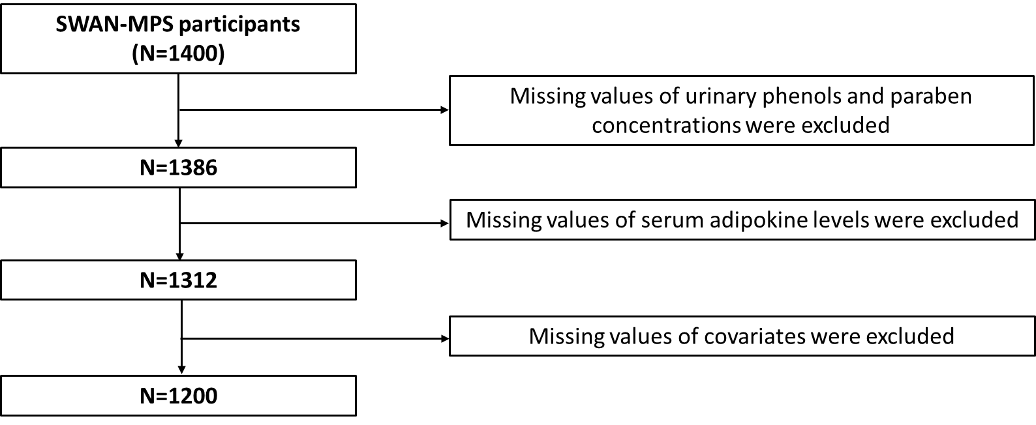

Figure S2. Spearman correlation coefficients matrix between log-transformed urinary phenols and parabens concentrations.
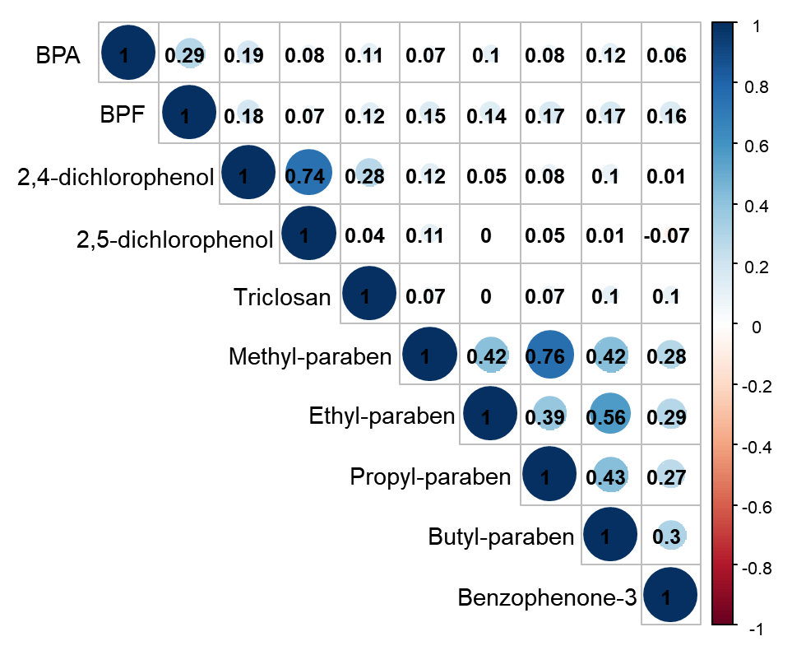
Note: The color intensity of circle in boxes indicates the magnitude of correlation. Blue and red color represents a positive and negative correlation, respectively. BPA, bisphenol A; BPF, bisphenol F.

Table S1. Least square geometric mean with 95% confidence intervals of serum adipokine levels stratified by race.
 | White | Black | Asian
HMW adiponectin, μg/mL | 6.39 (5.76,7.09) | 3.70 (3.22,4.25) | 4.37 (3.81,5.01)
Leptin, ng/mL | 21.98 (20.17,23.95) | 25.06 (22.33,28.12) | 13.47 (12.02,15.09)
sOB-R, ng/mL | 30.02 (28.87,31.21) | 27.78 (26.37,29.27) | 29.45 (27.97,31.01)
Abbreviation: HMW, High molecular weight; sOB-R, soluble leptin receptor.
All models were adjusted for age, site, education level, smoking status, menopausal status, physical activity score, total caloric intake (per day), and obesity status.

Table S2. Distribution of standardized concentrations of log-transformed urinary phenols and parabens
 | Detection rate (%) | All subjects | White | Black | Asian
BPA | 82.98 | -0.02 (-0.54,0.56) | 0.04 (-0.46,0.58) | 0.10 (-0.46,0.65) | -0.25 (-0.71,0.4)
BPF | 73.32 | -0.08 (-0.67,0.57) | 0.02 (-0.58,0.63) | -0.05 (-0.67,0.66) | -0.29 (-0.82,0.27)
2,4-dichlorophenol | 98.50 | -0.21 (-0.65,0.37) | -0.38 (-0.76,0.09) | 0.23 (-0.23,0.89) | -0.16 (-0.63,0.52)
2,5-dichlorophenol | 99.79 | -0.22 (-0.71,0.45) | -0.5 (-0.84,0.06) | 0.42 (-0.08,1.08) | -0.15 (-0.70,0.69)
Triclosan | 80.83 | -0.13 (-0.73,0.57) | -0.2 (-0.75,0.53) | 0 (-0.53,0.55) | -0.17 (-0.82,0.73)
Methyl paraben | 99.71 | 0.14 (-0.61,0.67) | 0.01 (-0.79,0.53) | 0.54 (-0.03,1.13) | 0.10 (-0.59,0.56)
Ethyl paraben | 58.94 | -0.24 (-0.81,0.67) | -0.28 (-0.85,0.62) | -0.41 (-0.84,0.56) | -0.1 (-0.68,0.81)
Propyl paraben | 97.71 | 0.17 (-0.69,0.77) | 0.05 (-0.79,0.75) | 0.42 (-0.37,0.83) | 0.17 (-0.76,0.74)
Butyl paraben | 52.79 | -0.22 (-0.77,0.69) | -0.3 (-0.78,0.64) | -0.43 (-0.81,0.46) | 0.13 (-0.7,1.03)
Benzophenone-3 | 97.42 | -0.14 (-0.83,0.7) | 0.01 (-0.72,0.71) | -0.69 (-1.1, -0.1) | 0.09 (-0.75,1.01)
Data are expressed as median (1st quartile, 3rd quartile).

Table S3. P-value for interaction between urinary phenols and parabens and race group.
 | HMW-Adiponectin | Leptin | s-OB R
BPA | 0.226 | 0.476 | 0.510
BPF | 0.536 | 0.412 | 0.680
2,4-dichlorophenol | 0.290 | 0.929 | 0.396
2,5-dichlorophenol | 0.508 | 0.952 | 0.287
Triclosan | 0.029* | 0.460 | 0.441
Methyl paraben | 0.817 | 0.001* | 0.626
Ethyl paraben | 0.693 | 0.478 | 0.566
Propyl paraben | 0.382 | 0.030* | 0.291
Butyl paraben | 0.541 | 0.628 | 0.866
Benzophenone-3 | 0.696 | 0.169 | 0.770
Abbreviation: HMW, High molecular weight; sOB-R, soluble leptin receptor.
All models were adjusted for age, race, site, education level, smoking status, menopausal status, physical activity score, total caloric intake (per day), and obesity status.

Figure S3. Percent change (95% confidence interval) for serum adipokine levels of change in an inter-quantile range of standardized log-transformed average concentrations of urinary phenols and parabens. All models were adjusting for age, site, education level, smoking status, menopausal status, physical activity score, total caloric intake (per day), and obesity status. Abbreviation: HMW, High molecular weight; sOB-R, soluble leptin receptor.
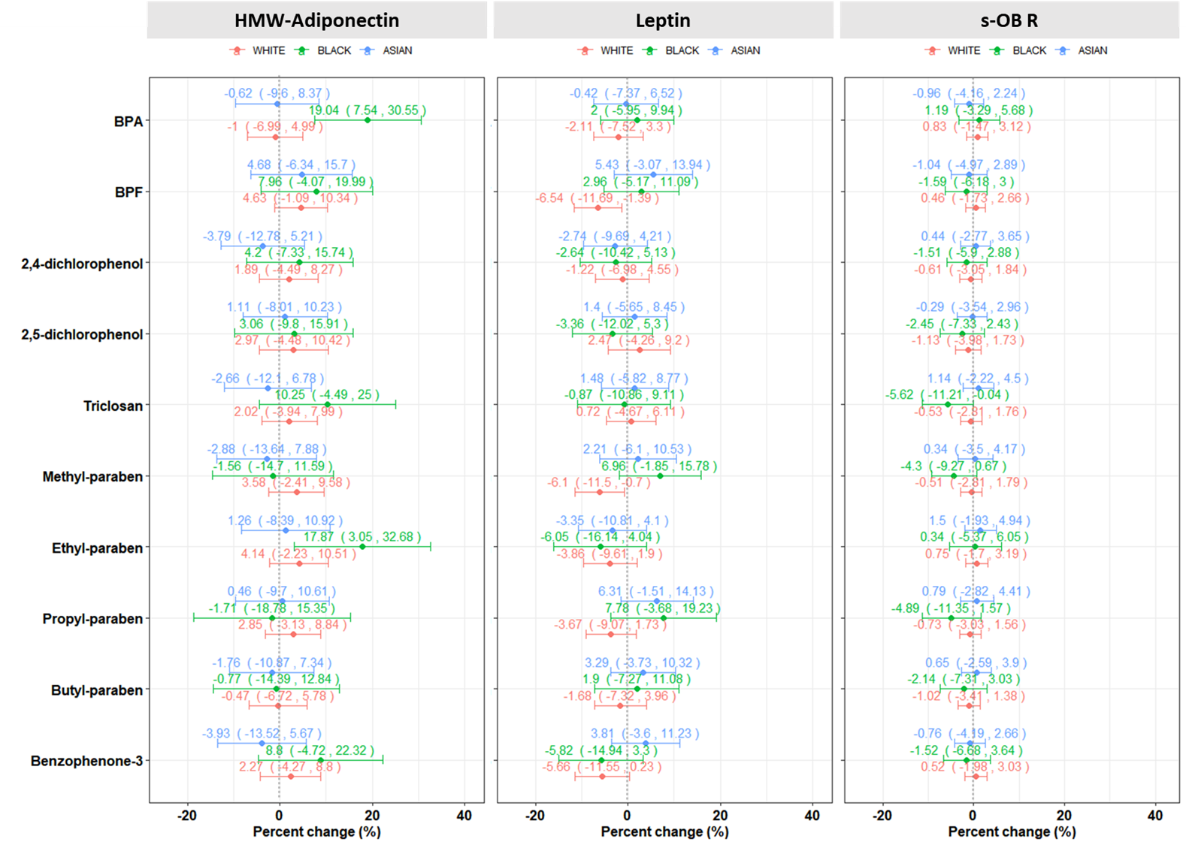

Figure S4. Boxplot of urinary methyl paraben stratified by race. Red circle represents the mean of urinary methyl paraben.
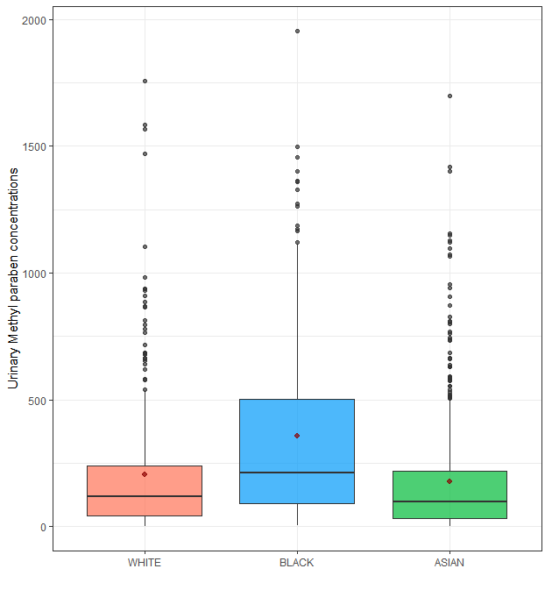

Figure S5. Relationship between log-transformed exposures at MPS baseline (1999-2000) and MPS Follow-up visit (2002-2003).
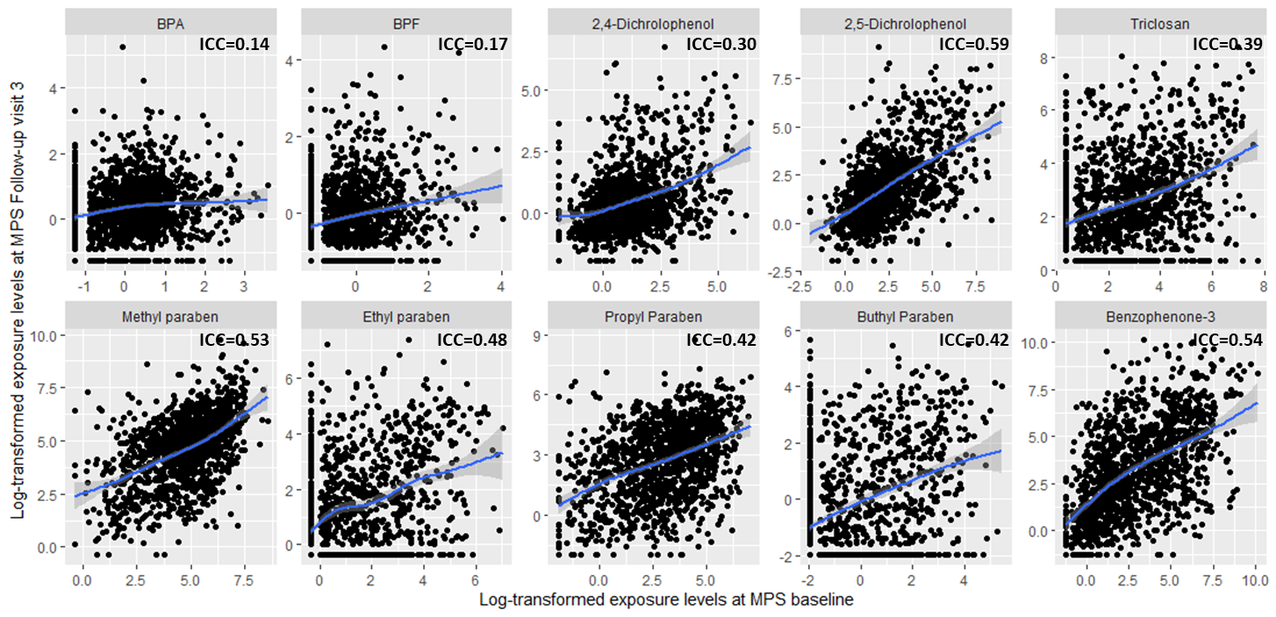
Note: The solid blue line and grey scales represent the smooth lines and 95% confidence interval, respectively. MPS, multi-pollutant study; BPA, bisphenol A; BPF, bisphenol F; 2,4-DCP, 2,4-dichlorophenol; 2,4-DCP, 2,5-dichlorophenol; TCS, triclosan; METB, methyl-paraben; ETPB, ethyl-paraben; PRPB, propyl paraben; BUPB, butyl paraben; BP3, benzophenone-3; ICC, intra-class correlation
Table S4. Percent change (95% confidence interval) in serum adipokine levels for an inter-quartile range increase in standardized log-transformed urinary concentrations of phenols and parabens with additional adjustment for urinary monoethyl phthalate (MEP).
Phenols and parabensª | Additional adjustment for MEP
 | HMW-Adiponectin^{b} | Leptin^{b} | sOB-R^{b}
BPA | 1.05 (-3.97, 6.06) | 0.23 (-3.93, 4.39) | 0.76 (-1.12, 2.63)
BPF | 8.10 (-0.06, 16.3) | -2.79 (-7.49, 1.90) | 2.46 (0.35, 4.58)
2,4-dichlorophenol | 6.03 (1.20, 10.9) | -1.81 (-5.83, 2.22) | 1.28 (-0.54, 3.09)
2,5-dichlorophenol | 5.07 (-0.68, 10.8) | -0.16 (-4.94, 4.61) | 0.64 (-1.52, 2.79)
Triclosan | 1.24 (-4.70, 7.18) | 2.07 (-2.86, 7.00) | 2.06 (-0.16, 4.28)
Methyl paraben | 1.70 (-4.70, 8.09) | -6.60 (-11.9, -1.31) | 2.51 (0.12, 4.90)
Ethyl paraben | 5.08 (-1.85, 12.0) | -5.15 (-10.9, 0.60) | 2.81 (0.22, 5.40)
Propyl paraben | 4.51 (-2.57, 11.6) | -5.41 (-11.3, 0.46) | 2.44 (-0.21, 5.08)
Butyl paraben | 3.55 (-3.33, 10.4) | -2.86 (-8.57, 2.86) | 0.98 (-1.60, 3.56)
Benzophenone-3 | 1.17 (-6.14, 8.48) | -5.10 (-11.2, 0.96) | 1.47 (-1.27, 4.20)
Abbreviation: MEP, Monoethyl phthalate, HMW, High molecular weight; sOB-R, soluble leptin receptor.
ªAll urinary phenols, parabens, and phthalates concentrations were log-transformed and standardized.
^{b}All models were adjusted for age, race, site, education level, smoking status, menopausal status, physical activity score, and total caloric intake (per day).

Table S5. Percent change (95% confidence interval) in serum adipokine levels for an inter-quartile range increase in standardized log-transformed urinary concentrations of phenols and parabens stratified by obesity status.
Phenols and parabensª | Normal and overweight group  (N=749) |  |  | Obese group  (N=451)
 | HMW-Adiponectin^{b} | Leptin^{b} | sOB-R^{b} | HMW-Adiponectin^{b} | Leptin^{b} | sOB-R^{b}
BPA | 6.11 (-0.09,12.31) | 0.91 (-5.33,7.14) | 1.8 (-0.66,4.26) | -5.53 (-13.98,2.92) | 0.12 (-4.42,4.67) | -1.14 (-4.06,1.78)
BPF | 12.43 (2.54,22.32) | -3.31 (-10.21,3.58) | 2.65 (-0.07,5.38) | -0.12 (-14.2,13.96) | -1.17 (-6.41,4.06) | 1.88 (-1.48,5.25)
2,4-dichlorophenol | 9.71 (3.79,15.62) | -2.1 (-8.07,3.87) | 1.27 (-1.09,3.63) | 1.43 (-6.89,9.74) | -1.46 (-5.92,3.00) | 0.88 (-1.99,3.75)
2,5-dichlorophenol | 10.31 (3.35,17.26) | 0.26 (-6.75,7.27) | 0.38 (-2.4,3.15) | -2.78 (-12.9,7.35) | -1.4 (-6.84,4.03) | 0.59 (-2.9,4.09)
Triclosan | 1.64 (-5.21,8.48) | 2.68 (-4.18,9.54) | 2.16 (-0.55,4.87) | 1.41 (-9.68,12.5) | 1.43 (-4.52,7.39) | 1.83 (-2,5.65.00)
Methyl paraben | 2.38 (-5.22,9.99) | -7.02 (-14.63,0.59) | 1.77 (-1.24,4.78) | -1.7 (-12.09,8.69) | -2.85 (-8.42,2.72) | 3.09 (-0.48,6.67)
Ethyl paraben | 5.23 (-2.71,13.16) | -1.36 (-9.33,6.61) | 3.47 (0.33,6.61) | 2.3 (-10.76,15.35) | -8.73 (-15.69,-1.77) | -0.11 (-4.62,4.40)
Propyl paraben | 6.76 (-1.41,14.93) | -2.71 (-10.91,5.49) | 2.58 (-0.66,5.81) | -3.55 (-15.62,8.52) | -6.23 (-12.69,0.22) | 1.89 (-2.27,6.06)
Butyl paraben | 5.79 (-2.11,13.7) | -1.56 (-9.49,6.38) | 1.52 (-1.61,4.66) | -2.72 (-15.62,10.18) | -3.73 (-10.65,3.19) | -0.61 (-5.07,3.84)
Benzophenone-3 | -1.51 (-10.09,7.06) | -5.86 (-14.44,2.73) | 1.69 (-1.71,5.08) | 5.13 (-8.42,18.68) | -1.14 (-8.42,6.13) | 0.43 (-4.25,5.11)
Abbreviation: HMW, High molecular weight; sOB-R, soluble leptin receptor.
ªAll urinary phenols and parabens concentrations were log-transformed and standardized.
^{b}All models were adjusted for age, race, site, education level, smoking status, menopausal status, physical activity score, and total caloric intake (per day).

Table S6. Difference (95% credible interval) in predicted serum HMW-Adiponectin and sOB-R levels when the standardized concentrations of log-transformed urinary phenols and parabens were increased from their 25th to 75th percentile via Bayesian kernel machine regression (BKMR)
 | HMW-Adiponectin |  |  | sOB-R
 | Whiteª  (N=630) | Blackª  (N=232) | Asianª  (N=338) | Whiteª  (N=630) | Blackª  (N=232) | Asianª  (N=338)
BPA | -2.02 (-15.52,11.47) | 0.44 (-3.11,4.00) | 0.08 (-1.88,2.04) | 1.65 (-16.12,19.43) | -0.34 (-2.79,2.11) | -0.16 (-6.84,6.52)
BPF | 0.11 (-3.81,4.04) | -0.73 (-8.06,6.61) | -1.4 (-8.65,5.85) | -0.49 (-10.58,9.60) | -0.25 (-2.74,2.24) | -0.23 (-3.77,3.31)
2,4-dichlorophenol | 0.07 (-2.77,2.91) | -1.20 (-9.03,6.62) | 0.86 (-5.75,7.47) | -0.1 (-5.09,4.88) | 0.06 (-1.92,2.04) | 0.64 (-4.59,5.87)
2,5-dichlorophenol | 0.37 (-7.40,8.15) | -0.07 (-1.75,1.60) | 0.24 (-2.15,2.63) | 0.1 (-14.78,14.97) | 0.05 (-2.21,2.31) | 0.09 (-2.95,3.14)
Triclosan | 0.86 (-11.8,13.51) | -0.12 (-2.00,1.77) | -0.17 (-3.04,2.7) | 3.49 (-12.03,19.00) | 1.09 (-6.18,8.37) | 2.9 (-5.81,11.62)
Methyl paraben | -0.54 (-13.58,12.5) | -1.87 (-8.24,4.50) | -0.16 (-6.88,6.56) | -0.07 (-4.42,4.28) | -1.02 (-5.69,3.64) | 0.1 (-2.68,2.87)
Ethyl paraben | 1.95 (-10.45,14.36) | 0.07 (-2.07,2.22) | -0.29 (-3.06,2.48) | 0.32 (-18.48,19.13) | 0.31 (-6.85,7.48) | 0.53 (-4.46,5.53)
Propyl paraben | 0.17 (-7.72,8.07) | -0.14 (-2.20,1.93) | -0.03 (-2.92,2.85) | 2.12 (-13.09,17.33) | -0.04 (-2.42,2.34) | -0.74 (-6.59,5.10)
Butyl paraben | 0.51 (-8.42,9.44) | -0.81 (-8.57,6.94) | -0.78 (-7.52,5.96) | -0.33 (-7.37,6.71) | 0.12 (-1.97,2.21) | -0.2 (-3.38,2.99)
Benzophenone-3 | 0.62 (-7.05,8.29) | -0.11 (-2.65,2.43) | -0.03 (-2.46,2.41) | -0.25 (-8.43,7.93) | 0.29 (-2.33,2.92) | 0.35 (-4.73,5.42)
Overall | -1.09 (-13.27,11.08) | -0.01 (-0.01, 3.76) | 0.95 (-6.5,8.41) | -0.45 (-17.87,16.98) | 0.75 (-0.94,3.69) | 2.38 (-6.63,11.4)
Abbreviation: HMW, High molecular weight; sOB-R, soluble leptin receptor.
ªAll models were adjusted for age, site, education level, smoking status, menopausal status, physical activity score, total caloric intake (per day), and obesity status.

