SUPPLEMENTAL MATERIAL

Table S1. Hemoglobin concentrations by AHA and HemoCue
 |  | Hemoglobin, g/dL¹
 | n | GM (95% CI)
Overall | 896
Hemoglobin, HemoCue |  | 12.1 (12.0, 12.2)
Hemoglobin, (AHA) |  | 11.9 (11.7, 12.0)
Sensitivity Analyses
HemoCue analysis by main laboratory technician | 816
Hemoglobin, HemoCue |  | 12.1 (12.0, 12.2)
Hemoglobin, (AHA) |  | 11.8 (11.7, 12.0)
Non-smokers | 850
Hemoglobin, HemoCue |  | 12.1 (12.0, 12.2)
Hemoglobin, (AHA) |  | 11.9 (11.8, 12.0)
Hb≥8.0 g/dL (no severe anemia) | 870
Hemoglobin, HemoCue |  | 12.3 (12.2, 12.4)
Hemoglobin, (AHA) |  | 12.0 (11.9, 12.1)
WRA <18 y | 44
Hemoglobin, HemoCue |  | 12.0 (11.4, 12.6)
Hemoglobin, (AHA) |  | 11.7 (11.1, 12.4)
WRA ≥18 y | 852
Hemoglobin, HemoCue |  | 12.1 (12.0, 12.2)
Hemoglobin, (AHA) |  | 11.9 (11.7, 12.0)
WRA residing in rural households | 704
Hemoglobin, HemoCue |  | 12.0 (11.8, 12.1)
Hemoglobin, (AHA) |  | 11.8 (11.6, 11.9)
¹Hemoglobin adjusted for smoking (14); Abbreviations: AHA: automated hematology analyzer; WRA: women of reproductive age

Table S2. Comparison of hemoglobin concentrations in venous blood, assessed by HemoCue and AHA
 | AHA vs. HemoCue
Overall
Linn’s Concordance Correlation Coefficient (CCC (95% CI)) | 0.82 (0.80, 0.84)
Bland-Altman relative bias (±2SD limits of agreement) | 0.2 (-1.8, 2.3)
Sensitivity Analyses
HemoCue analysis by main laboratory technician
Linn’s Concordance Correlation Coefficient (CCC (95% CI)) | 0.83 (0.80, 0.85)
Bland-Altman relative bias (±2SD limits of agreement) | 0.2 (-1.7, 2.2)
Non-smokers
Linn’s Concordance Correlation Coefficient (CCC (95% CI)) | 0.82 (0.79, 0.84)
Bland-Altman relative bias (±2SD limits of agreement) | 0.2 (-1.8, 2.2)
Hb≥8.0 g/dL (no severe anemia)
Linn’s Concordance Correlation Coefficient (CCC (95% CI)) | 0.76 (0.73, 0.79)
Bland-Altman relative bias (±2SD limits of agreement) | 0.2 (-1.9, 2.3)
WRA <18 y
Linn’s Concordance Correlation Coefficient (CCC (95% CI)) | 0.90 (0.82, 0.94)
Bland-Altman relative bias (±2SD limits of agreement) | 0.2 (-1.4, 1.9)
WRA ≥18 y
Linn’s Concordance Correlation Coefficient (CCC (95% CI)) | 0.81 (0.79, 0.84)
Bland-Altman relative bias (±2SD limits of agreement) | 0.2 (-1.9, 2.3)
WRA residing in rural households
Linn’s Concordance Correlation Coefficient (CCC (95% CI)) | 0.83 (0.80, 0.85)
Bland-Altman relative bias (±2SD limits of agreement) | 0.2 (-1.9, 2.3)
¹Hemoglobin adjusted for smoking status (14); Abbreviations: CCC: concordance correlation coefficient, SD: standard deviation, WRA: women of reproductive age

Table S3. Diagnostic accuracy parameters of anemia screening methods ¹
 | AHA vs. HemoCue
Overall | % (95% CI)
Sensitivity | 74.8 (70.4, 79.2)
Specificity | 91.2 (88.8, 93.6)
Positive Predictive Value | 85.8 (82.1, 89.6)
Negative Predictive Value | 83.5 (80.5, 86.6)
Accuracy | 84.4 (82.0, 86.8)
Sensitivity Analyses
HemoCue analysis by main laboratory technician
Sensitivity | 74.6 (70.0, 79.2)
Specificity | 92.0 (89.5, 94.4)
Positive Predictive Value | 87.1 (83.2, 90.9)
Negative Predictive Value | 83.3 (80.1, 86.5)
Accuracy | 84.7 (82.2, 87.2)
Non-smokers
Sensitivity | 73.9 (69.2, 78.5)
Specificity | 91.5 (89.1, 94.0)
Positive Predictive Value | 86.0 (82.0, 89.9)
Negative Predictive Value | 83.3 (80.2, 86.5)
Accuracy | 84.3 (81.8, 86.7)
Hb≥8.0 g/dL (no severe anemia)
Sensitivity | 72.9 (68.2, 77.6)
Specificity | 91.2 (88.8, 93.6)
Positive Predictive Value | 84.6 (80.5, 88.7)
Negative Predictive Value | 83.5 (80.5, 86.6)
Accuracy | 83.9 (81.5, 86.3)
WRA <18 y
Sensitivity | 82.4 (64.2, 100.0)
Specificity | 88.9 (77.0, 100.0)
Positive Predictive Value | 82.4 (64.2, 100.0)
Negative Predictive Value | 88.9 (77.0, 100.0)
Accuracy | 86.4 (76.2, 96.5)
WRA ≥18 y
Sensitivity | 74.4 (69.9, 79.0)
Specificity | 91.3 (88.9, 93.8)
Positive Predictive Value | 86.0 (82.2, 89.9)
Negative Predictive Value | 83.3 (80.1, 86.4)
Accuracy | 84.3 (81.8, 86.7)
WRA residing in rural households
Sensitivity | 77.9 (73.2, 82.6)
Specificity | 91.1 (88.3, 93.9)
Positive Predictive Value | 86.6 (82.6, 90.7)
Negative Predictive Value | 84.8 (81.5, 88.2)
Accuracy | 85.5 (82.9, 88.1)
¹Hemoglobin adjusted for smoking status (14); Abbreviations: 95% CI: 95% Confidence Interval

Supplemental Figure Legends

Figure S1. Concordance of hemoglobin concentrations as assessed via HemoCue and AHA

Figure S2. Linn’s Concordance Correlation Coefficient for hemoglobin concentrations assessed via HemoCue and AHA

Figure S3. Bland-Altman plot of differences in hemoglobin concentrations evaluated by HemoCue and AHA compared to mean hemoglobin concentrations, with discordant anemia results highlighted

Figure S4. Area under the curve for anemia and severe anemia
Figure S1. Concordance of hemoglobin concentrations as assessed via HemoCue and AHA

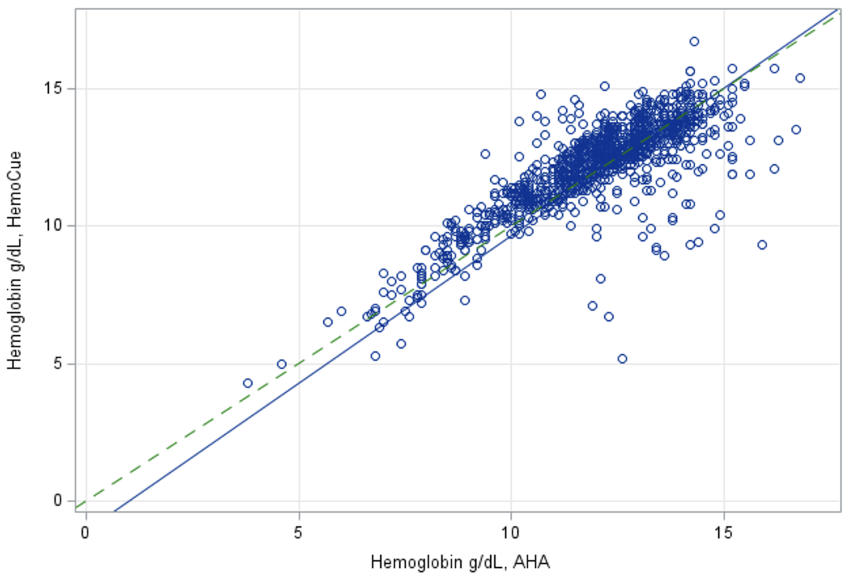

Figure S2. Linn’s Concordance Correlation Coefficient for hemoglobin concentrations assessed via HemoCue and AHA

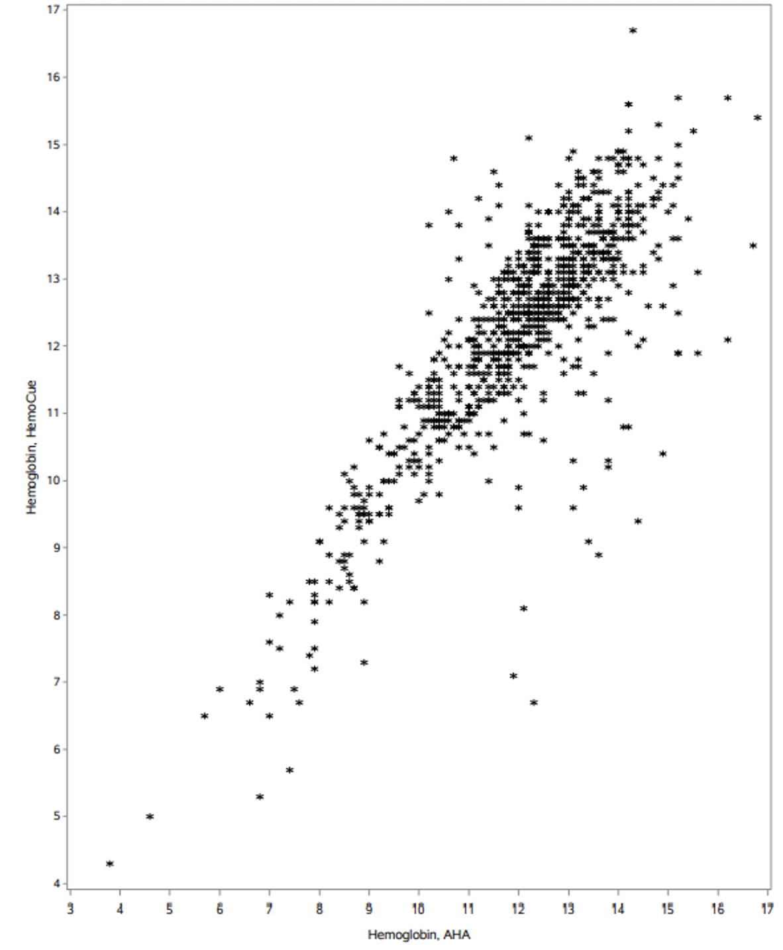

Figure S3. Bland-Altman plot of differences in hemoglobin concentrations evaluated by HemoCue and AHA (HemoCue – AHA) compared to mean hemoglobin concentrations, with discordant anemia results highlighted

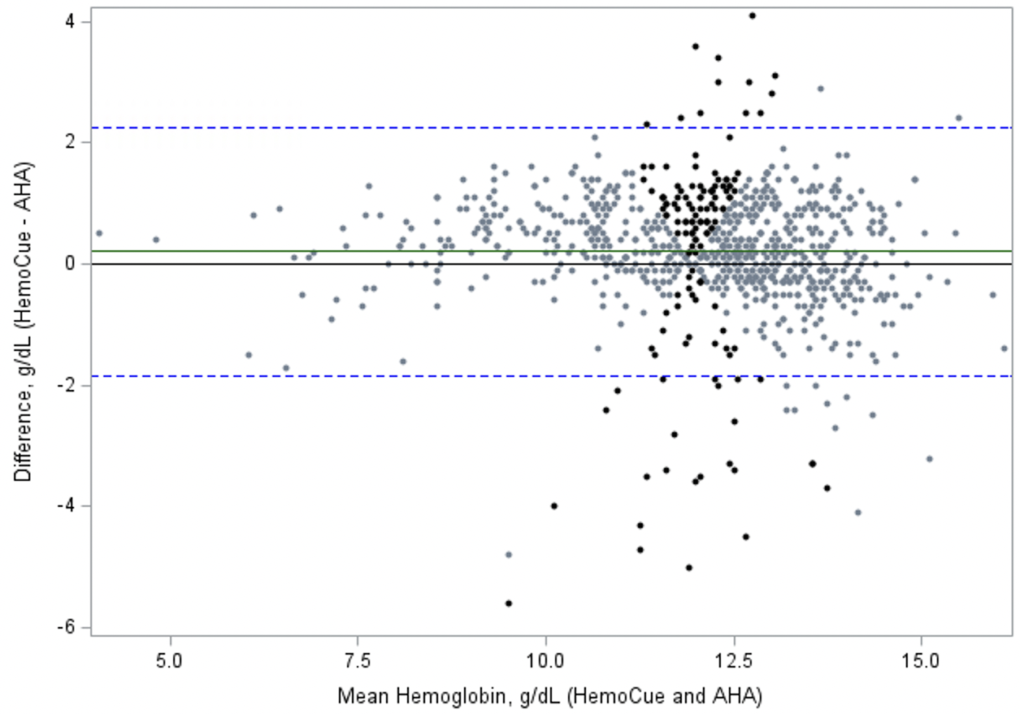

The solid line represents the mean difference (HemoCue –AHA; 0.2 g/dL) and dashed lines represent the limits of agreement (±2 Standard deviation of the difference: -1.8, 2.3). Markers that are bolded (black color) represent datapoints where anemia screening results differed by HemoCue vs. AHA assessment.

Figure S4. Area under the curve for anemia and severe anemia
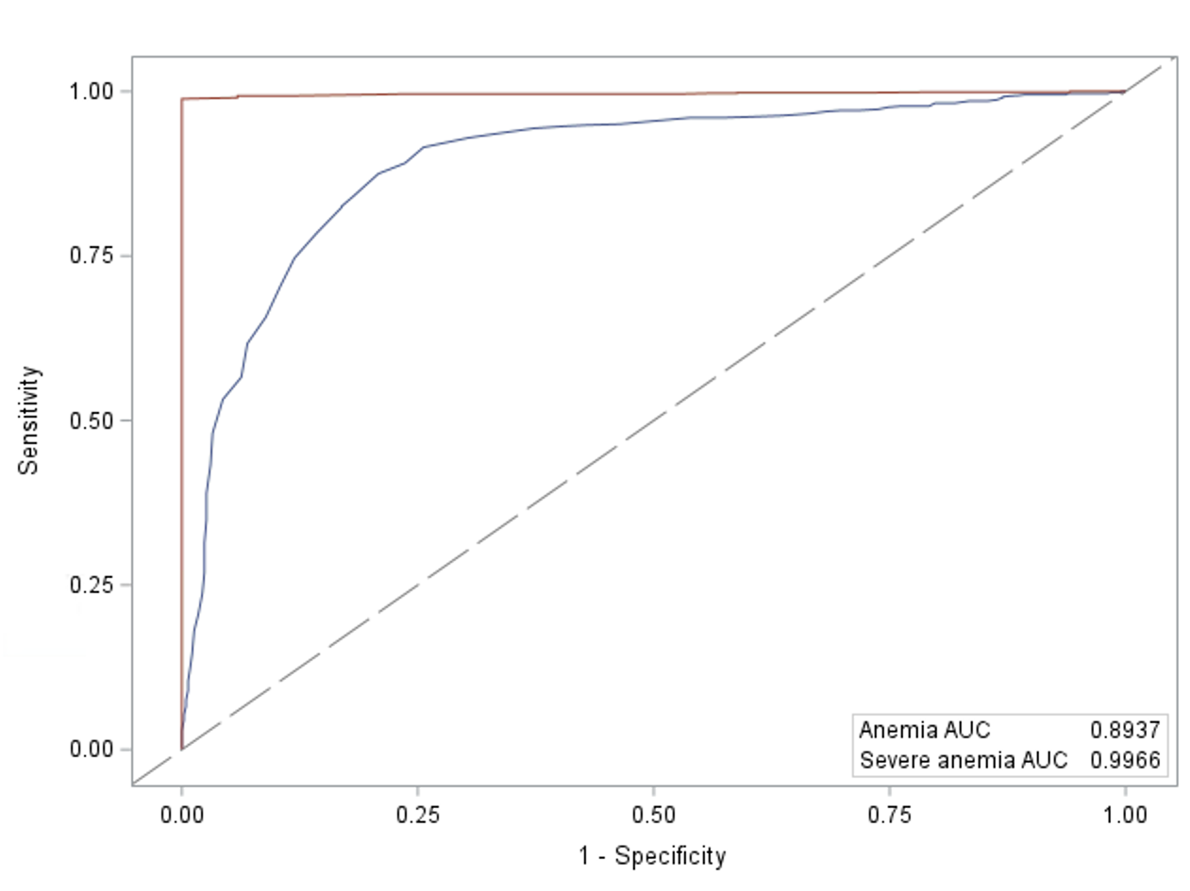

The red line represents the ROC for severe anemia, and the dark blue line represents the ROC for anemia.

