**Appendix/Online Supplemental information:**

**Table of Contents**

**Figure S1.** Global Comparison of 2016 U.S. Mortality Rates (Deaths per 100,000 Childrent/Adolescentws) to other High-Income (HIC) and Low-Middle Income (LMIC) Countries for the three leading causes of U.S.Child and Adolescent Death**2**

**Figure S2.** Mortality Rates (Deaths per 100,000 Children/Adolescents) a for the leading causes of childhood and adolescent death by rurality.**3**

**Figure S3.** ICD Definitions of Injury**4**

**Table S1.** Ten Leading Causes of Child and Adolescent Mortality (ages 1-19)a **5**

**References6**

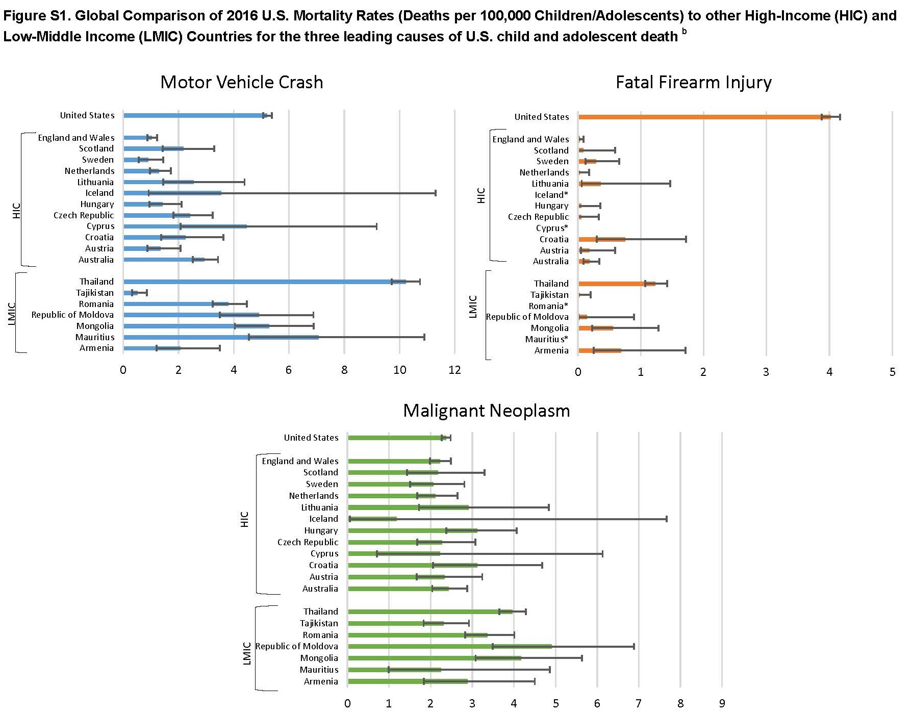

**Figure S2. Mortality Rates (Deaths per 100,000 Children/Adolescents) a for the leading causes of childhood and adolescent death by rurality.**

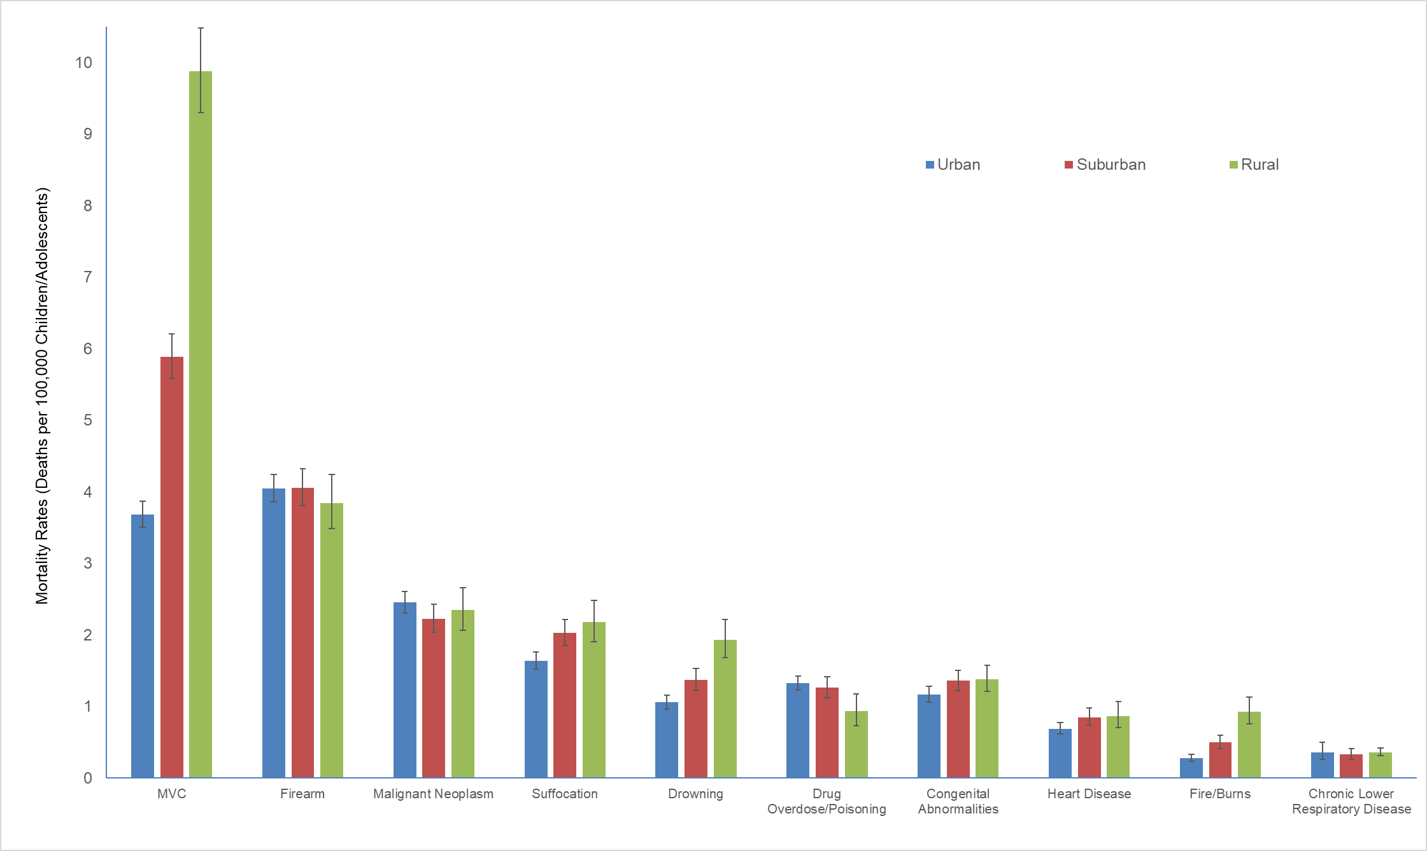

a Data obtained from Centers for Disease Control (CDC) Wide-ranging On-line Data for Epidemiological Research (WONDER)1 database using ICD-102 codes for the leading causes of death among children and adolescents.  The 2013 NCHS Urban-Rural Classification Scheme for Counties was used to assign one of six urbanicity categories to each county in the US. Counties were classified as Urban (Large Central Metro or Large Fringe Metro), Suburban (Medium Metro or Small Metro), and Rural (Micropolitan or NonCore).

**Figure S3. ICD Definitions of Injury**

**ICD-102 Codes For The Leading Causes Of Death (as defined By WISQUARS For Injury Death And WONDER For Other Causes Of Death) Among Children And Adolescents.**

Deaths due to MVC (V02-V04; V09.0; V09.2; V12-V14; V19.0-V19.2; V19.4-V19.6; V20-V79; V80.3-V80.5; V81.0-V81.1; V82.0-V82.1; V83-V86; V87.0-V87.8; V88.0-V88.8; V89.0; V89.2; X82; Y03; Y32) includes any motor vehicle crash fatality involving one or more drivers/occupants of a car, bus, light or heavy truck, moped/motorcycle or other transport vehicle (e.g., buggy, 4-wheeler). This includes any crash involving a car and a pedestrian and/or pedal cyclist, and excludes any pedestrian or pedal cyclist fatality that did not include a vehicle.

Firearm injuries (ICD 10 W32-W34; X72-74; X93-X95; Y22-Y24; Y35.0; U01.4) include any firearm fatalities due to discharge of a handgun or long-gun, including a rifle, shotgun, or larger firearm.

Malignant neoplasm (ICD 10 C00-C97) includes a malignant cancer arising from any primary site, and the category includes malignant neoplasms originating from lymphoid, hematopoietic, or related tissue types (e.g., leukemia, multiple myeloma).

Suffocation (W75-W84; X70; X91; Y20) includes such incidents as suffocation or strangulation due to bed linen, mother’s body, pillows, plastic bags. It also includes aspiration or obstruction of the airway by food bolus, foreign body, and/or vomitus. The category also includes intentional self-harm by hanging and/or intentional violence by strangulation or suffocation.

Drowning (ICD 10 W65-W74; X71; X92; Y21) includes any event where the individual drowned or was submersed in water, resulting in a fatality. This includes bathtubs, swimming pools, and natural bodies of water, etc.

Drug Overdose/Poisoning (X40-44; X60-64; X85; Y10-Y14) includes any overdose or ingestion of a drug and/or it’s derivative that results in fatality. Examples include Tylenol, Psychotropic Medications, Opioids, and Illicit drugs (i.e., cannabis, cocaine).

Congenital Abnormalities (Q00-Q99) includes malformation, deformations and chromosomal abnormalities such as Spina Bifida, Tetralogy of Fallow, and Down’s syndrome.

Heart Disease (I00-I09; I11; I20-I51) includes any non-congenital disease affecting the heart and would include such diseases as Rheumatic Heart Disease, Pulmonary Embolism, Pericarditis, Valvular Diseases, and Ischemic and Non-ischemic Cardiomyopathy.

Fire/Burn (X00-X19; X76-77; X97-98; Y26-Y27; Y36.3; U01.3) category includes fatalities due to a fire event (e.g., exposure to flames; smoke inhalation) and burns resulting from exposure to hot surfaces (e.g., stove, iron).

Chronic Lower Respiratory Diseases (J40-J47) includes respiratory illnesses of a chronic nature, and includes such diseases as asthma, chronic bronchitis, obstructive pulmonary disease, and bronchiectasis.

**Table S1. Ten Leading Causes of Child and Adolescent Mortality (ages 1-19)**a

|  |  |  |  |
| --- | --- | --- | --- |
| **CAUSES OF DEATH** | **Total # deaths** | **Rate/100,000 (95% CI)** | **% deaths** |
| **All Death** | **20,360** | **26.06 (25.70-26.42)** |  |
| **All Injury** | **12,336** | **15.79 (15.51-16.07)** | **60.6** |
| **#1 MVC** | **4,074** | **5.21 (5.06-5.38)** | **20.0** |
| MVC Homicide | 2 | 0.00# (0.00-0.01) |  |
| MVC Suicide | 15 | 0.02# (0.01-0.03) |  |
| MVC Unintentional | 4056 | 5.19 (5.03-5.35) |  |
| MVC Undetermined | 1 | 0.00# (0.00-0.01) |  |
| **#2 FIREARM** | **3,143** | **4.02 (3.88-4.16)** | **15.4** |
| Firearm Homicide | 1865 | 2.39 (2.28-2.50) |  |
| Firearm Suicide | 1102 | 1.41(1.33-1.50) |  |
| Firearm Unintentional | 126 | 0.16 (0.13-0.19) |  |
| Firearm Undetermined | 50 | 0.06 (0.05-0.09) |  |
| **#3 MALIGNANT NEOPLASMS** | **1,853** | **2.37 (2.27-2.48)** | **9.1** |
| **#4 SUFFOCATION b** | **1,430** | **1.83 (1.74-1.93)** | **7.0** |
| Suffocation Homicide | 54 | 0.07 (0.05-0.09) |  |
| Suffocation Suicide | 1110 | 1.42 (1.34-1.51) |  |
| Suffocation Unintentional | 235 | 0.30 (0.26-0.34) |  |
| Suffocation Undetermined | 31 | 0.04 (0.03-0.06) |  |
| **#5 DROWNING** | **995** | **1.27 (1.20-1.36)** | **4.9** |
| Drowning Homicide | 18 | 0.02# (0.01-0.04) |  |
| Drowning Suicide | 22 | 0.03 (0.02-0.04) |  |
| Drowning Unintentional | 928 | 1.19 (1.11-1.27) |  |
| Drowning Undetermined | 27 | 0.03 (0.02-0.05) |  |
| **#6 DRUG OVERDOSE / POISONING** | **982** | **1.26 (1.18-1.34)** | **4.8** |
| Overdose Homicide | 19 | 0.02# (0.01-0.04) |  |
| Overdose Suicide | 123 | 0.16 (0.13-0.19) |  |
| Overdose Unintentional | 761 | 0.97 (0.91-1.05) |  |
| Overdose Undetermined | 79 | 0.10 (0.08-0.13) |  |
| **#7 CONGENITAL ANOMALIES** | **979** | **1.25 (1.18-1.33)** | **4.8** |
| **#8 HEART DISEASE** | **599** | **0.77 (0.71-0.83)** | **2.9** |
| **#9 FIRE / BURNS** | **340** | **0.44 (0.39-0.48)** | **1.7** |
| Fire/ Burns Homicide | 38 | 0.05 (0.03-0.07) |  |
| Fire/ Burns Suicide | 6 | 0.01# (0.00-0.02) |  |
| Fire/ Burns Unintentional | 272 | 0.35 (0.31-0.39) |  |
| Fire/ Burns Undetermined | 24 | 0.03 (0.02-0.05) |  |
| **#10 CHRONIC LOW RESPIRATORY**  **DISEASE** | **274** | **0.35 (0.31-0.40)** | **1.3** |

aTable 1 data were obtained from the Centers for Disease Control (CDC) Wide-ranging On-line Data for Epidemiological Research (WONDER)2 database using ICD-102 codes for the leading causes of death among children and adolescents. Age was restricted to children and adolescents 1-19 years of age. Crude rates (Deaths per 100,000) were calculated using a population denominator of 78,134,923, with 95% confidence intervals (CI) presented where applicable. All data are calculated for 2016, the most recent year of available data. bSuffocation (W75-W84; X70; X91; Y20) includes such incidents as suffocation/strangulation due to bed linen, mother’s body, pillows, plastic bags. It also includes aspiration or obstruction of the airway by food bolus, foreign body, and/or vomitus. The category also includes intentional self-harm by hanging and/or intentional violence by strangulation or suffocation. For complete list of ICD codes and definitions see online appendix

#Confidence Intervals calculated with crude rates for causes of death with a value of less than 20 deaths are unstable.

**REFERENCES**

1. Centers for Disease Control and Prevention, National Center for Health Statistics. Compressed Mortality File 1999-2016 on CDC WONDER Online Database. 2017; <https://wonder.cdc.gov/cmf-icd10.html>. Accessed May 6, 2018.
2. ICD10Data.com. <http://www.icd10data.com/>. Accessed May 6, 2018.