Supplemental Figures

Supplemental Figure 1. Wet/ dry ratios of WTC_{PM} exposed mouse septums. Reported values are averages of individually measured samples ±SEM with n=3. NO significant differences were found between control and exposure groups.

Supplemental Figure 2. ICP-MS insoluble elemental trace analysis evaluation in WTC_{PM} exposed septums. Reported values are averages of individually measured samples ±SEM with n=3. Asterisks (*) indicate a statistically significant difference from control vehicle values (p<0.05).
Supplemental Figure 3. ICP-MS soluble elemental trace analysis evaluation in WTC_{PM} exposed septums. Reported values are averages of individually measured samples ±SEM with n=3. Asterisks (*) indicate a statistically significant difference from control vehicle values (p<0.05).

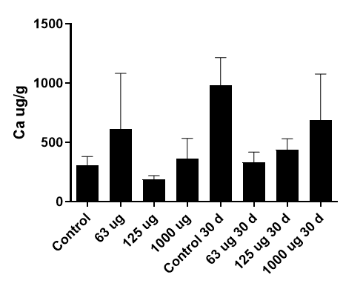
Supplemental Figure 4. ICP-MS insoluble and soluble elemental trace analysis evaluation in WTC_{PM} exposed whole brain tissues. Reported values are single-dose exposures measured 24 hours post-exposure with the exception of Ca measure 24 hours and 30 days post-exposure. Reported values are averages of individually measured samples ±SEM with n=3. Asterisks (*) indicate a statistically significant difference from control vehicle values (p<0.05). Below limit of detection is indicated by <LOD.

Supplemental Figure 5. Temporal Asph1 mRNA changes in repeat-dose WTC_{PM} exposed mouse olfactory bulbs. Reported values are averages of individually calculated ΔΔCT values ±SEM; n=3. Asterisks (*) indicates a statistically significant difference from corresponding control values (p<0.05).

