SUPPLEMENTAL MATERIALS

Blood Cadmium, Lead, Manganese, Mercury, and Selenium Levels in
American Indian Populations: the Strong Heart Study
Zheng Li^{1*}, Michael Lewin¹, Patricia Ruiz², Anne E. Nigra³, Noelle Henderson¹, Jeffery M. Jarrett⁴, Cynthia Ward⁴, Jianhui Zhu⁵, Jason G. Umans^{5,6}, Marcia O’Leary,⁷ Ying Zhang,⁸ Angela Ragin-Wilson⁹, Ana Navas-Acien³

- Office of Community Health and Hazard Assessment, Agency for Toxic Substances and Disease Registry, Centers for Disease Control and Prevention, Atlanta, Georgia, USA
- Office of Innovation and Analytics, Agency for Toxic Substances and Disease Registry, Centers for Disease Control and Prevention, Atlanta, Georgia, USA
- Department of Environmental Health Sciences, School of Public Health, Columbia University, New York City, New York, USA
- Division of Laboratory Sciences, National Center for Environmental Health, Centers for Disease Control and Prevention, Atlanta, Georgia, USA
- MedStar Health Research Institute, Hyattsville, Maryland, USA
- Georgetown-Howard Universities Center for Clinical and Translational Science, Washington DC, USA
- Missouri Breaks Industries and Research, Inc., USA
- Center for American Indian Health Research, University of Oklahoma Health Sciences Center, Oklahoma City, OK, USA
- Office of Associate Director, Agency for Toxic Substances and Disease Registry, Centers for Disease Control and Prevention, Atlanta, Georgia, USA

Figure S-1. Distribution plots for the original and ln-transformed concentrations for five metals: cadmium, lead, total mercury, manganese, and selenium in Strong Heart Study cohort (1998-1999).
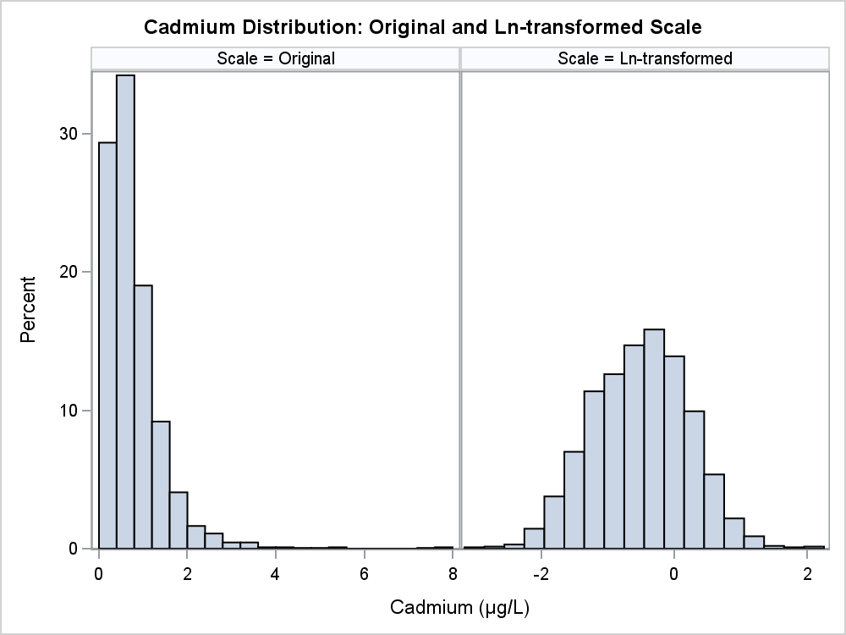
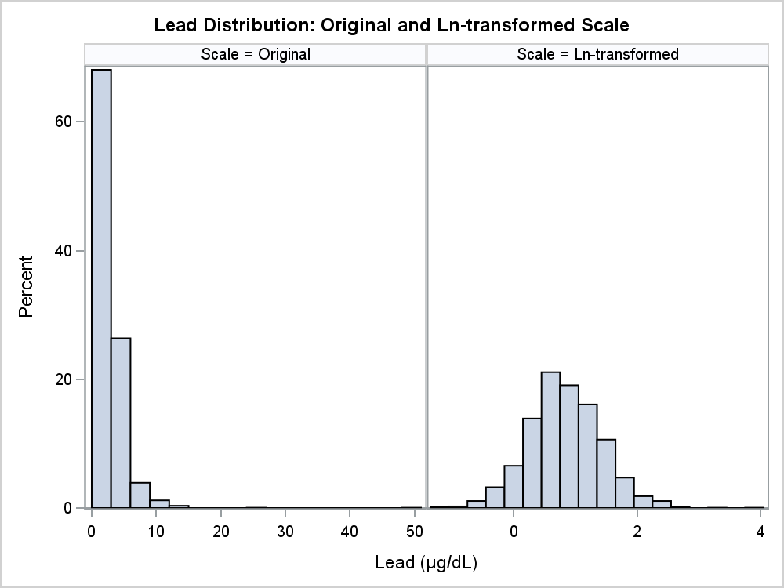
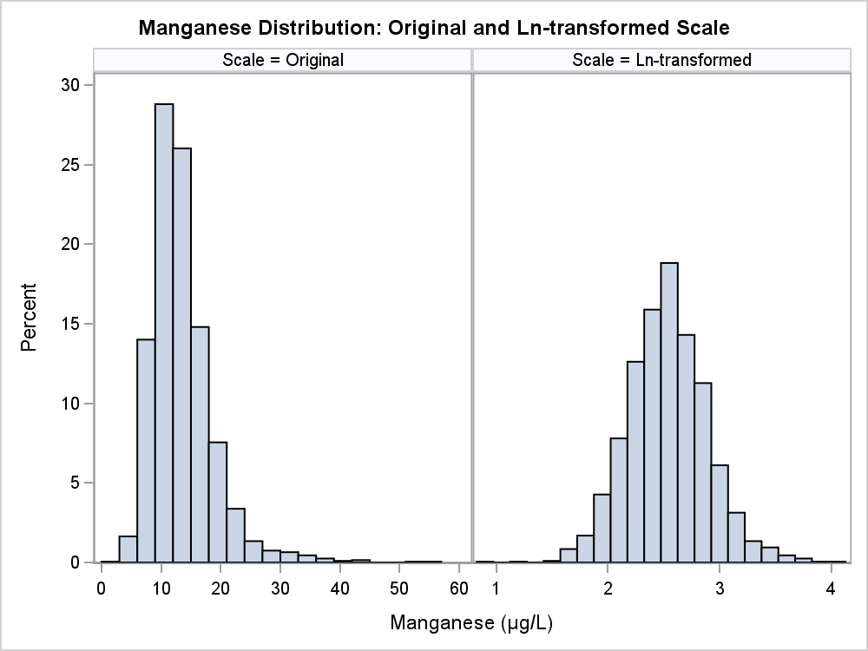
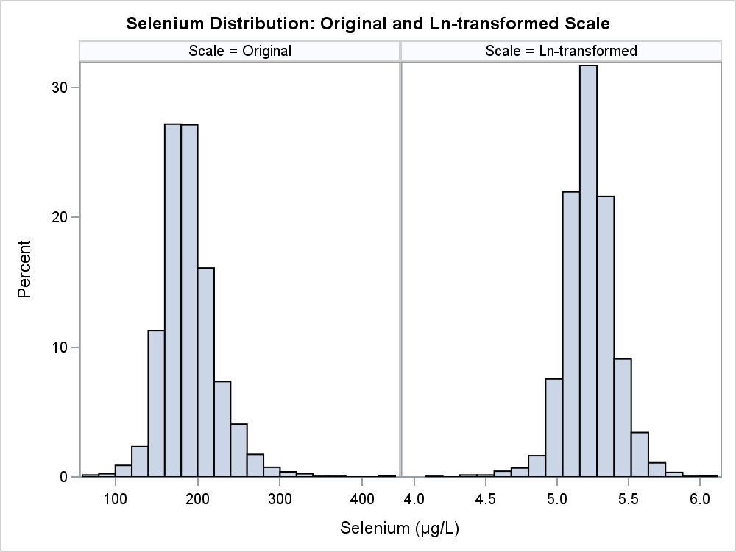
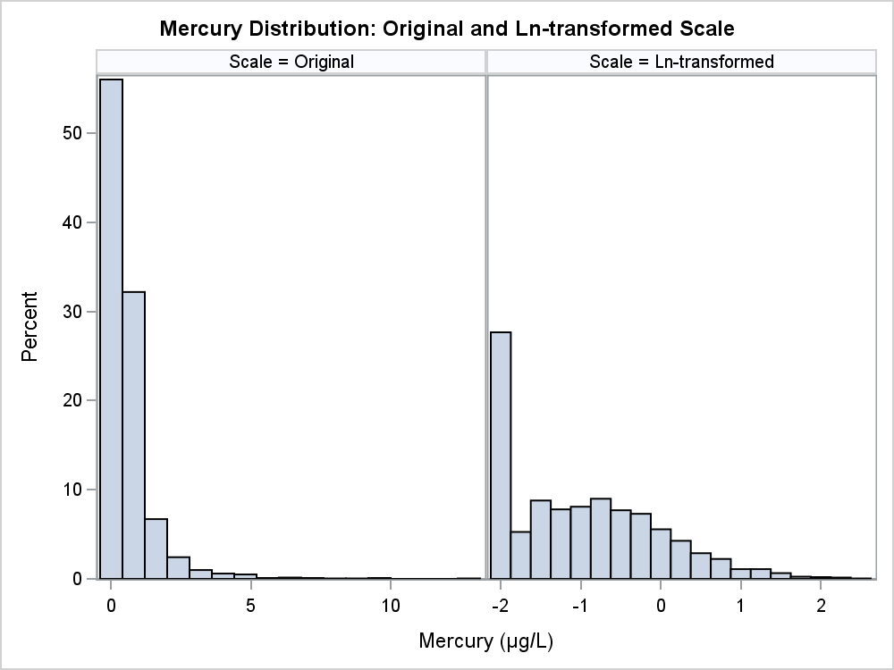
Table S-1. Descriptive statistics with 95% conference intervals of blood cadmium, lead, mercury, manganese, and selenium in Strong Heart Study (Phase III, 1998-1999), entire cohort and by study center
Region |  | Geometric Mean  (95% CI) | Min |  | 25th  (95% CI) |  | Median  (95% CI) |  | 75th  (95% CI) |  | 95th  (95% CI) |  | Max
Cadmium (µg/L)
All |  | .605  (.587-.625) | 0.046 |  | .360  (.341-.379) |  | .617  (.589-.645) |  | .987  (.952-1.04) |  | 1.93  (1.85-2.01) |  | 7.86
Arizona |  | .363  (.335-.394) | 0.098 |  | .241  (.211-.259) |  | .343  (.312-.383) |  | .514  (.476-.591) |  | .949  (.817-1.17) |  | 7.27
Oklahoma |  | .472  (.451-.494) | 0.046 |  | .289  (.272-.303) |  | .445  (.418-.475) |  | .766  (.719-.826) |  | 1.49  (1.40-1.63) |  | 4.41
North and South Dakota |  | .864  (.832-.898) | 0.046 |  | .595  (.567-.626) |  | .853  (.821-.900) |  | 1.27  (1.20-1.34) |  | 2.25  (2.02-2.47) |  | 7.86
Lead (ug/dL)
All |  | 2.30  (2.24-2.36) | 0.305 |  | 1.57  (1.51-1.62) |  | 2.24  (2.18-2.33) |  | 3.36  (3.24-3.51) |  | 6.19  (5.78-6.55) |  | 50.7
Arizona |  | 1.66  (1.53-1.80) | 0.321 |  | 1.15  (.995-1.24) |  | 1.57  (1.43-1.74) |  | 2.30  (2.00-2.49) |  | 6.21  (3.94-7.66) |  | 9.99
Oklahoma |  | 2.13  (2.05-2.21) | 0.305 |  | 1.48  (1.38-1.55) |  | 2.09  (1.98-2.21) |  | 3.16  (3.04-3.29) |  | 5.30  (4.88-6.01) |  | 14.6
North and South Dakota |  | 2.67  (2.58-2.77) | 0.53 |  | 1.80  (1.76-1.89) |  | 2.58  (2.48-2.71) |  | 3.85  (3.66-4.02) |  | 6.77  (6.23-7.71) |  | 50.7
Total Mercury (ug/L)
All |  | .359  (.345-.375) | 0.12 |  | .120  (.120-.169) |  | .325  (.299-.340) |  | .696  (.647-.735) |  | 2.00  (1.82-2.21) |  | 13
Arizona |  | .359  (.321-.401) | 0.12 |  | .173  (.120-.198) |  | .338  (.274-.389) |  | .654  (.539-.767) |  | 1.58  (1.23-1.90) |  | 4.37
Oklahoma |  | .393  (.369-.419) | 0.12 |  | .161  (.120-.183) |  | .371  (.339-.410) |  | .768  (.708-.840) |  | 2.10  (1.81-2.36) |  | 8.89
North and South Dakota |  | .330  (.310-.352) | 0.12 |  | .120  (.120-.170) |  | .275  (.241-.298) |  | .623  (.560-.700) |  | 2.07  (1.78-2.40) |  | 13
Manganese (ug/L)
All |  | 12.6  (12.4-12.8) | 2.41 |  | 9.95  (9.79-10.2) |  | 12.6  (12.3-12.8) |  | 15.7  (15.4-16.1) |  | 22.6  (21.8-23.5) |  | 55.9
Arizona |  | 11.3  (10.7-11.9) | 3.48 |  | 8.65  (8.17-9.30) |  | 10.8  (10.1-11.7) |  | 13.7  (13.0-14.8) |  | 22.3  (19.0-32.4) |  | 38.8
Oklahoma |  | 11.9  (11.6-12.1) | 2.41 |  | 9.37  (9.10-9.64) |  | 11.7  (11.4-12.0) |  | 14.8  (14.2-15.4) |  | 21.7  (20.5-22.7) |  | 51
North and South Dakota |  | 13.7  (13.4-14.0) | 4.32 |  | 11.1  (10.8-11.5) |  | 13.6  (13.3-13.8) |  | 16.9  (16.5-17.4) |  | 22.9  (22.2-24.3) |  | 55.9
Selenium (ug/L)
All |  | 187  (185-188) | 61.9 |  | 169  (167-170) |  | 186  (184-187) |  | 206  (204-209) |  | 250  (246-254) |  | 429
Arizona |  | 174  (171-178) | 101 |  | 161  (155-165) |  | 174  (170-177) |  | 192  (186-196) |  | 216  (206-226) |  | 278
Oklahoma |  | 182  (180-184) | 86.1 |  | 166  (165-168) |  | 181  (180-183) |  | 198  (196-200) |  | 233  (225-238) |  | 373
North and South Dakota |  | 194  (192-197) | 61.9 |  | 175  (172-177) |  | 194  (192-196) |  | 218  (215-221) |  | 262  (254-277) |  | 429

