Title: Trends in co-mention of stimulants and opioids: A natural language processing driven analysis of Reddit forums (Appendix)

Authors:

Abeed Sarker, PhD¹
Mohammed Ali Al-Garadi, PhD¹
Yao Ge, MS¹
Nisha Nataraj, PhD, MS²
Christopher M Jones, PharmD, DrPH²
Steven A Sumner, MD, MSc²

¹Department of Biomedical Informatics, School of Medicine, Emory University, Atlanta, GA 30322
²National Center for Injury Prevention and Control, Centers for Disease Control and Prevention, Atlanta, GA 30341

Corresponding author:
Abeed Sarker
101 Woodruff Circle
Suite 4101
Atlanta, GA 30322
Email: abeed@dbmi.emory.edu

Appendix

Table A1. Names of subreddits included in this study and corresponding numbers of Redditors subscribing to the subreddits at the time
of writing of the manuscript (August, 2021).
Subreddit name | Number of Redditors subscribing
opiates | 127,000
heroin | 32,400
OpiatesRecovery | 32,300
OpiateChurch | 27,800
Methadone | 16,400
suboxone | 14,700
opiates_gonewild | 9,700
fentanyl | 6,800
HeroinHeroines | 4,300
OurOverUsedVeins | 3,200
opiateswriters | 2,400
Carfentanil | 481
Vivitrol | 303
InAHeroinSunrise | <100; [currently removed]

Table A2. Substance names and their automatically-generated misspellings.
OPIOIDS

Prescription Opioids
hydrocodone hyrdrocodone hydrocodiene hydro_codone hydrocodene hydrocordone hydorcodone hydrocodeine hidrocodone hyrocodone hydrocone hydrodone hyrdocodone hydrcodone hydrocodones hydrocordisone hydocodone hydrocode hydrocodons hydracodone hydrocodone hydrocodin hydrocodine hydrocodon hydrocondone hydrocodne hydrocdone hydros 357s lortab lortabs lorcet lorcets lortab norco
vicodin vicoden vicadin viodin vicodin vicodines vicodan vicodien viccodin vocodin vicondin vicoding vicodins vicodon vicidin vidodin vikodin viacodin vicodine vicdin vicotin
percocet perkocet percocete percacet pecocet percocette perocets percoets percoet percot perocet percoset percocets percocett pecocets percocoet percocit percet percoct percocet10 percicet percocetes percecet percocet
oxycodone oxocodone oxycodene oxycondone oycodone oxyxodone oxycodones oxicodone oxy_codone oxycodone oxycodine roxycodone ocycodone oxycodons oxcodone oycondone oxycodon oyxcodone oxcycodone oxycodne oxy oxys roxy roxies roxicodone OC OP percs M30 M30s dilaudid hydromorphone oxymorphone
oxycontin ocycontin oxcontin oxcotin oxcycontin oxycotine oxycontin roxycontin oycotin oxyconton oxycontine oxycotins oxycontin oxycintin oxy_contin oxicontin oxycontins oxycottin oycontin
morphine morphin morfin morphs
tramadol tramadol trmadol tramdol tramadol

Illicit Opioids
fentanyl fentinyl fentenyl fenanyl fentanly fentnyal fentanol fental fetanyl fentayl fentanayl fentanyl fentyl fentanal fetnyl fentynyl fentnayl fentanl fentyanl fentonyl fentanyal fentany fentnyl fent fents
carfentanil carfentanyl carfentanyl carfent
heroin heroin herroin herioin heroins

Medications for Opioid Use Disorder (MOUD)
suboxone suboxine subuxone suboxne suboxone saboxone seboxone subxone suboxene suboxones soboxone suboxon subs subutex zubsolv bunavail probuphine
sublocade sublocade
methadone methodone methadon methadrone methadose methadones methadone mathadone methedone metadone mehtadone methdone
blue_methadone blue_methadone
buprenorphine bupenorphine burprenorphine bupronorphine buprenophine bupernorphine buprenorphin buprenorphine bup bupe bupes
naltrexone naltrexone naltraxone natrexone naltrexon naltroxone vivitrol vivitrol
Opioid Reversal Agents
naloxone naloxone nalaxone
narcan narcan evzio

STIMULANTS

speedball speedballin speedballing speedballs speedball
methamphetamine methamphetamines meth methl meths methi methy crystal_meth crystalmeth crystal ice speed crank crystal_meth crystalmeth meth methl meths meth methy methamphetamine
lisdexamfetamine lisdexamfetamine dexamfetamine lisdexamphetamine
ritalin ritialin ritallin ritaline ritlian ritalan ritatlin ritlin riain retalin ritalins ridalin rittalin rittlin ritalyn rialin ritilin ritalin
vyvanse vyvans vvyvanse vyvanses vyvanes vyavanse vyvanse17 vyvense vyvannse vyvance vyvanse vanse vyvanss vivanse vyvanze vyvnase vyvase vyvan vyvansse vyvanase vyanese vyvanse” vyvanese vynanse vyanse vvyanse
dextroamphetamine dextroamphetamines dextroamphetamine levoamphetamine dexamphetamines dextromethamphetamine dexamphetamine
levoamphetamine dexamphetamine dextroamphetamine levoamphetamine levomethamphetamine
dexedrine dexerdrine dexodrine dexetrine dexidrine dexadrine dexedrine
amphetamine amphetamine amphetimines amphetemine amphetimine amphetaminesalt amphetemines anphetamine amphetamines amphetamine amfetamine
biphetamine biphetamine
adderall adderall addrerall sadderall adderell addrall adderals addera adderall adderoll addorall addarall adderrall dadderall aderal adderalll adderallll adderal badderall smadderall addreall adderallxr madderall aderall aderrall adderral adderally adderalls seadderall
goofball goofballs goofball goof

*Note: Cocaine was excluded from our analyses due to challenges associated with accurately identifying mentions of the drug

Table A3. Negation phrases associated with specific substance keywords.
stimulant cardiac-stimulant|cardiac stimulant|cardiac-stimulant
methamphetamine meth gmt|meth group|meth obstet|meth odist|meth germantown|meth gmt|meth group|meth obstet
oxycodone not enough oxy|oxy clean|oxy deep cleaner|oxy given|oxy high|oxy level|oxy low|oxy mask|pulse oxy

Table A4. List of negations used for detecting negated substance mentions.
no
not
without
absence of
cannot
couldn't
could not
didn't
did not
denied
denies
free of
negative for
never had
resolved
exclude
with no
rule out
aside from
except
apart from

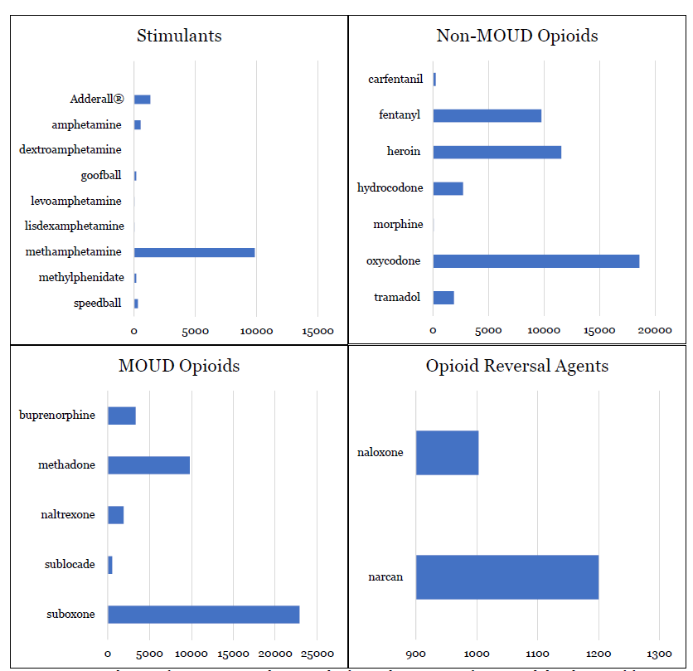
MOUD
Illicit and Prescription Opioids
Figure A5. Distribution of mentions per substance, organized alphabetically. The figure shows a more fine-grained distribution of frequencies compared to the groupings used in the article. In the article, the following mentions of substances are grouped together: (i) Speedball/Goofball (a combination of methamphetamine and heroin), (ii) levoamphetamine, amphetamine, dextroamphetamine, Adderall® and lisdexamphetamine (amphetamine type stimulants), (iii) carfentanil and fentanyl (fentanyl & analogs), (iv) morphine, hydrocodone, tramadol and oxycodone (prescription opioid pain relievers), (v) naltrexone, sublocade, buprenorphine, methadone and suboxone (MOUD), and (vi) narcan and naloxone (opioid reversal agents). Heroin and methamphetamine are not grouped with any other keyword/substance.

Table A6. Metrics for posts and Redditors from 2011 to 2020.
Year | Total posts | Total Redditors | Opioids and opioid-related medications mentions | Stimulant mentions | People who use opioids or being treated for with medication for opioid use disorder (PWUO/PTMOUD) | People who use stimulants (PWUS) | People who co-use opioids and stimulants (PWCU) | Ratio: PWCU/Redditors
2011 | 9,001 | 244 | 75 | 36 | 22 | 29 | 9 | 0.037
2012 | 32,152 | 579 | 353 | 132 | 89 | 103 | 35 | 0.060
2013 | 57,443 | 982 | 885 | 246 | 165 | 195 | 71 | 0.072
2014 | 84,697 | 1,440 | 1,284 | 326 | 243 | 263 | 98 | 0.068
2015 | 141,044 | 1,959 | 1,756 | 474 | 381 | 370 | 156 | 0.080
2016 | 212,145 | 2,898 | 3,529 | 750 | 619 | 578 | 261 | 0.090
2017 | 398,217 | 4,474 | 6,852 | 1,298 | 1,132 | 997 | 523 | 0.117
2018 | 772,258 | 6,713 | 13,507 | 2,166 | 2,053 | 1,660 | 910 | 0.136
2019 | 1,306,354 | 9,128 | 20,624 | 3,021 | 2,944 | 2,351 | 1,288 | 0.141
2020 | 2,140,854 | 11,072 | 31,417 | 3,669 | 3,930 | 2,866 | 1,718 | 0.155

