**Supplemental Figure 3.** Adjusted odds ratios from multivariable logistic regression model of predictors of high Visual Analog Scale (VAS) score controlling for site and season among persons with laboratory-confirmed influenza who completed the VAS within 3 days of illness onset.

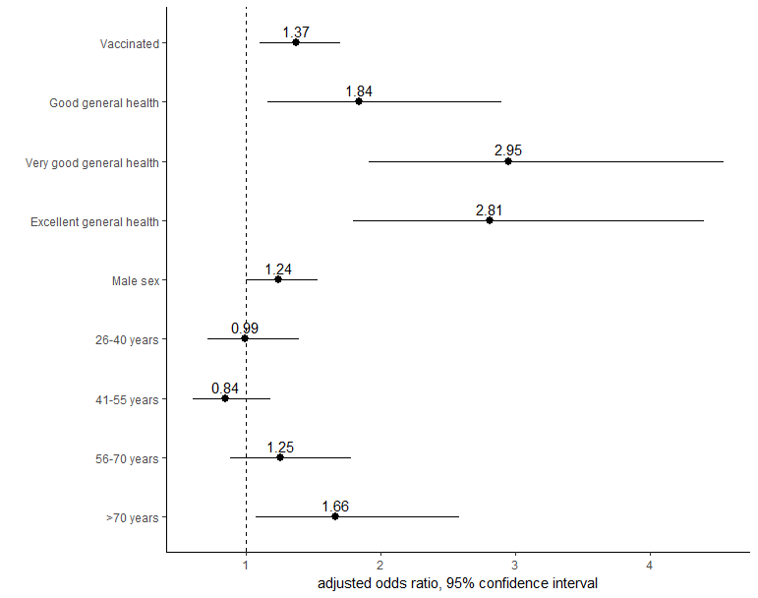

Reference groups – unvaccinated; fair or poor general health; female sex; age 16-25 years