**SUPPLEMENT**

Supplemental Table 1. Sociodemographics among 12th grade students from 2000-2004 and 2015-2020

|  |  |  |
| --- | --- | --- |
|  | **2000-2004** | **2015-2020** |
|  | **Weighted Percent or Mean**  **(N=** **9,362)** | **Weighted Percent or Mean**  **(N=** **8,990)** |
| Sex |  |  |
| Male | 46.30 | 46.76 |
| Female | 53.70 | 53.24 |
| Mean Age | 17.60 | 17.61 |
| Race |  |  |
| Black | 10.94 | 11.29 |
| White | 70.58 | 55.80 |
| Other | 18.48 | 32.91 |
| Parental education |  |  |
| Some high school or lower | 7.13 | 9.99 |
| At least one parent finished high school or some college | 42.55 | 36.61 |
| At least one parent finished college or more | 50.31 | 53.40 |

Supplemental Table 2. Multinomial logistic regressions of past-year use alcohol and/or cannabis use, adjusting for the interaction between race/ethnicity and survey year (N= 37,799)

|  |  |  |  |  |
| --- | --- | --- | --- | --- |
| Covariate | Past-year simultaneous use  Vs. no use | Past-year alcohol-use-only  Vs. no use | Past-year cannabis-use-only  Vs. no use | Past-year alcohol and cannabis use but not simultaneously  Vs. no use |
|  | aRRR [95% CI] | aRRR [95% CI] | aRRR [95% CI] | aRRR [95% CI] |
| Survey year (ref=2000-2004) |  |  |  |  |
| 2005-2009 | **0.83 [0.69, 0.99]** | 0.93 [0.80, 1.09] | 0.78 [0.47, 1.28] | 0.89 [0.74, 1.09] |
| 2010-2014 | **0.68 [0.57, 0.80]** | **0.65 [0.57, 0.75]** | 0.94 [0.58, 1.52] | **0.82 [0.69, 0.98]** |
| 2015-2020 | **0.54 [0.46, 0.64]** | **0.59 [0.52, 0.68]** | **1.94 [1.24, 3.06]** | **0.79 [0.66, 0.94]** |
|  |  |  |  |  |
| Sex (ref=male) |  |  |  |  |
| Female | **0.80 [0.74, 0.86]** | **1.15 [1.08, 1.22]** | 0.87 [0.72, 1.06] | **1.10 [1.01, 1.20]** |
|  |  |  |  |  |
| Parental education (ref=finished college or more) |  |  |  |  |
| Some high school or lower | 0.97 [0.83, 1.13] | 0.94 [0.84, 1.05] | 1.31 [0.93, 1.84] | 1.06 [0.91, 1.25] |
| Finished high school or some college | **1.15 [1.07, 1.25]** | 1.05 [0.98, 1.13] | **1.35 [1.08, 1.69]** | **1.20 [1.10, 1.31]** |
|  |  |  |  |  |
| Race/ethnicity (ref=white) |  |  |  |  |
| Black | **0.32 [0.25, 0.41]** | **0.51 [0.43, 0.61]** | 1.29 [0.68, 2.45] | **0.66 [0.49, 0.88]** |
| Other | **0.64 [0.52, 0.79]** | 0.92 [0.77, 1.08] | 0.92 [0.50, 1.71] | 0.85 [0.68, 1.06] |
|  |  |  |  |  |
| Race/Ethnicity x Survey year |  |  |  |  |
| Black x 2005-2009 | 1.22 [0.83, 1.80] | 1.09 [0.84, 1.42] | **2.62 [1.16, 5.90]** | 1.17 [0.78, 1.77] |
| Black x 2010-2014 | **1.66 [1.14, 2.40]** | **1.51 [1.15, 1.99]** | 2.24 [0.98, 5.11] | 1.21 [0.81, 1.82] |
| Black x 2015-2020 | 1.41 [0.95, 2.09] | 0.75 [0.56, 1.02] | 1.84 [0.84, 4.00] | 1.40 [0.95, 2.06] |
| Other x 2005-2009 | 0.89 [0.66, 1.19] | 0.89 [0.71, 1.12] | 1.30 [0.58, 2.89] | 0.98 [0.72, 1.32] |
| Other x 2010-2014 | **1.43 [1.09, 1.89]** | 1.02 [0.82, 1.28] | **2.44 [1.13, 5.27]** | 1.22 [0.91, 1.64] |
| Other x 2015-2020 | 1.13 [0.86, 1.49] | **0.79 [0.63, 0.99]** | 1.86 [0.92, 3.78] | 1.25 [0.94, 1.66] |
|  |  |  |  |  |
| Survey mode (ref=paper) |  |  |  |  |
| Tablet | 0.93 [0.73, 1.19] | 0.87 [0.71, 1.07] | 1.18 [0.81, 1.73] | 0.92 [0.75, 1.13] |

Note: aRRR=Adjusted relative risk ratio. Alcohol-use-only is defined as past-year alcohol use and no report of past-year cannabis or simultaneous use. Cannabis-use-only is defined as past-year cannabis use and no report of past-year alcohol or simultaneous use. Models also adjusted for sex, parental education, and survey mode.

Supplemental Table 3. Multinomial logistic regressions of past-year alcohol and/or cannabis use, adjusting for the interaction between parental education and survey year (N= 37,799)

|  |  |  |  |  |
| --- | --- | --- | --- | --- |
| Covariate | Past-year simultaneous use  Vs. no use | Past-year alcohol-use-only  Vs. no use | Past-year cannabis-use-only  Vs. no use | Past-year alcohol and cannabis use but not simultaneously  Vs. no use |
|  | aRRR [95% CI] | aRRR [95% CI] | aRRR [95% CI] | aRRR [95% CI] |
| Survey year (ref=2000-2004) |  |  |  |  |
| 2005-2009 | **0.78 [0.65, 0.93]** | 0.92 [0.79, 1.07] | 0.81 [0.49, 1.33] | 0.84 [0.68, 1.03] |
| 2010-2014 | **0.71 [0.59, 0.85]** | **0.69 [0.60, 0.80]** | 0.91 [0.57, 1.45] | **0.81 [0.68, 0.98]** |
| 2015-2020 | **0.56 [0.47, 0.67]** | **0.58 [0.51, 0.67]** | **1.86 [1.21, 2.86]** | 0.85 [0.71, 1.03] |
|  |  |  |  |  |
| Sex (ref=male) |  |  |  |  |
| Female | **0.80 [0.74, 0.86]** | **1.15 [1.08, 1.23]** | 0.87 [0.72, 1.06] | **1.10 [1.01, 1.20]** |
|  |  |  |  |  |
| Parental education (ref=finished college or more) |  |  |  |  |
| Some high school or lower | 0.81 [0.60, 1.09] | 0.90 [0.73, 1.11] | 1.17 [0.51, 2.65] | 1.01 [0.73, 1.40] |
| Finished high school or some college | 1.09 [0.94, 1.26] | 1.09 [0.96, 1.23] | 0.67 [0.39, 1.14] | 1.09 [0.92, 1.29] |
|  |  |  |  |  |
| Race/ethnicity (ref=white) |  |  |  |  |
| Black | **0.41 [0.36, 0.47]** | **0.56 [0.50, 0.62]** | **2.41 [1.84, 3.17]** | **0.78 [0.68, 0.90]** |
| Other | **0.70 [0.64, 0.77]** | **0.85 [0.78, 0.92]** | **1.59 [1.25, 2.01]** | 0.95 [0.85, 1.06] |
|  |  |  |  |  |
| Parental education x Survey year |  |  |  |  |
| Some high school or lower x 2005-2009 | 1.01 [0.66, 1.56] | 1.02 [0.75, 1.38] | 0.80 [0.25, 2.54] | 1.02 [0.64, 1.62] |
| Some high school or lower x 2010-2014 | **1.74 [1.13, 2.69]** | 1.34 [0.98, 1.83] | 1.94 [0.66, 5.67] | 1.10 [0.70, 1.72] |
| Some high school or lower x 2015-2020 | 1.15 [0.77, 1.72] | 0.82 [0.61, 1.10] | 1.01 [0.39, 2.57] | 1.08 [0.72, 1.61] |
| Finished high school or some college x 2005-2009 | 1.12 [0.91, 1.39] | 1.00 [0.83, 1.21] | 1.95 [0.97, 3.92] | 1.19 [0.93, 1.53] |
| Finished high school or some college x 2010-2014 | 1.14 [0.92, 1.41] | 0.96 [0.80, 1.15] | **2.44 [1.23, 4.82]** | 1.21 [0.95, 1.53] |
| Finished high school or some college x 2015-2020 | 1.01 [0.81, 1.26] | 0.89 [0.74, 1.06] | **2.28 [1.21, 4.28]** | 1.04 [0.80, 1.33] |
|  |  |  |  |  |
| Survey mode (ref=paper) |  |  |  |  |
| Tablet | 0.93 [0.73, 1.19] | 0.86 [0.70, 1.06] | 1.19 [0.82, 1.75] | 0.92 [0.75, 1.13] |

Note: aRRR=Adjusted relative risk ratio. Alcohol-use-only is defined as past-year alcohol use and no report of past-year cannabis or simultaneous use. Cannabis-use-only is defined as past-year cannabis use and no report of past-year alcohol or simultaneous use. Model also adjusted for sex, race/ethnicity, and survey mode.

Supplemental Figure 1: Joinpoint Results for Simultaneous Use

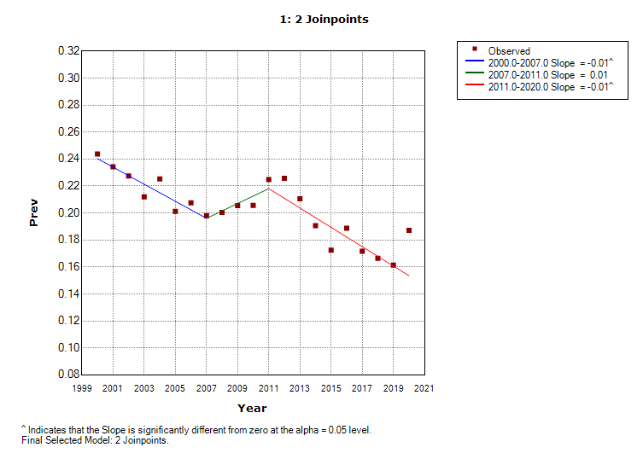

Supplemental Figure 2. Trends in past-year simultaneous use (split by frequency), alcohol and cannabis use but not simultaneously, cannabis-use-only, and alcohol-use-only among 12th graders from 2000-2020



Note: Alcohol-use-only is defined as past-year alcohol use and no report of past-year cannabis or simultaneous use. Cannabis-use-only is defined as past-year cannabis use and no report of past-year alcohol or simultaneous use. Simultaneous use was split based on whether people engaged most/every time (more frequent) or a few/some times they used cannabis (less frequent). Certain years of cannabis-use-only censored due to small sample sizes.