Table S1. Bivariate correlations among study variables at fall 8th grade
 | 1. | 2. | 3. | 4. | 5. | 6. | 7. | 8. | 9. | 10.
1. Gender (0 = female, 1 = male) | --
2. Age | .04*** | --
3. Parent education | .04*** | -.16*** | --
4. Household structure (0 = other structure, 1 = two-parent) | .01* | -.04*** | .07*** | --
5. Repeated a grade (0 = no, 1 = yes) | .01 | .20*** | -.12*** | -.03*** | --
6. Alcohol use | -.01 | .05*** | -.05** | -.03*** | .03*** | --
7. Marijuana use | .02 | .12*** | -.10*** | -.05*** | .07*** | .38*** | --
8. Grades | -.04*** | -.17*** | .33*** | .08*** | -.13*** | -.09*** | -.14*** | --
9. School behavior problems | .01 | .02** | -.01 | -.02** | .02*** | .20*** | .20*** | -.07*** | --
10. School belonging | .03** | -.02 | .07** | .07*** | -.02* | -.11*** | -.09*** | .16*** | -.10*** | --
11. Valuing education | -.01* | -.06*** | .08*** | .02*** | -.04*** | -.09*** | .11*** | .10*** | -.07*** | .05***
*p < .05, **p < .01, ***p < .001

Table S2. Bivariate correlations among study variables at fall 8th grade by race, with correlations for Black youth below the diagonal and correlations for White youth above the diagonal
 | 1. | 2. | 3. | 4. | 5. | 6. | 7. | 8. | 9. | 10. | 11.
1. Gender (0 = female, 1 = male) | -- | .04*** | .05*** | .01 | -.01 | -.01 | .04 | -.06*** | -.01 | .01 | -.02**
2. Age | .05*** | -- | -.12*** | -.02*** | .13*** | .05*** | .07*** | -.12*** | .01 | -.01 | -.05***
3. Parent education | .01 | -.15*** | -- | .05*** | -.11*** | -.10*** | -.10*** | .35*** | -.02 | .11* | .10***
4. Household structure (0 = other structure, 1 = two-parent) | .01 | -.03*** | .03** | -- | -.02*** | -.05*** | -.05*** | -.02*** | -.02*** | .05*** | .03***
5. Repeated a grade (0 = no, 1 = yes) | .04*** | .28*** | -.08*** | -.02** | -- | .03*** | .04*** | -.10*** | .02** | -.02 | -.05***
6. Alcohol use | .01 | .06** | .02 | -.03* | .04*** | -- | .40*** | -.14*** | .22*** | -.15*** | -.12***
7. Marijuana use | .06*** | .16*** | -.06 | -.03* | .09*** | .37*** | -- | -.13*** | .19*** | -.10*** | -.12***
8. Grades | -.03* | -.17*** | .17*** | .03* | -.12*** | -.05 | -.17*** | -- | -.08*** | .17*** | .13***
9. School behavior problems | .02* | .03* | .01 | .01 | .02* | .17*** | .21*** | -.05* | -- | -.12*** | -.09***
10. School belonging | .07*** | .01 | -.05 | .06** | -.01 | -.07* | -.05 | .08* | -.06** | -- | .07***
11. Valuing education | -.01 | -.07*** | .05* | .02 | -.04*** | -.04* | -.08*** | .06*** | -.04** | .01 | --
*p < .05, **p < .01, ***p < .001

Table S3. Depiction of longitudinal cohort design and current study measurement occasions
Cohort | Grade and term in school
 | S6th | F7th | S7th | F8th | S8th | F9th | S9th | F10th | S10th | F11th
Cohort 1 | W1 | W2 | W3 | W4 | W5 | W6 | -- | W7 | --
Cohort 2 | -- | -- | W1 | W2 | W3 | W4 | W5 | W6 | -- | W7
Cohort 3 | -- | -- | -- | -- | W1 | W2 | W3 | W4 | W5 | W6
Note. S = spring semester; F = fall semester; W = wave of data collection. Bolded measurement occasions were utilized in the current study.

Table S4. Associations of covariates with random intercepts of core study constructs from multiple group random intercepts cross-lagged panel model
Group | Covariate | Marijuana Use | Grades | School behavior problems | School belonging | Valuing education
 |  | B (SE) | B (SE) | B (SE) | B (SE) | B (SE)
Black youth | Gender (0 = female, 1 = male) | .21 (.04)*** | -.10 (.03)*** | .04 (.02)* | .34 (.04)*** | -.06 (.02)***
Black youth | Age | .20 (.04)*** | -.02 (.03) | .01 (.01) | .08 (.05) | -.08 (.03)***
Black youth | Parent education | -.03 (.02) | .11 (.02)*** | .01 (.01) | -.01 (.02) | .04 (.01)***
Black youth | Household structure (0 = other structure, 1 = two-parent) | -.06 (.04) | .04 (.03) | .03 (.02) | .03 (.04) | -.01 (.02)
Black youth | Repeated a grade by 8th (0 = no, 1 = yes) | .08 (.08) | -.32 (.05)*** | .02 (.04) | -.02 (.08) | -.06 (.04)
Black youth | Alcohol use | .46 (.04)*** | -.03 (.02) | .18 (.02)*** | -.07 (.03)* | -.05 (.02)**
Black youth | Study cohort | .01 (.02) | -.02 (.02) | -.02 (.01) | .01 (.03) | .01 (.01)
White youth | Gender | .09 (.03)*** | -.21 (.02)*** | .07 (.02)*** | .06 (.03) | -.13 (.01)***
White youth | Age | .07 (.04) | -.02 (.03) | -.07 (.02)** | .12 (.05)* | -.01 (.03)
White youth | Parent education | -.03 (.01)* | .19 (.01)*** | .01 (.01) | .06 (.02)*** | .05 (.01)***
White youth | Household structure (0 = other structure, 1 = two-parent) | -.17 (.04)*** | .12 (.03)*** | -.05 (.02)* | .12 (.04)** | .09 (.02)**
White youth | Repeated a grade by 8th (0 = no, 1 = yes) | .17 (.06)** | -.47 (.05)*** | .13 (.04)*** | -.11 (.08) | -.28 (.05)***
White youth | Alcohol use | .40 (.03)*** | -.09 (.01)*** | .19 (.02)*** | -.11 (.02)*** | -.08 (.01)***
White youth | Study cohort | -.03 (.02) | -.03 (.02) | -.02 (.01) | -.07 (.02)** | .01 (.01)
*p < .05, **p < .01, ***p < .001

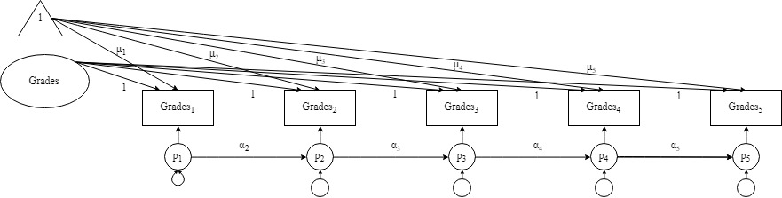

Figure S1. Depiction of an unconditional model with random intercept, means, and autoregressive paths

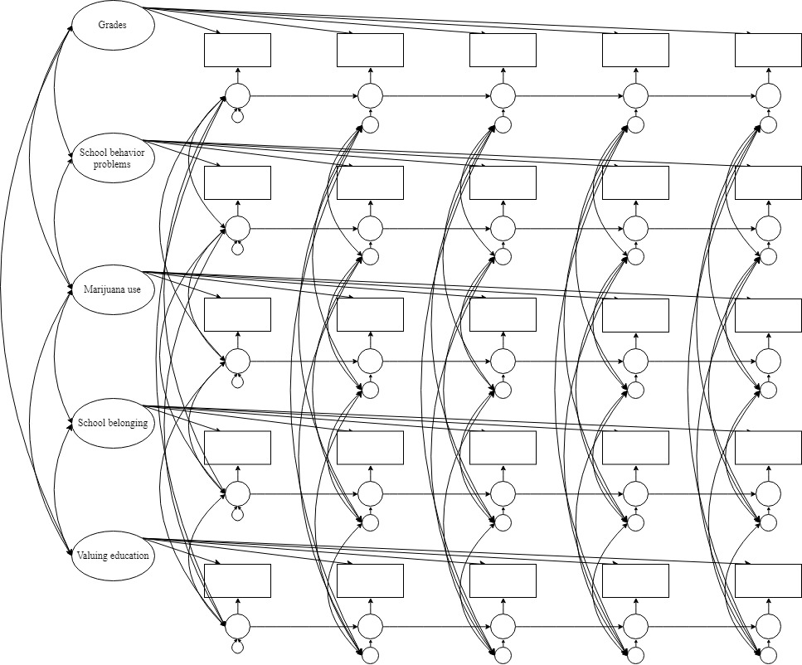

Figure S2. Panel model including all constructs, with covariances allowed among intercepts, among variables at t₁, and among residuals at t₂-t₅

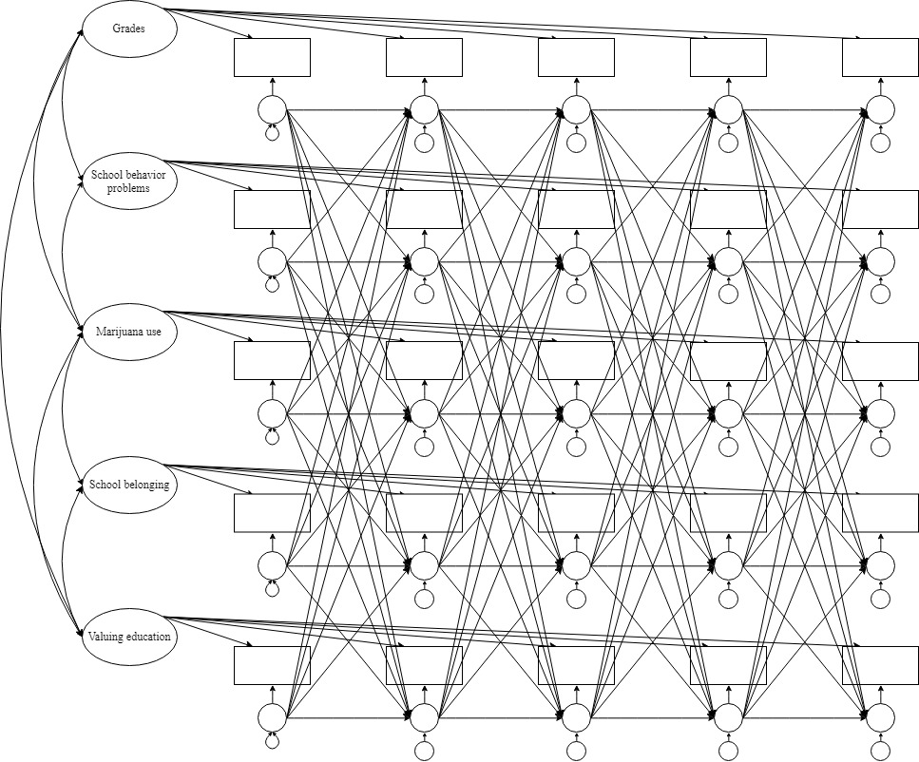
Figure S3. Random intercepts cross-lagged panel model
Note: The following components are included in the models but are not depicted in the figure for clarity: means, covariances among variables at t₁, covariances among residuals at t₂-t₅, and the time-invariant covariates.

