Supplementary Material
Chemical Contaminant Exposures Assessed Using Silicone Wristbands Among Occupants in Office Buildings in the USA, UK, China, and India

Anna S. Young*^{1,2}, Nicholas Herkert³, Heather M. Stapleton³, Jose Guillermo Cedeño Laurent¹, Emily R. Jones^{1,2}, Piers MacNaughton¹, Brent A. Coull¹, Tamarra James-Todd¹, Russ Hauser¹, Marianne Lahaie Luna^{1,4}, Yu Shan Chung¹, Joseph G. Allen¹

¹ Harvard T.H. Chan School of Public Health, Boston, MA, USA
² Harvard Graduate School of Arts and Sciences, Cambridge, MA, USA
³ Duke Nicholas School of the Environment, Durham, NC, USA
⁴ University of Toronto Dalla Lana School of Public Health, Toronto, Canada

Contents
Methods: Study population.
Methods: Laboratory analyses of wristbands.
Methods: Quality assurance and quality control.
Methods: Statistical analyses.
Results: Indoor air quality measurements in sensitivity analyses.
Figure S1: Principal component analysis results.
Figure S2: Boxplots of PCBs by country.
Figure S3: Boxplots of BFRs by country.
Figure S4: Boxplots of OPEs by country.
Figure S5: Boxplots of phthalates and phthalate alternatives by country.
Figure S6: Boxplots of pesticides by country.
Figure S7: Boxplots of PAHs by country.
Figure S8: Comparison of BFR exposures to previous wristband studies.
Figure S9: Comparison of OPE exposures to previous wristband studies.
Figure S10: Comparison of phthalate exposures to previous wristband studies.
Figure S11: Comparison of pesticide exposures to previous wristband studies.
Figure S12: Comparison of PAH exposures to previous wristband studies.
Figure S13: Correlations between chemicals.
Figure S14: Latent class analysis on product user types relevant to phthalates.
Figure S15: Boxplots of chemicals by building.
Table S1: Building, workstation, and individual characteristics of study population.
Table S2: Chemical names and detection limits.
Table S3: Information on internal standards and recoveries.
Table S4: Summary statistics of chemical concentrations scaled to 32-hour exposure.
Table S5: Summary statistics of chemical concentrations scaled to 7-day exposure.
Table S6: Between-building variability in log chemical concentrations in models.
Table S7: Results of sensitivity models controlling for indoor air measurements.
Methods: Study Population

Participants for this nested sub-study were recruited from the pre-existing Global CogFx building cohort. Briefly, the Global CogFx building cohort included a convenience sample of knowledge work companies (e.g. architecture, technology, real estate investment, coworking, and engineering) located in urban commercial real estate (i.e. no retail or manufacturing sites). Within each building of the CogFx study, any company employee was invited to take the eligibility survey. There was a median of 10 volunteers per building who were selected to join the study and met the following eligibility criteria: between the ages of 18 and 65 years, used a smartphone, was a permanent full-time employee, worked at least three days per week in the office, was a non-smoker, and was not color blind (due to other cognitive function tests that are not relevant to this current study). We invited all of the original study participants in most of these buildings to participate in our nested study. In China, we also extended recruitment to other employees in the same office who were not original participants in the parent study in order to increase our population size. From the original CogFx study cohort of buildings we recruited from, we successfully sampled about 55% of the USA participants, 66% of the UK participants, 56% of the participants in India, and 35% of the original participants in China (not considering other coworkers we opened recruitment to in China).
The final 251 workers who participated in this nested sub-study of chemical exposures occupied 36 different buildings across the four countries. The included USA buildings were located in the following cities (states): Chicago (IL), Cleveland (OH), Phoenix (AZ), Overland Park (KS), Los Angeles (CA), Minneapolis (MN), Omaha (NE), Denver (CO), Seattle (WA), Washington DC, San Francisco (CA), Clearwater (FL), and Boston (MA). The UK buildings were located in Cambridge (East of England), London (Greater London), Sheffield (Yorkshire and the Humber), Birmingham (West Midlands), and Croydon (Greater London). The six buildings in China were all located in either Shanghai (municipality) and Chengdu (Sichuan Province). The buildings in India were in Bengaluru (KA), Mumbai (MH), Gurugram (HR), Hyderabad (TS), Pune (MH), and Gurgaon (HR).

Methods: Laboratory Analyses of Wristbands

Approximately one-fifth of each wristband was used for analyses, with sample masses around 0.75 g. The wristband segments were transferred to a clean 50 mL glass centrifuge tube and spiked with isotopically-labeled compounds (Table S3). The wristband samples were extracted via sonication (15 minutes repeated three times) with 10 mL of a 50:50 mixture (v:v) of hexane:dichloromethane for a final extraction volume of 30 mL. Samples were then concentrated to ~ 1 mL using purified nitrogen. Extracts were purified using 8 g of water deactivated, 100-200 mesh Acros Organics Florisil (Thermo Fisher Scientific, Waltham, MA, USA). Two 30 mL fractions, hexane and ethyl acetate respectively, were collected together, concentrated to near dryness, and reconstituted in 1 mL of hexane. Most target analytes were analyzed using an Exactive GC Hybrid Quadrupole-Orbitrap GC-MS/MS system (Thermo Fisher Scientific, Waltham, MA, USA) operated in full scan Electron Ionization (EI) mode. BEHTBP, BDE 183, and BDE 209 in Batch 1 were analyzed using a single quadrupole GC-MS (Agilent 6890N and 5975, respectively) (Agilent Technologies, Inc., Santa Clara, CA, USA) operated in electron capture negative chemical ionization (ECNI) mode. BEHTBP, BDE 183, and BDE 209 in Batch 2 were analyzed using the Exactive GC Hybrid Quadrupole-Orbitrap GC-MS/MS system operated in NCI mode.
Wristbands from eight participants (3.2%) in the first small set of samples, including three from the USA and five from the UK, were not measured for some of the analytes, including PCBs [PCB-11], OPEs [TEP, TiPP, TPrP, TiBP, TPeP, TEHP, ToCP, TmCP, TpCP, TDMPP], pesticides [atrazine, fipronil, malathion, p,p’-DDE, trifloxystrobin], and all PAHs (Table S2).

Methods: Quality Assurance and Quality Control
Field blanks and lab blanks were processed and analyzed with each batch of wristbands for quality assurance and quality control. A six-point calibration curve was used to quantify each individual SVOC in samples and blanks. Method detection limits (MDLs) were calculated as three times the standard deviation of the field and lab blank responses. The MDLs by batch are presented in Table S2.
Isotopically labelled standards and their average recovery in the samples can be found in Table S3. Target analyte concentrations were recovery-corrected with an appropriate internal standard to account for loss during laboratory processing.
Prior to sample analysis, the QE-GC was tuned and calibrated to ensure maximum mass accuracy (<0.5 ppm). The tune was examined after samples had run to ensure no significant sensitivity loss had occurred. Additionally, a standard mixture of all target analytes was injected periodically (every 15 injections) to monitor stability during the instrument run.

Methods: Statistical Analyses
For formal statistical modeling, we excluded eight participants (3.2%) who did not respond to at least one activity survey. For models of BFRs, OPEs, and phthalates, we excluded another two (0.8%) who did not respond to the workstation survey. Eight others (3.2%) were excluded for modeled chemicals that were not measured in the first sample batch: TiBP, TpCP, PCB-11, malathion, and p,p’-DDE. Thus, final sample sizes in statistical models ranged from n=233 to n=243 (except lower when only a subset of countries had enough detections to analyze).
The multilevel models included covariates for country; building covariates: construction year, presence of foam chair (for flame retardants), flooring type (for flame retardants and plasticizers), recent building pesticide application; and individual behaviors while wearing wristbands: hand-washing frequency (daily average after recoding 0 for “Never”, 2 for “1-3”, 5 for “4-6”, 8 for “7-9”, and 12 for “10 or more”); wearing the wristband under clothing any day; eating produce at desk any day (for pesticides); wearing clothing cleaned with fragranced laundry detergent/softener/conditioner (for phthalates); and product user type (for phthalates). For models of phthalates and their alternatives, we also conducted latent class analysis (LCA) to identify covariate for personal care product user types based on self-reported use on any study day of: aftershave; body or hand lotion; deodorant; hair oil, grease, or leave-in conditioner; hair spray; makeup foundation, blush, or eye shadow; nail polish; and perfume or cologne. The survey questions about personal care products included products they applied any time before they took off the wristband (i.e. including the morning before putting the wristband on, because many fragrances persist over time). We chose the LCA model with optimal AIC and BIC while minimizing latent classes (all less than seven) and ensuring interpretability. User types were based on product weight-based probabilities of assignment into a latent class and on which products differentiated latent classes the most.
To avoid multiple testing issues that could arise from statistical models on 99 chemicals, we first selected pesticides detected in over half of samples within at least one country. For chemical classes with building material uses (PCBs, BFRs, and OPEs), and separately for phthalates with personal care product sources, we used principal component analysis results to select key chemicals for models (Figure S1). We chose one to two tracer chemicals per principal component to use as model outcomes. We prioritized the chemical(s) with the highest contributions to each component, then the chemicals with the highest detection frequencies, while including a second chemical if used in different product applications.

Results: Indoor Air Quality Measurements in Sensitivity Analyses
In sensitivity analyses, we conducted the same statistical models but with additional covariates for average indoor air exchange rate (calculated from CO₂), PM_{2.5} concentration, temperature, and relative humidity during the study week. As these variables were not available for 32 participants due to sensor technological issues, we did not include them in the main models. The base sample size for these models was n=212. We did not find any appreciable differences in the results of our primary covariates except for a change in the precision of some estimates but negligible changes in the actual point estimates. The consistency between the original and sensitivity models indicates that differences in indoor climate in the buildings across countries did not appreciably explain our findings. There was only one significant association between the indoor air conditions and chemical exposures: a 1 µg/m³ increase in the indoor PM_{2.5} level was associated with 5% higher levels of EHDPP on wristbands (95% CI: 1–10%; p=0.041). This result makes sense given that EHDPP is often found particle-bound in air (in addition to gas-phase) (Sühring et al., 2016; Yaman et al., 2020). We also found that an increase in the air exchange rate (i.e. better outdoor air ventilation) such that the volume of air in the room is completely changed once more per hour is associated with a 100% decrease in levels of cypermethrin on the wristbands (95% CI: -100– -95%; p=0.012) and a 78% decrease in levels of permethrin (95% CI: -94– -23%; p=0.04). However, the models of these two pesticides could only be conducted on 29 samples from China with sufficient detections and in buildings with sensor data, so the model may have been over-specified, and only three different air exchange rates were represented.

Figure S1. Contributions of a) PCBs, BFRs, and OPES and b) phthalates and phthalate alternatives to the principal components explaining over 70% of variance from analysis of analytes detected in over one-third of silicone wristband samples in a country (n=251).

- PCBs, BFRs, and OPEs (primarily building material sources)

- Phthalates and phthalate alternatives
Figure S2. Log concentrations (ng/g-wristband, scaled to 32 hours of sampling) and detection frequencies of polychlorinated biphenyls (detected in over one-third of samples in a country) in silicone wristbands worn by n=251 (PCB-101) or n=243 (PCB-11) office workers in the USA, UK, China, and India.

Note: non-detect values were substituted with half the limit of detection.

Figure S3. Log concentrations (ng/g-wristband, scaled to 32 hours of sampling) and detection frequencies of brominated flame retardants (detected in over one-third of samples in a country) in silicone wristbands worn by 251 office workers in the USA, UK, China, and India.

Note: non-detect values were substituted with half the limit of detection.
Figure S4. Log concentrations (ng/g-wristband, scaled to 32 hours of sampling) and detection frequencies of organophosphate esters (detected in over one-third of samples in a country) in silicone wristbands worn by n=243–251 office workers in the USA, UK, China, and India.

Note: non-detect values were substituted with half the limit of detection.
Figure S5. Log concentrations (ng/g-wristband, scaled to 32 hours of sampling) and detection frequencies of phthalates and phthalate alternatives (detected in over one-third of samples in a country) in silicone wristbands worn by 251 office workers in the USA, UK, China, and India.

Note: non-detect values were substituted with half the limit of detection.
Figure S6. Log concentrations (ng/g-wristband, scaled to 32 hours of sampling) and detection frequencies of pesticides (detected in over one-third of samples in a country) in silicone wristbands worn by n=243–251 office workers in the USA, UK, China, and India.

Note: non-detect values were substituted with half the limit of detection.
Figure S7. Log concentrations (ng/g-wristband, scaled to 32 hours of sampling) and detection frequencies of polycyclic aromatic hydrocarbons (detected in over one-third of samples in a country) in silicone wristbands worn by n=243 office workers in the USA, UK, China, and India.

Note: non-detect values were substituted with half the limit of detection.

Figure S8. Comparison of geometric mean concentrations of brominated flame retardants in silicone wristbands from our study in the USA, UK, China, and India (n=251) to central tendency (geometric mean, median, or mean) previous studies of wristbands where we scaled their concentrations to our 32 hours of exposure sampling duration.

Caution: some previous studies did not employ the same lab analysis methods except when marked with * below.
Doherty et al. 2020: pregnant moms in New Hampshire, USA (n=255; sampled 2017-8; wristbands worn for 7 days; we substituted 0s with 0.001).
*Hammel et al. 2018: general population in North Carolina, USA (n=30; compatible lab methods; sampled 2016; wristbands worn for 7 days).
Kile et al. 2016: preschool children in Oregon, USA (n=72; sampled 2012-3; wristbands worn for 7 days and concentrations scaled by time; only mean levels available).
Travis et al. 2020: elementary school children in Montevideo, Uruguay (n=24; wristbands worn for 7 days).
Wang et al. 2019: community in rural Appalachia, USA (n=101; sampled 2017-8; wristbands worn for 7 days).
Wang et al. 2020: older adults in France (n=40; sampled 2018-2019; wristbands worn for 5 days).
Wang et al. 2020.: young adults in Italy (n=32; sampled 2018-2019; wristbands worn for 5 days).

Figure S9. Comparison of geometric mean concentrations of organophosphate esters in silicone wristbands from our study in the USA, UK, China, and India (n=243–251) to central tendency (geometric mean, median, or mean) previous studies of wristbands where we scaled their concentrations to our 32 hours of exposure sampling duration.

Caution: some previous studies did not employ the same lab analysis methods except when marked with * below.
Doherty et al. 2020: pregnant moms in New Hampshire, USA (n=255; sampled 2017-8; wristbands worn for 7 days; we substituted 0s with 0.001).
Gibson et al. 2019: mothers in New York, USA (n=38; sampled 2015; wristbands worn for 7 days).
*Hammel et al. 2016: general population in North Carolina, USA (n=40; compatible lab methods; sampled 2015; wristbands worn for 5 days).
*Hammel et al. 2020: children in North Carolina, USA (n=77; compatible lab methods; sampled 2015; wristbands worn for 7 days).
Kile et al. 2016: preschool children in Oregon, USA (n=72; sampled 2012-2013; wristbands worn for 7 days; only mean levels available).
*Reddam et al. 2020: undergraduate students in California, USA (n=88; compatible lab methods; sampled 2019; wristbands worn for 5 days).
Travis et al. 2020: elementary school children in Montevideo, Uruguay (n=24; wristbands worn for 7 days).
Wang et al. 2019: community in rural Appalachia, USA (n=101; sampled 2017-2018; wristbands worn for 7 days).
Wang et al. 2020: older adults in France (n=40; sampled 2018-2019; wristbands worn for 5 days).
Wang et al. 2020.: young adults in Italy (n=32; sampled 2018-2019; wristbands worn for 5 days).

Figure S10. Comparison of geometric mean concentrations of phthalates and phthalate alternatives in silicone wristbands from our study in the USA, UK, China, and India (n=251) to central tendency (geometric mean or median) previous studies of wristbands where we scaled their concentrations to our 32 hours of exposure sampling duration.

Caution: some previous studies did not employ the same lab analysis methods except when marked with * below.
Doherty et al. 2020: pregnant moms in New Hampshire, USA (n=255; sampled 2017-8; wristbands worn for 7 days; we substituted 0s with 0.001).
*Hammel et al. 2020: children in North Carolina, USA (n=77; compatible lab methods; sampled 2015; wristbands worn for 7 days).

Figure S11. Comparison of geometric mean concentrations of pesticides in silicone wristbands from our study in the USA, UK, China, and India (n=243–251) to central tendency (geometric mean or median) previous studies of wristbands where we scaled their concentrations to our 32 hours of exposure sampling duration.

Caution: These previous studies did not employ the same lab analysis methods.
Doherty et al. 2020: pregnant moms in New Hampshire, USA (n=255; sampled 2017-8; wristbands worn for 7 days; we substituted 0s with 0.001).
Donald et al. 2016: farmers in Senegal (n=35 x 2 sampling periods; sampled 2014; wristbands worn for about 4.5 days; we calculated the geometric means).
Travis et al. 2020: elementary school children in Montevideo, Uruguay (n=24; wristbands worn for 7 days).
Vidi et al. 2017: Latino children of farmworkers in North Carolina, USA (n=10; wristbands worn for 7 days although there was a range for some participants).

Figure S12. Comparison of geometric mean concentrations of polycyclic aromatic hydrocarbons in silicone wristbands from our study in the USA, UK, China, and India (n=243) to central tendency (geometric mean or median) previous studies of wristbands where we scaled their concentrations to our 32 hours of exposure sampling duration.

Caution: These previous studies did not employ the same lab analysis methods.
Doherty et al. 2020: pregnant moms in New Hampshire, USA (n=255; sampled 2017-8; wristbands worn for 7 days; we substituted 0s with 0.001).
Paulik et al. 2018: people living near natural gas extraction in Ohio, USA (n=19; sampled 2014; wristbands worn for 21 days; we were able to calculate medians from raw concentrations or non-detects provided).
Wang et al. 2020: older adults in France (n=40; sampled 2018-2019; wristbands worn for 5 days).
Wang et al. 2020.: young adults in Italy (n=32; sampled 2018-2019; wristbands worn for 5 days).

Figure S13. Spearman correlation coefficients for chemicals detected in at least one-third of silicone wristband samples by country (USA: n=85; UK: n=42; China: n=70; India: n=54), with only significant relationships presented based on the Benjamini-Hochberg procedure by country.

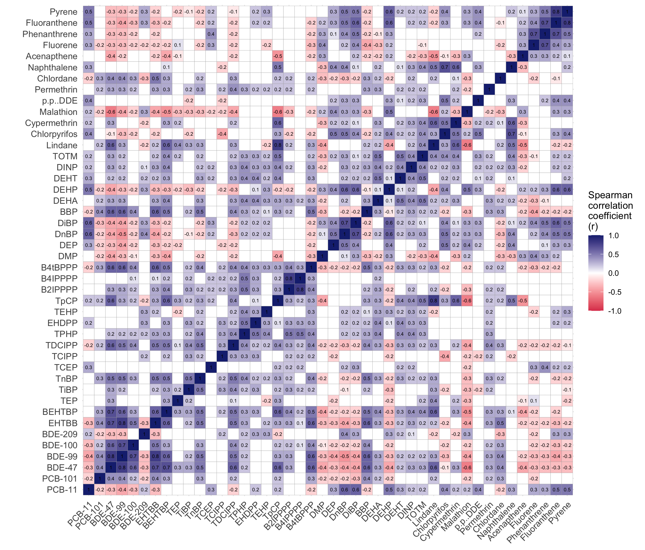

Figure S14. Results of latent class analysis of product user types based on any reported use of personal care products during the sampling days, where we distinguished and interpreted class 2 as minimal product users, class 1 as deodorant users, and class 3 as perfume and makeup users.

Figure S15. Boxplots (excluding outliers) of log concentrations (ng/g-wristband) of modeled chemicals within each building by country.

Table S1. Summary of information, when available, on individual, workstation, and building factors overall and by country (USA: n=85; UK: n=42; China: n=70; India: n=54).

CONTINUED ON NEXT PAGE:

Table S1 continued.

¹These demographic questions were only asked in the parent Global CogFx Study, so the degree of missing data is different.
²Including makeup foundation, blush, or eyeshadow
Table S2. Method detection limits for chemical analytes across three batches of samples.

CONTINUED ON NEXT PAGE:
Table S2 continued.

NA = not measured.
Note: In total, 21 field blanks were measured in batch 1 (n=1), batch 2 (n=10), and batch 3 (n=10).

Table S3. Information on internal standards and percent recoveries for the wristband samples.

Table S4. Summary of detection frequencies and concentrations (ng per g wristband, scaled to 32 hours of sampling) of chemical analytes in wristbands worn by 251 office workers in the USA, UK, China, and India.
CONTINUED ON NEXT PAGE:

Table S4 continued.
Note: Medians, GMs, and GSDs are shown as "<MDL" if there were no detected concentrations of that chemical.

Table S5. Summary of concentrations (ng per g wristband, scaled to 7 full days [168 hours] of sampling time) of chemical analytes in wristbands worn by 251 office workers in the USA, UK, China, and India.

CONTINUED ON NEXT PAGE:
Table S5 continued.

Note: Medians, GMs, and GSDs are shown as "<MDL" if there were no detected concentrations of that chemical.

Table S6. Percent of variability in log chemical concentrations explained by differences between buildings, as opposed to differences between individuals within buildings, in multilevel regression models (Tables 1-3).

¹ Note that some countries often had to be excluded in the pesticide models.
Table S7. Results of multilevel regression models from the sensitivity analyses adjusted for building indoor air quality measurements compared to the primary analyses presented in the main manuscript (Tables 1-3).
*** p<0.001
** p<0.01
* p<0.05
. p<0.10

References
Sühring, R., Wolschke, H., Diamond, M.L., Jantunen, L.M., Scheringer, M., 2016. Distribution of Organophosphate Esters between the Gas and Particle Phase–Model Predictions vs Measured Data. Environ. Sci. Technol. 50, 6644–6651. https://doi.org/10.1021/acs.est.6b00199
Yaman, B., Dumanoglu, Y., Odabasi, M., 2020. Measurement and Modeling the Phase Partitioning of Organophosphate Esters Using Their Temperature-Dependent Octanol–Air Partition Coefficients and Vapor Pressures. Environ. Sci. Technol. 54, 8133–8143. https://doi.org/10.1021/acs.est.0c02823

