Supplementary material 1.
Outline of human papillomavirus (HPV) vaccine introduction guidelines, 2018 Tanzania HPV vaccine introduction
Tanzania HPV Vaccine Introduction Guidelines for Regional and District Personnel (English)
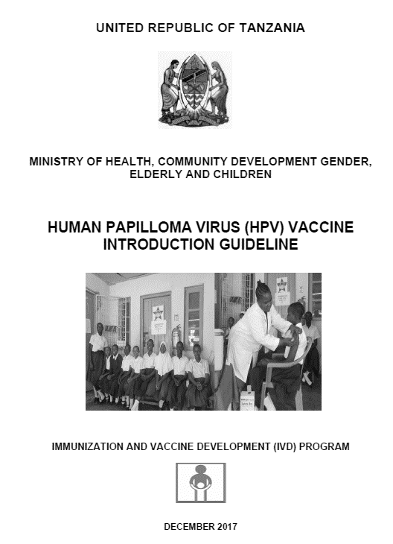 | Chapter 1 | Introduction
 | Chapter 2 | Experience of HPV Vaccination Demonstration Project
 | Chapter 3 | Planning at National, Regional, District, and Health Facility Level
 | Chapter 4 | HPV Vaccination Implementation
 | Chapter 5 | Vaccine Management
 | Chapter 6 | Injection Safety
 | Chapter 7 | Advocacy, Communication, and Social Mobilization for HPV
 | Chapter 8 | Linking HPV Vaccination with Other Health Interventions
 | Chapter 9 | Monitoring and Evaluation
 | Annexes | HPV Vaccination Card, School register, Community register, Council microplanning tools
Tanzania HPV Vaccine Introduction Guidelines for Service Providers (Kiswahili)
 | Chapter 1 | Introduction
 | Chapter 2 | HPV Infection and Cervical Cancer
 | Chapter 3 | HPV Vaccine
 | Chapter 4 | HPV Vaccine Delivery
 | Chapter 5 | Education and Social Mobilization
 | Chapter 6 | Waste Management
 | Annexes | School register, Community register, HPV vaccination card

