Supplemental Content
This appendix has been provided by the authors to give readers additional information about their work.
Supplement to: Samuels, AM, et al: Diagnostic performance of loop-mediated isothermal amplification (LAMP) and ultra-sensitive rapid diagnostic tests (usRDTs) for malaria screening in pregnant women attending their first antenatal care clinic visit in western Kenya

Table of Contents
Supplemental methods 2
Microscopy 2
LAMP 2
PET-PCR 2
Supplemental references 3
Supplemental figures 4
Figure-S1: Participant flow diagram Overview 4
Figure-S2: Relative diagnostic sensitivity by first or second trimester and gravidity 4
Supplemental tables 6
Supplmental Table 1: STARD checklist 6

Supplemental methods

Microscopy
Blood smear reads were considered discordant if they differed qualitatively by the presence of parasites or species identification. Additionally, reads were considered discordant if they differed quantitively by the following parameters:
- For high and medium parasitemia results (parasite density ≥400 parasites/µL): if the higher count divided by the lower count is ≥2
- For low parasitemia results (parasite density ≤400 parasites/µL): if the higher count divided by the lower count is ≥10
- If one parasitemia result is ≥400 parasites/µL and the other is ≤400 parasites/µL: if the higher count divided by the lower count is ≥10
A third microscopist, blinded to the results of prior examinations, confirmed discordant results. The final results used the results from the third reader combined with those the results of the microscopist most similar to the third reader.

LAMP
50 µL microlitres of whole blood sample were added to a collection tube containing illumigene® buffer and thoroughly mixed by inverting the tube five times. After incubation for 2 minutes at room temperature, 50 µL of the lysate was added to a sample device (SMP PREP IV) containing 900 µL of reaction buffer. After inverting five times, 5-10 drops of the lysate/reaction buffer mixture were gently squeezed into a clean tube. Fifty microlitres of the prepared eluate were added to both the test and control chambers of the illumigene® Malaria Test Device consisting of a TEST tube containing primers targeting the genus Plasmodium and a CONTROL tube with primers targeting the housekeeping human gene, NADH dehydrogenase subunit 1. Amplification and detection of malaria parasites were done by inserting the sample and control tubes in the Illumipro-10™ Incubator/Reader, which detects the change in turbidity associated with the production of magnesium pyrophosphate. A qualitative test result (positive, negative or invalid) is printed out after the run. The limit of detection (LoD) using the WHO standard has been determined to be equivalent to 2 parasites/μl [1].

PET-PCR
Genus-specific photo-induced electron transfer (PET) PCR was used as described previously,¹ with some modifications. Briefly, the PET-PCR assay was performed in triplicate using a 20µl reaction mix containing 2x TaqMan Environmental Master Mix 2.0 (Applied BioSystems), forward (GGCCTAACATGGCTATGACG) and FAM-labeled reverse (aggcgcatagcgcctggCTGCCTTCCTTAGATGTGGTAGCT) Plasmodium-specific primers and 5µl of DNA template. All runs included a P. falciparum positive lab control (3D7 strain) and PCR water as a no-template control. The cycling parameters used included an initial hot-start at 95°C for 15 minutes, followed by 45 cycles of denaturation at 95°C for 20 seconds, annealing at 63°C for 40 seconds and an extension at 72°C for 10 seconds. Samples with a cycle threshold (Ct) value of <40 Ct were considered positive; otherwise, all Ct values above 40 Ct were considered negative.
The mean cycle threshold (Ct) value from the PET-PCR was used to prepare a standard curve which to obtain parasite densities of the field isolates. Briefly, parasite density was calculated using a standard curve obtained from seven parasite isolates with known parasite density. A 5-fold serial dilution was prepared for each parasite isolate starting from a parasite density of 2000 to 0.64 parasites/µl. The dilutions were evaluated in quadruplicates by PET-PCR as described above.
The reported LOD for detecting P. falciparum infections is 3.2 parasites/µL.

Supplemental references
1. Lucchi NW, Narayanan J, Karell MA, et al. Molecular diagnosis of malaria by photo-induced electron transfer fluorogenic primers: PET-PCR. PLoS One 2013; 8(2): e56677.

Supplemental figures

Figure-S1: Participant flow diagram Overview
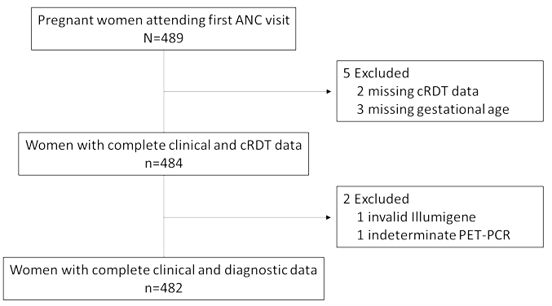

Figure-S2: Relative diagnostic sensitivity by first or second trimester and gravidity
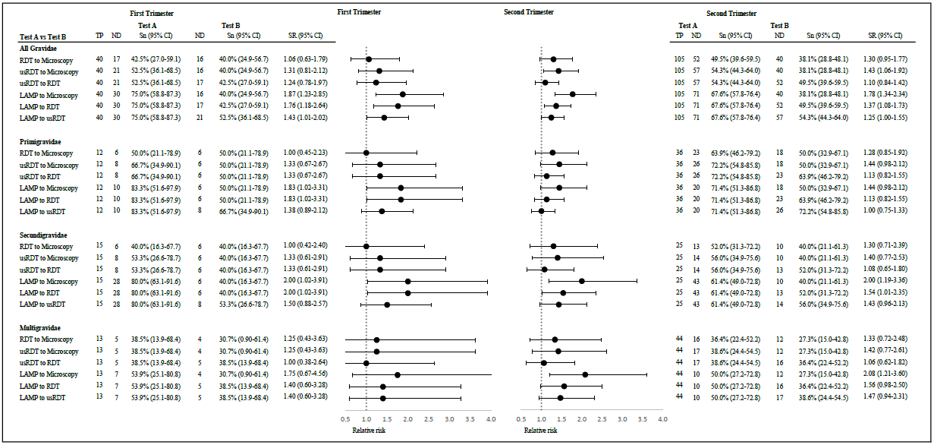
Sensitivity ratios were modelled using Poisson regression. Sensitivities of tests were calculated using PET-PCR results as the gold standard. SRs greater than 1 indicate that test A is more sensitive than test B for the given criteria. Abbreviations: TP, true positives within sub-group by PET-PCR; ND, number of true positives detected by the given test; Sn (95% CI), sensitivity (95% confidence interval); SR, sensitivity ratio; NE, non-estimable due to sample size limitation.

Supplemental tables

Supplmental Table 1: STARD checklist
Section & Topic | No | Item | Reported on page #
TITLE OR ABSTRACT
 | 1 | Identification as a study of diagnostic accuracy using at least one measure of accuracy  (such as sensitivity, specificity, predictive values, or AUC) | 1
ABSTRACT
 | 2 | Structured summary of study design, methods, results, and conclusions  (for specific guidance, see STARD for Abstracts) | 2
INTRODUCTION
 | 3 | Scientific and clinical background, including the intended use and clinical role of the index test | 4
 | 4 | Study objectives and hypotheses | 4
METHODS
Study design | 5 | Whether data collection was planned before the index test and reference standard  were performed (prospective study) or after (retrospective study) | 4
Participants | 6 | Eligibility criteria | 4
 | 7 | On what basis potentially eligible participants were identified  (such as symptoms, results from previous tests, inclusion in registry) | 4
 | 8 | Where and when potentially eligible participants were identified (setting, location and dates) | 4
 | 9 | Whether participants formed a consecutive, random or convenience series | 4
Test methods | 10a | Index test, in sufficient detail to allow replication | 5
 | 10b | Reference standard, in sufficient detail to allow replication | 5, Supplement Methods
 | 11 | Rationale for choosing the reference standard (if alternatives exist) | 5
 | 12a | Definition of and rationale for test positivity cut-offs or result categories  of the index test, distinguishing pre-specified from exploratory | 5
 | 12b | Definition of and rationale for test positivity cut-offs or result categories  of the reference standard, distinguishing pre-specified from exploratory | 4, Supplemental Methods
 | 13a | Whether clinical information and reference standard results were available  to the performers/readers of the index test | 5
 | 13b | Whether clinical information and index test results were available  to the assessors of the reference standard | 5
Analysis | 14 | Methods for estimating or comparing measures of diagnostic accuracy | 6
 | 15 | How indeterminate index test or reference standard results were handled | 6
 | 16 | How missing data on the index test and reference standard were handled | 6
 | 17 | Any analyses of variability in diagnostic accuracy, distinguishing pre-specified from exploratory | 6
 | 18 | Intended sample size and how it was determined | 5
RESULTS
Participants | 19 | Flow of participants, using a diagram | 5
 | 20 | Baseline demographic and clinical characteristics of participants | 6
 | 21a | Distribution of severity of disease in those with the target condition | 6
 | 21b | Distribution of alternative diagnoses in those without the target condition | N/A
 | 22 | Time interval and any clinical interventions between index test and reference standard | 5
Test results | 23 | Cross tabulation of the index test results (or their distribution)  by the results of the reference standard | 6
 | 24 | Estimates of diagnostic accuracy and their precision (such as 95% confidence intervals) | 6
 | 25 | Any adverse events from performing the index test or the reference standard | N/A
DISCUSSION
 | 26 | Study limitations, including sources of potential bias, statistical uncertainty, and generalisability | 8
 | 27 | Implications for practice, including the intended use and clinical role of the index test | 8
OTHER INFORMATION
 | 28 | Registration number and name of registry | N/A
 | 29 | Where the full study protocol can be accessed | Submitted upon request
 | 30 | Sources of funding and other support; role of funders | 6, 10

1. Lucchi NW, Narayanan J, Karell MA, et al. Molecular diagnosis of malaria by photo-induced electron transfer fluorogenic primers: PET-PCR. PLoS One 2013; 8:e56677.

