Supplemental Figure 1. Serogroup distribution of specimens which tested positive for Neisseria meningitidis by WHO Region, including all countries regardless of meningococcal conjugate vaccine introduction, 2014-2019 (N=391 specimens serogrouped). The number of countries that reported these specimens are indicated below per WHO Region.

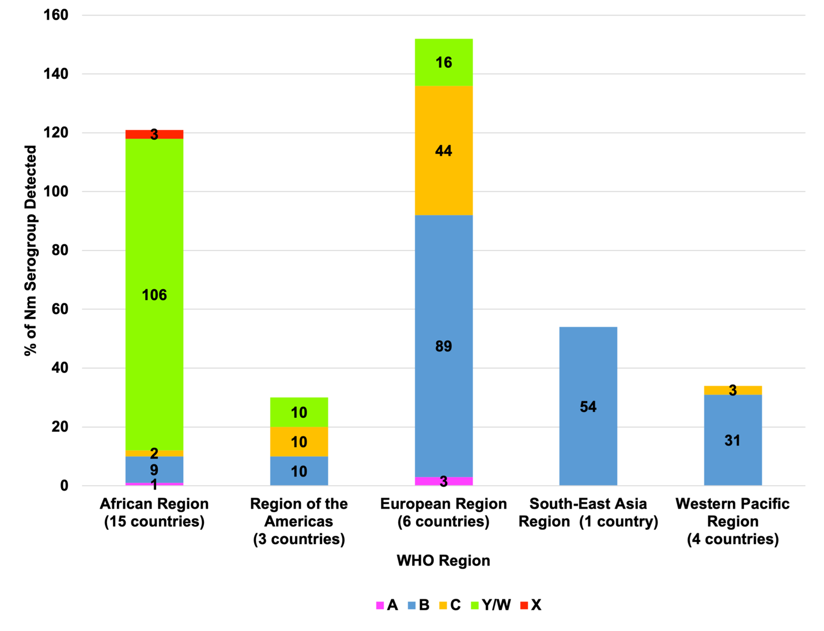
Supplemental Figure 2. Serogroup distribution of specimens which tested positive for Neisseria meningitidis by year from 2014-2019 (N=391 specimens serogrouped) including all countries regardless of meningococcal conjugate vaccine introduction.

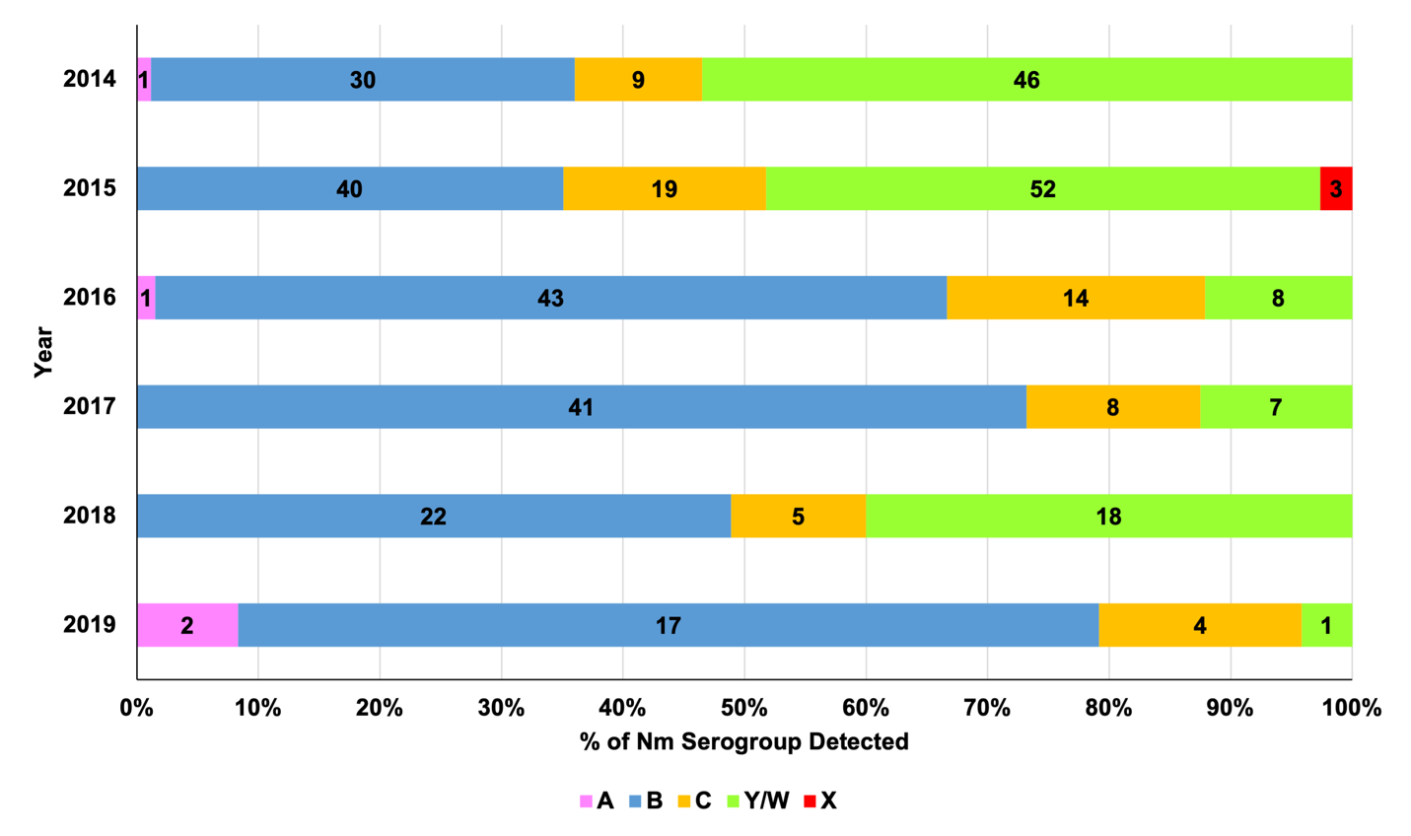

Countries from the Eastern Mediterranean Region were not included as no Nm serogroup results were reported during 2014-2019.

