Supplementary Figures
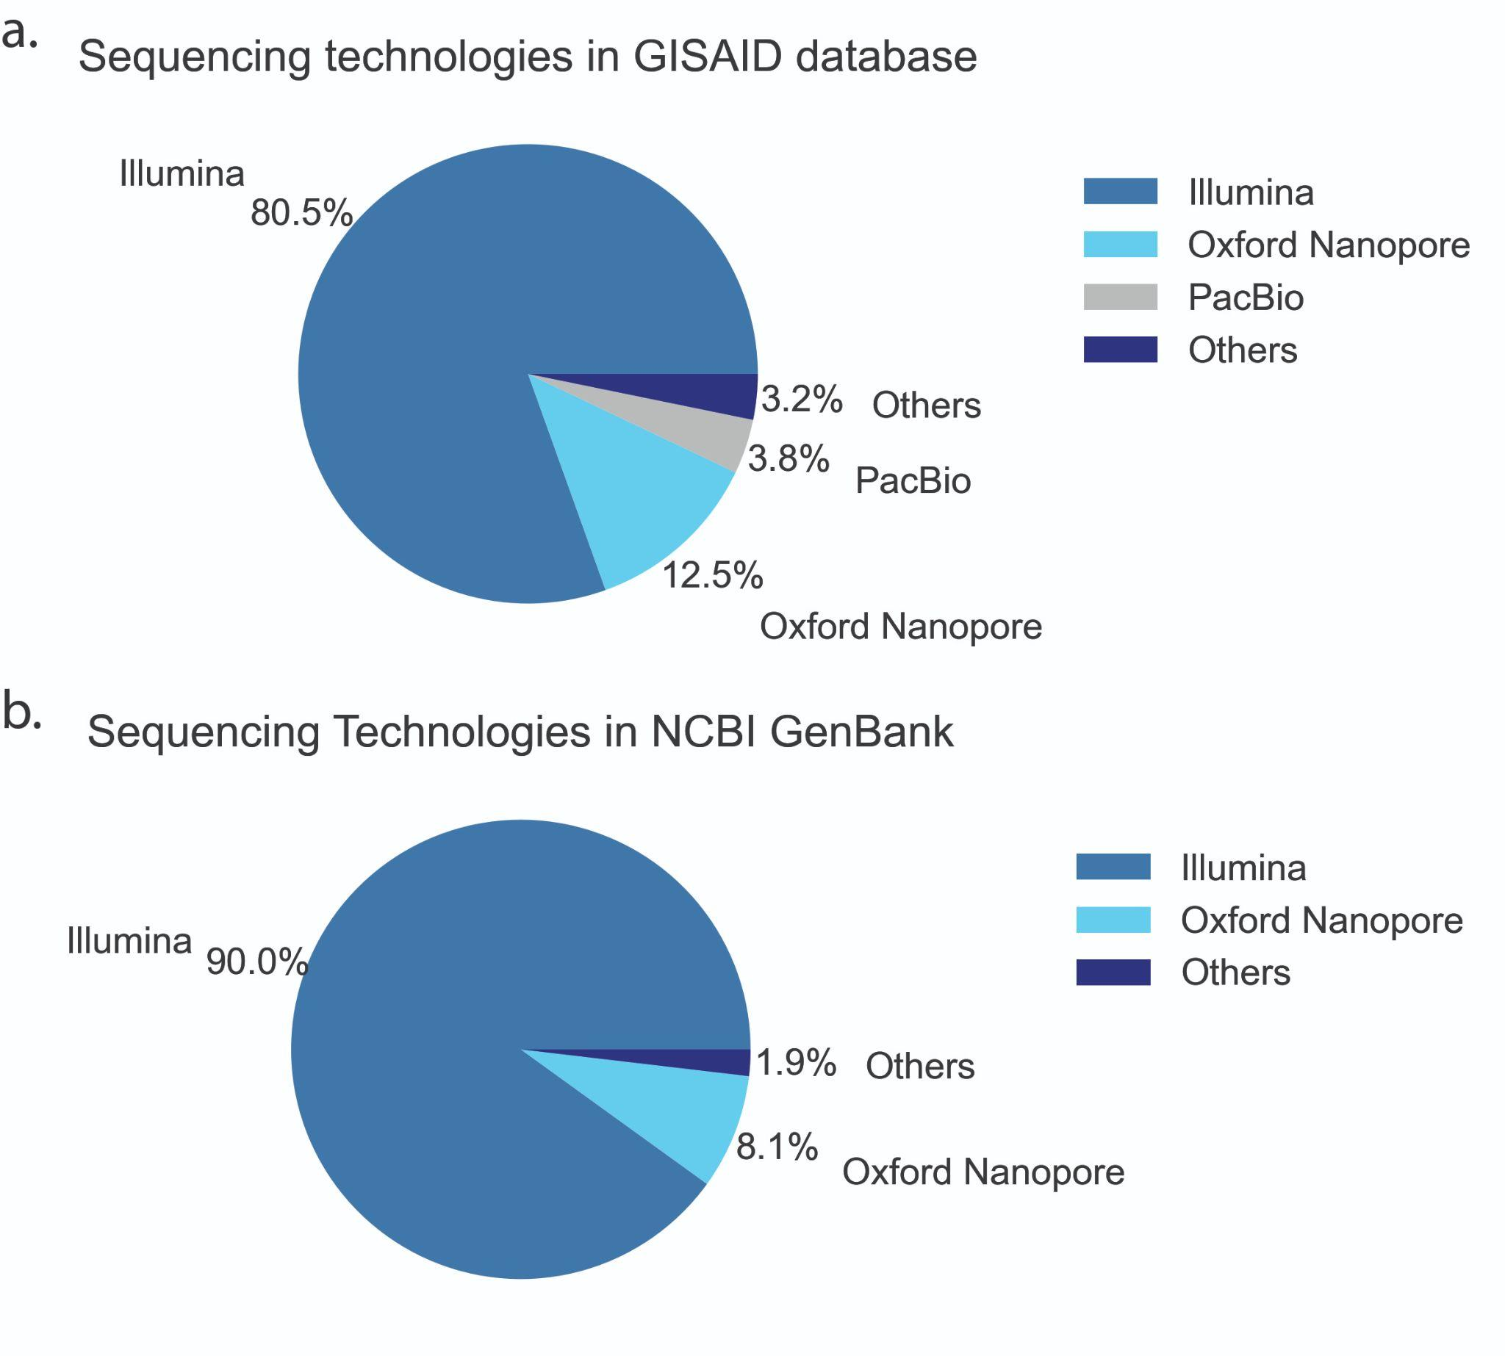

Figure S1 a) Sequenced genomes present on GISAID database sequenced by Illumina, Nanopore, PacBio, and other sequencing technologies. b) Sequenced genomes present on SRA database sequenced by Illumina, Nanopore, and other sequencing technologies that include Pacbio, IonTorrent, and BGISEQ.

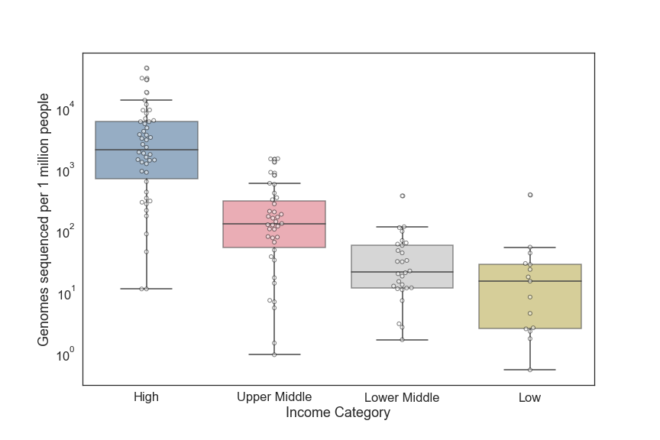

Figure S2 The number of genomes sequenced per million people per income category
(country-level).

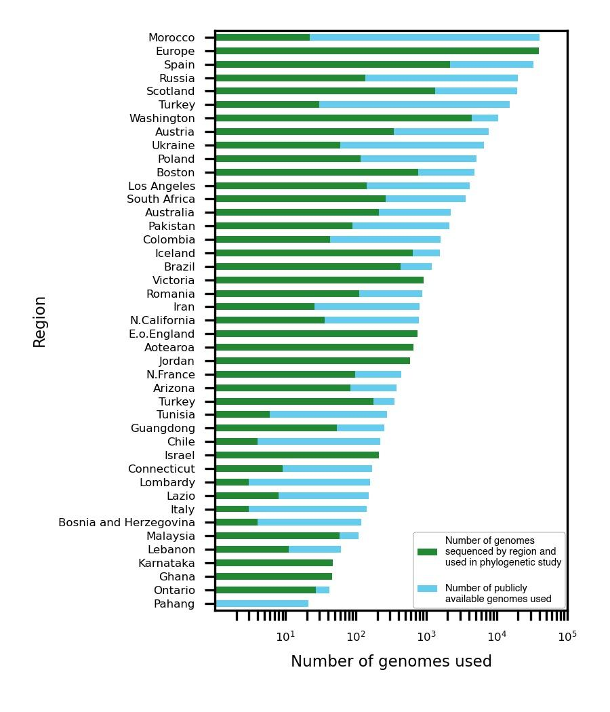
Figure S3 Number of genomes sequenced and/or publicly available across regions that were used for outbreak investigation studies in different regions.

Supplementary Table 1: Public repositories collecting SARS-CoV-2 genomes.
Database | Genomes* | Raw data* | Link
GISAID | 6,393,864 | - | https://www.gisaid.org/
COG-UK | 1,730,253 | - | https://www.cogconsortium.uk/
NCBI GenBank | 2,937,702 | 2,734,080 | https://www.ncbi.nlm.nih.gov/sars-cov-2/
* - Submitted by December 22, 2021

