Supplementary Appendix
Supplement to: Scott NA, Lee KK, Sadowski C, et al. Optimizing Drug Inventory Management with a Web-based Information System: The TBTC Study 31 / ACTG A5349 Experience

Contents
1. Strengthening the reporting of empirical simulation studies (STRESS): System Dynamics guideline STRESS-SD 3
1.1 Objectives 3
Supplementary Figure S1: Example output from RStudio® program: 3
1.2 Logic 4
Supplementary Figure S2: Study Drug Stock-out Logic Overview 4
1.3 Data 6
1.4 Experimentation 6
1.5 Implementation 7
1.6 Code access 7
2. Challenges of Study Drug Management in S31/A5349 10
2.1 Complexity of Study Treatment Kit Design within S31/A5349 10
2.2 Complexity of Study Drug Procurement within S31/A5349 11
2.3 Complexity in Shipments to Countries within S31/A5349 12
3. Supplementary Table S1: Description of Study Drugs used in TBTC Study 31/ACTG A5349 Regimens 13
4. Supplementary Table S2: Dimensions of Treatment Kits used in TBTC Study 31/ACTG A5349 14
5. Supplementary Figure S3: Study Drug Stock-out Schema 15
6. Supplementary Figure S4: Summary Manual Study Drug Kit Shipment Process 16
7. Drug Management Module Process Flow Scheme 17
7.1 Supplementary Figure S5a: Kit Restock Request Process 17
7.2 Supplementary Figure S5b: Shipment Receipt/Kit Management Process (Study Site View) 18
7.3 Supplementary Figure S5c: Kit Management Process (CDC Administrative View) 19
7.4 Supplementary Figure S5d: Restock Request/Reminders/Stock-out Process 20
8. Supplementary Picture S1: Pharmacy at Uganda -Case Western Reserve University Research Collaboration Showing TBTC Study 31/ACTG A5349 Kits 21
9. Supplementary Picture S2: Drug Management Module (DMM) Screenshot of Site Restock Request Page 21
10. Supplementary Picture S3: Drug Management Module (DMM) Screenshot of Site Kit Management Page 22

Strengthening the reporting of empirical simulation studies (STRESS): System Dynamics guideline STRESS-SD

1.1 Objectives
- Purpose of the model: To estimate the time to shipment-related study drug stock-out at sites by simulating likely enrollment scenarios. Study drug stock-out is defined as the complete consumption of study kits in any one study arm.
- Model outputs: At the end of these simulated stock-outs, a distribution of the number of participants randomized and the stock-out times were generated. The RStudio® program calculated the mean projected enrollment count and mean projected stock-out time at sites, in months. The corresponding 5th and 95th percentiles of projected enrollment and stock-out time were also calculated.

Supplementary Figure S1: Example output from RStudio® program:
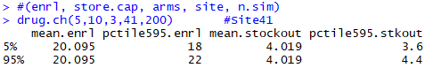
Notes:
Input variables, in blue, for shipment-related study drug stock-out algorithm R function (drug.ch):
enrl: Average monthly site enrollment rate, based on previous 3 months.
store.cap: Site pharmacy storage capacity, or quantity of kit pairs included in shipment.
arms: Number of treatment arms.
site: Study site identifying number.
n.sim: Number of simulation runs.

Output variables in black:
mean.enrl: Estimated mean enrollment, after 200 simulation runs.
pctile595.enrl: Estimated 5th and 95th percentile of enrollment, after 200 simulation runs.
mean.stockout: Estimated mean stock-out time in months, after 200 simulation runs.
pctile595.stkout: Estimated 5th and 95th percentile of stock-out time in months, after 200 simulation runs.

Output Interpretation:
The estimated 5th and 95th percentiles of stock-out time were 3.6 and 4.4 months respectively. Considering Supplementary Figure S3: Study Drug Stock-out Schema, these percentiles implied site stock-out between 3.6 to 4.4 months after date of first enrolled participant from the given shipment. Projected stock-out dates and Reminder notification dates were calculated, per Supplementary Figure S3 (footnotes 2 and 3 respectively).

- Experimentation aims: To provide into the Drug Management Module (DMM), the estimated number of months to study drug stock-outs. These estimates were used to determine when automated notifications are sent by the DMM to study sites informing them to start the resupply process. Supplementary Figure S3 (footnote 1) describes the calculation of these automated notifications (Reminder Date).

1.2 Logic
- Base model overview diagram:

Supplementary Figure S2: Study Drug Stock-out Logic Overview

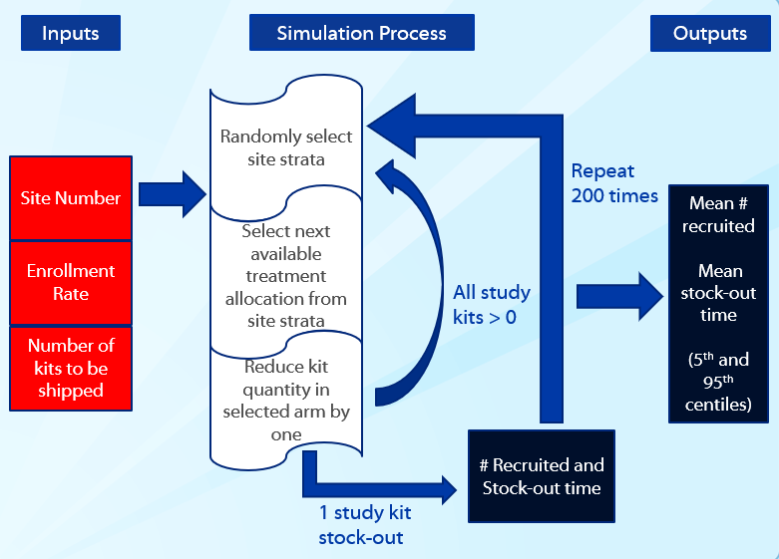
Inputs: Site number used to identify the site-specific block of treatment allocations within a pre-generated random table. Enrollment rate is based on the mean of the most recent 3 months of enrollments at sites. Number of kits to be shipped is the number of kit pairs in the arm with the most number of kits in the incoming shipment. See Supplementary Table S1 for definition of kit pair.
Simulation Process: The next available treatment allocation is selected from the randomly selected strata within a site. The quantity of kits in the corresponding regimen is reduced by 1. Process continues until there are no available kit pairs in any one arm. Simulations ran 200 times.
Outputs: The resulting distributions are used to calculate the 5th and 95th percentiles of the mean number of participants recruited, and of the mean time to stock-out. This mean time to stock-out is used in calculating the projected stock-out time as described in Supplementary Figure S3: Study Drug Stock-out Schema.
- Base model logic: The RStudio® program (See Section 6: Code access) simulated randomizations into one of the site-specific strata. A uniform distribution determined which stratum to select and allowed equal chance of randomization into each stratum. The next available treatment allocation within the selected stratum was selected. The quantity of kits in the arm selected was then reduced by one. This process; of randomly selecting a stratum, selecting the next available allocation within that stratum, and reducing the corresponding quantity of kits by one; continued if at least kit remained in each arm. When one arm was depleted, the program recorded the number of participants randomized during the simulation and estimated the time to stock-out based on the 3-month average site enrollment rate.

- Scenario logic: Not applicable. There are no logical differences between the base case model and scenarios.

- Algorithm: The algorithm mimicked the participant enrollments at study sites. Site-specific values entered into the algorithm were: site identification number; projected/actual site enrollment rate; and the quantity of kits in an incoming shipment. Randomization in S31/A5349 was stratified by site, presence of cavitation on baseline chest X-ray and HIV status⁹. Each site’s identification number was linked to a site-specific block of treatment assignments in the trial’s pre-generated randomization table. Site-specific blocks were partitioned into cavitation and HIV strata. At time of DMM implementation, projected site enrollment rates for sites currently enrolling in S31/A5349, were based on average enrollment from the most recent 3 months. For new sites beginning enrollment after DMM implementation, projected enrollment was based on sites’ anticipated enrollment capacity, until enough enrollment history was accumulated to use a 3-month average. Site storage capacity was obtained from site pharmacists at the beginning of the study based on kit dimensions in Supplementary Table S2 and used to estimate a cap for incoming shipments. The algorithm used the maximum quantity of kit pairs (Supplementary Table S1) from any one regimen in the new incoming shipment.

- Components:
- Stock/levels – The simulation estimated the stock-out of treatment kits at a study site. For this process, Intensive Phase (IP) and Continuation Phase (CP) kits, for each regimen, were treated as one unit “kit pairs.” (Supplementary Table S1) That is, reduction of kits implied a reduction of one kit pair (IP and CP). Levels of kit pairs are based on the quantity of kit pairs included in a specified shipment to a study site.
- Flows/Rates – All applicable flows were described in the Algorithm.
- Constants/Converters/auxiliary variables – All constants and variables in the model are included in Section 1.3.b.
- Graphical functions/lookup tables – The pre-generated random table was used as a lookup table for the specified study site and randomly selected strata. The random table provided the assignment of a simulated enrolled participant and hence which arm would be reduce by 1 kit pair unit.
- Sources and Sinks – Not applicable to this simulation, since the data source was a pre-generated random table, with a specified randomization structure.

1.3 Data
- Data sources: A pre-generated random table is used to assign participants to treatment regimens. This random table was stratified by study site, where each site was further stratified by clinical factors of interest, namely HIV status (yes/no), and cavitation on chest X-ray (yes/no) for S31/A5349. This resulted in 4 strata within each study site. An example of a random table is provided. For confidentiality reasons and to maintain the integrity of TBTC trials, the random table was limited to one dummy site and a new seed for generating random assignments.
Site No. | Strata¹ | Arm
A | ch | A
A | ch | C
A | cnh | A
A | cnh | B
A | nch | B
A | nch | C
A | ncnh | A
A | ncnh | A
¹ ch: Cavitation/HIV; cnh: Cavitation/non-HIV; nch: non-Cavitation/HIV; ncnh: non-Cavitation/non-HIV.

- Input parameters: The following is a description of the input paraments used for the Study Drug Stock-out Algorithm:
enrl: Average monthly site enrollment rate, based on previous 3 months.
store.cap: Site pharmacy storage capacity, or quantity of kit pairs included in shipment.
arms: Number of treatment arms. This was set at 3 treatment arms for S31/A5349.
site: Study site identifying number. This was a unique 2-digit number representing enrolling study sites in the pre-generated random table.
n.sim: Number of simulation runs. For this study, the number of runs was maintained at 200, which allows consistent results to 3 decimal places.
- Pre-processing: Prior to running the Study Drug Stock-out Algorithm, the pre-generated random table was updated to remove rows previously assigned to participants. This was accomplished by use of the SAS code (Section 1.6).
- Assumptions: The Study Drug Stock-out Algorithm used a Uniform distribution, with parameters: α = 0, β = 1. This distribution allowed equal opportunity for random assignment into 1 of the 4 strata described in Section 1.3.a “Data sources”.

1.4 Experimentation
- Initialization: The number of treatment kits included in a given shipment was used as an initial value, when estimating months until study drug stock-out.
- Run length: The model run time generally ranged from under 1 minute to about 3 minutes, depending on the quantity of treatment kits specified at initiation.
- Estimation approach: Point estimates for the number of months until stock-out and the number of participants enrolled from available study drugs in a given shipment were based on the average of 200 replications. The corresponding 5th and 95th percentiles of these point estimates were based on the distribution generated from the 200 replications.

1.5 Implementation
- Software or programming language: The model was implemented in commercial software SAS® 9.4 for updating the pre-generated random table. The Study Drug Stock-out algorithm was initially implemented in the open-source software RStudio® Version 1.0.136.
- Random sampling: Mersenne Twister in RStudio® was used as pseudorandom number generator for the Uniform distribution in the Study Drug Stock-out algorithm.
- Model execution: Not applicable for this model.
- System specification: The model was run on a Dell laptop, with a 2.6GHz Intel Core i7 processor and 8 GB of memory under 64-bit operating system, x64-based processor.

1.6 Code access

SAS® Code for updating original pre-generated random table

data work.s31_updated_rand;
set work.strata1_assign (keep = seq site strat_orig arm_orig USUBJID);
if USUBJID = '';
run;

proc export data = work.s31_updated_rand
outfile = "\\work directory\s31_updated_rand.csv" replace dbms = csv;
run;

RStudio® Code for Stock-Out Simulation
rand.orig <- read.csv("s31_updated_rand.csv", header=TRUE, sep = ",")

##function for drug stock-out
drug.ch <- function(n, store.cap, arms, site, n.sim)
{
simul.run <- data.frame(reg.A=rep(n.sim,5), reg.B=rep(n.sim,5),
reg.C=rep(n.sim,5), enrl.cnt=rep(n.sim,5), time.stockout=rep(n.sim,5))
for (s in 1:n.sim)
{
rand<-rand.orig #resets to original random alloc
drug.avail <- rep(store.cap,arms)
go<-1
strat <- rep('x',store.cap*arms) #max number of enrl based on storage cap
rand.assign <- matrix(0,nr=1,nc=arms) #matrix used to store assignments
m<-store.cap*arms

for (i in 1:m)
{
##check that drug is available for enrl
for (k in 1:arms){
if (drug.avail[k]==0) {go<-0} }

if (go==1)
{
rn <- runif(1)
if (rn<0.25) {strat[i]<-'ncnh'}
else if (rn>=0.25 & rn<0.5) {strat[i]<-'nch'}
else if (rn>=0.5 & rn<0.75) {strat[i]<-'cnh'}
else {strat[i]<-'ch'}

rand1 <- rand[rand$site == site,]
rand1 <- rand1[rand1$strat == strat[i],]
rand2 <- rand1$arm[1]

rand<-rand[!rand$seq == rand1$seq[1],]

if(rand2 == 'A') {drug.avail[1]<-drug.avail[1]-1}
if(rand2 == 'B') {drug.avail[2]<-drug.avail[2]-1}
if(rand2 == 'C') {drug.avail[3]<-drug.avail[3]-1}

if(rand2 == 'A') {rand.assign[1]<-rand.assign[1]+1}
if(rand2 == 'B') {rand.assign[2]<-rand.assign[2]+1}
if(rand2 == 'C') {rand.assign[3]<-rand.assign[3]+1}
}
}
enrl.sum<-sum(rand.assign)
time.stockout<-enrl.sum/n
simul.run[s,] <- data.frame(reg.A=rand.assign[1,1], reg.B=rand.assign[1,2],
reg.C=rand.assign[1,3], enrl.cnt=enrl.sum, time.stockout=time.stockout)
}
simul.run
summary1 <- data.frame(mean.enrl = mean(simul.run[,4]),
pctile595.enrl = quantile(simul.run[,4], probs = c(0.05, 0.95)),
mean.stockout = mean(simul.run[,5]),
pctile595.stkout = quantile(simul.run[,5], probs = c(0.05, 0.95)))
summary1
}

Challenges of Study Drug Management in S31/A5349

Effective management of study drug inventory in clinical trials depends on the nature of the supply chain. Factors that complicate the supply chain include the complexity of the study drug regimens, the number of drug suppliers involved, and whether supplies are procured through central management or by individual sites. Adding to these challenges are the widely varying national regulatory requirements for drug importation approvals and for Customs clearance. Regulatory authorities in different countries require a diverse range of documents, which may change, without notice, during the conduct of the trial. Delays may occur at Customs clearance as regulators assess taxes on imported goods or determine tax exemption status. Further complicating some approvals are restrictions on the length of time to receive approvals, on the duration of approval validity, on the number of importations allowed per approval, and on the quantity of study drugs allowed per shipment.
Temperature excursions, either during shipment or at site pharmacies, are additional challenges experienced by trial networks. Sites may be required to quarantine and subsequently destroy large quantities of study drugs, temporarily close for enrollment or contend with an increased risk of not having enough drugs for participants to complete treatment. Networks encounter further challenges to provide sites with a reliable platform to request restocking of study drugs, to track multiple product expiration dates and to maintain accurate and up-to-date counts of available site inventory.

2.1 Complexity of Study Treatment Kit Design within S31/A5349

S31/A5349 included three treatment arms, with two treatment phases per arm: Intensive Phase (IP) and Continuation Phase (CP). Supplementary Table S1 provides a detailed list of the study drugs used in the two treatment phases of each arm.
Each treatment phase had its own treatment kit box, resulting in six kit types. Pictures of the kits in a pharmacy are shown in Supplementary Picture S1. Each kit type, IP and CP, contained drug supply for the highest participant weight range for the duration of the phases. The kits were relatively large (157 – 976 in³) as detailed in Supplementary Table S2. The large kit size required sites to allocate a substantial amount of space in their pharmacies for storage. For sites with storage limitations, this meant only an appropriately limited number of kits could be accepted and stored at any time in their pharmacy. The small number of kits stored reduced efficiency by increasing the risk of study drug depletion and forcing high-enrolling sites to perform the restock process more frequently to maintain enrollment capacity.

2.2 Complexity of Study Drug Procurement within S31/A5349

Sanofi assembled study drugs into the six kits types, at their packaging facility in France. Sanofi acquired study drugs from nine different manufacturers or suppliers across seven countries (Belgium, Canada, England, Germany, Greece, Ireland, and Italy) to sustain drug supplies over the 3.5 years needed to enroll and treat all participants. Sanofi required the DCC to order the quantity of drug needed for each kit type at least six (6) months in advance of expected shipment date. This allowed time to obtain the necessary importation permits to receive individual drugs from the specific countries, and for delivery to the packaging plant for kit assembly. It also provided the suppliers time to determine whether it was possible to supply drugs for the requested quantity of kits, with any specified preferences, such as study drugs expiring 12 months or more after packaging. These requests were not always fulfilled. Kits packaged with study drugs expiring in less than 12 months required immediate distribution to sites for assigning to participants. For each batch of kits, we defined a last allowable enrollment date (LAED), beyond which no participant would be assigned to those specific kits, to ensure participants had enough time to complete treatment prior to kit expiration dates. Adhering to Sanofi’s 6-month timeline helped to avoid delays in packaging runs and distribution to study sites. Therefore, the ability to project the quantity of kits needed for production, distribution and assignment to participants at least six months in advance was critical.

2.3 Complexity in Shipments to Countries within S31/A5349

Sanofi obtained the necessary documentation associated with each study drug from the suppliers. Each receiving country required a different set of documents to provide approvals for shipments. These approvals were sometimes restricted by the length of time to receive approvals, the duration of validity, and/or the number of importations allowed per approval. Table 1 in the main manuscript summarizes these restrictions.
Sanofi was responsible for shipping all kits to individual participating countries and sites within those countries. They shipped to 21 study sites across 11 countries, in addition to two storage depots: one in the United States (U.S.) and another in the Republic of South Africa (R.S.A.). The CDC Drug Service operated as the U.S. depot and was responsible for shipping kits to all six U.S. sites following kit importation into the U.S. For shipments to sites within the R.S.A., Sanofi contracted a local clinical trial materiel storage and distribution company to serve as the R.S.A. depot and to deliver kits to all eight sites within the R.S.A.
To facilitate shipments from France to all countries, Sanofi sequentially contracted two large international shipping couriers. These couriers are experts in pharmaceutical storage, shipping and distribution. They were responsible for collecting kits from Sanofi’s packaging and distribution facility, shipping to destination countries, clearing shipments through local Customs in each country, and delivering shipments to either sites’ or depots’ temperature-controlled storage facilities. The kits required temperature monitoring throughout transit; continuous electronic monitoring devices were placed in each shipment.
Each courier restricted the numbers of kits allowed in any one shipment. These restrictions were designed to reduce the number of kits exposed to possible temperature excursions during shipment. Additionally, because of the size of each kit and the quantities required by sites, these shipments had to compete with other bulky goods for cargo space on the courier’s aircraft. Such restrictions directly affected high enrolling study sites, capable of storing the large quantity of kits required to maintain their monthly enrollment rates. In order to ensure robust kit supply and to avoid enrollment-limiting study drug depletion at these sites, the site pharmacists had to apply well in advance for import permit approvals.

Supplementary Table S1: Description of Study Drugs used in TBTC Study 31/ACTG A5349 Regimens
Name of Regimen | Names of Study Drugs in Intensive Phase (IP) Treatment Kits | Names of Study Drugs in Continuation Phase (CP) Treatment Kits
Regimen 1 (Control arm) | Rifampin, Isoniazid, Pyrazinamide and Ethambutol | Rifampin and Isoniazid
Regimen 2 (Experimental arm 1) | Rifapentine, Isoniazid, Pyrazinamide and Ethambutol | Rifapentine and Isoniazid
Regimen 3 (Experimental arm 2) | Rifapentine, Isoniazid, Pyrazinamide, and Moxifloxacin | Rifapentine, Isoniazid and Moxifloxacin
Notes:
- Treatment kit pairs consisted of 1 IP kit and 1 CP kit. The study drug stock-out algorithm reduced one kit pair for each simulated randomization. See Section 1 of this Supplementary Appendix for further details.
- Rifapentine was manufactured by Sanofi.
- Rifampin, Isoniazid, Pyrazinamide, Ethambutol and Moxifloacin were acquired by Sanofi from nine different manufacturers and supplies, across seven countries (Belgium, Canada, England, Germany, Greece, Ireland and Italy).
- Dosage for Pyrazinamide and Ethambutol were adjusted based on participant weight.

Supplementary Table S2: Dimensions of Treatment Kits used in TBTC Study 31/ACTG A5349
Name of Regimen | Dimensions of Intensive Phase Treatment Kits¹ | Dimensions of Continuation Phase Treatment Kits¹
Regimen 1 | 250 x 170 x 130 (mm)  9.8 x 6.7 x 5.1 (in) | 180 x 120 x 120 (mm)  7.1 x 4.7 x 4.7 (in)
Regimen 2 | 310 x 175 x 295 (mm)  12.2 x 6.9 x 11.6 (in) | 310 x 175 x 205 (mm)  12.2 x 6.9 x 8.1 (in)
Regimen 3 | 310 x 175 x 295 (mm)  12.2 x 6.9 x 11.6 (in) | 310 x 175 x 295 (mm)  12.2 x 6.9 x 11.6 (in)
¹ Dimensions ordered as length by width by height.

Supplementary Figure S3: Study Drug Stock-out Schema
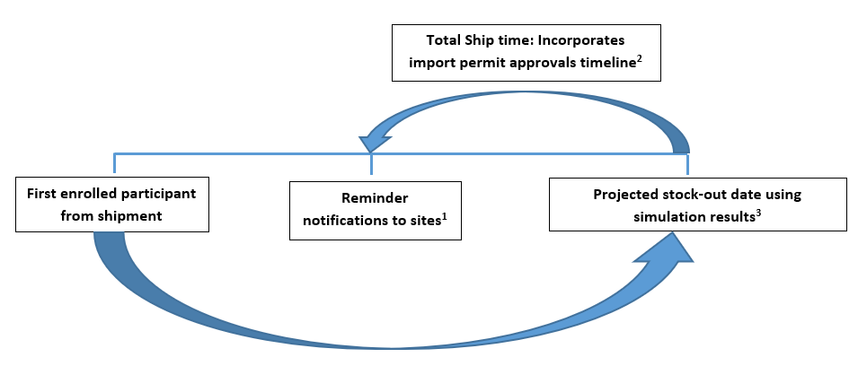

- Reminder date was the Projected Stock-out Date minus the Total Ship Time (in days). This was the date notifications were sent to study sites reminding sites to submit a restock request.
- Total Ship Time was the time from shipment request being received by Sanofi, to actual delivery to study site. This included time to obtain importation permit approval, transit time to destination country, custom clearance, and transit time to site pharmacy. For sites receiving shipments directly from Sanofi, the “Total ship time” was based on the average shipment time for the most recent 3 months of shipments delivered. The “Total ship time” was adjusted in advance when changes in regulatory requirements and timelines were known. For sites receiving shipments from depots, the “Total ship time” was held at 3 days for shipments originating from the South African depot, and 7 days for shipments from the U.S. depot.
- Projected stock-out date is the earlier of a) the last allowable enrollment date (LAED) for any kit type on site, and b) the sum of the date of the first enrolled participant from a shipment and time to stock-out from simulations. The LAED is the last date a participant can be enrolled with a set of kits, to ensure that a participant can complete treatment with assigned kit, before actual expiration date of kit.

Supplementary Figure S4: Summary Manual Study Drug Kit Shipment Process

Drug Management Module Process Flow Scheme

7.1 Supplementary Figure S5a: Kit Restock Request Process
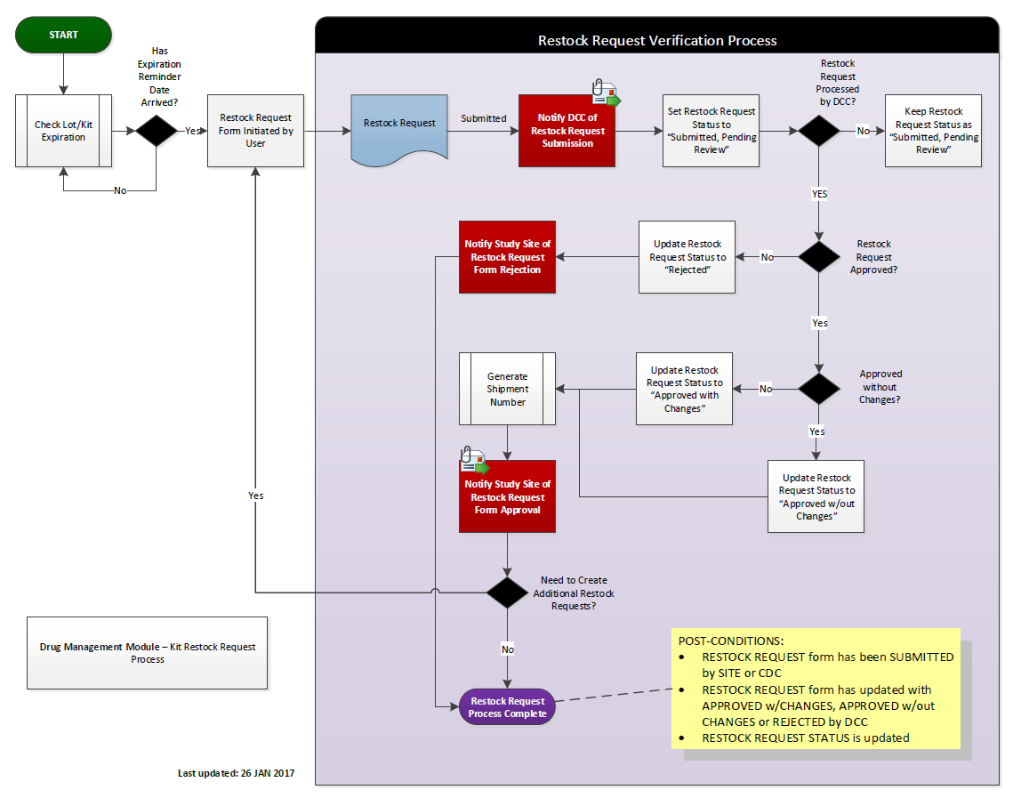

7.2 Supplementary Figure S5b: Shipment Receipt/Kit Management Process (Study Site View)
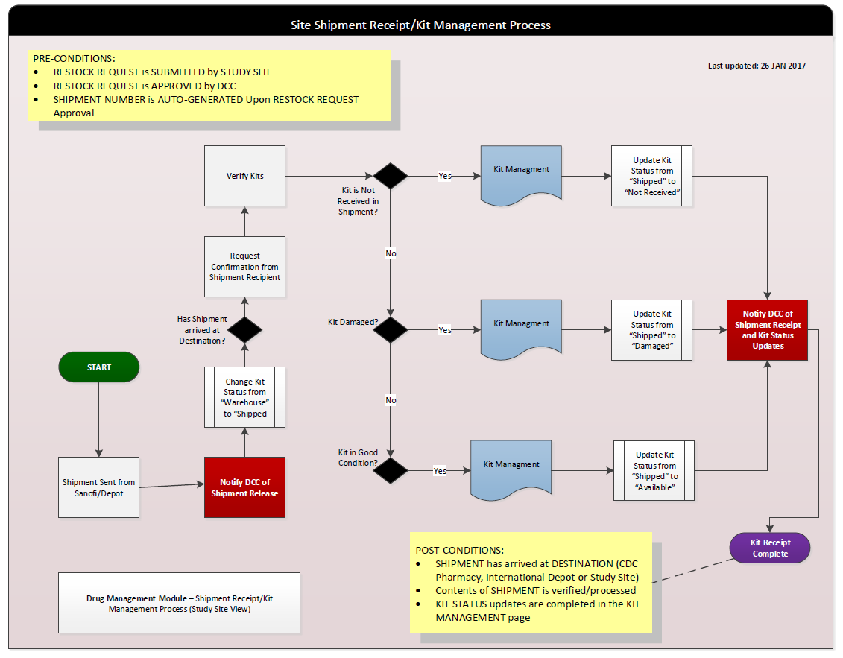

7.3 Supplementary Figure S5c: Kit Management Process (CDC Administrative View)
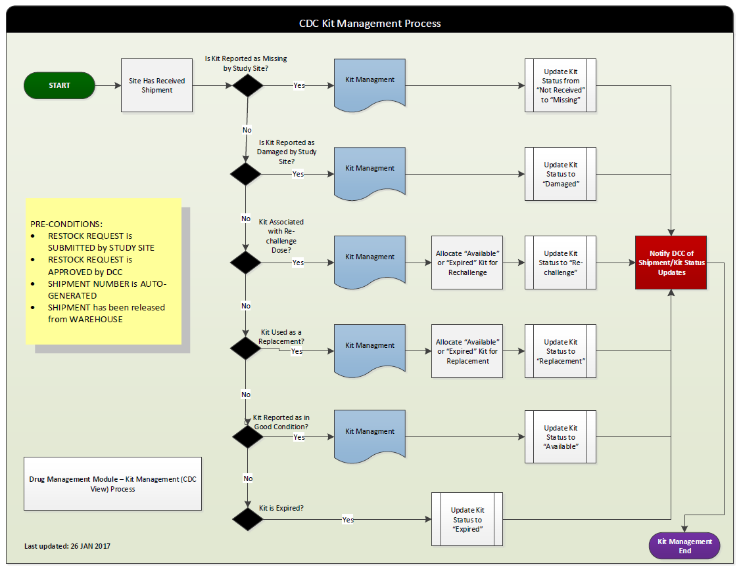

7.4 Supplementary Figure S5d: Restock Request/Reminders/Stock-out Process
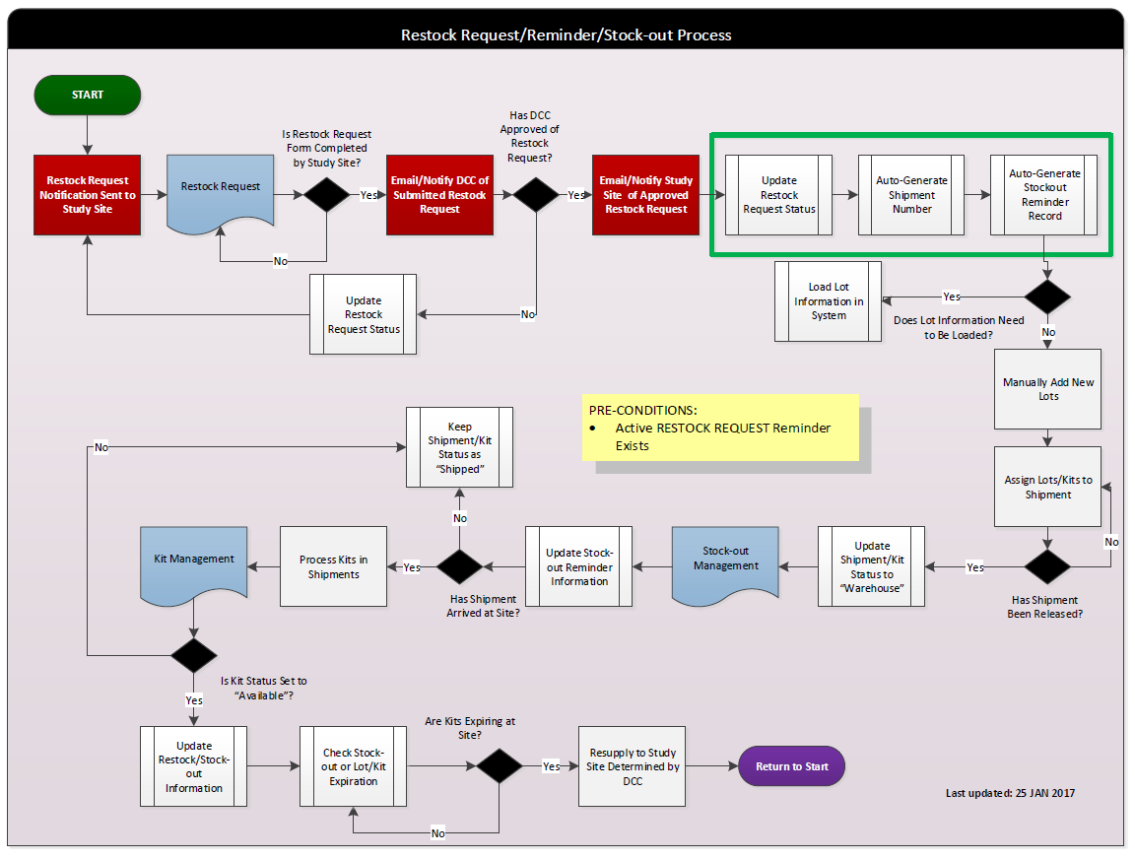

Supplementary Picture S1: Pharmacy at Uganda -Case Western Reserve University Research Collaboration Showing TBTC Study 31/ACTG A5349 Kits
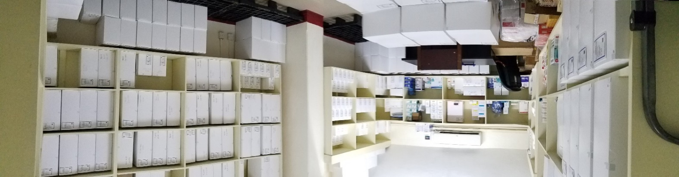
Photo courtesy: Case Western Reserve University Research Collaboration, Kampala, Uganda

Supplementary Picture S2: Drug Management Module (DMM) Screenshot of Site Restock Request Page

Note: Screenshot displays available search criteria based on status of submitted restock request, and shipment number.

Supplementary Picture S3: Drug Management Module (DMM) Screenshot of Site Kit Management Page

Note: Screenshot displays available search categories, by drug name, shipment numbers, expiration dates, etc. Batch update of kits used to automatically make kits available for enrollment is displayed.

