SUPPLEMENTARY FIGURE 3. Cases of brain abscess, epidural empyema, or subdural empyema in persons aged ≤18 years, by Pediatric Medical Complexity Algorithm* category and quarter — Pediatric Health Information System database, United States, January 2016–May 2022
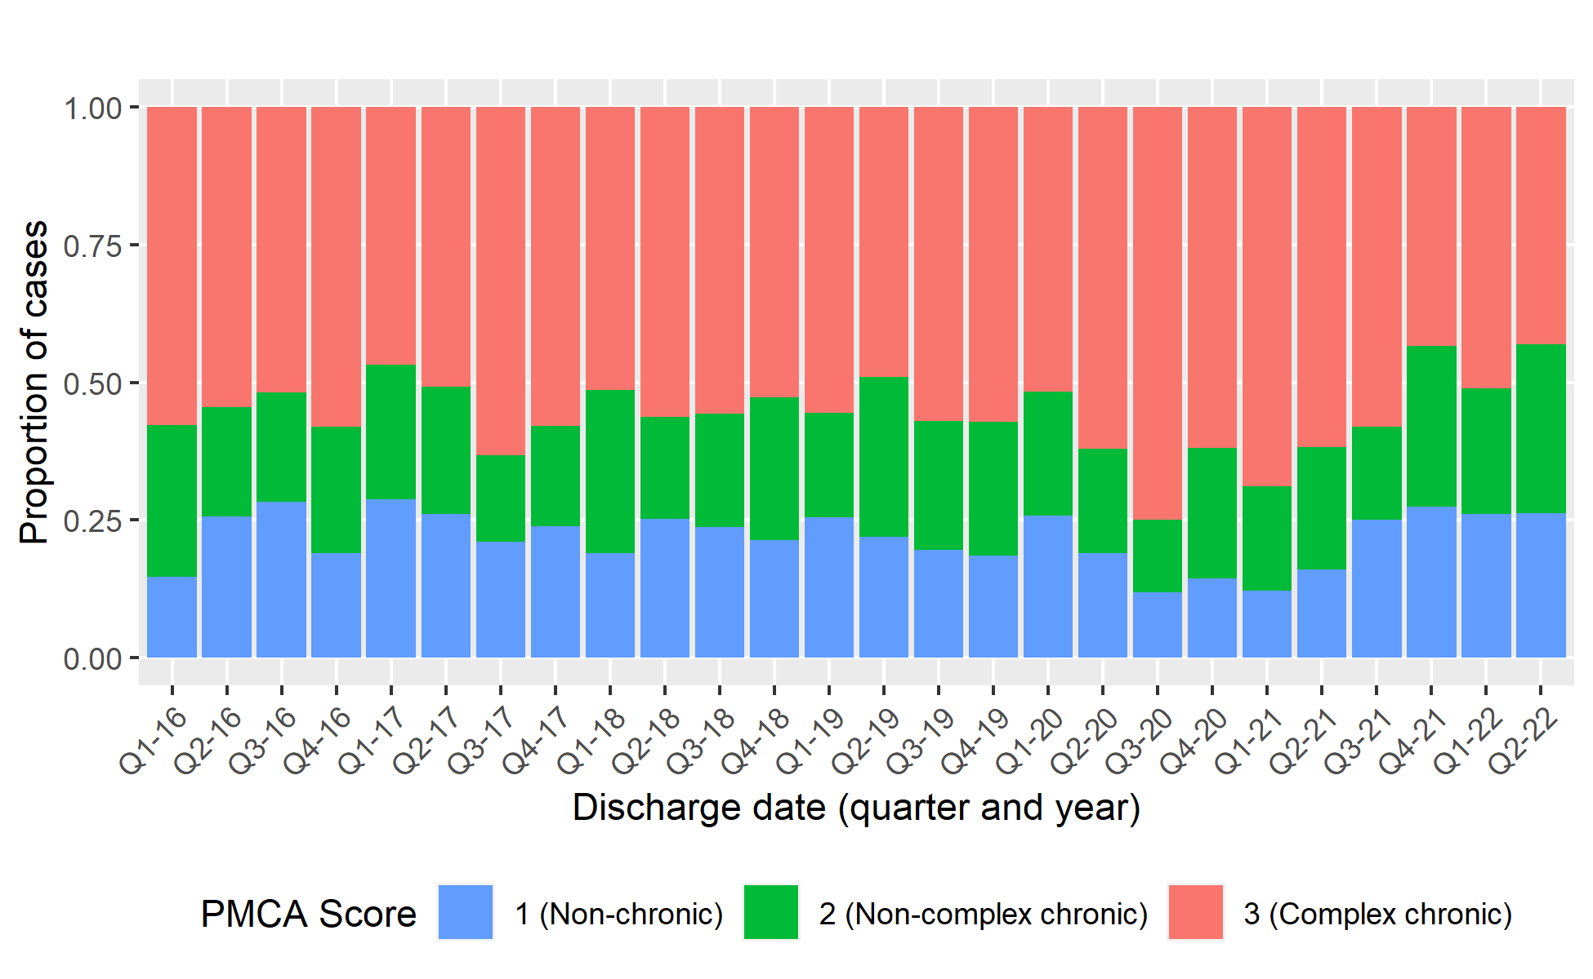
Abbreviation: PCMA = Pediatric Medical Complexity Algorithm.
* The PMCA stratifies children into levels of medical complexity based on chronic underlying conditions: [1] without chronic disease (i.e., healthy or with non-chronic acute conditions, such as ear infection or diarrhea), [2] non-complex chronic disease (chronic conditions lasting ≥1 year, involving only one system of the body, that are not progressive, such as asthma or depression), and [3] complex chronic disease (significant chronic conditions in two or more systems of the body, or a progressive condition related to deteriorating health, or continuous dependence on technology for ≥6 months, or malignancies (e.g., type 1 diabetes and depression, or cystic fibrosis, or renal dialysis, or leukemia).

