SUPPLEMENTARY FIGURE 2. Cases of brain abscess, epidural empyema, or subdural empyema, in persons aged ≤18 years, percentage admitted to an intensive care unit, percentage mortality, and percentage with concurrent COVID-19 diagnosis,* by quarter† — Pediatric Health Information System, United States, January 2016–May 2022
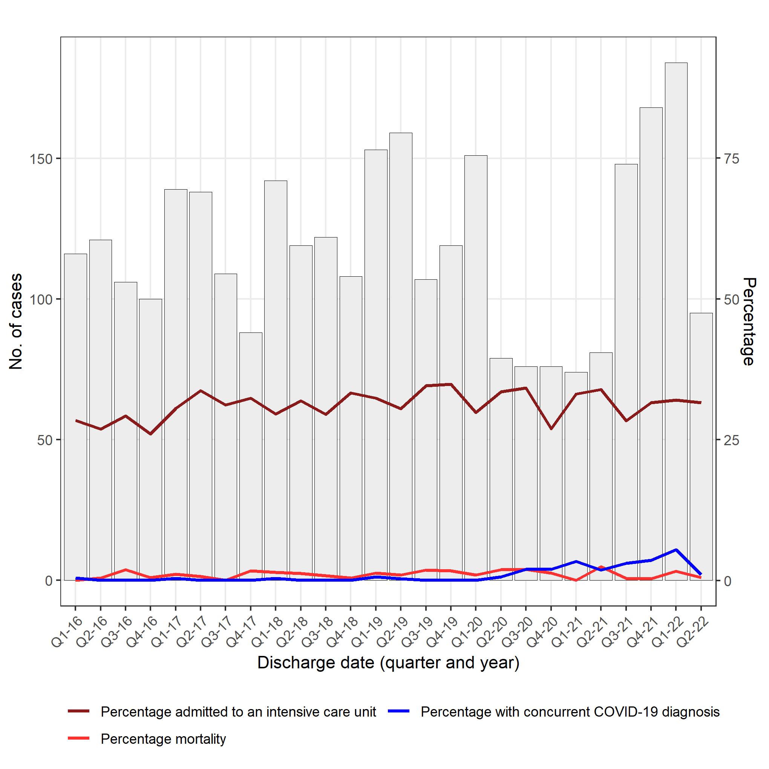
Abbreviation: ICD-10 = International Classification of Diseases, Tenth Revision.
* Concurrent COVID-19 diagnosis was defined as having ICD-10 codes U07.1 (2019-novel coronavirus acute respiratory disease; introduced on April 1, 2020) or B97.29 (Other coronavirus as the cause of diseases classified elsewhere; recommended by CDC as the primary diagnosis for patients with COVID-19 before April 1, 2020) listed anywhere on the discharge diagnosis list. Since B97.29 is not specific to COVID-19, there are occasional cases with this code before the onset of the COVID-19 pandemic.
† Case counts for the second quarter 2022 only include two of three months of data, so appear artificially low.

