**SUPPLEMENTARY FIGURE 1. Age* (A), sex (B), length of stay\***† **(C), and race/ethnicity (D) of persons aged ≤18 years with brain abscess, epidural empyema, or subdural empyema, by quarter — Pediatric Health Information System database, United States, January 2016–May 2022**

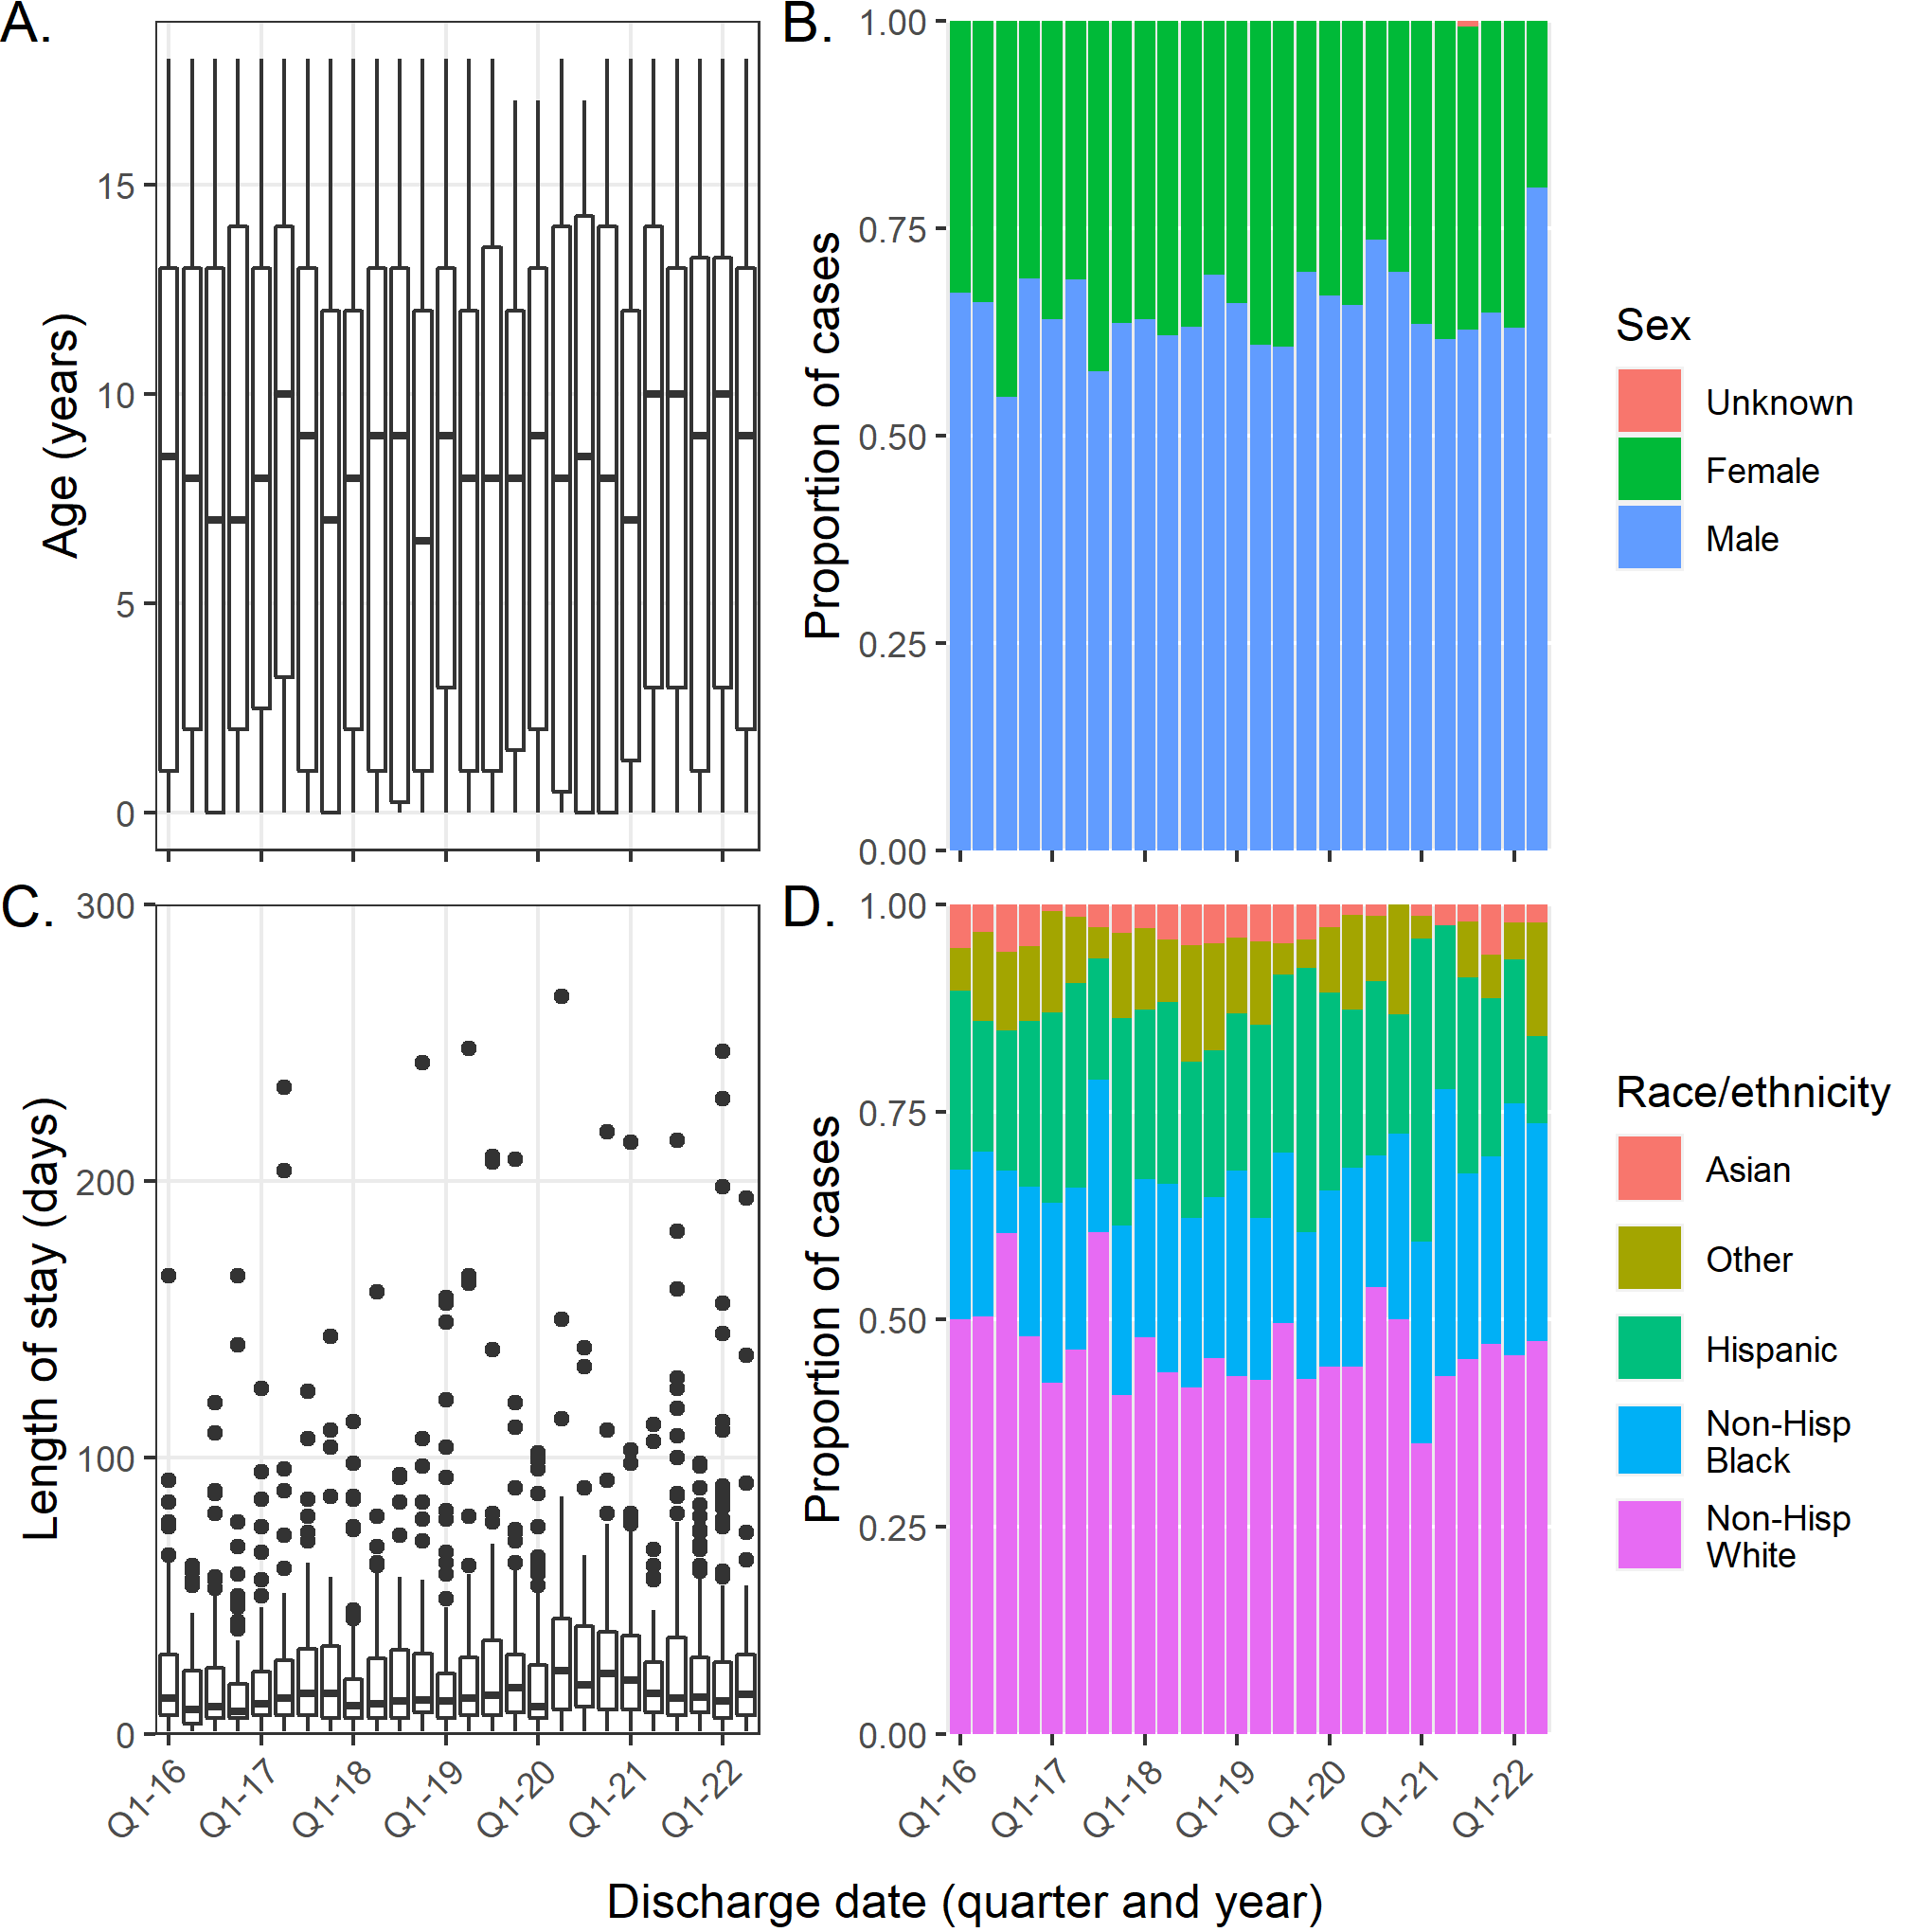

* On each box plot, going from top to bottom, lines in the box correspond with the 75th percentile, median, and 25th percentile. The whiskers extend to the largest and smallest values up to 1.5 times the interquartile range from the 75th and 25th percentiles, respectively. Data outside the ends of the whiskers are plotted as individual points.

† For visualization purposes, three hospitalizations with lengths of stay >300 days are not displayed. One hospitalization was missing length of stay.