Facilitator Guide - Effect Modifier Assessment (EMA) chronical workshop

VIRTUAL DELIVERY VERSION (3-Dec 2020)

Statement of Purpose
The purpose of this guide is to provide a script with instructions for facilitating a virtual (online) delivery of a qualitative data collection method, Effect Modifier Assessment, for evaluating program impact. Instructions are provided for a pre-session technical check-in, workshop welcome messages, starting/stopping video recording, the script for facilitating the workshop components, and cues for using presentation slides to deliver instructions. Additional instructions for data management and data coding are at the end of the document.

The Effect Modifier Assessment Protocol
The Effect Modifier Assessment protocol serves as a method for evaluating a specific program or intervention and identifying any co-occurring contextual factors (i.e., effect modifiers) that were relevant for a given time period. The purpose of this qualitative assessment is to determine the impact of an intervention and whether there has been any substantial interference with or counterfactual explanations for the observed outcomes of the intervention. For a full description of the effect modifier assessment (EMA) process, please refer to Edwards & Winkel (2018).
Edwards, K., & Winkel, J. (2018). A method for effect modifier assessment (EMA) in ergonomic intervention research. Applied Ergonomics, 72, 113-120. https://doi.org/10.1016/j.apergo.2018.05.007

Facilitator Guide - Effect Modifier Assessment (EMA) chronical workshop

VIRTUAL DELIVERY VERSION

Pre-session technical check (15 minutes)
- Sound check
- Lighting, background – any other visual issues
- Shared online spreadsheet test – frame in Browser – Facilitator #1 AND Facilitator #2 computer. Minimize headers.
- Final review of WHO is doing WHICH section(s). Any requests for Monitor as moderator?
Videoconferencing session opens for participants (15 minutes)
- Monitor greets participants, assures privacy name labels are on screen.
  - Plan to assist participants with on-screen name labels before the session.
- Reminds of supplies needed – paper and writing instrument.
- Addresses any technical or interface issues.

Cloud based materials to use during the EMA session
Cloud-based timeline for listing and coding participant responses:
[insert link to shared online spreadsheet here]
Cloud-based slides for question prompts:
[insert link to shared online presentation here]
FOCUS GROUP BEGINS

WELCOME (MODERATOR) 10 min
Welcome to the employee focus group on [topic] at [insert name of facility here].
This focus group is being organized by [insert name of organization here]. We focus on [brief description].
We appreciate your time today!
Before we begin, I would like to review a few logistics, so you know what to expect.
Focus group roles:
  - Moderator/monitor – My role will be as monitor of the focus group. I will watch the chat window and can respond to any concerns or difficulties during the session. I will remain off-camera until later in the workshop.
  - Two co-facilitators of the workshop – they will lead the rest of the session.
Facilitator #1, Facilitator #2 -- Introduce yourselves

Housekeeping items: Videoconferencing instructions slide
- The focus group is organized into two parts; we will take a 5-minute break between part 1 and part 2. We will end the focus group within 2 hours.

- Time management: 1) please be as concise as possible in your responses, 2) There may be times when the facilitators will need to steer discussion back to the main topics. We do this in the interest of time and for making sure we hear everyone’s ideas.
- Just a reminder to have paper and pen handy for jotting notes.
- Please limit distractions during the focus group. For example, turning off email notifications, and silencing your phone.

- We will use the chat window to collect your responses to questions today. Can everyone please send a chat “Everyone” message to verify you know how to do this?
- Based on receiving your permission, we will record today’s session. Before we record, I would like to review a few aspects of the focus group, so you know your rights and what to expect related to privacy during this session.
  - The purpose of this workshop is to [insert purpose]. Your feedback will be useful for [insert intent].
  - This study is an activity of the [insert study sponsor]. The lead investigator for this study is [insert name, position, institution].
  - There are no direct benefits to you for participating in the focus group today. However, your name will be entered into a drawing for a $50 gift card. If you do NOT want to be entered into the raffle, please let us know.
  - The feedback you share today will be kept private and confidential. We combine the discussion topics from this focus group and others when we summarize the findings. We will NOT use your name or discuss what you say with anyone outside of the research team. You are using fake names on your screen displays as a measure to protect your privacy.
  - In addition to our privacy procedures, we ask that you as participants also protect the privacy of individuals in this group by avoiding sharing specific points outside of this group. It is important to recognize that we cannot guarantee that what you say will not be shared, so please avoid sharing highly detailed or personal information about yourselves or others during the conversation.
- Are there any questions before we begin recording?

If there are no other questions, I will begin recording now, and we can proceed.
TURN ON RECORDING

PARTICIPANT INTRODUCTIONS (FACILITATOR #1) 5 min
Good afternoon
Before we get started, let’s take a few minutes to allow each person to check in by stating your role or background relative the group and anything else you would like to share. If you would just like to say hello, that is alright too.
Participants introduce themselves relative to the topic.

PART 1 – FOCUS GROUP ON WORKPLACE CULTURE (Facilitator #1) 45 min
FACILITATOR #1
The purpose of this focus group is to map significant events that have occurred at [insert name of facility here] during the past [time period (years) of intervention], or since [insert year here]. Some of you may not have been employed here for all that time, and that is OK.
In this part of the session, I will ask you a series of questions that all relate to important changes or events at this organization that have had an impact on your work situation.
One obvious aspect of our current work situation that we are in a period of a public health crisis that has upended EVERYTHING about our work environment.
To accomplish what we planned for this session, we are going to ask you to go back historically in time to the “pre-COVID-19” situation. We realize this may be challenging, but please do the best you can to answer questions as if we were doing this focus group “pre” COVID-19.
Alright, so let us begin.
There will be 3 questions in total in this first part of the session. We will take them one by one.
As you give us your answers, we will use a shared online spreadsheet to “map” the changes or events a timeline.
After we have discussed the 3 questions, we will take a short break, and then move to Part 2 of the session, where we will code the responses together as a group.

Question 1:
Again, the purpose of this focus group is to map significant events effecting the employee work situation that have occurred at [insert name of facility here] during the past 3 years, or since [insert year here].

Q1 SLIDE
Think back in time, since [insert year here] … what important changes or events have you noticed related to your workplace?

When I say “change or event” I mean something that occurred that had an impact on the work situation here.
[Tip: Clarify the scope of the environment that is being investigated. E.g., the work unit, the department, the organization.]
I am going to give you 2-5 minutes write down your individual responses on note paper.
- Think of as many changes or events as you can. There is no min or max.
- Try to use as few words as possible (like 2-5 words) for EACH IDEA.
- If you can, please jot down WHEN this event or change occurred.
- When you are done writing down your ideas, please send a chat message to confirm you are done.
Participants write responses for 2-5 minutes. They do this individually, without discussion with each other.

Processing Q1 responses:
Now I am going to collect your answers one at a time so we can discuss them.
- I will call on one person at a time to submit ONE idea or answer into the chat window.
- My co-facilitator will copy what you send into our timeline.
- Try to limit to 2-5 words. Please add the timing took, so we can plot it.

Facilitator asks for one event at a time, doing the following:
- Place on the timeline, and read out loud to participants (see page 10 for example of how to set up the cloud-based timeline)
  - Write/paste the event in the shared online spreadsheet and number it.
  - Ask the participant, “How did you experience this event? How did this even affect the work situation for you? How did it affect your coworkers?”
  - Ask if other participants have noted this same event. If so, collect and pool them on the timeline by numbering each new incidence.
  - When no more comments on that event, proceed to the next one. Repeat the process (a-f), circulating to the next participant for each new event related to Question 1. Continue collecting events in a round-robin fashion until all events have been discussed for Q1.

Question 2:
Q2 SLIDE
Think back in time, again from [insert year here]. What important changes or events related to your [insert focus of the intervention here] occurred during this time period?
[Insert definition here if needed – see example]
Example: When I say work climate, this is the definition we are using.
CLIMATE:
The general character of the organizational environment as perceived by those who work within it. (American Psych Assoc)
- Includes recurring patterns of behavior, attitudes and feelings that characterize life in the organization.
- Includes the things people say and do, as well as policies and practices.
Please take 2-5 minutes to write your individual responses on note paper.
- Write down as many changes or events that come to mind. No max.
- Try to use as few words as possible (like 2-5 words) for EACH IDEA.
- If you can, please jot down WHEN this event or change occurred.
- If your ideas overlap with some of what was said for the first question, please write them down anyway. It is ok if there is some repetition.
- When you are done writing down your ideas, please send a chat message to confirm you are done.
Participants write responses for 2-5 minutes.

Processing Q2 responses:
Now I am going to collect your answers one at a time so we can discuss them.
Again, we will ask you submit them into the chat window, so we copy and paste your ideas into the timeline.
- Try to limit to 2-5 words. Please note WHEN this event or change occurred.

Facilitator asks for one event at a time, one by one, doing the following:
- Read the event out loud to participants.
- Write/paste the event in the shared online spreadsheet and number it.
- Ask the participant, “How did you experience this event? How did this even affect the work situation for you? How did it affect your coworkers?”
- Ask if other participants have noted this same event. If so, collect and pool them with others on the timeline.
- When no more comments on that event, proceed to the next one. Repeat the process (a-f), circulating to the next participant for each new event related to Question 2. Continue collecting events in a round-robin fashion until all events have been discussed for Q2.
Question 3:
Q3 SLIDE
Think back in time, again since [insert year here]. What important changes/events related to [insert intervention outcome being investigated] occurred during this time period?
Please take 2-5 minutes write down your individual responses on note paper.

- Write down as many changes or events that come to mind. No max.
- Try to use as few words as possible (like 2-5 words) for EACH IDEA.
- If you can, please jot down WHEN this event or change occurred.
- If your ideas overlap with some of what was said for prior questions, please write them down anyway. It is ok if there is some repetition.
- When you are done writing down your ideas, please send a chat message to confirm you are done.
Participants write responses for 2-5 minutes.

Processing Q3 responses:
Now I am going to collect your answers one at a time so we can discuss them.
Again, we will ask you submit them into the chat window, so we copy and paste your ideas into the timeline.
- Try to limit to 2-5 words. Please note WHEN this event or change occurred.

Facilitator asks for one event at a time, one by one, doing the following:
- Read the event out loud to participants.
- Write the event in the shared online spreadsheet and number it.
- Ask the participant, “How did you experience this event? How did this even affect the work situation for you? How did it affect your coworkers?”
- Ask if other participants have noted this same event. If so, collect and pool them with others on the timeline. ASSIGN DIFFERENT NUMBERS FOR EACH PARTICIPANT WHO NOTED SAME EVENT
- When no more comments on that event, proceed to the next one. Repeat the process (a-f), circulating to the next participant for each new event related to Question 3.

SHORT BREAK – 5 MIN (optional)

PART 2 – CODING OF RESPONSES (FACILITATOR #2) 30 min

Q4 SLIDE
Question 4: FACILITATOR #2
“In this part of our session, we’re going to discuss all of the topics on the board to get your feedback about whether the changes or the events in the timeline are related to a specific [program/intervention] at [insert name of workplace here]. The program is called, [insert name of intervention here]. Have any of you heard of it?
SLIDE: [Insert name of intervention here]
[Insert a brief description of the program and its goals. If applicable, list some past events or activities from the intervention.]
SLIDE [Scoring instructions]
“We are going to discuss each event and code it in two ways:
- Whether or not the change or event has been part of - or resulted from - the [insert name of intervention here] project.
I am going to mark the event with an “Y” for yes if you see it as related to [insert name of intervention here].
I am going to mark “N” for No if you do not see it as related to [insert name of intervention here]. If some of you do not agree, that is OK.
- We will list what the person thinks, and later after the focus group, the research team will have a chance to validate the information in other ways.
- Whether you see this change or event as having a positive or negative impact on the [insert targeted outcome of the intervention here] for [insert target audience here]. We’re interested in hearing both about what you’ve experienced and what you’ve observed around you.”

Facilitator invites participants to discuss each event and marks with:
- Intervention Yes/No – marks post-it notes with “Y” if yes, “N” if no.
- Perceived impact on general work climate (+, 0, -) i.e., Positive impact, no impact, negative impact
  - Use “+1, +2, +3” and “-1, -2, -3” to indicate strength of impacts (mild, moderate, major).
- Perceived impact on work climate for [insert target audience of intervention here] (+, 0, -) i.e., Positive impact, no impact, neg. impact.
  - Use “+1, +2, +3” and “-1, -2, -3” to indicate strength of impacts.
Once all the changes or events on the board are coded, ask,
“Seeing all the information in front of you, are there any last changes you’d like to make in the coding before we call the session to a close?”
“If no further questions, then I’ll turn it over to [researcher name] Monitor to wrap up the session.”

WRAP UP – (Monitor) 5 min
“We want to thank you for the valuable insights you have shared today.
It is obvious that there have been many changes going on at [workplace] that affect the employee work situation.
We will use the data we have collected here today and take some time to organize it. We may need to reach out to you individually to clarify details. After that, we will analyze the data, and will summarize themes from the discussion.
[Add statement of planned use of results and any other next steps that are relevant]
Are there any questions before we end our session today?
If no other questions, we will send you a short 5-minute survey following this session to collect your feedback on this focus group. We would appreciate any suggestions you have to help enhance the process in the future.
Thank you again for your valuable insights today.”

FOCUS GROUP ENDS (2 hours)

STOP RECORDING

Example of physical timeline from Edwards & Winkel (2018):
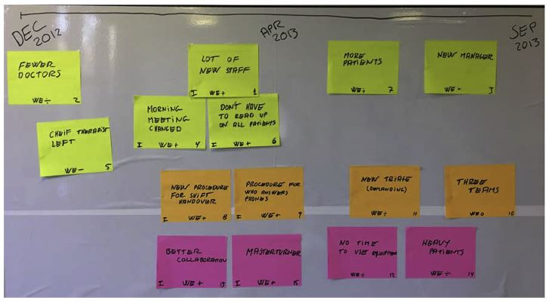
Event #
Interv’n YES/NO
WE “0”
No Impact
Example of a cloud-based timeline
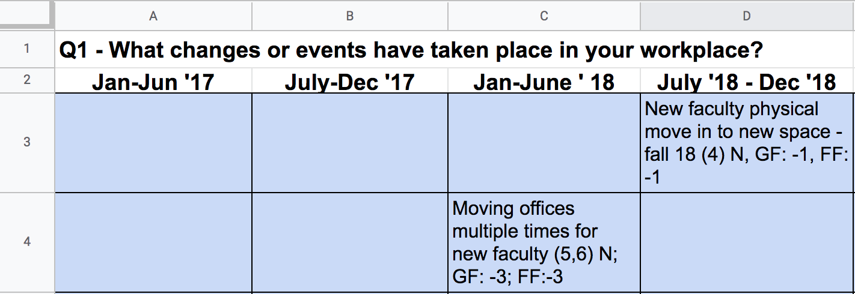
DATA MANAGEMENT
Monitor photographs the timeline (keeping all post it notes) for later analysis [or consolidates all electronic feedback].
Prepare dataset (Edwards and Winkler p. 115)
- Transcribe the audio recordings; use the transcription plus the post it notes to organizing data into data fields and exclude invalid data.
- Reassess the attribution of “intervention” relative to each event.
  - Use participants or stakeholders to validate the workshop coding.
- Determine work environment impacts (+, 0, -) as needed.
  - Use at least two researchers for this step.
  - Create an integrated score for physical and psychosocial scores.
- Develop themes; pool related events as appropriate.

DATA ANALYSIS (Edwards and Winkel p. 116)
- Compute number of total events, # events related to interventions, # events not related to interventions (“effect modifiers”).
- Assess impact of each theme based on three criteria: 1) number of employees impacted, 2) amount of work time for impacted employees, and 3) level of impact for the affected employees.
  - Use “+++, ++, +” and “---, --, -” to indicate strength of positive and negative impacts.
  - Assess impacts for all themes – intervention-related and non-intervention related.
  - Use participants and/or stakeholders to validate impacts for each theme (Intervention & non-intervention)
  - Tabulate the results for each theme in a table, sorting themes into Intervention/Non-intervention (see example Table 5 Edwards paper, p. 117)
- Use assessment of themes to qualitatively assess the relative contribution of intervention events vs non-intervention events (effect modifiers) to the health impacts reported.

