Supplementary Materials for:

A Learning Collaborative to Improve Antibiotic Prescribing in Primary Care Pediatric Practices.
Chuck Norlin, MD, Katherine Fleming-Dutra, MD, Jeff Mapp, MD, MBA, Jennifer Monti, PhD , Allison Shaw, MPH, MS, Monina Bartoces, PhD, Kevin Barger, MBA , Suzanne Emmer , Judith C. Dolins, MPH

Anyone interested in replicating this project should feel free to contact:
- Suzanne Emmer, Director, Division of Chapter Quality Improvement Initiatives, Chapter Quality Network, American Academy of Pediatrics; semmer@aap.org, 847-434-4077
- Katherine Fleming-Dutra, MD, medical epidemiologist, Office of Antibiotic Stewardship, Division of Healthcare Quality Promotion, Centers for Disease Control and Prevention (CDC); antibioticuse@cdc.gov
- Jeffrey S. Mapp, MD, general pediatrician and project lead physician, Pediatric Associates of Richmond; divot40@gmail.com, 804-282-4205
- Chuck Norlin, MD, Professor, Department of Pediatrics, University of Utah and former Director, Utah Pediatric Partnership to Improve Healthcare Quality (UPIQ); chuck.norlin@hsc.utah.edu, 801-581-7877
(information current as of 6/23/20)

Supplement Contents:
Page 2 Supplemental Figures 1-7, practice-specific run charts
Project-related information and materials (may be helpful for replication)
Page 9 Key messages from our project
Maintenance of Certification information
Infectious Disease expertise
Page 10 Key Driver Diagram
Page 11 Education and implementation resources
Page 12 Educational Poster – URI treatment
Page 13 “Viral Prescription”
Page 14 “SNAP Rx”
Page 15 Blank PDSA worksheet
Page 16 Sample PDSA worksheet
Page 17 Project measures table
Page 21 ICD-10 codes for upper respiratory infection and otitis media
Page 22 Random sampling instructions
Page 23 Competing diagnosis list

Supplemental Figure 1. Practice-level performance on percent of patients ≥3 months diagnosed with URI and no competing diagnosis who were not prescribed an antibiotic
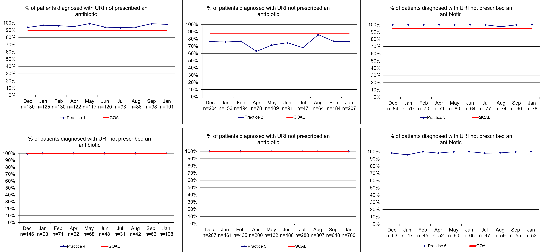

Supplemental Figure 2. Practice-level performance on percent of patients ≥3 months diagnosed with URI and no competing diagnosis who were provided appropriate education regarding treatment for URI
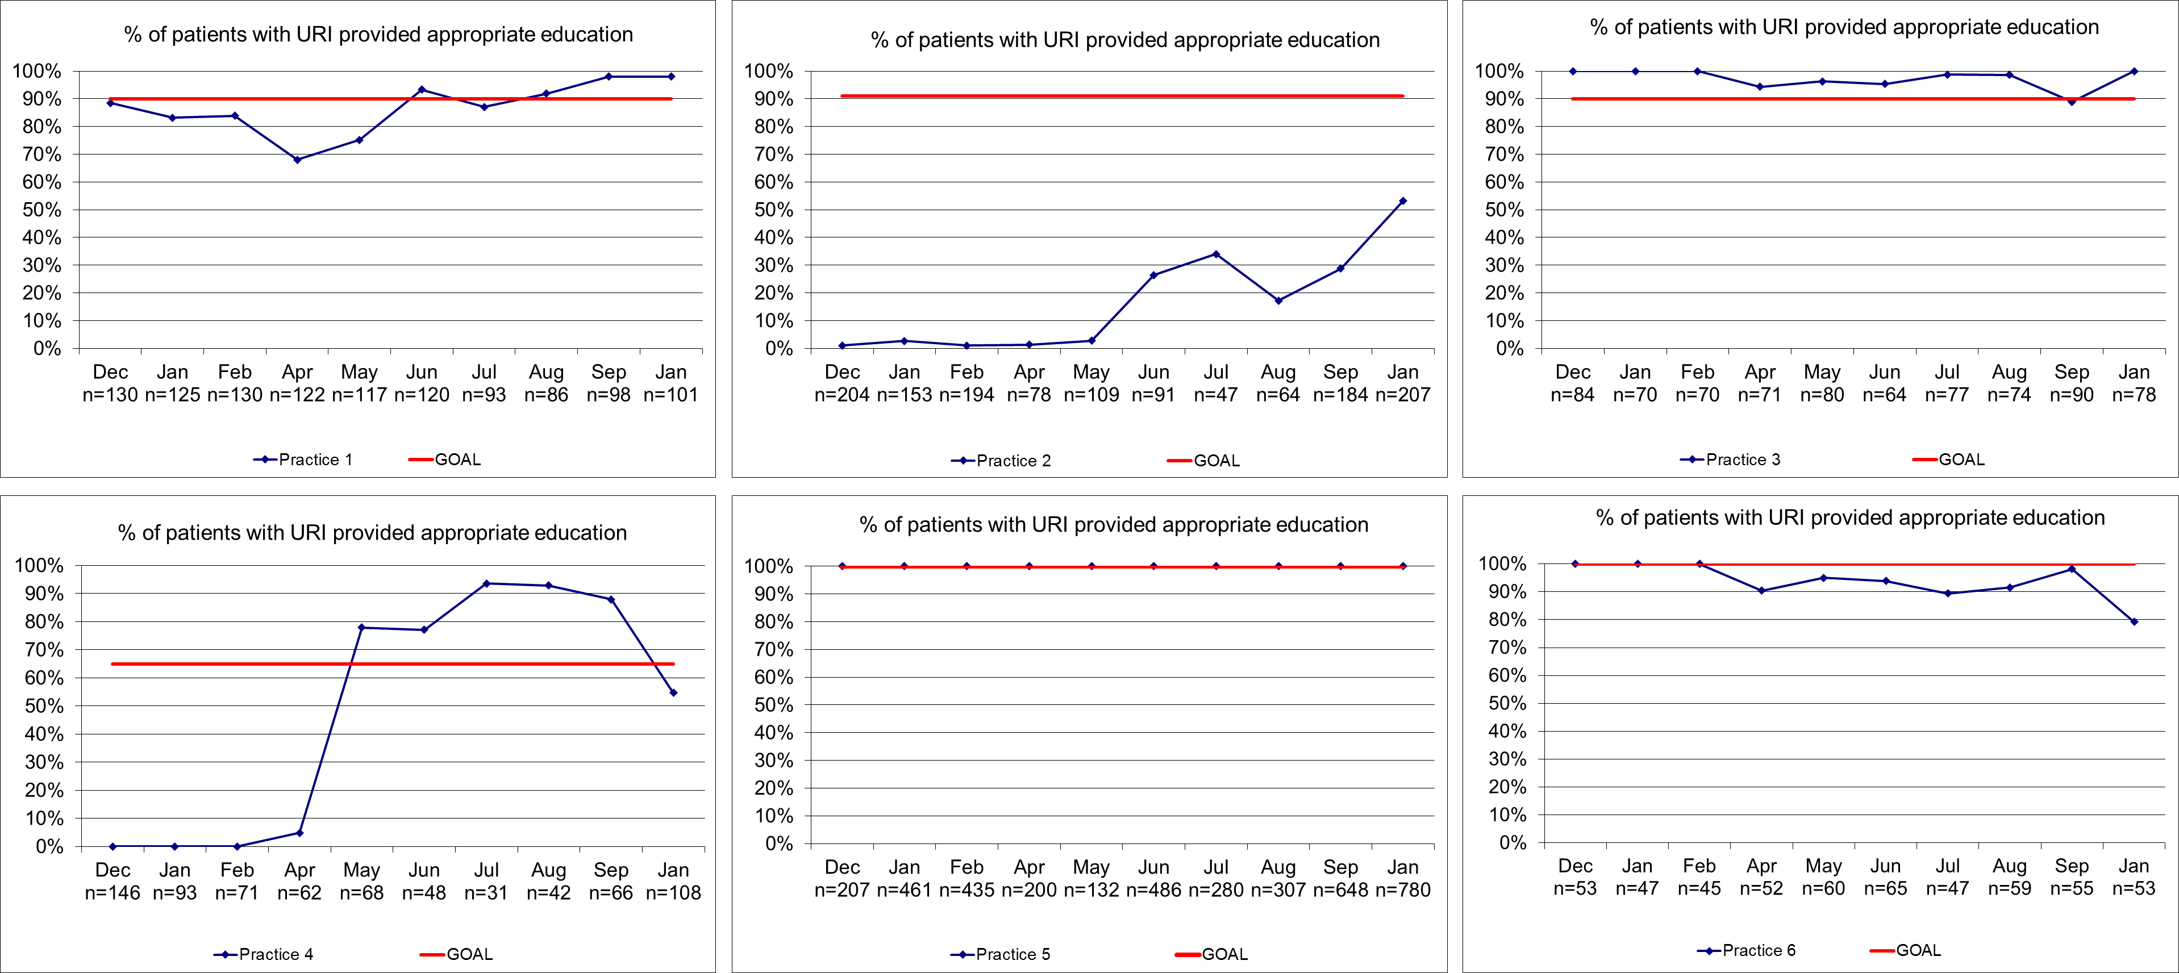

Supplemental Figure 3. Practice-level performance on percent of patients ≥6 months and <2 years diagnosed with AOM who were prescribed an antibiotic
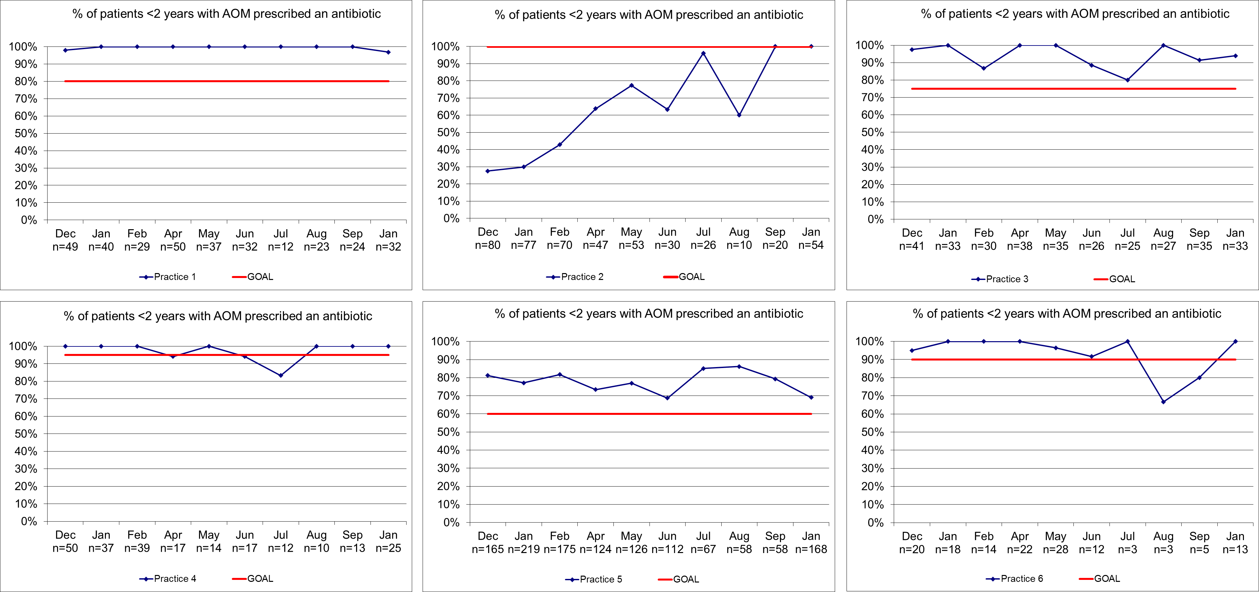

Supplemental Figure 4. Practice-level performance on percent of patients ≥2 years diagnosed with AOM who were prescribed an antibiotic
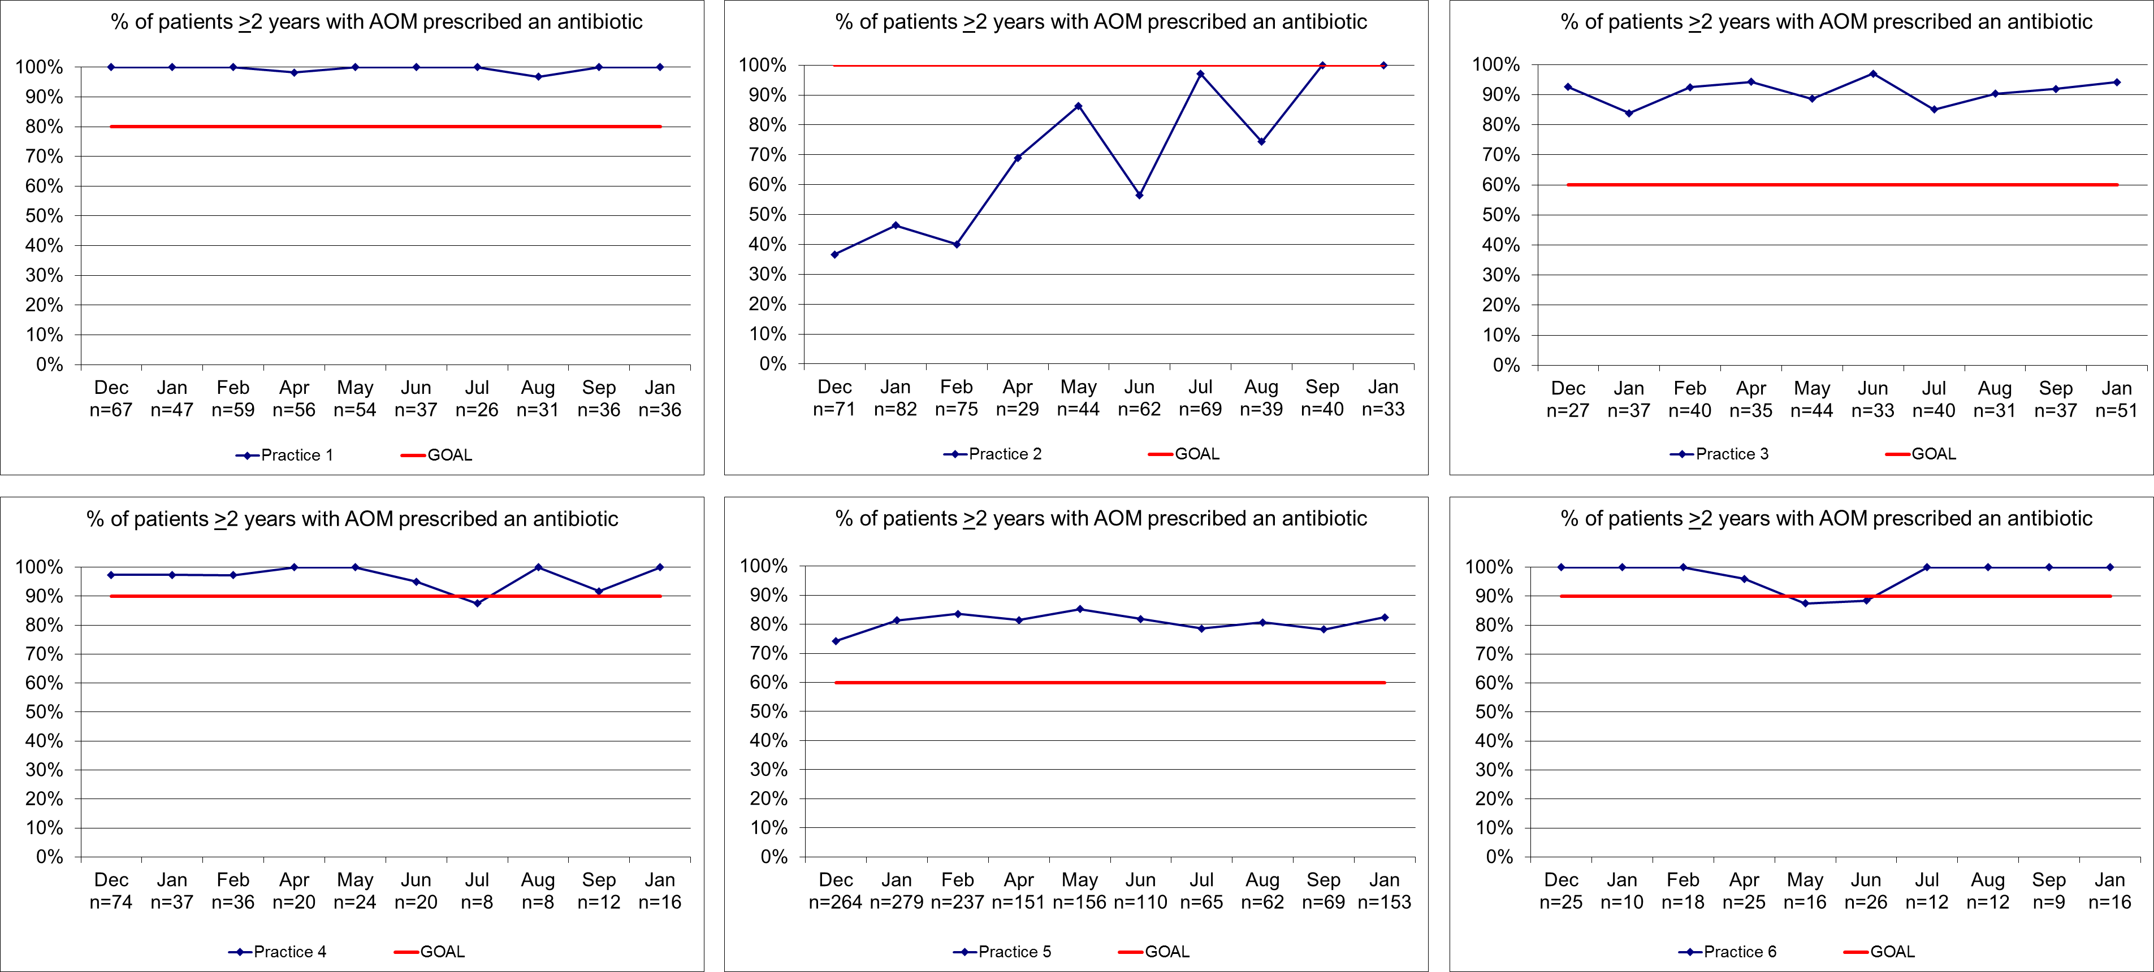

Supplemental Figure 5. Practice-level performance on percent of antibiotic prescriptions for patients ≥6 months diagnosed with AOM that were written as a SNAP
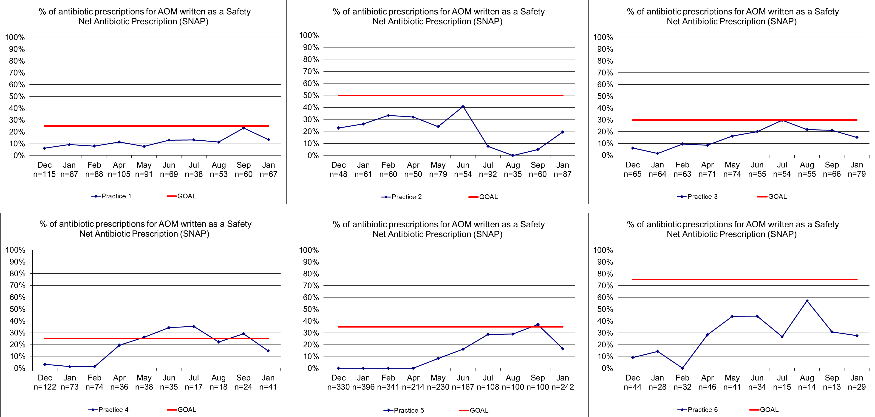

Supplemental Figure 6. Percent of antibiotic prescriptions for patients ≥6 months diagnosed with AOM that were written for a 1st-line antibiotic (amoxicillin or amoxicillin-clavulanate)
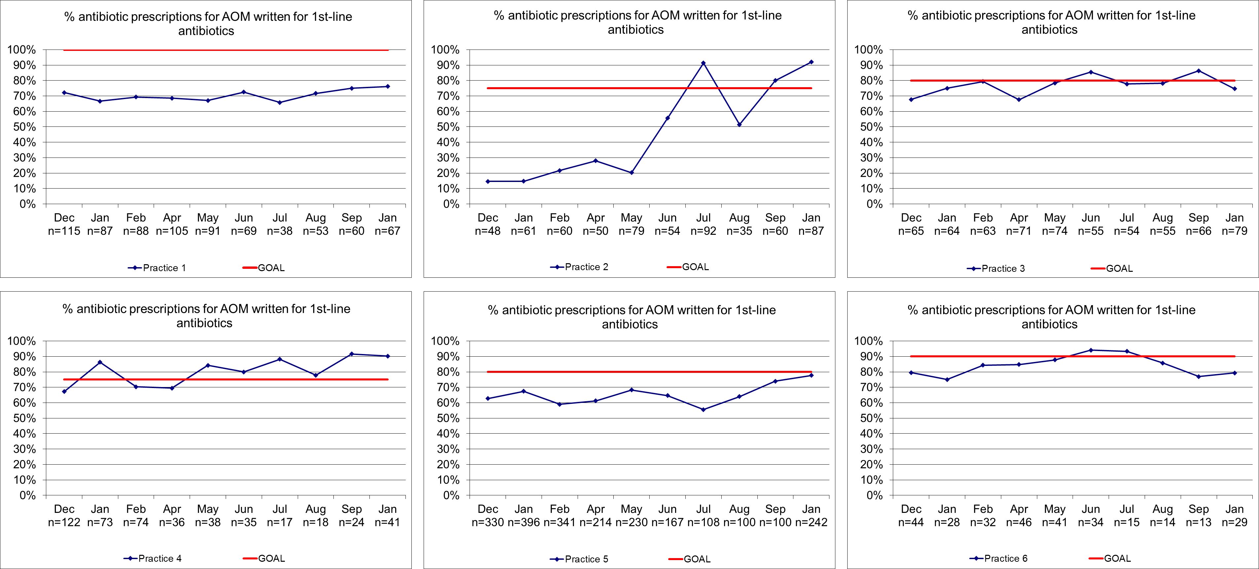

Supplemental Figure 7. Percent of patients ≥6 months diagnosed with AOM who were provided appropriate education regarding symptom management
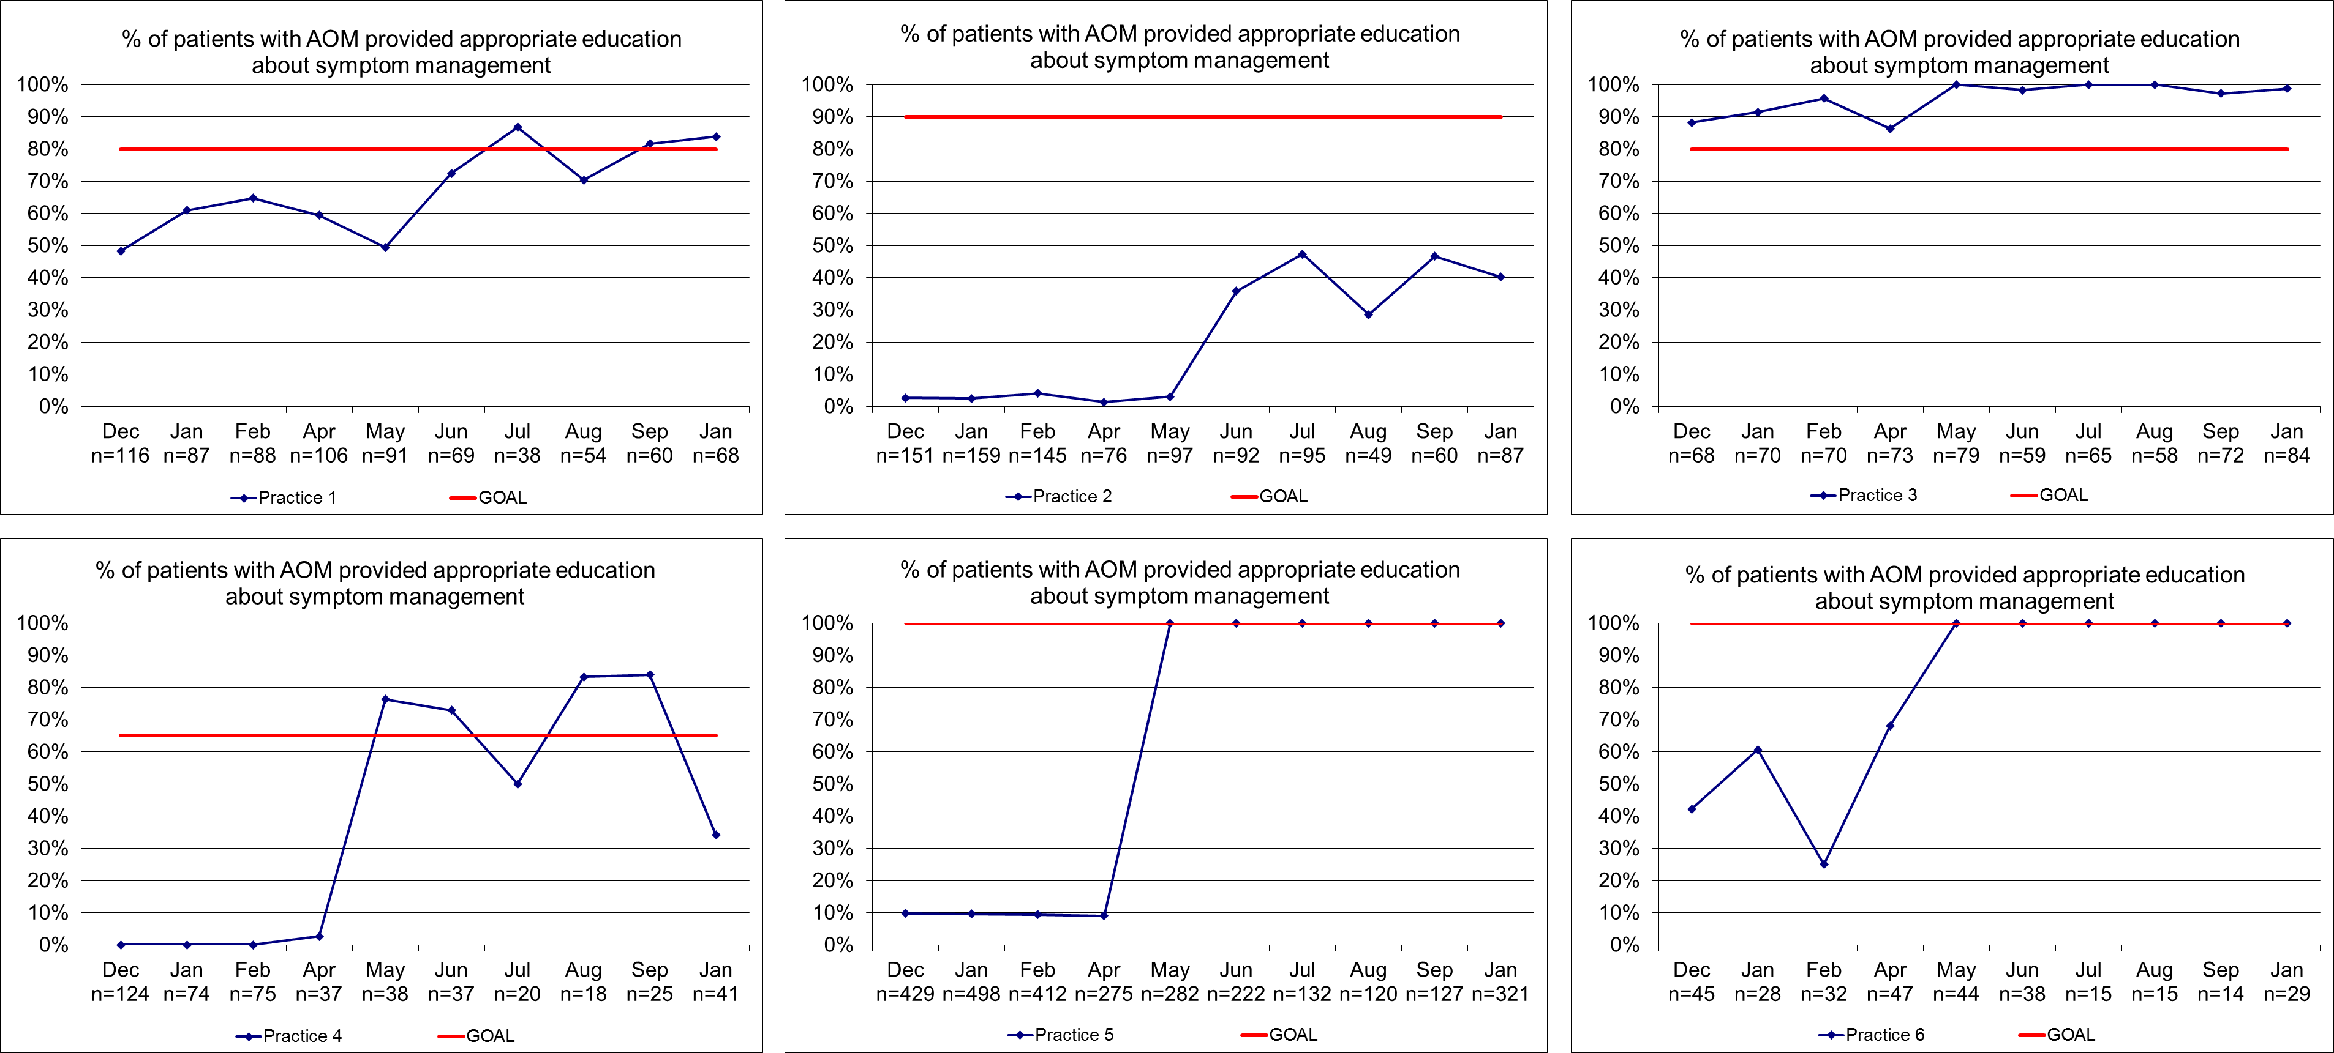

A Learning Collaborative to Improve Antibiotic Prescribing in Primary Care Pediatric Practices.
Chuck Norlin, MD, Katherine Fleming-Dutra, MD, Jeff Mapp, MD, MBA, Jennifer Monti, PhD , Allison Shaw, MPH, MS, Monina Bartoces, PhD, Kevin Barger, MBA , Suzanne Emmer , Judith C. Dolins, MPH

Key messages from our project:
- Improvement in antibiotic prescribing is possible in independent private practice settings
- Existing no-cost tools, including educational materials, guidelines, and improvement strategies, are available for use by practices and projects; many can be customized
- Low-cost tools, such as web conferences and collaboration platforms, can be effective for convening teams, sharing information, data, ideas, and lessons learned
- Local organizations, such as AAP chapters, improvement partnerships, groups of practices, or academic programs, may be able to lead and manage similar projects
- Even small practices could alone access the resources and strategies used in this project to assist and guide efforts to improve prescribing practices

Maintenance of Certification (MOC) credit (information current as of 6/23/20)
Although it is not clear how important offering MOC credit is to recruiting physicians to participate in quality improvement projects, obtaining credit for participants in your project could be fairly easy and may enhance engagement, timely data submission, and persistence.
- The American Academy of Pediatrics (AAP), through its PediaLink QI program offers MOC credit, as well as a data collection/analysis system, for approved projects designed and implemented by pediatricians. See pedialink.aap.org/visitor/pedialinkqi/about-pedialink-qi or email PediaLinkQI@aap.org.
- The American Board of Pediatrics (ABP) provides Part 4 credit for projects developed and implemented by practices or groups of practices. There is a $75 processing fee per project. See www.abp.org/content/your-own-qi-project for details.
- An ABP Portfolio Sponsor in your area may offer similar projects or may offer MOC credit for projects developed by local physicians/practices. For a list of Portfolio Sponsors, see www.abp.org/content/local-and-national-qi-projects.

Infectious Disease Expertise
To access local expertise in infectious diseases and antibiotic stewardship, consider contacting your local University Department of Pediatrics, Children’s Hospital, or public health department. The guidelines and studies cited in our article offer a foundation for educating project participants, but we’ve found that interacting with experts is highly valued by participating clinicians. Specialists also need to earn MOC credits and can do so through substantive participation in a QI project, which may entice them, beyond their native desire to teach and improve care, to support your project.

Education and Implementation Resources

- Core Elements of Outpatient Antibiotic Stewardship – www.cdc.gov/antibiotic-use/community/improving-prescribing/core-elements/core-outpatient-stewardship.html offers a pdf version of the Core Elements and related resources, including a recorded webinar, checklists for clinicians and facilities, continuing education and curriculum opportunities, and more
- CDC resources: www.cdc.gov/antibiotic-use/community/materials-references/print-materials/hcp/index.html
  - An Antibiotic is the Wrong Tool to Treat a Virus poster
  - Commitment posters
  - Delayed prescribing prescription pads
  - Viral prescription pads
  - Other fact sheets, brochures, and a return to day care letter
- Dialogue Around Respiratory Illness Treatment (DART) Learning Modules – outstanding set of 7 videos addressing and modeling communications with caregivers around treatment of viral upper respiratory illness, from Rita Mangione-Smith’s lab at Seattle Children’s/University of Washington Department of Pediatrics (www.uwimtr.org/dart/)
- Additional resources from the AAP and participating practices on the next 5 pages

Educational Poster from Virginia Pediatric Group (used with permission)

“Viral Prescription” from Reston Town Center Pediatrics (used with permission)

“SNAP Rx” from Virginia Pediatric Group (used with permission)

Safety-Net Antibiotic Prescription (SNAP) for middle ear infection (acute otitis media)
Medical research shows that most children with a new middle ear infection will get better on their own, without antibiotics, over a few days. You can help them feel better while their bodies fight the infection by providing:
• Rest
• Extra water or other fluids to drink
• Cool mist vaporizer or saline nasal spray to help with congestion
• Pain control with ibuprofen or acetaminophen, if needed
Because antibiotics may not be necessary and may cause other problems (such as diarrhea, rash, and bacterial resistance), I recommend that you do not fill the prescription unless your child is not feeling better within 48 hours.
Please leave a message on nurse’s line if you fill the Rx.
If your child gets better without the prescription, please destroy and discard it.

To learn more about appropriate antibiotics prescribing please see the CDC’s "Antibiotic Prescribing and Use in Doctor’s Offices" (cdc.gov/antibiotic-use/community/index.html).

Chapter Quality Network Antibiotics Project
MEASURES TABLE
Data Collection Tool and Collection Frequency: Most of the participating practices will collect data for the measures below through queries from their EMR. If EMR queries are not an option, data will be collected through randomized chart pull. In that case, each participating provider will review 10 records for patients with an upper respiratory infection diagnosis each month and 10 mutually exclusive patient records for patients diagnosed with acute otitis media each month. If a provider does not have 10 patients with either diagnosis they will enter as many as they can. These data will be collected in QIDA.
Upper Respiratory Infection (URI) Measures
Ref  # | Measure Name & Type | Measure Definition | Source of Measure | Measure Calculation  (Numerator/Denominator) | Measure Exclusion | Measure Benchmark | Goal
1 | Appropriate treatment for children with URIª  Process Measure | % of patients ≥ 3 months old with a diagnosis of upper respiratory infection and no competing diagnosis* who had no antibiotic prescribed. | HEDIS | Numerator:  # of patients ≥ 3 months old with:  - A diagnosis of upper respiratory infection and no competing diagnosis  AND  - No antibiotic prescribed  Denominator:  # of patients ≥ 3 months old with a diagnosis of upper respiratory infection and no competing diagnosis* | Patients < 3 months old.  Visits associated with a competing diagnosis* | A one-year project with educational and reporting feedback elements saw a decrease in off-guideline prescribing for URIs from 27% to 14% over the life of the project.¹ | Goal will be set after baseline data is collected.
2 | Appropriate URI treatment education  Process Measure | % of patients ≥ 3 months old with diagnosis of upper respiratory infection and no competing diagnosis* who were educated regarding appropriate treatment for URI. | Adapted from EQIPP’s Judicious Use of Antibiotics’ Upper Respiratory Infection Track | Numerator:  # of patients ≥ 3 months old:  - With a diagnosis of upper respiratory infection and no competing diagnosis  AND  - Who were educated regarding appropriate treatment for URI.  Denominator:  # of patients ≥ 3 months old with a diagnosis of upper respiratory infection and no competing diagnosis* | Patients < 3 months old.  Visits associated with a competing diagnosis* | Data collected in EQIPP have illustrated improvements in related processes after 2 cycles of data collection; Counseling regarding the expected course of antibiotics improved from 70% at baseline to 97% after 2 cycles^{b} of data collection. Documentation of a follow up plan occurred at 59% of visits at baseline and 95% of visits after 2 cycles of data collection.² | Goal will be set after baseline data is collected.
*see the competing diagnosis list
Acute Otitis Media (AOM) Measures
Ref# | Measure Name & Type | Measure Definition | Source of Measure | Measure Calculation  (Numerator/Denominator) | Measure Exclusion | Measure Benchmark | Goal
3 | Antibiotic given to patients with AOM < 2 years of age  Process Measure | % of patients ≥ 6 months and < 2 years of age with a diagnosis of AOM who had an antibiotic prescribed | Adapted from Utah Pediatrics Partnership to Improve Healthcare Quality’s Using Antibiotics Wisely Project and EQIPP’s Judicious Use of Antibiotics’ Acute Otitis Media Track | Numerator:  # of patients ≥ 6 months and < 2 years of age with:  - A diagnosis of AOM  AND  - An antibiotic prescribed  Denominator:  # of patients ≥ 6 months and < 2 years of age with a diagnosis of AOM | Patients ≥ 2 years of age, patients < 6 months of age | A 2015 study found that the percentage of pediatric patients prescribed broad spectrum antibiotics ranged widely from practice to practice, 18%-60%.³ | Goal will be set after baseline data is collected.
4 | Antibiotic given to patients with AOM ≥ 2 years of age  Process Measure | % of patients ≥ 2 years of age with a diagnosis of AOM who had an antibiotic prescribed | Adapted from Utah Pediatrics Partnership to Improve Healthcare Quality’s Using Antibiotics Wisely Project and EQIPP’s Judicious Use of Antibiotics’ Acute Otitis Media Track | Numerator:  # of patients ≥ 2 years of age with:  - A diagnosis of AOM  AND  - An antibiotic prescribed  Denominator:  # of patients ≥ 2 years of age with a diagnosis of AOM | Patients < 2 years of age. | A 2015 study found that the percentage of pediatric patients prescribed broad spectrum antibiotics ranged widely from practice to practice, 18%-60%.³ | Goal will be set after baseline data is collected.
5 | Antibiotic prescription written as a safety-net antibiotic prescription (SNAP)  Process Measure | % of patients ≥ 6 months with a diagnosis of AOM who had an antibiotic prescribed as a SNAP | Adapted from Utah Pediatrics Partnership to Improve Healthcare Quality’s Using Antibiotics Wisely Project | Numerator:  # of patients ≥ 6 months with:  - A diagnosis of AOM  AND  - An antibiotic prescribed as SNAP  Denominator:  # of patients ≥ 6 months with:  - A diagnosis of AOM  AND  - An antibiotic prescribed | Patients < 6 months of age | In the EQIPP AOM module, documentation of watchful waiting occurred for 55% of visits at baseline and 90% of visits after 2 cycles of data collection.⁴ | Goal will be set after baseline data is collected.
6 | 1st line antibiotic use in children with AOM  Process Measure | % of patients ≥ 6 months who had a 1st line antibiotic prescribed for a diagnosis of AOM | Adapted from Utah Pediatrics Partnership to Improve Healthcare Quality’s Using Antibiotics Wisely Project | Numerator:  # of patients ≥ 6 months with:  - A diagnosis of AOM  AND  - A 1st line antibiotic prescribed  Denominator:  # of patients ≥ 6 months with:  - A diagnosis of AOM  AND  - An antibiotic prescribed | Patients < 6 months of age | A 2010 study indicated that 49% of visits for a diagnosis of acute otitis media included a prescription for amoxicillin.⁵ | Goal will be set after baseline data is collected.
7 | Appropriate AOM treatment education  Process Measure | % of patients ≥ 6 months with a diagnosis of AOM who were educated regarding appropriate treatment for AOM. | Adapted from UPIQ’s Using Antibiotics Wisely Project | Numerator:  # of patients ≥ 6 months:  - With a diagnosis of AOM  AND  - Who were educated regarding appropriate treatment for AOM.  Denominator:  # of patients ≥ 6 months with a diagnosis of AOM | Patients < 6 months of age | Data collected in EQIPP have illustrated improvements in related processes after 2 cycles of data collection; recommendation of pain treatment improved from 84% to 97%, documentation of a follow up plan occurred at 73% to 94%, discussions regarding the risks related to antibiotic therapy occurred for 38% to 88%.⁴ | Goal will be set after baseline data is collected.
Notes:
- HEDIS measure name: Appropriate treatment for children with upper respiratory infection
  - HEDIS measure definition: The percentage of children 3 months˗18 years of age who were given a diagnosis of URI and were not dispensed an antibiotic prescription. A higher rate indicates appropriate treatment of children with URI (i.e., the proportion for whom antibiotics were not prescribed).
  - Source: http://www.ncqa.org/report-cards/health-plans/state-of-health-care-quality/2015-table-of-contents/uri#sthash.fJcnfT0a.dpuf
- In EQIPP, data collection cycles are determined by the user. EQIPP does not prescribe that each stat cycle should be a specific length of time.

References
- Gerber JS, Prasad PA, Fiks AG, et al. Effect of an Outpatient Antimicrobial Stewardship Intervention on Broad-Spectrum Antibiotic Prescribing by Primary Care Pediatricians. JAMA. 2013;309(22):2345-2352.
- American Academy of Pediatrics.; 2016. EQIPP: Judicious Use of Antibiotics, URI Track. Accessed December 19, 2016.
- Gerber JS, Prasad PA, Localio AR, et a. Variation in Antibiotic Prescribing Across a Pediatric Primary Care Network. JPIDS. 2015;4(4):297-304.
- American Academy of Pediatrics.; 2016. EQIPP: Judicious Use of Antibiotics, AOM Track. Accessed December 19, 2016.
- Coco A, Vernacchio L, Horst M, et al. Management of Acute Otitis Media After Publication of the 2004 AAP and AAFP Clinical Practice Guideline. Pediatrics. 2010;125(214):214-220.

ICD-10 codes related to otitis media (AOM) and upper respiratory infections (URI)
For the AOM project, only visits coded Acute Otitis Media would be pulled

Acute Otitis Media
H66.0xx
H66.4xx
Not Acute Otitis Media
H66.9xx
H65.xxx
H66.1x
H66.2x
H66.3xx
H66.9xx (included here because non-specific)
H67.x
H68.xxx
H69.xx

Acute nasopharyngitis (common cold)
J00
Acute upper respiratory infections of multiple and unspecified sites
J06.x

How to select a random sample for a chart audit

A sample of all eligible records is usually used in research and in quality improvement (QI) projects because measuring or auditing all records would be too onerous and would not increase accuracy very much. However, to be statistically reliable, the sample needs to be large enough and randomly selected to be certain that it closely resembles all of the records. For QI purposes, 30 records (or patients) is usually enough to provide for statistical reliability. That means that in fewer than 5% of QI interventions where the difference between the pre-and post-project measures is statistically significant (a separate calculation) that difference would be due to something other than the intervention (assuming other things that could have affected the outcome did not occur or were statistically controlled for). In QI projects, the statistical reliability is often 99% or greater.
A large enough sample for statistical reliability is important for pre- and post-intervention measures but not so important for the interim (usually monthly) measures. Their purpose is primarily to recognize when perfection has yet to be achieved and to help identify the reasons, or opportunities for further improvement. We have found that auditing 10 charts is usually sufficient to identify those “opportunities.”
In those situations where the total of all eligible records is less than 30 (or 10 for interim measures) then no sampling is necessary – all eligible records are audited, providing 100% statistical reliability.
The purpose of randomly selecting records to audit is to make sure that there were no “systematic” similarities among the visits or patients that would make the sample or the results different than all of the eligible visits/patients. Examples might include more visits that occurred when the MA in charge of the screening forms was out sick or more patients who were seen after school (and thus might not have been as sick as those who didn’t go to school that day and were seen in the morning).

Process for selecting a random sample
- Determine the number of records you need to audit according to the rationale on the other side (e.g., 10 or 30).
- Create a list of patient visits or patients that meet your practice’s criteria for the specific QI measure (e.g., 4 year olds seen for WCC in the last month or all patients with persistent asthma in their problem list).
- Import the list into Excel (if it’s not already) with the patient identifiers in columns. It doesn’t matter how this list is ordered – it could be alphabetic by name, numeric by ID#, or whatever.
- Number the cells in the column next to the identifiers. See example below.
  - Start at the first identifier and enter 1.
  - Select the cell with the 1 and all of the cells in that column next to the identifiers.
  - On a PC, go to Home>Editing>Fill>Series, enter 1 in the Step value box and # of records in Stop value (columns and linear should be checked). Click OK. On a MAC, go to Edit>Fill>Series.
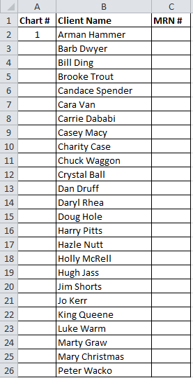
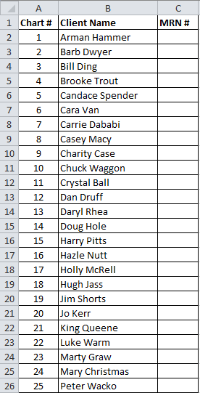


This is the # of eligible charts

- Go to www.random.org/sequences/ 6. Select a sequence of those random numbers
Fill in the boxes as shown below. Click Get Sequence. equal to the number of charts needed and
and the site will return a list of random numbers audit the corresponding charts.
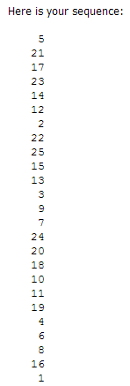
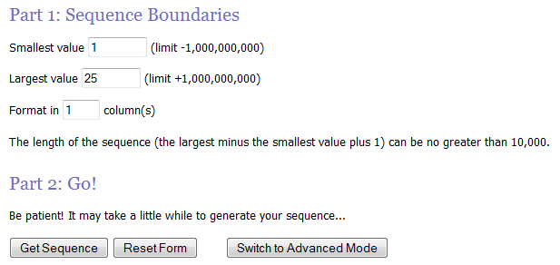
Always 1
Enter 1 for user friendly view
# of eligible charts

Competing Diagnosis List (AOM codes excluded for queries related to AOM)

000 | CHOLERA D/T VIBRIO CHOLRAE 01 BIOVR
A001 | CHOLRA D/T V CHOLRAE 01 BIOVR ELTOR
A009 | CHOLERA UNSPECIFIED
A0100 | TYPHOID FEVER UNSPECIFIED
A0101 | TYPHOID MENINGITIS
A0102 | TYPHOID FEVER W/HEART INVOLVEMENT
A0103 | TYPHOID PNEUMONIA
A0104 | TYPHOID ARTHRITIS
A0105 | TYPHOID OSTEOMYELITIS
A0109 | TYPHOID FEVER W/OTHER COMPLICATIONS
A011 | PARATYPHOID FEVER A
A012 | PARATYPHOID FEVER B
A013 | PARATYPHOID FEVER C
A014 | PARATYPHOID FEVER UNSPECIFIED
A020 | SALMONELLA ENTERITIS
A021 | SALMONELLA SEPSIS
A0220 | LOCALIZED SALMONELLA INFECTION UNS
A0221 | SALMONELLA MENINGITIS
A0222 | SALMONELLA PNEUMONIA
A0223 | SALMONELLA ARTHRITIS
A0224 | SALMONELLA OSTEOMYELITIS
A0225 | SALMONELLA PYELONEPHRITIS
A0229 | SALMONELLA W/OTHER LOCALIZED INF
A028 | OTH SPECIFIED SALMONELLA INFECTIONS
A029 | SALMONELLA INFECTION UNSPECIFIED
A030 | SHIGELLOSIS D/T SHIGELLA DYSNTERIAE
A031 | SHIGELLOSIS DUE SHIGELLA FLEXNERI
A032 | SHIGELLOSIS DUE TO SHIGELLA BOYDII
A033 | SHIGELLOSIS DUE TO SHIGELLA SONNEI
A038 | OTHER SHIGELLOSIS
A039 | SHIGELLOSIS UNSPECIFIED
A040 | ENTROPATHOGNIC ESCHERICHIA COLI INF
A041 | ENTEROTOXIGNIC ESCHERICHIA COLI INF
A042 | ENTEROINVASIVE ESCHERICHIA COLI INF
A043 | ENTEROHEMORR ESCHERICHIA COLI INF
A044 | OTH INTESTINAL ESCHERICHIA COLI INF
A045 | CAMPYLOBACTER ENTERITIS
A046 | ENTERIT D/T YERSINIA ENTEROCOLITICA
A047 | ENTEROCOLIT D/T CLOSTRIDM DIFFICILE
A048 | OTH SPEC BACTERIAL INTESTINAL INF
A049 | BACTERIAL INTESTINAL INFECTION UNS
A050 | FOODBORNE STAPHYLOCOCCAL INTOXICATN
A051 | BOTULISM FOOD POISONING
A052 | FOODBORNE CLOSTRIDM PERFRNGNS INTOX
A053 | FOODBORNE V PARAHAEMOLYTCUS INTOX
A054 | FOODBORNE BACILLUS CEREUS INTOX
A055 | FOODBORNE VIBRIO VULNIFICUS INTOX
A058 | OTH SPEC BACT FOODBORNE INTOXICATN
A059 | BACTERIAL FOODBORNE INTOXICATN UNS
A060 | ACUTE AMEBIC DYSENTERY
A061 | CHRONIC INTESTINAL AMEBIASIS
A062 | AMEBIC NONDYSENTERIC COLITIS
A063 | AMEBOMA OF INTESTINE
A064 | AMEBIC LIVER ABSCESS
A065 | AMEBIC LUNG ABSCESS
A066 | AMEBIC BRAIN ABSCESS
A067 | CUTANEOUS AMEBIASIS
A0681 | AMEBIC CYSTITIS
A0682 | OTH AMEBIC GENITOURINARY INFECTION
A0689 | OTHER AMEBIC INFECTIONS
A069 | AMEBIASIS UNSPECIFIED
A070 | BALANTIDIASIS
A071 | GIARDIASIS LAMBLIASIS
A072 | CRYPTOSPORIDIOSIS
A073 | ISOSPORIASIS
A074 | CYCLOSPORIASIS
A078 | OTHER SPEC PROTOZOAL INTESTINAL DZ
A079 | PROTOZOAL INTESTINAL DISEASE UNSPEC
A080 | ROTAVIRAL ENTERITIS
A0811 | ACUTE GASTROENTROPATHY NORWALK AGNT
A0819 | AC GASTROENTEROPATHY OTH SM RND VIR
A082 | ADENOVIRAL ENTERITIS
A0831 | CALICIVIRUS ENTERITIS
A0832 | ASTROVIRUS ENTERITIS
A0839 | OTHER VIRAL ENTERITIS
A084 | VIRAL INTESTINAL INFECTION UNSPEC
A088 | OTH SPECIFIED INTESTINAL INFECTIONS
A09 | INF GASTROENTERITIS & COLITIS UNS
A3700 | WC D/T BORDETELLA PERTUSS W/O PNEUM
A3701 | WC D/T BORDETELLA PERTUSS W/PNEUMON
A3710 | WC D/T B PARAPERTUSS W/O PNEUMONIA
A3711 | WC D/T B PARAPRTUSSIS W/PNEUMONIA
A3780 | WC OTH BORDETELLA SPECIES W/O PNEUM
A3781 | WC OTH BORDETELLA SPECIES W/PNEUMON
A3790 | WC UNSPECIED SPECIES W/O PNEUMONIA
A3791 | WHOOPING COUGH UNS SPECIES PNEUMON
A440 | SYSTEMIC BARTONELLOSIS
A441 | CUTANEOUS MUCOCUTANEOUS BARTONELLOS
A448 | OTHER FORMS OF BARTONELLOSIS
A449 | BARTONELLOSIS UNSPECIFIED
A499 | BACTERIAL INFECTION UNSPECIFIED
A5001 | EARLY CONGEN SYPHILITIC OCULOPATHY
A5002 | EARLY CONGN SYPHILIT OSTEOCHNDROPTH
A5003 | EARLY CONGENIT SYPHILIT PHARYNGITIS
A5004 | EARLY CONGENIT SYPHILITIC PNEUMONIA
A5005 | EARLY CONGENIT SYPHILITIC RHINITIS
A5006 | EARLY CUTANEOUS CONGENITAL SYPHILIS
A5007 | EARLY MUCOCUTANEOUS CONGEN SYPHILIS
A5008 | EARLY VISCERAL CONGENITAL SYPHILIS
A5009 | OTH EARLY CONGEN SYPH SYMPTOMATIC
A501 | EARLY CONGENITAL SYPHILIS LATENT
A502 | EARLY CONGENITAL SYPHILIS UNSPEC
A5030 | LATE CONGEN SYPH OCULOPATHY UNSPEC
A5031 | LATE CONGEN SYPH INTERST KERATITIS
A5032 | LATE CONGN SYPHILIT CHORIORETINITIS
A5039 | OTH LATE CONGEN SYPHILIT OCULOPATHY
A5040 | LATE CONGEN NEUROSYPHILIS UNSPEC
A5041 | LATE CONGENITAL SYPHILIT MENINGITIS
A5042 | LATE CONGEN SYPHILITIC ENCEPHALITIS
A5043 | LATE CONGEN SYPHILIT POLYNEUROPATHY
A5044 | LATE CONGN SYPH OPTIC NERVE ATROPHY
A5045 | JUVENILE GENERAL PARESIS
A5049 | OTHER LATE CONGENITAL NEUROSYPHILIS
A5051 | CLUTTONS JOINTS
A5052 | HUTCHINSONS TEETH
A5053 | HUTCHINSONS TRIAD
A5054 | LATE CONGEN CARDIOVASCULAR SYPHILIS
A5055 | LATE CONGEN SYPHILITIC ARTHROPATHY
A5056 | LATE CONGEN SYPH OSTEOCHONDROPATHY
A5057 | SYPHILITIC SADDLE NOSE
A5059 | OTH LATE CONGEN SYPHIL SYMPTOMATIC
A506 | LATE CONGENITAL SYPHILIS LATENT
A507 | LATE CONGENITL SYPHILIS UNSPECIFIED
A509 | CONGENITAL SYPHILIS UNSPECIFIED
A510 | PRIMARY GENITAL SYPHILIS
A511 | PRIMARY ANAL SYPHILIS
A512 | PRIMARY SYPHILIS OF OTHER SITES
A5131 | CONDYLOMA LATUM
A5132 | SYPHILITIC ALOPECIA
A5139 | OTHER SECONDARY SYPHILIS OF SKIN
A5141 | SECONDARY SYPHILITIC MENINGITIS
A5142 | SECNDRY SYPHILITIC FEMALE PELVIC DZ
A5143 | SECONDARY SYPHILITIC OCULOPATHY
A5144 | SECONDARY SYPHILITIC NEPHRITIS
A5145 | SECONDARY SYPHILITIC HEPATITIS
A5146 | SECONDARY SYPHILITIC OSTEOPATHY
A5149 | OTH SECONDARY SYPHILITIC CONDITIONS
A515 | EARLY SYPHILIS LATENT
A519 | EARLY SYPHILIS UNSPECIFIED
A5200 | CARDIOVASCULAR SYPHILIS UNSPECIFIED
A5201 | SYPHILITIC ANEURYSM OF AORTA
A5202 | SYPHILITIC AORTITIS
A5203 | SYPHILITIC ENDOCARDITIS
A5204 | SYPHILITIC CEREBRAL ARTERITIS
A5205 | OTHER CEREBROVASCULAR SYPHILIS
A5206 | OTHER SYPHILITIC HEART INVOLVEMENT
A5209 | OTHER CARDIOVASCULAR SYPHILIS
A5210 | SYMPTOMATIC NEUROSYPHILIS UNSPEC
A5211 | TABES DORSALIS
A5212 | OTHER CEREBROSPINAL SYPHILIS
A5213 | LATE SYPHILITIC MENINGITIS
A5214 | LATE SYPHILITIC ENCEPHALITIS
A5215 | LATE SYPHILITIC NEUROPATHY
A5216 | CHARCOTS ARTHROPATHY TABETIC
A5217 | GENERAL PARESIS
A5219 | OTHER SYMPTOMATIC NEUROSYPHILIS
A522 | ASYMPTOMATIC NEUROSYPHILIS
A523 | NEUROSYPHILIS UNSPECIFIED
A5271 | LATE SYPHILITIC OCULOPATHY
A5272 | SYPHILIS OF LUNG AND BRONCHUS
A5273 | SX LATE SYPHILIS OTH RESP ORGANS
A5274 | SYPHILIS OF LIVER AND OTHER VISCERA
A5275 | SYPHILIS OF KIDNEY AND URETER
A5276 | OTH GU SYMPTOMS LATE SYPHILIS
A5277 | SYPHILIS OF BONE AND JOINT
A5278 | SYPHILIS OTH MUSCULOSKELETAL TISS
A5279 | OTHER SYMPTOMATIC LATE SYPHILIS
A528 | LATE SYPHILIS LATENT
A529 | LATE SYPHILIS UNSPECIFIED
A530 | LATENT SYPHILIS UNS AS EARLY/LATE
A539 | SYPHILIS UNSPECIFIED
A5400 | GONOCOCCAL INF OF LOW GU TRACT UNS
A5401 | GONOCOCCL CYSTITIS & URETHRITIS UNS
A5402 | GONOCOCCAL VULVOVAGINITIS UNSPEC
A5403 | GONOCOCCAL CERVICITIS UNSPECIFIED
A5409 | OTH GONOCOCCAL INF OF LOW GU TRACT
A541 | GC INF LOW GU TRACT W/GLAND ABSCSS
A5421 | GONOCOCCAL INF OF KIDNEY & URETER
A5422 | GONOCOCCAL PROSTATITIS
A5423 | GONOCCL INF OF OTH MALE GENIT ORGNS
A5424 | GONOCOCCAL FEMALE PELVIC INFLAM DZ
A5429 | OTHER GONOCOCCAL GENITOURINARY INF
A5430 | GONOCOCCAL INFECTION OF EYE UNSPEC
A5431 | GONOCOCCAL CONJUNCTIVITIS
A5432 | GONOCOCCAL IRIDOCYCLITIS
A5433 | GONOCOCCAL KERATITIS
A5439 | OTHER GONOCOCCAL EYE INFECTION
A5440 | GONOCOCCAL INF MUSCULOSKEL SYS UNS
A5441 | GONOCOCCAL SPONDYLOPATHY
A5442 | GONOCOCCAL ARTHRITIS
A5443 | GONOCOCCAL OSTEOMYELITIS
A5449 | GONOCOCCAL INF OTH MUSCULOSKEL TISS
A545 | GONOCOCCAL PHARYNGITIS
A546 | GONOCOCCAL INF OF ANUS AND RECTUM
A5481 | GONOCOCCAL MENINGITIS
A5482 | GONOCOCCAL BRAIN ABSCESS
A5483 | GONOCOCCAL HEART INFECTION
A5484 | GONOCOCCAL PNEUMONIA
A5485 | GONOCOCCAL PERITONITIS
A5486 | GONOCOCCAL SEPSIS
A5489 | OTHER GONOCOCCAL INFECTIONS
A549 | GONOCOCCAL INFECTION UNSPECIFIED
A55 | CHLAMYDIAL LYMPHOGRANULOMA VENEREUM
A5600 | CHLAMYDIAL INF OF LOWR GU TRACT UNS
A5601 | CHLAMYDIAL CYSTITIS AND URETHRITIS
A5602 | CHLAMYDIAL VULVOVAGINITIS
A5609 | OTH CHLAMYDIAL INF OF LOWR GU TRACT
A5611 | CHLAMYDIAL FEMALE PELVIC INFLAM DZ
A5619 | OTHER CHLAMYDIAL GENITOURINARY INF
A562 | CHLAMYDIAL INFECTION GU TRACT UNS
A563 | CHLAMYDIAL INF OF ANUS AND RECTUM
A564 | CHLAMYDIAL INFECTION OF PHARYNX
A568 | SEX TRANSMIT CHLAMYDL INF OTH SITES
A57 | CHANCROID
A58 | GRANULOMA INGUINALE
A5900 | UROGENITAL TRICHOMONIASIS UNSPEC
A5901 | TRICHOMONAL VULVOVAGINITIS
A5902 | TRICHOMONAL PROSTATITIS
A5903 | TRICHOMONAL CYSTITIS AND URETHRITIS
A5909 | OTHER UROGENITAL TRICHOMONIASIS
A598 | TRICHOMONIASIS OF OTHER SITES
A599 | TRICHOMONIASIS UNSPECIFIED
A630 | ANOGENITAL VENEREAL WARTS
A638 | OTHER SPECIFIED PREDOMINANTLY STD
A64 | UNSPECIFIED SEXUALLY TRANSMITTED DZ
A690 | NECROTIZING ULCERATIVE STOMATITIS
A691 | OTHER VINCENTS INFECTIONS
A6920 | LYME DISEASE UNSPECIFIED
A6921 | MENINGITIS DUE TO LYME DISEASE
A6922 | OTH NEUROLOGIC DISORDERS IN LYME DZ
A6923 | ARTHRITIS DUE TO LYME DISEASE
A6929 | OTH CONDITIONS ASSOCIATED W/LYME DZ
A698 | OTHER SPECIFIED SPIROCHETAL INF
A699 | SPIROCHETAL INFECTION UNSPECIFIED
B600 | BABESIOSIS
B6010 | ACANTHAMEBIASIS UNSPECIFIED
B6011 | MENINGOENCEPHALITIS ACANTHAMOEBA
B6012 | CONJUNCTIVITIS DUE TO ACANTHAMOEBA
B6013 | KERATOCONJUNCTIVITIS ACANTHAMOEBA
B6019 | OTHER ACANTHAMEBIC DISEASE
B602 | NAEGLERIASIS
B608 | OTHER SPECIFIED PROTOZOAL DISEASES
B64 | UNSPECIFIED PROTOZOAL DISEASE
B781 | CUTANEOUS STRONGYLOIDIASIS
B9689 | OTH SPEC BACTERIAL DZ CLASS ELSW
E832 | DISORDERS OF ZINC METABOLISM
H66001 | AC SUPPRTV OM W/O RUPT EAR DRUM RT
H66002 | AC SUPPRTV OM W/O RUPT EAR DRUM LT
H66003 | AC SUPPRTV OM W/O RUPT EAR DRUM BIL
H66004 | AC SUPP OM W/O RUP EAR DRM RECUR RT
H66005
H66006 | AC SUPP OM W/O RUP EAR DRM RECUR BI
H66007 | AC SUPP OM W/O RUP EAR DRM RECUR UN
H66009 | AC SUPP OM W/0 RUPT EAR DRM UNS EAR
H66011 | AC SUPP OM W RUPT EAR DRUM RT
H66012 | AC SUPP OM W RUPT EAR DRUM LT
H66013 | AC SUPP OM W RUPT EAR DRUM BIL
H66014 | AC SUPP OM W RUP EAR DRUM RECUR RT
H66015 | AC SUPP OM W RUP EAR DRUM RECUR LT
H66016 | AC SUPP OM W RUP EAR DRUM RECUR BIL
H66017 | AC SUPP OM W RUP EAR DRUM RECUR UNS
H66019 | AC SUPP OM W RUP EAR DRUM UNS
H6610 | CHRON TUBOTYMPANIC SUPPURATV OM UNS
H6611 | CHRON TUBOTYMPANIC SUPPURATV OM RT
H6612 | CHRON TUBOTYMPANIC SUPPURATV OM LT
H6613 | CHRON TUBOTYMPANIC SUPPURATV OM BIL
H6620 | CHRON ATTICOANTRAL SUPPURATV OM UNS
H6621 | CHRON ATTICOANTRAL SUPPURATV OM RT
H6622 | CHRON ATTICOANTRAL SUPPURATV OM LT
H6623 | CHRON ATTICOANTRAL SUPPURATV OM BIL
H663X1 | OTH CHRON SUPPURATIVE OM RT EAR
H663X2 | OTH CHRON SUPPURATIVE OM LT EAR
H663X3 | OTH CHRON SUPPURATIVE OM BIL
H663X9 | OTH CHRON SUPPURATIVE OM UNS EAR
H6640 | SUPPURATIV OTITIS MEDIA UNS UNS EAR
H6641 | SUPPURATIV OTITIS MEDIA UNS RT EAR
H6642 | SUPPURATIV OTITIS MEDIA UNS LT EAR
H6643 | SUPPURATIV OTITIS MEDIA UNS BIL
H6690 | OTITIS MEDIA UNSPECIFIED UNS EAR
H6691 | OTITIS MEDIA UNSPECIFIED RIGHT EAR
H6692 | OTITIS MEDIA UNSPECIFIED LEFT EAR
H6693 | OTITIS MEDIA UNSPECIFIED BILATERAL
H671 | OTITIS MEDIA DZ CLASS ELSW RT EAR
H672 | OTITIS MEDIA DZ CLASS ELSW LT EAR
H673 | OTITIS MEDIA DZ CLASS ELSW BIL
H679 | OTITIS MEDIA DZ CLASS ELSW UNS EAR
H70001 | ACUTE MASTOIDITIS W/O COMP RT EAR
H70002 | ACUTE MASTOIDITIS W/O COMP LT EAR
H70003 | ACUTE MASTOIDITIS W/O COMP BILAT
H70009 | ACUTE MASTOIDITIS W/O COMP UNS EAR
H70011 | SUBPERIOSTEAL ABSC MASTOID RT EAR
H70012 | SUBPERIOSTEAL ABSC MASTOID LT EAR
H70013 | SUBPERIOSTEAL ABSC MASTOID BIL
H70019 | SUBPERIOSTEAL ABSC MASTOID UNS EAR
H70091 | ACUTE MASTOIDITIS W/OTH COMP RT EAR
H70092 | ACUTE MASTOIDITIS W/OTH COMP LT EAR
H70093 | ACUTE MASTOIDITIS W/OTH COMP BILAT
H70099 | ACUTE MASTOIDITIS W/OTH COMP UNS
H7010 | CHRONIC MASTOIDITIS UNSPECIFIED EAR
H7011 | CHRONIC MASTOIDITIS, RIGHT EAR
H7012 | CHRONIC MASTOIDITIS, LEFT EAR
H7013 | CHRONIC MASTOIDITIS, BILATERAL
H70201 | UNSPECIFIED PETROSITIS RIGHT EAR
H70202 | UNSPECIFIED PETROSITIS LEFT EAR
H70203 | UNSPECIFIED PETROSITIS BILATERAL
H70209 | UNSPECIFIED PETROSITIS UNSPEC EAR
H70211 | ACUTE PETROSITIS RIGHT EAR
H70212 | ACUTE PETROSITIS LEFT EAR
H70213 | ACUTE PETROSITIS BILATERAL
H70219 | ACUTE PETROSITIS UNSPECIFIED EAR
H70221 | CHRONIC PETROSITIS RIGHT EAR
H70222 | CHRONIC PETROSITIS LEFT EAR
H70223 | CHRONIC PETROSITIS BILATERAL
H70229 | CHRONIC PETROSITIS UNSPECIFIED EAR
H70811 | POSTAURICULAR FISTULA RIGHT EAR
H70812 | POSTAURICULAR FISTULA LEFT EAR
H70813 | POSTAURICULAR FISTULA BILATERAL
H70819 | POSTAURICULAR FISTULA UNS EAR
H70891 | OTH MASTOIDITIS RELATED COND RT EAR
H70892 | OTH MASTOIDITIS RELATED COND LT EAR
H70893 | OTH MASTOIDITIS RELATED COND BIL
H70899 | OTH MASTOIDITIS RELATED COND UNS
H7090 | UNSPECIFIED MASTOIDITIS UNSPEC EAR
H7091 | UNSPECIFIED MASTOIDITIS RIGHT EAR
H7092 | UNSPECIFIED MASTOIDITIS LEFT EAR
H7093 | UNSPECIFIED MASTOIDITIS BILATERAL
H9500 | RECUR CHOLSTEATOMA PSTMSTDECTMY UNS
H9501 | RECUR CHOLSTEATOMA PSTMSTDECTMY RT
H9502 | RECUR CHOLSTEATOMA PSTMSTDECTMY LT
H9503 | RECUR CHOLSTEATOMA PSTMSTDECTMY BIL
H95111 | CHR INFLAM PSTMSTOIDECTMY CAV RT
H95112 | CHR INFLAM PSTMSTOIDECTMY CAV RT
H95113 | CHR INFLAM PSTMSTOIDECTMY CAV BIL
H95119 | CHR INFLAM PSTMSTOIDECTMY CAV UNS
H95121 | GRANULATION PSTMSTOIDECTMY CAV RT
H95122 | GRANULATION PSTMSTOIDECTMY CAV RT
H95123 | GRANULATION PSTMSTOIDECTMY CAV BIL
H95129 | GRANULATION PSTMSTOIDECTMY CAV UNS
H95131 | MUCOSL CYST POSTMASTOIDCTMY CAV RT
H95132 | MUCOSL CYST POSTMASTOIDCTMY CAV LT
H95133 | MUCOSL CYST POSTMASTOIDCTMY CAV BIL
H95139 | MUCOSL CYST POSTMASTOIDCTMY CAV UNS
H95191 | OTH D/O FOLLOW MASTOIDECTOMY RT EAR
H95192 | OTH D/O FOLLOW MASTOIDECTOMY LT EAR
H95193 | OTH D/O FOLLOW MASTOIECT BIL ERS
H95199 | OTH D/O FOLLOW MASTOIECT UNS EAR
H9521 | INTRAOP HEM HEMAT EAR MAST COMP EAR
H9522 | INTRAOP HEM HEMAT EAR MAST OTH COMP
H9531 | ACC PUNCT LAC EAR MAST DUR EAR PROC
H9532 | ACC PUNCT LAC EAR MAST DUR OTH PROC
H9541 | PST PROC HEM HEMAT EAR MAST PRC EAR
H9542 | PSTPROC HEM HEMAT EAR MAST PROC OTH
H95811 | POSTPROC STENOSIS RT EXT EAR CANAL
H95812 | POSTPROC STENOSIS LT EXT EAR CANAL
H95813 | POSTPROC STENOS EXT EAR CANAL BIL
H95819 | POSTPROC STENOSIS UNS EXT EAR CANAL
H9588 | OTH INTRAOP COMP D/O EAR MAST NEC
H9589 | OTH POSTPROC COMP D/O EAR MAST NEC
J0100 | ACUTE MAXILLARY SINUSITIS UNS
J0101 | ACUTE RECURRENT MAXILLARY SINUSITIS
J0110 | ACUTE FRONTAL SINUSITIS UNSPECIFIED
J0111 | ACUTE RECURRENT FRONTAL SINUSITIS
J0120 | ACUTE ETHMOIDAL SINUSITIS UNS
J0121 | ACUTE RECURRENT ETHMOIDAL SINUSITIS
J0130 | ACUTE SPHENOIDAL SINUSITIS UNS
J0131 | ACUTE RECUR SPHENOIDAL SINUSITIS
J0140 | ACUTE PANSINUSITIS UNSPECIFIED
J0141 | ACUTE RECURRENT PANSINUSITIS
J0180 | OTHER ACUTE SINUSITIS
J0181 | OTHER ACUTE RECURRENT SINUSITIS
J0190 | ACUTE SINUSITIS UNSPECIFIED
J0191 | ACUTE RECURRENT SINUSITIS UNS
J020 | STREPTOCOCCAL PHARYNGITIS
J028 | AC PHARYNGIT D/T OTH SPEC ORGANISMS
J029 | ACUTE PHARYNGITIS UNSPECIFIED
J0300 | ACUTE STREPTOCOCCAL TONSILLITIS UNS
J0301 | ACUTE RECUR STREP TONSILLITIS
J0380 | AC TONSILLITI D/T OTH SPEC ORGANISM
J0381 | AC RECUR TONSILLIT D/T OTH ORGANISM
J0390 | ACUTE TONSILLITIS UNSPECIFIED
J0391 | ACUTE RECURRENT TONSILLITIS UNS
J0410 | ACUTE TRACHEITIS W/O OBSTRUCTION
J0411 | ACUTE TRACHEITIS WITH OBSTRUCTION
J042 | ACUTE LARYNGOTRACHEITIS
J050 | ACUTE OBSTRUCTIVE LARYNGITIS CROUP
J0510 | ACUTE EPIGLOTTITIS W/O OBSTRUCTION
J0511 | ACUTE EPIGLOTTITIS WITH OBSTRUCTION
J13 | PNEUMONIA D/T STREP PNEUMONIAE
J14 | PNEUMONIA D/T HEMOPHILUS INFLUENZAE
J150 | PNEUMONIA D/T KLEBSIELLA PNEUMONIAE
J151 | PNEUMONIA DUE TO PSEUDOMONAS
J1520 | PNEUMONIA D/T STAPHYLOCOCCUS UNS
J15211 | PNEUMON D/T METHICILLIN SUSCP STAPH
J15212 | PNEUMON D/T METHICILLIN RSIST STAPH
J1529 | PNEUMONIA D/T OTHER STAPHYLOCOCCUS
J153 | PNEUMONIA D/T STREPTOCOCCUS GROUP B
J154 | PNEUMONIA DUE TO OTHER STREPTOCOCCI
J155 | PNEUMONIA DUE TO ESCHERICHIA COLI
J156 | PNEUMONIA D/T AEROBIC GM-NEG BACT
J157 | PNEUMONIA D/T MYCOPLASMA PNEUMONIAE
J158 | PNEUMONIA D/T OTHER SPEC BACTERIA
J159 | UNSPECIFIED BACTERIAL PNEUMONIA
J160 | CHLAMYDIAL PNEUMONIA
J168 | PNEUMONIA D/T SPEC INF ORGANISMS
J17 | PNEUMONIA DZ CLASSIFIED ELSEWHERE
J180 | BRONCHOPNEUMONIA UNS ORGANISM
J181 | LOBAR PNEUMONIA UNS ORGANISM
J188 | OTHER PNEUMONIA UNS ORGANISM
J189 | PNEUMONIA UNSPECIFIED ORGANISM
J200 | ACUTE BRONCHITIS D/T MYCOPLASMA PN
J201 | AC BRONCHIT D/T HEMOPHILUS INFLUENZ
J202 | ACUTE BRONCHITIS D/T STREPTOCOCCUS
J320 | CHRONIC MAXILLARY SINUSITIS
J321 | CHRONIC FRONTAL SINUSITIS
J322 | CHRONIC ETHMOIDAL SINUSITIS
J323 | CHRONIC SPHENOIDAL SINUSITIS
J324 | CHRONIC PANSINUSITIS
J328 | OTHER CHRONIC SINUSITIS
J329 | CHRONIC SINUSITIS UNSPECIFIED
J3501 | CHRONIC TONSILLITIS
J3502 | CHRONIC ADENOIDITIS
J3503 | CHRONIC TONSILLITIS AND ADENOIDITIS
J351 | HYPERTROPHY OF TONSILS
J352 | HYPERTROPHY OF ADENOIDS
J353 | HYPERTROPHY TONSILS W/HYP ADENOIDS
J358 | OTH CHRON DISEASES TONSILS ADNOIDS
J359 | CHRON DISEASES TONSILS ADNOIDS UNS
J387 | OTHER DISEASES OF LARYNX
J390 | RETROPHARYNGEAL PARAPHARYNGEAL ABSC
J391 | OTHER ABSCESS OF PHARYNX
J392 | OTHER DISEASES OF PHARYNX
J398 | OTH SPEC DZ UP RESPIRATORY TRACT
J399 | DISEASE UPPER RESPIRATORY TRACT UNS
K122 | CELLULITIS AND ABSCESS OF MOUTH
L0100 | IMPETIGO UNSPECIFIED
L0101 | NON-BULLOUS IMPETIGO
L0102 | BOCKHARTS IMPETIGO
L0103 | BULLOUS IMPETIGO
L0109 | OTHER IMPETIGO
L011 | IMPETIGINIZATION OTHER DERMATOSES
L03011 | CELLULITIS OF RIGHT FINGER
L03012 | CELLULITIS OF LEFT FINGER
L03019 | CELLULITIS OF UNSPECIFIED FINGER
L03021 | ACUTE LYMPHANGITIS OF RIGHT FINGER
L03022 | ACUTE LYMPHANGITIS OF LEFT FINGER
L03029 | ACUTE LYMPHANGITIS UNS FINGER
L03031 | CELLULITIS OF RIGHT TOE
L03032 | CELLULITIS OF LEFT TOE
L03039 | CELLULITIS OF UNSPECIFIED TOE
L03041 | ACUTE LYMPHANGITIS OF RIGHT TOE
L03042 | ACUTE LYMPHANGITIS OF LEFT TOE
L03049 | ACUTE LYMPHANGITIS UNSPECIFIED TOE
L03111 | CELLULITIS OF RIGHT AXILLA
L03112 | CELLULITIS OF LEFT AXILLA
L03113 | CELLULITIS OF RIGHT UPPER LIMB
L03114 | CELLULITIS OF LEFT UPPER LIMB
L03115 | CELLULITIS OF RIGHT LOWER LIMB
L03116 | CELLULITIS OF LEFT LOWER LIMB
L03119 | CELLULITIS UNSPECIFIED PART OF LIMB
L03121 | ACUTE LYMPHANGITIS OF RIGHT AXILLA
L03122 | ACUTE LYMPHANGITIS OF LEFT AXILLA
L03123 | ACUTE LYMPHANGITIS RIGHT UPPER LIMB
L03124 | ACUTE LYMPHANGITIS LEFT UPPER LIMB
L03125 | ACUTE LYMPHANGITIS RIGHT LOWER LIMB
L03126 | ACUTE LYMPHANGITIS LEFT LOWER LIMB
L03129 | ACUTE LYMPHANGITIS UNS PART LIMB
L03211 | CELLULITIS OF FACE
L03212 | ACUTE LYMPHANGITIS OF FACE
L03221 | CELLULITIS OF NECK
L03222 | ACUTE LYMPHANGITIS OF NECK
L03311 | CELLULITIS OF ABDOMINAL WALL
L03312 | CELLULITIS BACK ANY PRT NO BUTTOCK
L03313 | CELLULITIS OF CHEST WALL
L03314 | CELLULITIS OF GROIN
L03315 | CELLULITIS OF PERINEUM
L03316 | CELLULITIS OF UMBILICUS
L03317 | CELLULITIS OF BUTTOCK
L03319 | CELLULITIS OF TRUNK UNSPECIFIED
L03321 | ACUTE LYMPHANGITIS ABDOMINAL WALL
L03322 | AC LYMPHANG BACK ANY PRT NO BUTTOCK
L03323 | ACUTE LYMPHANGITIS OF CHEST WALL
L03324 | ACUTE LYMPHANGITIS OF GROIN
L03325 | ACUTE LYMPHANGITIS OF PERINEUM
L03326 | ACUTE LYMPHANGITIS OF UMBILICUS
L03327 | ACUTE LYMPHANGITIS OF BUTTOCK
L03329 | ACUTE LYMPHANGITIS TRUNK UNS
L03811 | CELLULITIS HEAD ANY PRT EXCEPT FACE
L03818 | CELLULITIS OF OTHER SITES
L03891 | AC LYMPHANGIT HEAD ANY PART NO FACE
L03898 | ACUTE LYMPHANGITIS OF OTHER SITES
L0390 | CELLULITIS UNSPECIFIED
L0391 | ACUTE LYMPHANGITIS UNSPECIFIED
L040 | ACUTE LYMPHADENITIS FACE HEAD NECK
L041 | ACUTE LYMPHADENITIS OF TRUNK
L042 | ACUTE LYMPHADENITIS OF UPPER LIMB
L043 | ACUTE LYMPHADENITIS OF LOWER LIMB
L048 | ACUTE LYMPHADENITIS OF OTHER SITES
L049 | ACUTE LYMPHADENITIS UNSPECIFIED
L081 | ERYTHRASMA
L0881 | PYODERMA VEGETANS
L0882 | OMPHALITIS NOT OF NEWBORN
L0889 | OTH SPEC LOC INFECT SKIN SUBQ TISS
L089 | LOCAL INFECT SKIN SUBQ TISSUE UNS
L88 | PYODERMA GANGRENOSUM
L928 | OTH GRANULOMATOUS D/O SKN SUBQ TISS
L980 | PYOGENIC GRANULOMA
L983 | EOSINOPHILIC CELLULITIS WELLS
M4620 | OSTEOMYELITIS VERTEBRA SITE UNS
M4621 | OSTEOMYELITIS VERTEBRA OAA REGION
M4622 | OSTEOMYELITIS VERTEBRA CERV REGION
M4623 | OSTEOMYELITIS VERTEBRA CT REGION
M4624 | OSTEOMYELITIS VERTEBRA THORACIC RGN
M4625 | OSTEOMYELITIS VERTEBRA TL REGION
M4626 | OSTEOMYELITIS VERTEBRA LUMBAR RGN
M4627 | OSTEOMYELITIS VERTEBRA LS REGION
M4628 | OSTEOMYELITIS VERTEBRA SACRL SC RGN
M4630 | INFECTION INTERVERT DISC SITE UNS
M4631 | INFECTION INTERVERT DISC OAA REGION
M4632 | INFECTION INTERVERT DISC CERV RGN
M4633 | INFECTION INTERVERT DISC CT REGION
M4634 | INFECTION INTERVERT DISC THOR RGN
M4635 | INFECTION INTERVERT DISC TL REGION
M4636 | INFECTION INTERVERT DISC LUMBAR RGN
M4637 | INFECTION INTERVERT DISC LS REGION
M4638 | INFECTION INTERVERT DISC SACRAL SC
M4639 | INFECTION INTERVERT DISC MX SITES
M8900 | ALGONEURODYSTROPHY UNSPECIFIED SITE
M89011 | ALGONEURODYSTROPHY RIGHT SHOULDER
M89012 | ALGONEURODYSTROPHY LEFT SHOULDER
M89019 | ALGONEURODYSTROPHY UNS SHOULDER
M89021 | ALGONEURODYSTROPHY RIGHT UPPER ARM
M89022 | ALGONEURODYSTROPHY LEFT UPPER ARM
M89029 | ALGONEURODYSTROPHY UNS UPPER ARM
M89031 | ALGONEURODYSTROPHY RIGHT FOREARM
M89032 | ALGONEURODYSTROPHY LEFT FOREARM
M89039 | ALGONEURODYSTROPHY UNS FOREARM
M89041 | ALGONEURODYSTROPHY RIGHT HAND
M89042 | ALGONEURODYSTROPHY LEFT HAND
M89049 | ALGONEURODYSTROPHY UNSPECIFIED HAND
M89051 | ALGONEURODYSTROPHY RIGHT THIGH
M89052 | ALGONEURODYSTROPHY LEFT THIGH
M89059 | ALGONEURODYSTROPHY UNS THIGH
M89061 | ALGONEURODYSTROPHY RIGHT LOWER LEG
M89062 | ALGONEURODYSTROPHY LEFT LOWER LEG
M89069 | ALGONEURODYSTROPHY UNS LOWER LEG
M89071 | ALGONEURODYSTROPHY RT ANKLE & FOOT
M89072 | ALGONEURODYSTROPHY LT ANKLE & FOOT
M89079 | ALGONEURODYSTROPHY UNS ANKLE & FOOT
M8908 | ALGONEURODYSTROPHY OTHER SITE
M8909 | ALGONEURODYSTROPHY MULTIPLE SITES
M89121 | COMPL PHYSEAL ARREST RT PROX HUM
M89122 | COMPL PHYSEAL ARREST LT PROX HUM
M89123 | PART PHYSEAL ARREST RT PROXIMAL HUM
M89124 | PART PHYSEAL ARREST LT PROXIMAL HUM
M89125 | COMPL PHYSEAL ARREST RT DISTAL HUM
M89126 | COMPL PHYSEAL ARREST LT DISTAL HUM
M89127 | PART PHYSEAL ARREST RT DISTAL HUM
M89128 | PART PHYSEAL ARREST LT DISTAL HUM
M89129 | PHYSEAL ARREST HUMERUS UNSPECIFIED
M89131 | COMPL PHYSEAL ARREST RT DIST RADIUS
M89132 | COMPL PHYSEAL ARREST LT DIST RADIUS
M89133 | PART PHYSEAL ARREST RT DIST RADIUS
M89134 | PART PHYSEAL ARREST LT DIST RADIUS
M89138 | OTHER PHYSEAL ARREST OF FOREARM
M89139 | PHYSEAL ARREST FOREARM UNSPECIFIED
M89151 | COMPL PHYSEAL ARREST RT PROX FEMUR
M89152 | COMPL PHYSEAL ARREST LT PROX FEMUR
M89153 | PART PHYSEAL ARREST RT PROX FEMUR
M89154 | PART PHYSEAL ARREST LT PROX FEMUR
M89155 | COMPL PHYSEAL ARREST RT DIST FEMUR
M89156 | COMPL PHYSEAL ARREST LT DIST FEMUR
M89157 | PART PHYSEAL ARREST RT DIST FEMUR
M89158 | PART PHYSEAL ARREST LT DIST FEMUR
M89159 | PHYSEAL ARREST FEMUR UNSPECIFIED
M89160 | COMPL PHYSEAL ARREST RT PROX TIBIA
M89161 | COMPL PHYSEAL ARREST LT PROX TIBIA
M89162 | PART PHYSEAL ARREST RT PROX TIBIA
M89163 | PART PHYSEAL ARREST LT PROX TIBIA
M89164 | COMPL PHYSEAL ARREST RT DIST TIBIA
M89165 | COMPL PHYSEAL ARREST LT DIST TIBIA
M89166 | PART PHYSEAL ARREST RT DIST TIBIA
M89167 | PART PHYSEAL ARREST LT DIST TIBIA
M89168 | OTHER PHYSEAL ARREST OF LOWER LEG
M89169 | PHYSEAL ARREST LOWER LEG UNS
M8918 | PHYSEAL ARREST OTHER SITE
M8920 | OTH D/O BONE DEV GROWTH UNS SITE
M89211 | OTH D/O BONE DEV GROWTH RT SHOULDER
M89212 | OTH D/O BONE DEV GROWTH LT SHOULDER
M89219 | OTH D/O BONE DEV GROWTH UNS SHLDR
M89221 | OTH D/O BONE DEV GROWTH RT HUM
M89222 | OTH D/O BONE DEV GROWTH LT HUM
M89229 | OTH D/O BONE DEV GROWTH UNS HUM
M89231 | OTH D/O BONE DEV GROWTH RT ULNA
M89232 | OTH D/O BONE DEV GROWTH LT ULNA
M89233 | OTH D/O BONE DEV GROWTH RT RADIUS
M89234 | OTH D/O BONE DEV GROWTH LT RADIUS
M89239 | OTH D/O BONE DEV GRWTH UNS ULN RAD
M89241 | OTH D/O BONE DEV GROWTH RT HAND
M89242 | OTH D/O BONE DEV GROWTH LT HAND
M89249 | OTH D/O BONE DEV GROWTH UNS HAND
M89251 | OTH D/O BONE DEV GROWTH RT FEMUR
M89252 | OTH D/O BONE DEV GROWTH LT FEMUR
M89259 | OTH D/O BONE DEV GROWTH UNS FEMUR
M89261 | OTH D/O BONE DEV GROWTH RT TIBIA
M89262 | OTH D/O BONE DEV GROWTH LT TIBIA
M89263 | OTH D/O BONE DEV GROWTH RT FIBULA
M89264 | OTH D/O BONE DEV GROWTH LT FIBULA
M89269 | OTH D/O BONE DEV GROWTH UNS LOW LEG
M89271 | OTH D/O BONE DEV GROWTH RT ANK FOOT
M89272 | OTH D/O BONE DEV GROWTH LT ANK FOOT
M89279 | OTH D/O BONE DEV GROWTH UNS ANK FT
M8928 | OTH D/O BONE DEV GROWTH OTH SITE
M8929 | OTH D/O BONE DEV GROWTH MX SITES
M8930 | HYPERTROPHY OF BONE UNS SITE
M89311 | HYPERTROPHY OF BONE RIGHT SHOULDER
M89312 | HYPERTROPHY OF BONE LEFT SHOULDER
M89319 | HYPERTROPHY OF BONE UNS SHOULDER
M89321 | HYPERTROPHY OF BONE RIGHT HUMERUS
M89322 | HYPERTROPHY OF BONE LEFT HUMERUS
M89329 | HYPERTROPHY OF BONE UNS HUMERUS
M89331 | HYPERTROPHY OF BONE RIGHT ULNA
M89332 | HYPERTROPHY OF BONE LEFT ULNA
M89333 | HYPERTROPHY OF BONE RIGHT RADIUS
M89334 | HYPERTROPHY OF BONE LEFT RADIUS
M89339 | HYPERTROPHY OF BONE UNS ULNA RADIUS
M89341 | HYPERTROPHY OF BONE RIGHT HAND
M89342 | HYPERTROPHY OF BONE LEFT HAND
M89349 | HYPERTROPHY OF BONE UNS HAND
M89351 | HYPERTROPHY OF BONE RIGHT FEMUR
M89352 | HYPERTROPHY OF BONE LEFT FEMUR
M89359 | HYPERTROPHY OF BONE UNS FEMUR
M89361 | HYPERTROPHY OF BONE RIGHT TIBIA
M89362 | HYPERTROPHY OF BONE LEFT TIBIA
M89363 | HYPERTROPHY OF BONE RIGHT FIBULA
M89364 | HYPERTROPHY OF BONE LEFT FIBULA
M89369 | HYPERTROPHY BONE UNS TIBIA & FIBULA
M89371 | HYPERTROPHY BONE RIGHT ANKLE & FOOT
M89372 | HYPERTROPHY BONE LEFT ANKLE & FOOT
M89379 | HYPERTROPHY BONE UNS ANKLE & FOOT
M8938 | HYPERTROPHY OF BONE OTHER SITE
M8939 | HYPERTROPHY OF BONE MULTIPLE SITES
M8940 | OTHER HYPERTROPHIC OAP UNS SITE
M89411 | OTHER HYPERTROPHIC OAP RT SHOULDER
M89412 | OTHER HYPERTROPHIC OAP LT SHOULDER
M89419 | OTHER HYPERTROPHIC OAP UNS SHOULDER
M89421 | OTHER HYPERTROPHIC OAP RT UPPER ARM
M89422 | OTHER HYPERTROPHIC OAP LT UPPER ARM
M89429 | OTHER HYPERTROPHIC OAP UNS UPPER AR
M89431 | OTHER HYPERTROPHIC OAP RT FOREARM
M89432 | OTHER HYPERTROPHIC OAP LT FOREARM
M89439 | OTHER HYPERTROPHIC OAP UNS FOREARM
M89441 | OTHER HYPERTROPHIC OAP RT HAND
M89442 | OTHER HYPERTROPHIC OAP LT HAND
M89449 | OTHER HYPERTROPHIC OAP UNS HAND
M89451 | OTHER HYPERTROPHIC OAP RT THIGH
M89452 | OTHER HYPERTROPHIC OAP LT THIGH
M89459 | OTHER HYPERTROPHIC OAP UNS THIGH
M89461 | OTHER HYPERTROPHIC OAP RT LOWER LEG
M89462 | OTHER HYPERTROPHIC OAP LT LOWER LEG
M89469 | OTHER HYPERTROPHIC OAP UNS LOW LEG
M89471 | OTHER HYPERTROPHIC OAP RT ANKL FOOT
M89472 | OTHER HYPERTROPHIC OAP LT ANKL FOOT
M89479 | OTHER HYPERTROPHIC OAP UNS ANK FOOT
M8948 | OTHER HYPERTROPHIC OAP OTHER SITE
M8949 | OTHER HYPERTROPHIC OAP MX SITES
M8950 | OSTEOLYSIS UNSPECIFIED SITE
M89511 | OSTEOLYSIS RIGHT SHOULDER
M89512 | OSTEOLYSIS LEFT SHOULDER
M89519 | OSTEOLYSIS UNSPECIFIED SHOULDER
M89521 | OSTEOLYSIS RIGHT UPPER ARM
M89522 | OSTEOLYSIS LEFT UPPER ARM
M89529 | OSTEOLYSIS UNSPECIFIED UPPER ARM
M89531 | OSTEOLYSIS RIGHT FOREARM
M89532 | OSTEOLYSIS LEFT FOREARM
M89539 | OSTEOLYSIS UNSPECIFIED FOREARM
M89541 | OSTEOLYSIS RIGHT HAND
M89542 | OSTEOLYSIS LEFT HAND
M89549 | OSTEOLYSIS UNSPECIFIED HAND
M89551 | OSTEOLYSIS RIGHT THIGH
M89552 | OSTEOLYSIS LEFT THIGH
M89559 | OSTEOLYSIS UNSPECIFIED THIGH
M89561 | OSTEOLYSIS RIGHT LOWER LEG
M89562 | OSTEOLYSIS LEFT LOWER LEG
M89569 | OSTEOLYSIS UNSPECIFIED LOWER LEG
M89571 | OSTEOLYSIS RIGHT ANKLE AND FOOT
M89572 | OSTEOLYSIS LEFT ANKLE AND FOOT
M89579 | OSTEOLYSIS UNSPECIFIED ANKLE & FOOT
M8958 | OSTEOLYSIS OTHER SITE
M8959 | OSTEOLYSIS MULTIPLE SITES
M8960 | OSTEOPATHY AFTER POLIOMYEL UNS SITE
M89611 | OSTEOPATHY AFTER POLIOMYEL RT SHLDR
M89612 | OSTEOPATHY AFTER POLIOMYEL LT SHLDR
M89619 | OSTEOPATHY AFTR POLIOMYEL UNS SHLDR
M89621 | OSTEOPATHY AFTR POLIOMYEL RT UP ARM
M89622 | OSTEOPATHY AFTR POLIOMYEL LT UP ARM
M89629 | OSTEOPATH AFTR POLIOMYEL UNS UP ARM
M89631 | OSTEOPATHY AFTR POLIOMYEL RT FORARM
M89632 | OSTEOPATHY AFTR POLIOMYEL LT FORARM
M89639 | OSTEOPATH AFTR POLIOMYEL UNS FORARM
M89641 | OSTEOPATHY AFTER POLIOMYEL RT HAND
M89642 | OSTEOPATHY AFTER POLIOMYEL LT HAND
M89649 | OSTEOPATHY AFTER POLIOMYEL UNS HAND
M89651 | OSTEOPATHY AFTER POLIOMYEL RT THIGH
M89652 | OSTEOPATHY AFTER POLIOMYEL LT THIGH
M89659 | OSTEOPATHY AFTR POLIOMYEL UNS THIGH
M89661 | OSTEOPATHY AFTR POLIOMYEL RT LW LEG
M89662 | OSTEOPATHY AFTR POLIOMYEL LT LW LEG
M89669 | OSTEOPATH AFTR POLIOMYEL UNS LW LEG
M89671 | OSTEOPATHY AFTR POLIOMYEL RT ANK FT
M89672 | OSTEOPATHY AFTR POLIOMYEL LT ANK FT
M89679 | OSTEOPATH AFTR POLIOMYEL UNS ANK FT
M8968 | OSTEOPATHY AFTER POLIOMYEL OTH SITE
M8969 | OSTEOPATHY AFTER POLIOMYEL MX SITES
M8970 | MAJOR OSSEOUS DEFECT UNS SITE
M89711 | MAJOR OSSEOUS DEFECT RT SHLDR RGN
M89712 | MAJOR OSSEOUS DEFECT LT SHLDR RGN
M89719 | MAJOR OSSEOUS DEFECT UNS SHLDR RGN
M89721 | MAJOR OSSEOUS DEFECT RIGHT HUMERUS
M89722 | MAJOR OSSEOUS DEFECT LEFT HUMERUS
M89729 | MAJOR OSSEOUS DEFECT UNS HUMERUS
M89731 | MAJOR OSSEOUS DEFECT RIGHT FOREARM
M89732 | MAJOR OSSEOUS DEFECT LEFT FOREARM
M89739 | MAJOR OSSEOUS DEFECT UNS FOREARM
M89741 | MAJOR OSSEOUS DEFECT RIGHT HAND
M89742 | MAJOR OSSEOUS DEFECT LEFT HAND
M89749 | MAJOR OSSEOUS DEFECT UNS HAND
M89751 | MAJ OSSEOUS DEFEC RT PELV RGN THIGH
M89752 | MAJ OSSEOUS DEFEC LT PELV RGN THIGH
M89759 | MAJ OSSEOUS DEFEC UNS PELV THIGH
M89761 | MAJOR OSSEOUS DEFECT RT LOWER LEG
M89762 | MAJOR OSSEOUS DEFECT LEFT LOWER LEG
M89769 | MAJOR OSSEOUS DEFECT UNS LOWER LEG
M89771 | MAJOR OSSEOUS DEFECT RT ANKLE FOOT
M89772 | MAJOR OSSEOUS DEFECT LT ANKLE FOOT
M89779 | MAJOR OSSEOUS DEFECT UNS ANKLE FOOT
M8978 | MAJOR OSSEOUS DEFECT OTHER SITE
M8979 | MAJOR OSSEOUS DEFECT MULTIPLE SITES
M898X0 | OTHER SPEC DISORDERS BONE MX SITES
M898X1 | OTHER SPEC DISORDERS BONE SHOULDER
M898X2 | OTHER SPEC DISORDERS BONE UPPER ARM
M898X3 | OTHER SPEC DISORDERS BONE FOREARM
M898X4 | OTHER SPECIFIED DISORDERS BONE HAND
M898X5 | OTHER SPEC DISORDERS BONE THIGH
M898X6 | OTHER SPEC DISORDERS BONE LOWER LEG
M898X7 | OTHER SPEC DISORDERS BONE ANK FOOT
M898X8 | OTHER SPEC DISORDERS BONE OTH SITE
M898X9 | OTHER SPEC DISORDERS BONE UNS SITE
M899 | DISORDER OF BONE UNSPECIFIED
M9080 | OSTEOPATHY DZ CLASS ELSW UNS SITE
M90811 | OSTEOPATHY DZ CLASS ELSW RT SHLDR
M90812 | OSTEOPATHY DZ CLASS ELSW LT SHLDR
M90819 | OSTEOPATHY DZ CLASS ELSW UNS SHLDR
M90821 | OSTEOPATHY DZ CLASS ELSW RT UP ARM
M90822 | OSTEOPATHY DZ CLASS ELSW LT UP ARM
M90829 | OSTEOPATHY DZ CLASS ELSW UNS UP ARM
M90831 | OSTEOPATHY DZ CLASS ELSW RT FOREARM
M90832 | OSTEOPATHY DZ CLASS ELSW LT FOREARM
M90839 | OSTEOPATHY DZ CLASS ELSW UNS FORARM
M90841 | OSTEOPATHY DZ CLASS ELSW RT HAND
M90842 | OSTEOPATHY DZ CLASS ELSW LT HAND
M90849 | OSTEOPATHY DZ CLASS ELSW UNS HAND
M90851 | OSTEOPATHY DZ CLASS ELSW RT THIGH
M90852 | OSTEOPATHY DZ CLASS ELSW LT THIGH
M90859 | OSTEOPATHY DZ CLASS ELSW UNS THIGH
M90861 | OSTEOPATHY DZ CLASS ELSW RT LOW LEG
M90862 | OSTEOPATHY DZ CLASS ELSW LT LOW LEG
M90869 | OSTEOPATHY DZ CLASS ELSW UNS LW LEG
M90871 | OSTEOPATHY DZ CLASS ELSW RT ANK FT
M90872 | OSTEOPATHY DZ CLASS ELSW LT ANK FT
M90879 | OSTEOPATHY DZ CLASS ELSW UNS ANK FT
M9088 | OSTEOPATHY DZ CLASS ELSW OTH SITE
M9089 | OSTEOPATHY DZ CLASS ELSW MX SITES
N10 | ACUTE TUBULO-INTERSTITIAL NEPHRITIS
N110 | NONOBSTRUCTIV REFLUX- ASSOC CHRN PN
N111 | CHRONIC OBSTRUCTIVE PYELONEPHRITIS
N118 | OTH CHRON TUBULO-INTERST NEPHRITIS
N119 | CHR TUBULO-INTERSTITL NEPHRITIS UNS
N12 | TUBULO-INTERST NEPHRIT NOT AC/CHRN
N136 | PYONEPHROSIS
N151 | RENAL AND PERINEPHRIC ABSCESS
N16 | RENL TUBLO-INTRST D/O DZ CLASS ELSW
N2884 | PYELITIS CYSTICA
N2885 | PYELOURETERITIS CYSTICA
N2886 | URETERITIS CYSTICA
N3000 | ACUTE CYSTITIS WITHOUT HEMATURIA
N3001 | ACUTE CYSTITIS WITH HEMATURIA
N3010 | INTERST CYSTITIS CHRN W/O HEMATURIA
N3011 | INTERST CYSTITIS CHRON W/HEMATURIA
N3020 | OTH CHRONIC CYSTITIS W/O HEMATURIA
N3021 | OTHER CHRONIC CYSTITIS W/ HEMATURIA
N3030 | TRIGONITIS WITHOUT HEMATURIA
N3031 | TRIGONITIS WITH HEMATURIA
N3040 | IRRADIATION CYSTITIS W/O HEMATURIA
N3041 | IRRADIATION CYSTITIS WITH HEMATURIA
N3080 | OTHER CYSTITIS WITHOUT HEMATURIA
N3081 | OTHER CYSTITIS WITH HEMATURIA
N3090 | CYSTITIS UNS WITHOUT HEMATURIA
N3091 | CYSTITIS UNSPECIFIED WITH HEMATURIA
N390 | UTI SITE NOT SPECIFIED
N410 | ACUTE PROSTATITIS
N411 | CHRONIC PROSTATITIS
N412 | ABSCESS OF PROSTATE
N413 | PROSTATOCYSTITIS
N414 | GRANULOMATOUS PROSTATITIS
N418 | OTH INFLAMMATORY DISEASES PROSTATE
N419 | INFLAMMATORY DISEASE PROSTATE UNS
N7001 | ACUTE SALPINGITIS
N7002 | ACUTE OOPHORITIS
N7003 | ACUTE SALPINGITIS AND OOPHORITIS
N7011 | CHRONIC SALPINGITIS
N7012 | CHRONIC OOPHORITIS
N7013 | CHRONIC SALPINGITIS AND OOPHORITIS
N7091 | SALPINGITIS UNSPECIFIED
N7092 | OOPHORITIS UNSPECIFIED
N7093 | SALPINGITIS & OOPHORITIS UNS
N710 | ACUTE INFLAMMATORY DISEASE UTERUS
N711 | CHRONIC INFLAMMATORY DISEASE UTERUS
N719 | INFLAMMATORY DISEASE OF UTERUS UNS
N72 | INFLAMMATORY DISEASE CERVIX UTERI
N730 | ACUTE PARAMETRITIS PELV CELLULITIS
N731 | CHRON PARAMETRITIS PELV CELLULITIS
N732 | UNS PARAMETRITIS PELVIC CELLULITIS
N733 | FEMALE ACUTE PELVIC PERITONITIS
N734 | FEMALE CHRONIC PELVIC PERITONITIS
N735 | FEMALE PELVIC PERITONITIS UNS
N736 | FE PELV PERITON ADHES POSTINFECTIVE
N738 | OTH SPEC FE PELVIC INFLAMMATORY DZ
N739 | FE PELVIC INFLAMMATORY DISEASE UNS
N74 | FE PELVIC INFLAM D/O DZ CLASS ELSW
N750 | CYST OF BARTHOLINS GLAND
N751 | ABSCESS OF BARTHOLINS GLAND
N758 | OTHER DISEASES OF BARTHOLINS GLAND
N759 | DISEASE BARTHOLINS GLAND UNS
N760 | ACUTE VAGINITIS
N761 | SUBACUTE AND CHRONIC VAGINITIS
N762 | ACUTE VULVITIS
N763 | SUBACUTE AND CHRONIC VULVITIS
N764 | ABSCESS OF VULVA
N765 | ULCERATION OF VAGINA
N766 | ULCERATION OF VULVA
N7681 | MUCOSITIS ULCERATIVE VAGINA & VULVA
N7689 | OTH SPEC INFLAMMATION VAGINA VULVA
N770 | ULCERATION VULVA DZ CLASS ELSW
N771 | VAGINITIS VULVITIS VULVOVAGINIT DCE
Z202 | CONTCT W EXPOS INFECT SEXUAL TRNSMS
Z224 | CARRIER INFECT SEXUAL MODE TRANSMS

