SUPPLEMENTARY MATERIAL
Additional Methods
We developed a regression equation to impute baseline heart rate. The regression equation was developed from 2019 field data from a similar population of agricultural workers (Krenz et al., 2021). In the 2019 study, agricultural workers’ heart rates were logged using Polar® chest band monitors (Polar Inc; Lake Success, NY). Resting pulses were recorded by research staff in the morning before participants started their work shifts. Research staff measured the wrist pulse for 15 second and multiplied by four to calculate baseline heart rate in beats per minute. When possible, we took triplicate measurements, and measurements were averaged. We modeled the relationship between the average of the first five minutes of logged heart rate (HR_{L5}) and average resting heart rate: Resting heart rate = -25.55 + 1.90* HR_{L5} - 0.009*(HR_{L5}²).

Characteristics of excluded participants
The 11 participants excluded from the analysis had similar mean ages compared to the 35 included participants (39.4 versus 39.1 years, respectively). Excluded participants were more likely to be female than included participants (27% versus 11%, respectively). Five of the 11 excluded participants (45%) reported a diagnosis of diabetes mellitus, high blood pressure, heart disease, or overweight/obesity, compared to 20% of included participants. Two of 11 excluded participants (18%) reported taking medications for hypertension in the past week, compared to 6% for included participants.

Table S1. Analysis sample participant and work characteristics, n (%) or mean (standard deviation)

 | August pear harvest (n=27) | September apple harvest (n=8) | All (N=35)
Participant characteristics
Age
18-24 | 5 (19%) | 0 (0%) | 5 (14%)
25-44 | 16 (59%) | 3 (38%) | 19 (54%)
45-64 | 6 (22%) | 5 (63%) | 11 (31%)
Sex
Male | 26 (96%) | 5 (63%) | 31 (89%)
Female | 1 (4%) | 3 (38%) | 4 (11%)
Latinxª
Yes | 25 (96%) | 8 (100%) | 33 (97%)
No | 1 (4%) | 0 (0%) | 1 (3%)
Education
Primary school | 11 (41%) | 6 (75%) | 17 (49%)
Middle school | 11 (41%) | 1 (13%) | 12 (34%)
High school, college, or university | 5 (19%) | 1 (13%) | 6 (17%)
Years lived in the United States
Less than 1 year | 2 (7%) | 0 (0%) | 2 (6%)
1-2 years | 2 (7%) | 0 (0%) | 2 (6%)
3-10 years | 8 (30%) | 0 (0%) | 8 (23%)
More than 10 years | 15 (56%) | 8 (100%) | 23 (66%)
Country of birth
U.S. | 1 (4%) | 0 (0%) | 1 (3%)
Mexico | 25 (93%) | 8 (100%) | 33 (94%)
Central America | 1 (4%) | 0 (0%) | 1 (3%)
General health^{b}
Excellent | 6 (23%) | 2 (29%) | 8 (24%)
Very good | 5 (19%) | 0 (0%) | 5 (15%)
Good | 8 (31%) | 3 (43%) | 11 (33%)
Fair | 7 (27%) | 2 (29%) | 9 (27%)
Informed by a healthcare provider about the following conditions^{c}
Diabetes mellitus | 1 (4%) | 1 (13%) | 2 (6%)
High blood pressure | 2 (7%) | 1 (13%) | 3 (9%)
Heart disease | 0 (0%) | 1 (13%) | 1 (3%)
Overweight or obese | 2 (7%) | 1 (13%) | 3 (9%)
Medications take in the past week^{c}
High blood pressure | 2 (7%) | 0 (0%) | 2 (6%)
Pain, fever, or inflammation | 6 (22%) | 3 (38%) | 9 (26%)
Body mass index (kg/m²) | 27.5 (3.8) | 30.2 (5.4) | 28.1 (4.3)
Work characteristics
Years worked in agriculture
Less than 1 year | 3 (11%) | 0 (0%) | 3 (9%)
1 to 2 years | 2 (7%) | 0 (0%) | 2 (6%)
3 to 5 years | 4 (15%) | 0 (0%) | 4 (11%)
6 to 9 years | 2 (7%) | 0 (0%) | 2 (6%)
10 or more years | 16 (59%) | 8 (100%) | 24 (69%)
When during the 2015 season began agricultural work^{d}
Before May | 16 (64%) | 5 (71%) | 21 (66%)
During the first half of May | 3 (12%) | 1 (14%) | 4 (13%)
During the last half of May | 2 (8%) | 1 (14%) | 3 (9%)
During the first half of June | 1 (4%) | 0 (0%) | 1 (3%)
During the last half of June | 2 (8%) | 0 (0%) | 2 (6%)
After June | 1 (4%) | 0 (0%) | 1 (3%)
Number of days worked in the past week^{b}
3 | 4 (16%) | 0 (0%) | 4 (12%)
4 | 5 (20%) | 1 (13%) | 6 (18%)
5 | 4 (16%) | 0 (0%) | 4 (12%)
6 | 6 (24%) | 0 (0%) | 6 (18%)
7 | 6 (24%) | 7 (88%) | 13 (39%)
How long it takes to walk to where there is drinking water at work^{b}
Less than three minutes | 22 (88%) | 7 (88%) | 29 (88%)
More than three minutes | 3 (12%) | 1 (13%) | 4 (12%)
How long it takes to walk to a toilet at workª
Less than three minutes | 9 (35%) | 0 (0%) | 9 (26%)
More than three minutes | 17 (65%) | 8 (100%) | 25 (74%)
Top three available resources at work to help workers cool down^{c}
Trees | 24 (89%) | 8 (100%) | 32 (91%)
Rest stations | 6 (22%) | 0 (0%) | 6 (17%)
Shade structure | 2 (7%) | 2 (25%) | 4 (11%)
Received training about working outdoors in the heat or health effects of working in the heat (past year)^{b}
Yes | 10 (40%) | 2 (25%) | 12 (36%)
No | 15 (60%) | 6 (75%) | 21 (64%)
ªOne value missing; ^{b}Two values missing; ^{c}More than one category could be chosen; ^{d}Three values missing

Table S2. Bias, 95% limits of agreement (LoA), root mean square error (RMSE), and mean absolute error (MAE) between observed (gastrointestinal) and estimated (algorithm) core body temperature (°C) for each participant using 37.1°C baseline core body temperature

Bias | LoA | RMSE | MAE
-0.70 | 0.78 | 0.80 | 0.76
-0.75 | 0.70 | 0.83 | 0.75
0.01 | 0.29 | 0.15 | 0.12
-0.34 | 0.24 | 0.36 | 0.34
0.13 | 0.27 | 0.19 | 0.15
-0.28 | 0.31 | 0.32 | 0.29
-0.48 | 0.52 | 0.54 | 0.50
-0.36 | 0.52 | 0.44 | 0.38
-0.07 | 0.26 | 0.15 | 0.11
-0.20 | 0.24 | 0.23 | 0.20
-0.05 | 0.38 | 0.20 | 0.17
-0.03 | 0.45 | 0.23 | 0.15
-0.12 | 0.31 | 0.20 | 0.15
-0.07 | 0.43 | 0.23 | 0.18
-0.24 | 0.31 | 0.29 | 0.25
-0.61 | 0.98 | 0.78 | 0.70
-0.43 | 0.94 | 0.65 | 0.59
0.43 | 0.37 | 0.47 | 0.43
-0.27 | 0.39 | 0.34 | 0.30
0.02 | 0.48 | 0.24 | 0.18
-0.05 | 0.59 | 0.31 | 0.25
-0.10 | 0.25 | 0.16 | 0.10
-0.09 | 0.64 | 0.34 | 0.30
-0.54 | 0.70 | 0.65 | 0.56
-0.006 | 0.26 | 0.13 | 0.09
-0.56 | 0.52 | 0.62 | 0.59
-0.42 | 0.53 | 0.50 | 0.43
0.42 | 0.39 | 0.46 | 0.42
0.20 | 0.46 | 0.31 | 0.27
0.51 | 0.51 | 0.57 | 0.51
0.02 | 0.55 | 0.28 | 0.22
-0.19 | 0.42 | 0.29 | 0.24
0.13 | 0.39 | 0.24 | 0.20
-0.28 | 0.23 | 0.30 | 0.29
-0.23 | 0.47 | 0.34 | 0.28
Limits of Agreement (LoA); Root Mean Square Error (RMSE); Mean Absolute Error (MAE)

Figure S1. Observed gastrointestinal temperature (°C), estimated algorithm core body temperature (using default 37.1°C baseline temperature), and heart rate (beats per minute) by participant over the work-shift (minutes)
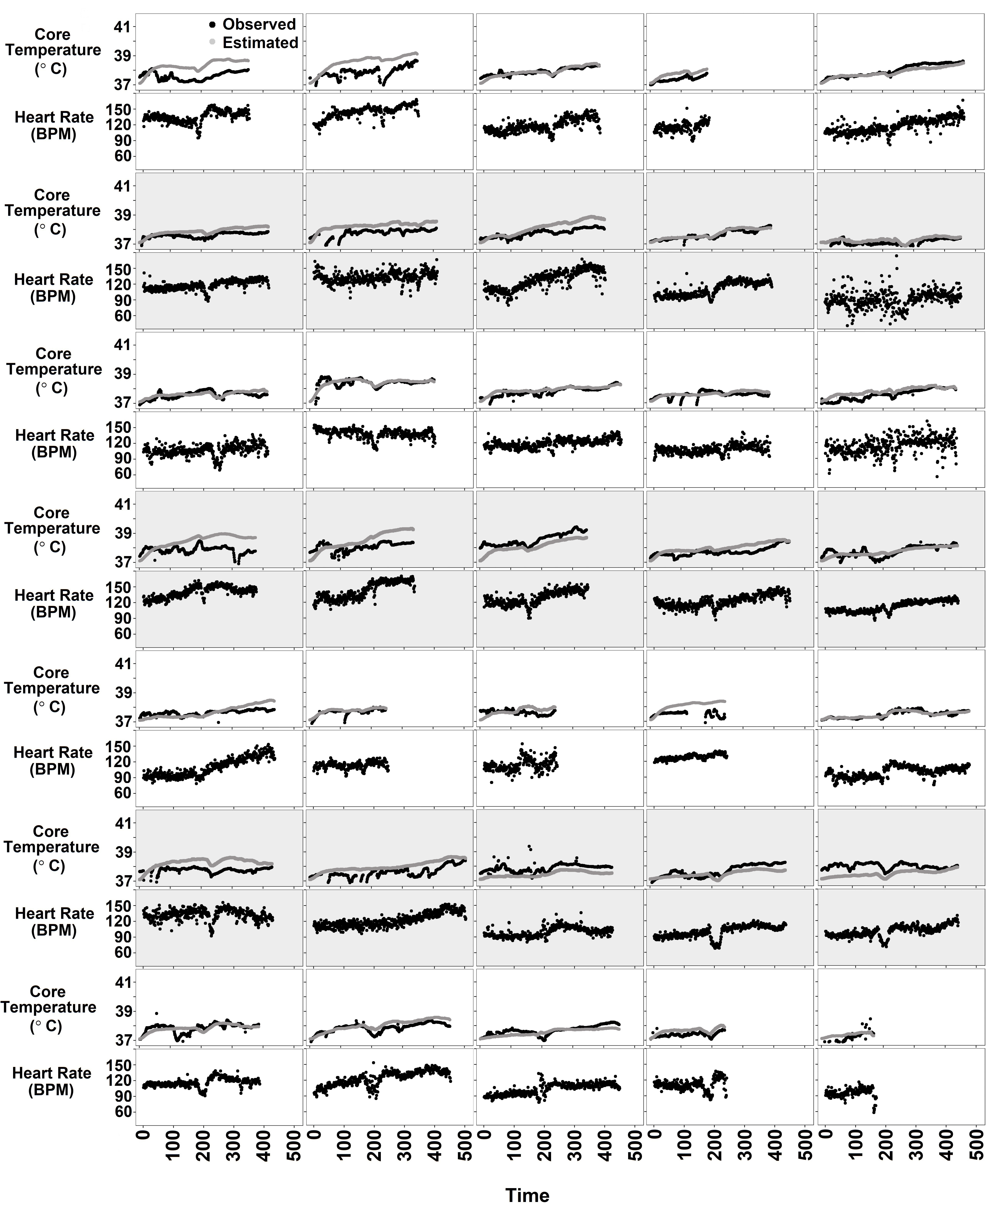
Beats per minute (BPM)

Figure S2. Histograms of bias (a,c) and root mean square error (RMSE) (b,d) for core body temperature (CBT) using: (a,b) default 37.1°C; and (c,d) estimated baseline CBT (aural temperature +0.27°C).

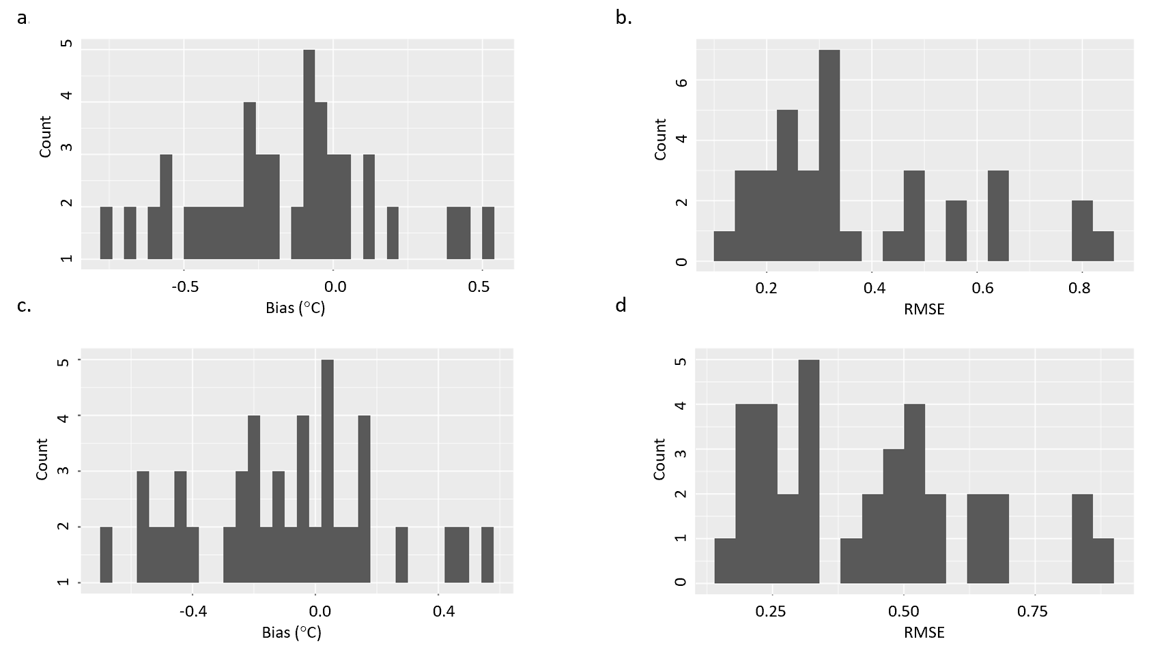

Figure S3. Histograms of bias (a,c) and root mean square error (RMSE) (b,d) for physiological strain index (PSI) using: (a,b) default 37.1°C; and (c,d) estimated baseline CBT (aural temperature +0.27°C).

