Supplemental Information

Lithium-ion Battery Explosion Aerosols: Morphology and Elemental Composition

Teresa L. Barone^{1*}, Thomas H. Dubaniewicz², Sherri A. Friend³, Isaac A. Zlochower², Aleksandar D. Bugarski¹, Naseem S. Rayyan²

¹ Health Hazards Prevention Branch, Pittsburgh Mining Research Division, National Institute for Occupational Safety and Health, Centers for Disease Control and Prevention, 626 Cochrans Mill Road, Pittsburgh PA 15236, U.S.A
² Mining Systems Safety Branch, Pittsburgh Mining Research Division, National Institute for Occupational Safety and Health, Centers for Disease Control and Prevention, 626 Cochrans Mill Road, Pittsburgh PA 15236, U.S.A
³ Pathology and Physiology Research Branch, Health Effects Laboratory Division, National Institute for Occupational Safety and Health, Centers for Disease Control and Prevention, 1095 Willowdale Rd. Morgantown, WV 26505.

* Corresponding author
Teresa L. Barone, Ph.D.
tbarone@cdc.gov
412-386-6768

For submission to Aerosol Science and Technology

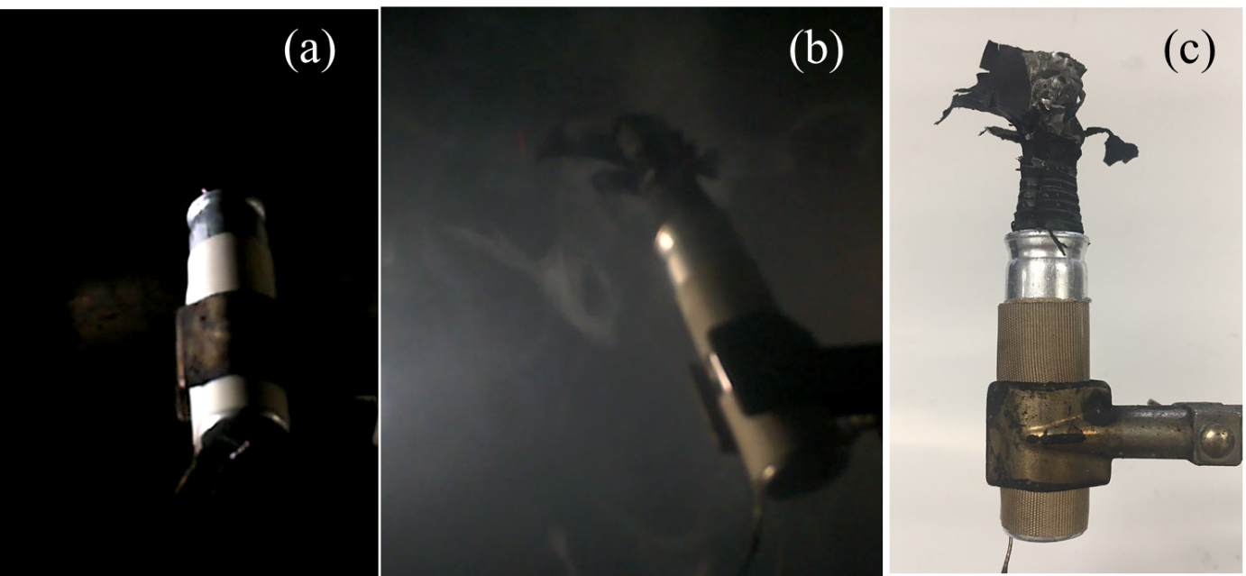
Figure S1. Images of the LTO cell (a) before, (b) during, and (c) after thermal runaway.

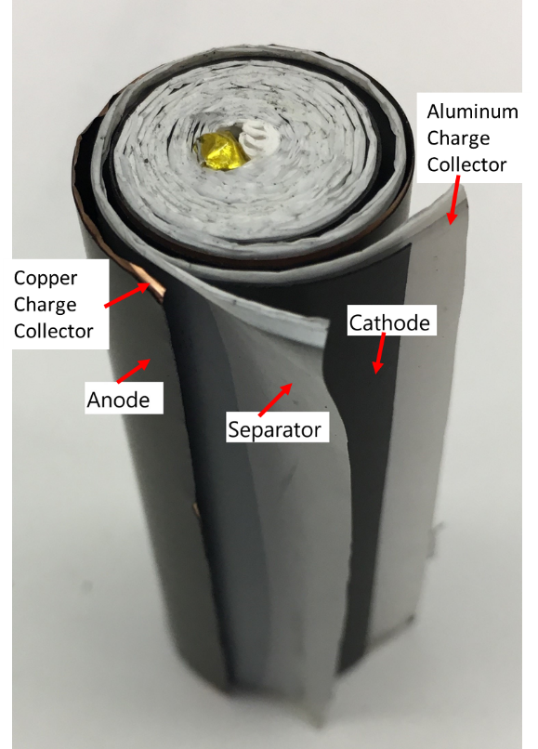
Figure S2. Internal components of NMC battery cell showing the spiral-wound films of the charge collectors, electrodes, and separator.

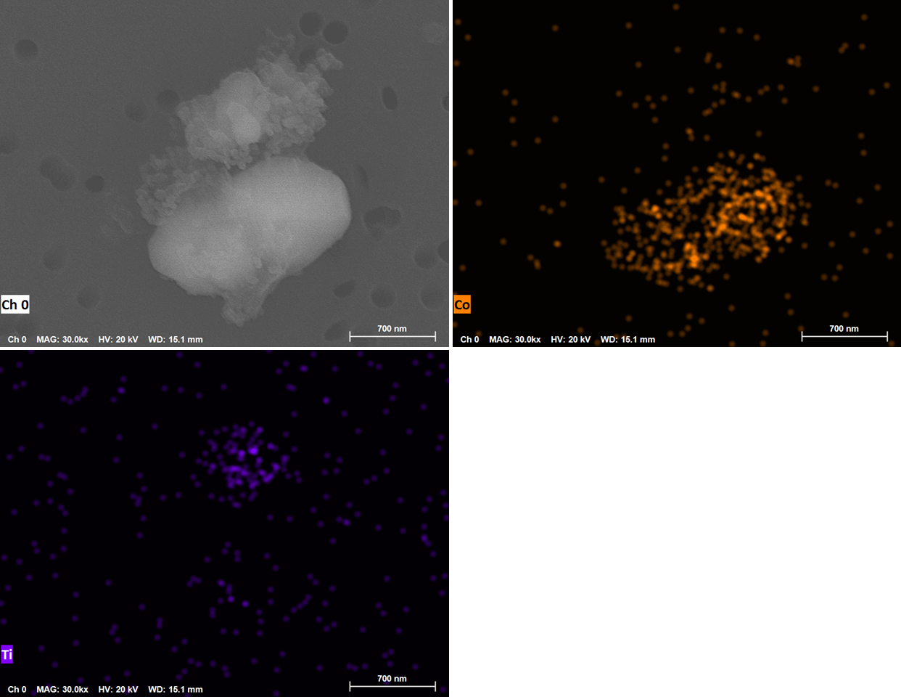
Figure S3. EDS mapping of particle containing cobalt (orange) next to a particle containing titanium (indigo) in LTO explosion aerosols.

