

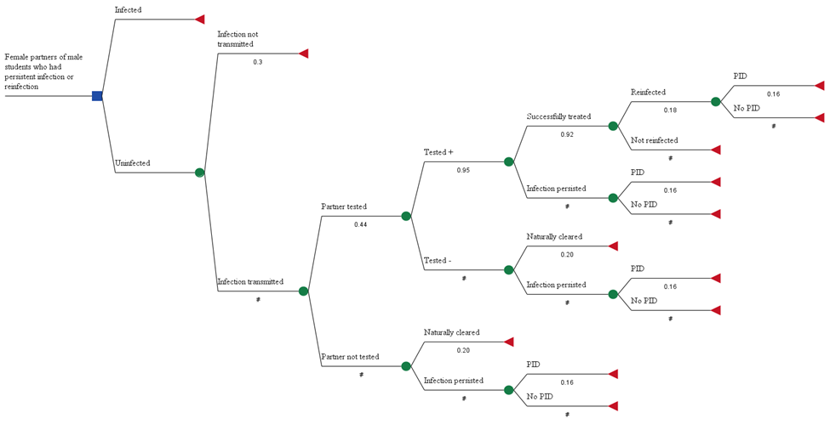

Figure A1. Disease pathway in female partners of infected male students