Supplementary Material
Table of Contents
Table S1: Microsatellite Markers of Venison Toxoplasma Gondii Strain and 46 Toxoplasma Gondii Strains Collected from North American Animals and Humans 2
Figure S1: Venison Kabobs on the Grill 4
References 5

Table S1: Microsatellite Markers of Venison Toxoplasma Gondii Strain and 46 Toxoplasma Gondii Strains Collected from North American Animals and Humans
Isolateª | Year | US state | Species | RFLP genotype number^{b} | Haplogroup (HG)^{c} | Microsatellite markers
 |  |  |  |  |  | TUB2 | W35 | TgM-A | B18 | B17 | M33 | MIV.1 | MXI.1 | M48 | M102 | N60 | N82 | AA | N61 | N83
ARI [1] | 1992 | No data | Human | 5 | HG12 | 289 | 242 | 209 | 158 | 336 | 169 | 274 | 362 | 215 | 170 | 147 | 131 | 295 | 089 | 316
B41 [1] | 1994 | No data | Bear | 4 | HG12 | 289 | 242 | 207 | 162 | 336 | 169 | 274 | 356 | 213 | 170 | 142 | 111 | 287 | 107 | 316
B73 [1] | 1994 | No data | Bear | 127 | HG2 | 289 | 242 | 207 | 160 | 336 | 169 | 274 | 356 | 213 | 190 | 142 | 111 | 267 | 101 | 310
CTG [1] | 1976 | NH | Cat (Felis silvestris catus) | 2 | HG3 | 289 | 242 | 205 | 160 | 336 | 165 | 278 | 356 | 215 | 190 | 147 | 111 | 269 | 089 | 312
GT1 [2] | 1980 | OH | Goat (Capra aegagrus hircus) | 10 | HG1 | 291 | 248 | 209 | 160 | 342 | 169 | 274 | 358 | 209 | 168 | 145 | 119 | 265 | 087 | 306
M7741 [1] | 1958 | IA | Sheep (Ovis aries) | 133 | HG3 | 289 | 242 | 205 | 160 | 336 | 165 | 278 | 356 | 215 | 190 | 147 | 111 | 267 | 091 | 312
ME49 [3] | 1965 | No data | Sheep (Ovis aries) | 1 | HG2 | 289 | 242 | 207 | 158 | 336 | 169 | 274 | 356 | 215 | 174 | 142 | 111 | 265 | 091 | 310
RAY [1] | 1993 | No data | Human | 5 | HG12 | 289 | 242 | 211 | 160 | 336 | 169 | 274 | 362 | 233 | 176 | 151 | 113 | 283 | 099 | 320
ROD [1] | 1993 | No data | Human | 72 | HG3 | 289 | 242 | 205 | 160 | 336 | 165 | 278 | 356 | 213 | 190 | 147 | 111 | 267 | 089 | 314
SOU [1] | 1985 | No data | Human | 139 | HG2 | 289 | 242 | 205 | 158 | 336 | 165 | 278 | 356 | 225 | 174 | 142 | 111 | 259 | 089 | 312
TgBbUs1 [4] | 2009 | AK | American black bear (Ursus americanus) | 147 | No data | 291 | 248 | 209 | 162 | 342 | 165 | 274 | 356 | 211 | 180 | 142 | 105 | 267 | 093 | 316
TgCoPa01 [4] | 2012 | PA | Coyote (Canis latrans) | 1 | No data | 289 | 242 | 207 | 158 | 336 | 169 | 274 | 356 | 235 | 174 | 142 | 121 | 261 | 093 | 310
TgCoPa02 [4] | 2012 | PA | Coyote (Canis latrans) | 5 | No data | 289 | 242 | 211 | 160 | 336 | 169 | 274 | 362 | 225 | 170 | 166 | 113 | 295 | 093 | 310
TgCoPa03 [4] | 2011 | PA | Coyote (Canis latrans) | 5 | No data | 289 | 242 | 211 | 162 | 336 | 169 | 274 | 360 | 237 | 172 | 151 | 111 | 269 | 117 | 316
TgCoPa04 [4] | 2011 | PA | Coyote (Canis latrans) | 5 | No data | 289 | 242 | 211 | 160 | 336 | 169 | 274 | 362 | 213 | 172 | 149 | 113 | 285 | 095 | 331
TgCoPa05 [4] | 2011 | PA | Coyote (Canis latrans) | 3 | No data | 289 | 242 | 207 | 158 | 336 | 169 | 274 | 356 | 215 | 174 | 140 | 119 | 261 | 099 | 308
TgCoPa06 [4] | 2011 | PA | Coyote (Canis latrans) | 4 | No data | 289 | 242 | 207 | 162 | 336 | 169 | 274 | 356 | 213 | 170 | 142 | 111 | 287 | 099 | 316
TgCoPa07 [4] | 2011 | PA | Coyote (Canis latrans) | 4 | No data | 289 | 242 | 211 | 160 | 336 | 169 | 274 | 356 | 213 | 178 | 145 | 111 | 267 | 109 | 316
TgCoPa08 [4] | 2011 | PA | Coyote (Canis latrans) | 1 | No data | 289 | 242 | 207 | 158 | 336 | 169 | 274 | 356 | 213 | 174 | 142 | 123 | 271 | 097 | 310
TgFoxPa01 [4] | 2011 | PA | Red fox (Vulpes vulpes) | 3 | No data | 289 | 242 | 207 | 158 | 336 | 169 | 274 | 356 | 233 | 174 | 142 | 111 | 259 | 097 | 310
TgFoxPa02 [4] | 2011 | PA | Red fox (Vulpes vulpes) | 54 | No data | 289 | 242 | 205 | 160 | 336 | 165 | 278 | 356 | 215 | 190 | 149 | 111 | 259 | 097 | 312
TgFoxPa03 [4] | 2011 | PA | Red fox (Vulpes vulpes) | 2 | No data | 289 | 242 | 205 | 160 | 336 | 165 | 278 | 356 | 213 | 190 | 142 | 111 | 269 | 089 | 312
TgFoxPa05 [4] | 2011 | PA | Red fox (Vulpes vulpes) | 1 | No data | 289 | 242 | 207 | 158 | 336 | 169 | 274 | 356 | 213 | 174 | 142 | 111 | 265 | 093 | 310
TgFoxPa0 6[4] | 2011 | PA | Red fox (Vulpes vulpes) | 216 | No data | 289 | 248 | 209 | 160 | 336 | 165 | 278 | 356 | 213 | 166 | 149 | 107 | 265 | 087 | 306
TgFoxPa08 [4] | 2011 | PA | Red fox (Vulpes vulpes) | 216 | No data | 289 | 248 | 209 | 160 | 336 | 165 | 278 | 356 | 213 | 166 | 145 | 107 | 265 | 087 | 306
TgFoxPa10 [4] | 2011 | PA | Red fox (Vulpes vulpes) | 4 | No data | 289 | 242 | 207 | 162 | 336 | 169 | 274 | 356 | 213 | 170 | 142 | 111 | 301 | 103 | 316
TgFoxPa11 [4] | 2011 | PA | Red fox (Vulpes vulpes) | 2 | No data | 289 | 242 | 205 | 160 | 336 | 165 | 278 | 356 | 213 | 190 | 149 | 111 | 279 | 089 | 312
TgGoosePa1 [4] | 2011 | PA | Canada Goose (Branta canadensis) | 143 | No data | 291 | 242 | 209 | 160 | 336 | 165 | 278 | 356 | 209 | 190 | 149 | 111 | 263 | 087 | 306
TgShUs28 [5] | 2007 | MD, VA, WM | Sheep (Ovis aries) | 73 | HG3 | 291 | 248 | 209 | 160 | 336 | 165 | 278 | 354 | 213 | 166 | 147 | 111 | 277 | 087 | 304
TgSoUs01 [6] | 1998 | CA | California Sea otter (Enhydra lutris nereis) | 39 | HG12 | 289 | 242 | 207 | 162 | 336 | 169 | 274 | 356 | 215 | 170 | 142 | 111 | 267 | 097 | 310
TgWolfMn09 [7] | 2010 | MN | Gray wolf (Canis lupus) | 5 | No data | 289 | 242 | 211 | 162 | 336 | 169 | 274 | 362 | 217 | 170 | 149 | 113 | 293 | 093 | 314
TgWolfMn11 [7] | 2010 | MN | Gray wolf (Canis lupus) | 5 | No data | 289 | 242 | 209 | 160 | 336 | 169 | 274 | 362 | 215 | 170 | 147 | 113 | 281 | 091 | 318
TgWolfMn12 [7] | 2010 | MN | Gray wolf (Canis lupus) | 5 | No data | 289 | 242 | 211 | 162 | 336 | 169 | 274 | 362 | 217 | 170 | 149 | 111 | 295 | 093 | 316
TgWolfMn13 [7] | 2010 | MN | Gray wolf (Canis lupus) | 5 | No data | 289 | 242 | 211 | 160 | 336 | 169 | 274 | 362 | 215 | 170 | 151 | 113 | 279 | 101 | 314
TgWolfMn20 [7] | 2011 | MN | Gray wolf (Canis lupus) | 219 | No data | 289 | 242 | 205 | 160 | 336 | 165 | 278 | 356 | 213 | 190 | 153 | 111 | 267 | 089 | 312
TgWolfMn25 [7] | 2011 | MN | Gray wolf (Canis lupus) | 5 | No data | 289 | 242 | 211 | 162 | 336 | 169 | 274 | 362 | 225 | 170 | 151 | 111 | 279 | 109 | 314
TgWolfMn26 [7] | 2011 | MN | Gray wolf (Canis lupus) | 5 | No data | 289 | 242 | 211 | 160 | 336 | 169 | 274 | 362 | 239 | 172 | 145 | 111 | 283 | 111 | 316
TgWolfMn27 [7] | 2011 | MN | Gray wolf (Canis lupus) | 5 | No data | 289 | 242 | 211 | 162 | 336 | 169 | 274 | 362 | 223 | 170 | 153 | 113 | 295 | 105 | 314
TgWolfMn29 [7] | 2011 | MN | Gray wolf (Canis lupus) | 5 | No data | 289 | 242 | 209 | 160 | 336 | 169 | 274 | 362 | 215 | 170 | 151 | 113 | 291 | 101 | 320
TgWtdPa01 [4] | 2011 | PA | White-tailed deer (Odocoileus virginianus) | 3 | No data | 289 | 242 | 207 | 158 | 336 | 169 | 274 | 356 | 235 | 174 | 142 | 111 | 273 | 087 | 310
TgWtdPa02 [4] | 2011 | PA | White-tailed deer (Odocoileus virginianus) | 3 | No data | 289 | 242 | 207 | 158 | 336 | 169 | 274 | 356 | 215 | 174 | 142 | 111 | 267 | 099 | 310
TgWtdPa03 [4] | 2011 | PA | White-tailed deer (Odocoileus virginianus) | 4 | No data | 289 | 242 | 211 | 160 | 336 | 169 | 274 | 356 | 213 | 174 | 145 | 111 | 271 | 103 | 316
TgWtdPa06 [4] | 2011 | PA | White-tailed deer (Odocoileus virginianus) | 4 | No data | 289 | 242 | 213 | 160 | 336 | 169 | 274 | 356 | 215 | 182 | 145 | 111 | 269 | 101 | 316
TgWtdUs08 [8] | 2007 | MN | White-tailed deer (Odocoileus virginianus) | 74 | HG12 | 289 | 242 | 207 | 160 | 336 | 169 | 274 | 356 | 227 | 190 | 142 | 111 | 269 | 103 | 310
TgWtdUs10 [8] | 2007 | MN | White-tailed deer (Odocoileus virginianus) | 54 | No data | 289 | 242 | 205 | 160 | 336 | 165 | 278 | 356 | 215 | 190 | 151 | 111 | 259 | 093 | 312
VEG [1] | 1988 | No data | Human | 2 | HG3 | 289 | 242 | 205 | 160 | 336 | 165 | 278 | 356 | 213 | 188 | 153 | 111 | 267 | 089 | 312
Venison strain | 2017 | WI | Venison | No data | No data | 289 | 242 | 211 | 160 | 336 | 169 | 274 | 362 | 235 | 174 | 147 | 111 | NA^{d} | 093 | 316
ªReference is the study in which the strain was first described.
^{b}https://toxodb.org/toxo/.
^{c}Information retrieved from published studies [9, 10].
^{d}NA = Not amplified.

Figure S1: Venison Kabobs on the Grill 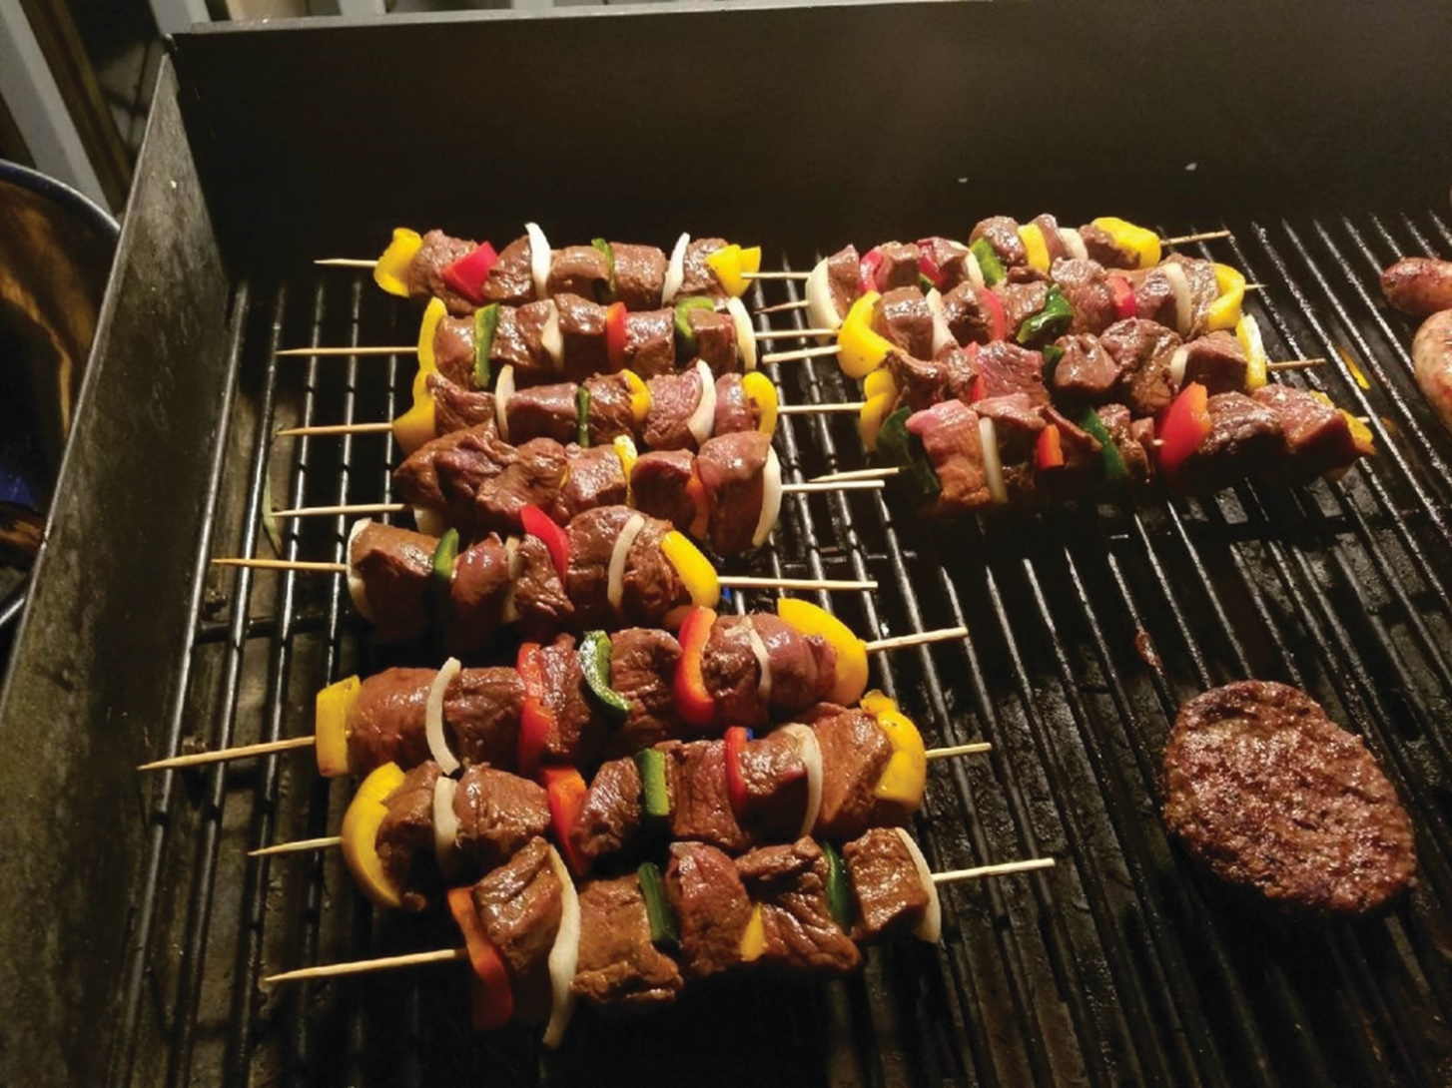
Photograph of venison kabobs that were served at the retreat.

References

1. Howe DK, Sibley LD. Toxoplasma gondii Comprises Three Clonal Lineages: Correlation of Parasite Genotype with Human Disease. J Infect Dis 1995; 172(6): 1561-6.
2. Dubey JP. Mouse pathogenicity of Toxoplasma gondii isolated from a goat. Am J Vet Res 1980; 41(3): 427-9.
3. Lunde MN, Jacobs L. Antigenic differences between endozoites and cystozoites of Toxoplasma gondii. J Parasitol 1983; 69(5): 806-8.
4. Dubey JP, Van Why K, Verma SK, et al. Genotyping Toxoplasma gondii from wildlife in Pennsylvania and identification of natural recombinants virulent to mice. Vet Parasitol 2014; 200(0): 74–84.
5. Dubey JP, Sundar N, Hill D, et al. High prevalence and abundant atypical genotypes of Toxoplasma gondii isolated from lambs destined for human consumption in the USA. Int J Parasitol 2008; 38(8-9): 999-1006.
6. Sundar N, Cole RA, Thomas NJ, Majumdar D, Dubey JP, Su C. Genetic diversity among sea otter isolates of Toxoplasma gondii. Vet Parasitol 2008; 151(2-4): 125-32.
7. Dubey JP, Choudhary S, Ferreira LR, et al. Isolation and RFLP genotyping of Toxoplasma gondii from the gray wolf (Canis lupus). Vet Parasitol 2013; 197(3): 685-90.
8. Dubey JP, Velmurugan GV, Ulrich V, et al. Transplacental toxoplasmosis in naturally-infected white-tailed deer: Isolation and genetic characterisation of Toxoplasma gondii from foetuses of different gestational ages. Int J Parasitol 2008; 38(8): 1057-63.
9. Lorenzi H, Khan A, Behnke MS, et al. Local admixture of amplified and diversified secreted pathogenesis determinants shapes mosaic Toxoplasma gondii genomes. Nat Commun 2016; 7: 10147.
10. Su C, Khan A, Zhou P, et al. Globally diverse Toxoplasma gondii isolates comprise six major clades originating from a small number of distinct ancestral lineages. Proc Natl Acad Sci U S A 2012; 109(15): 5844-9.

